BladeStorm

Candidate number:7266

Centre number: 13345

Muhammed abutaher siddique

Contents

Analysis 5

Background scenario 5

Description of problem 6

End user 7

Research of similar problems 7

Questionnaire 8

First questionnaire 9

Questionnaire results 9

Second questionnaire 11

Second questionnaire results 11

Interview 12

Questions asked 12

Teacher’s response 12

Interview with client 13

Research 14

Animations 14

Tkinter 15

Pygame 15

Objectives 16

Acceptable limitations 21

Minimum system requirements 21

Register data flow diagram 22

Login data flow diagram 22

Design 23

Main Menu, Student, and teacher menu 23

Register Page 24

Login System 25

Score Leader board 26

Add question 27

Pause menu 29

Game over screen 30

Images 31

Sprites 32

Game overview flowchart 34

login flowchart 36

Register flowchart 37

game flowchart 38

Animations 40

Leader board 41

Camera 43

Collisions 44

File structures 46

Data Base design 47

ER diagram 47

Table user 47

Table score 48

Table teachers 49

Table questions 50

Table Question choice 50

Table answer 51

SQL statements 52

UML Diagram 56

Data dictionary 56

Player 56

Enemy 63

Level 64

Questions 67

Event, procedure, and description 69

Test plan 72

Technical solution 79

Animations.py 79

database.py 83

Main.py 84

Testing 141

Evidence for tests 160

Evaluation 205

Objective 1 – Start menu 205

Objective 2 – Student or Teacher 205

Objective 3 – Login Page 205

Improvement 206

Objective 4 – register page 206

Improvements 206

Objective 5 – student page 206

Objective 6 – leader board page 207

Objective 7 – teacher page 207

Objective 8 – display 207

Objective 9 – questions 208

Improvement 208

Objective 10 – pause menu 209

Improvement 209

Objective 11 – enemy 209

Objective 12 – player 210

Objective 13 – puzzle 210

Objective 14 – game over 210

Improvement 211

User feedback 211

Client response 211

Potential improvements 212

Conclusion 214

Appendix 215

sprites 215

Background menu image 215

websites used 215

# Analysis

# Background scenario

When people are picking their A levels, they are told that A levels will be one of the toughest challenges they will have faced, as it requires a lot of hard work and dedication to get the grades that they desire. When trying to overcome this hurdle some hardships will be in our way, one of them is the stress that A levels bring to students. A study was carried out on whether video games help people cope with stress and in the study, it talked about how when people play a video game and enjoy it, their brain releases a neurotransmitter called dopamine into the nucleus accumbens, the brain’s pleasure centre, it is usually stimulated during rewarding experiences. When this dopamine release happens, they will feel good and exhilarated. The pleasure and enjoyment people receive from gaming helps them cope with the stresses the stress they had accumulated that day.

At my tuition there is a computer science teacher that has told me a problem that he is facing. He said that he has seen a consistent problem has risen amongst his students. When doing exam practice, he had seen that his students had been losing marks on questions that should be relatively easy and should be free marks, such as key definitions, simple calculations and sometimes using the incorrect terms in questions. He had asked them why this may have been the case and they told him it may be due to not doing consistent revision and playing too many games too often.

All A level students need to be revising regularly and be preparing for exams, which can lead to them being stressful or some may even find it tedious, and in turn will resort to them playing games as a form of stress relief and enjoyment. However, playing too many games too often can cause the games to become a distraction rather than helpful, which can cause students to fall behind on their revision. To resolve this problem, I will be creating a game that will be appealing and rewarding for the user, whilst also making it an educational game. This will allow students to be able to reap the benefits of playing games, whilst also being able to revise at the same time and ensure they don’t fall behind in their subject.

## Description of problem

Currently there are no games which can help computer science a level students play and revise at the same time. Furthermore, educational games such as the ones from bitesize all have similar problems. These games are heavily revolved around the questions, this does not cater to all types of people, as different people learn in different ways. Some people learn easier through visual ways, some people cannot wrap their heads around a concept until they are visually able to see it. Also, a lot of the educational games do not keep the user constantly engaged, what I mean by this is that a lot of these games are simple games where you just click the correct answer and you will progress, these types of games end up getting tedious very quickly. Also, I found that once the game finishes the user is not shown the questions, they had gotten wrong with the specific topic for that question. This may cause some students to be unaware of their own weaknesses and which topics may require more revision.

To solve these issues, I will be creating a 2D platformer that will have an educational twist added to it. The game will have multiple levels and each level will represent a topic from the computer science specification, for example level one may be based on encryption. The questions asked in this level will be related to what topic the level is based off and will help the user understand key ideas and concepts. The questions will be multiple choice this is so that the user will be able to retrieve all the knowledge they know about that topic and see if what they think the correct answer is and compare it to the options given to them and will be able to narrow down an answer. Each time they play the retry the game they may get a new question or one they have previously seen before, if they had gotten it wrong before they will be able to correct themselves the second time and if they had gotten it correct before they will be repeatedly looking at key information or the definitions of key terms about computer science, which will help the student retain this information and keep it in their long-term memory. The level will be split into different sections and once the user enters a section, they will be asked some questions and they will not be able to progress until they answer them correctly. This will ensure that while the user is playing, they are able to answer questions correctly and learn something while playing. After they have answered the questions, some enemies will spawn and once the user defeats the enemies, they will be able to proceed to the next section of the level. There will also be a section where the user will have to solve a puzzle and this puzzle will be based on a key concept about the topic. This will help those people that learn better visually as they must act out the concept themselves and will be able to see how that concept works. Additionally, the game will be designed in a way that the user will be having to constantly be active and engaged, as the user will have to control the player on their own and will have to constantly be avoiding enemies and attacking them and trying to survive and complete the level. I will also add a way so that the teacher is able to add their own questions to the game so that they can always be tested with new possible questions or questions they had gotten wrong they can be added to the game to see if they have understood their mistake and have learnt from it

## End user

My client would be the computer science teacher at my tuition, and I will be creating a game to help resolve his problem that his students are suffering. Since A level computer science is a subject that is usually known as one of the more difficult subjects as it has a lot of content and requires lots of logical thinking and planning. To help students my game will be an educational game aimed at A level computer science students. It will not only be a game for them to enjoy but also it will also act as a form of revision, as whilst playing the game students will be asked a variety of questions to help them revise the subject. The questions will help them remember key definitions and important information and terms about the subject. I will also make it so that the player is rewarded for any significant actions they do, this will help keep the user in engaged while player and make them feel a sense of accomplishment while playing

## Research of similar problems

There are other websites that contain educational games such as bitesize. From bitesize I have learnt that the games in bitesize a lot of the gameplay is centred on the questions, meaning that to progress you need to answer the questions. For example, in one of the games I looked at to do damage you had to answer the question correctly. To an extent this is good as this will make it so that the user must answer correctly to progress, if the user was able to progress by answering the questions incorrectly then it will seem like they are not learning anything or do not have a good enough understanding about the topic. However, I don’t think that the way the student loses should be up to them answering a question correctly as if they lose due to them not having a thorough understanding of the topic it could be disheartening for the student causing them to stop playing. Instead, I will create a game so that the user is more in control and how well they do in game is based on their own skill. In this way it will feel more like a game where the user is able to test their skills, whilst also having an educational aspect to it rather than a game solely based on answering questions.

From the games I had seen the questions that were given had different difficulties, some were more challenging than others whilst some were easier. This made it so that for some questions the user can easily answer whilst for others they would have to think about it and may even need to check their notes or even use paper for working out. This style of questions is something I will incorporate into my game as it will help the user identify how deep their understanding about a topic is. Also randomly chosen questions will help them game interesting as no new game will be same as the previous one, or the person may even get the same question again when restarting the game which will allow them to solidify their understanding of the topic and will help them not forget key definitions and points. Furthermore, if the player had gotten the question wrong previously, they will be able to reattempt it and see if they had learnt from mistakes and will help prevent them getting a similar question wrong again in the future.

Something that I also found out was that none of the games do not have a function that lets you add or create your own questions or for a teacher to make their own. This can be a problem as after some time the student may have answered all the questions and will only be repeating all that they have learnt and may not learn anything anymore. But by adding a way to add new questions it will help keep the game fresh and help students to always be constantly learning and expanding their knowledge whilst also still being able to revise some old questions that were asked before

## Questionnaire

I have asked sixth form students to complete a survey that will help me identify what key parts of a game will keep them engaged and that define a fun and enjoyable game

### First questionnaire

1. Have you played any educational games before, and did you find them helpful?
2. What type of difficulty do you enjoy while playing?
3. What part of a game keeps you interested?
4. What did you like about the educational games you had previously played?
5. What did you dislike about the educational games you had previously played?
6. Do you like having a competitive aspect to the game?

### Questionnaire results

1. Have you played any educational games before, and did you find them helpful?

- Yes [10]

- No [0]

2)What type of difficulty do you enjoy while playing?

- Easy [0]

- Medium [7]

- Hard [3]

3) What part of a game keeps you interested?

- Multiple attack moves [3]

- Art [2]

- Story [1]

- Animations [3]

- Music [1]

- Music [1]

4) What did you like about the educational games you had previously played?

- Most people said that they liked that the questions were short but were able to help the user revise key information about the subject

5) What did you dislike about the educational games you had previously played?

- The games can get boring quite quickly because most educational games require you to only answer questions to progress the game and achieve anything in the game, you don’t control a character and can end up not feeling like a game.

6) Do you like having a competitive aspect to a game?

- Yes [9]

-No [1]

From the data I had gathered everyone has played an educational game at least once in their life before and it has helped them in one way or another. Majority of the people I asked wanted a medium difficulty game, but there were some that did want the game to be hard.to try and tackle this I will make it so that at first to a new use the game may seem hard but once the user plays enough they will be able to get a feel for the enemy attack range and will be able to adjust and play around it which will make the game easier, this way I will be able to satisfy both types of people. Furthermore, there was a wide range of features that people had enjoyed in the games that they had played previously, so I will try and incorporate the main features that people had enjoyed which was having multiple attack moves and making them have flashy animations. Many people liked the fact that the questions in the educational games were informative and short at the same time, almost like revision cards, they will tell you the key information you will need to know about the topic. The problem with the educational games they had played before was that they felt too restricted by the questions answered and it caused it to not feel like an actual game, rather it felt like they were doing classwork or homework. To solve this problem, I will make it so that the core of the game will be revolved around the user rather than the questions, meaning the user skills will determine if they win or not whilst also having the ability to answer the questions correctly. They also want the game to contain a competitive aspect, to achieve this I will create a scoreboard so that each time the play the game they will have a goal in mind which is to beat their previous high score and to beat the score of other players and to achieve a high rank on the leader board, much like other common games such as Pacman.

### Second questionnaire

To make the second questionnaire I used the results of the first questionnaire to see what type features people wanted in the game that will keep them interested and have fun, also to see what part of educational games needed to be improved and what part of educational games did people like. The questions I will ask will be related to the features of the game I will add to my game, and I want to see If people will agree with my ideas.

1. How many attacks moves do u want the player to have?
2. Would rather have multiple choice questions or questions that the player must write the correct answer themselves?
3. Do you want the levels to contain any puzzles that will need to be solved?
4. Do you want to be in full control of the character?
5. Do you want there to be multiple types of enemies with different health?

### Second questionnaire results

1) How many attack moves do you want the player to have?

- 2 [2]

- 3 [5]

- 4 [3]

2) Would rather have multiple choice questions or questions that the player must write the correct answer themselves?

- Multiple choice [7]

- Write correct answer yourself [3]

3) Do you want the levels to contain any puzzles that will need to be solved?

- Yes [10]

- No [0]

4) Do you want to be in full control of the character?

- Yes [8]

- No [2]

5) Do you want there to be multiple types of enemies with different health?

- Yes [7]

- Yes, but they have the same health [2]

- No [1]

Many people wanted this game to feel like a normal action game that they had played before whilst still retaining the educational factor to the game, so they wanted to be in full control of the game. They also wanted multiple choice questions as they will be able to think about the possible choices it could be and will help them recall everything, they know about each of the choices that will be presented to them. I also think adding a puzzle will be very beneficial for the user as not only do they all want one but when they are playing it will cause them to stop and think to retrieve their knowledge for cs and think how it would help them solve the problem as I can make the puzzles based off computer science concepts

## Interview

Since this game will have an educational part to it, I wanted to make sure that the educational part will be beneficial for the user and will be able to help them revise. So, I decided to interview a teacher to get an understanding of how teachers help students learn and any ways I could make it easy for the students that play my game to retain the information they had learnt while playing the game.

### Questions asked

1) What is the best way to remember key definitions?

2) Should I add long questions or short questions?

3) What can I do to keep the students engaged?

4) What type of questions should I create, meaning should I for example only make questions about key terms and their definition?

5) What type of difficulty question would be best suited for when trying to make students retrieve information about a topic?

### Teacher’s response

1. “The best way to remember key definitions is constantly reading them again and again, looking at a definition once will not be able to help a student to remember it for a long time It may get stored in their short-term memory. But if the student is constantly retrieving their knowledge about a key term, then that definition will get stored in their long-term memory and the students will be able to recall information about a topic much more easily.”
2. “I think you should add a variety length of questions as added too many long questions may cause the student to lose interest and get bored very quickly, whilst having too many short questions might make the student think that the questions are too easy.”
3. “To keep the students engaged I think you should add some sort of system that rewards the player for doing something as it will cause the students to feel a sense of accomplishment and will make them keep playing the game.”
4. “Key terms and definitions are definitely important, and you should add them to your game, however I think that the questions shouldn’t only be about them maybe try to add questions about different scenarios related to the topic or ones that could require the student to recall a formula and perform a calculation to answer the question.”
5. “Try to add questions with different difficulties, the hard questions will be there to allow the student to challenge themselves and deepen their understanding more, the easy questions will be there so that some students will be able to start from scratch and work their way up. Every student has different abilities, and you should try to cater to all of them.”

This interview was very useful on giving me an insight on how to make the best possible service for the students. To make sure students can be constantly revising over key terms I will make it so that my game will randomly pick questions from a question bank that I will create. This is so that there will be a chance for the same question that the student had answered before will be able to appear again. The teacher also wanted to add some sort of rewards system, to incorporate this into my game I will make it so that if the student answers a question correctly or if they defeat an enemy they will be rewarded in some way. I will also make different styles of questions some may be to perform a calculation, and some may to recall a key term, this will make it so that some questions the student will be able to answer easily whilst for others the student will need to think carefully before answering. The questions will also have different difficulties added to them as I do think having too many difficult questions will make it discouraging for those who require a lot more work to do and too many easy questions may put off those students that want a challenge.

## Interview with client

I also had an interview with the client and asked him what type of game he wanted. He said that he wanted some sort of hack and slash type of game where the user will have to defeat enemies and will be asked questions throughout their time playing. We came up with the idea of a person from a period with swords and special abilities Since the character does not have any prior knowledge of computer science it can help relate to the user as when they first started computer science they did not know anything as well, so as they progress through the game the user will accompany the character in his learning journey and it will be like the user is reliving their computer science journey and will be going through the topics one by one and revising everything about the topic. We came up with a type of hack and slash type of game because the game is targeted to A level computer science students rather than a younger audience, we had asked the students at his tuition and other computer science student, and they said they would enjoy playing this type of game. This is important as if they can enjoy the game, it will cause them to repeatedly play the game and each time, they play they will be able to revise topics and learn something new.

## Research

### Animations

To create the animations, I will need some type of software store the images and to make it so that it is easy to edit. The software I have chosen is called GIMP. I have chosen this one as when placing the images, I will be able to put them each image in specific coordinates. This is extremely useful as when creating an animation if the images will need to be placed in the same coordinates some may need to be placed a couple coordinates away from the previous one as some frames of the animation will be doing different actions, so I will need to be able to track the coordinates with ease. Also, you can change the canvas size easily and are able to add grid lines onto the image will make the task of placing each frame of the animation in the correct spot a lot easier. The coordinates and canvas size are very important as when trying to put an image on the screen using pygame you will have to state the coordinates you want the image to be placed, so if some frames are placed in the coordinates the animation will not look normal as it will seem like the player would be teleporting in some sense, and the canvas size is important because when you scale an image in pygame it scales the canvas size to what you specify, so if you are creating an animation and some frames have different canvas sizes when you scale the images so frames will appear more bigger than others. Furthermore, this software allows you to add layers to an image, meaning that when you are trying to make the next frame in the animation you can see the previous frame and place the new frame on a new layer and you will be able to see the difference of each stage of the animation easily this is a technique I had learnt when researching about how to make animations easily and effectively. It also has a feature that lets you go through each frame quickly and in turn will create the animation and you will be able to change it accordingly.

The type of art style that the game will use is pixel art and GIMP has a brush called the pixel brush. This will allow me to create my own pixel art and I will be able to design my own platform and background image. It also lets you zoom in so much that you can see each pixel which makes it very easy to spot mistakes and correct them, you are also able to easy change the thickness of the brush and how many pixels one click will put onto the screen, and you are able to use a lot of different shades of a certain colour. Additionally, when you draw with the brush around the specific pixel you pick will have a different shade to the colour you had chosen. This is especially useful for pixel art as it makes shading easier as well as help the image to look more realistic. Using this software, you can also change many different properties about the brush such as the size, aspect ratio, angle, spacing, hardness, opacity, and force. Furthermore, when trying to create the platforms for the game I will be able to make one tile set which the different platforms will be based off. I also be able to test whether the platform tessellate easily, as GIMP has a built-in feature that lets me copy an image to a clipboard then I can select an area and paste that image into that area to fill it up completely. If I am not satisfied, I will easily be able to make adjustment to the base tile set and make amendments from there and updating as I go along.

### Tkinter

To create the GUI for the menu screens I will be using tkinter as by using tkinter I will be able to create a user-friendly interface that the user will be able to navigate through with ease. Tkinter contains many different features to help make the menu screens such as being able to create buttons on the screen for the user to interact with, through the buttons they will be able to navigate between the different pages.

I will also be able to display text onto the screen as well as add text entry boxes where the user will be able to enter in their details such as their username and password for the login page.

### Pygame

To create this game, I will be programming in python and will be using a module called python to create the game. There are many things I had to research such as learning how to load an image and put it onto the screen. Also, being to create some sort of way that will allow me to play an animation, For the animations I will use pygame to load all the animations into a list I will then user pygame to get the current time and a variable that will record the last time the frame of that animation had been updated. After a certain amount of time the animation frame number will increase and pygame will then load the next item in the list and keep doing this until it reaches the last frame of the animation. I will then have to think about how I can make a hitbox and found out that with pygame you are able to draw rectangles or a sort of “invisible” rectangle. So, I will make it so that around the player and enemy there will be a rectangle around it, and I will make it so that when the player performs an action the hitbox will change as each attack or action should have a different hitbox. Furthermore, pygame has a way so that I can detect collision between rectangles. So, when the player and enemy rectangles collide, I will make it so that one of them will be knocked back and lose hp depending on what is happening. The rectangles will also be useful for the level itself as each platform will have a rectangle around it as well so that the program will be able to detect when the player hits a platform they will be stopped, and it will be able to see when the player is on top of platform. If the platform is above the floor, then the program will need to detect if the player is standing on a platform so that the player will not fall through it and will be able to stand on top of it. Also, pygame can be coded in a way so that it can detect button presses as well as the mouse itself, being able to track the mouse is very useful so that the user will be able to click buttons and detecting button presses is useful to see when the player wants to move, attack jump or any other action and the user will be able to navigate through the menus with ease.

## Objectives

I have discussed with the client what objectives should be met and the features they wanted to be added to the game and this is what they came up with:

1. **Start menu- Once the user opens the game, they user will be presented with a start menu and will be able to choose from different menu options**

- Name of the game will be displayed with a background

-will have multiple options, such as being able to exit the game, start the game

1. **student or teacher – once the user clicks start the user will have to choose whether they are a student or a teacher as they will be taken to different menus after logging in**
   * 2 buttons will be displayer one called teacher and one called student
   * after logging in the user will be taken to different screens according to whether they are a teacher or a student

**3)Login page- Once the user clicks start game, they will be prompted with a login page where they will need to enter their username and password**

-The user will be asked to enter their username and password

- there will be a text entry box where the user will be able to enter their username and password

-If the username or password is entered incorrectly an error will be displayed

-There will be a login button for when all the correct account details have been entered

-there will be a back button so that if the user does not have an account they will be taken back to the page where they can select whether they want to register or login again, this is in case the user has not registered yet

**4)Register page- If the user does not have a login, they will be able to register an account here and will have to enter a unique username as well as a password and will need to confirm their password to prevent any mistakes**

-there will be a 3 text entry boxes where the user will have to enter a username, password and will have to confirm their password

-The user will be asked to create a unique username

-the user will have to make a password that is at least 3 characters long and less than 10 characters

-when confirming the password, the password much match the password they have previously written

-if any of the above conditions are not met an appropriate error will be displayed

-Once the user has registered their password and username will be stored in a database

**5) student page – if the user has selected, they are a student, then once they have logged in, they will be taken to the student page where they will be able to choose 3 different options**

- the user is shown 3 buttons called start, leader board and return to main menu

- clicking start will run the game and it will load up in the pygame window

-clicking return to main menu will return the user to the first main menu screen

-clicking leader board will take the user to the leader board page

**6) leader board page – in the leader board page the top 10 ranked players will be shown, the rank that player is, that player’s username and their high score**

- a list of all the high scores recorded in the database is retrieved

- a merge sort is performed to sort to the codes

-the top 10 scores are selected

- the user is shown the rank, username, and high score of the top 10 scoring players

**7) teacher page – if the user had selected teacher, then once they have logged in, they will be recognised as a teacher and will be asked to choose a level which they will then be able to add questions that should be asked for that level**

- the user is shown different options to select a level

- once they have selected a level, they will be able to add questions for that chosen level

-they will be shown a text entry box for the question, option a, option b, option c and the answer

- if any of these boxes are not filled in then an appropriate error message is displayed

- the question, option a, option b, option c and the answer will all be stored in the database

**8)Display- Once the user has logged in the game will then load and the appropriate features will then be loaded onto the user’s screen.**

* Any relevant text will appear on screen such as health, energy, and score
* Player energy bar and player health bar will always be displayed
* Enemy health bar will be displayed once hit
* All the platforms will be generated
* Once the player reaches a certain point on the screen the camera will follow the player
* The player and enemies will have their own image files for each animation, each of which will be loaded and displayed on to the screen according to what is happening in game
* If an enemy is defeated the player score will increase

**9)Questions- the levels will be divided into sections and each time the user enters a section they will be asked some questions and the user will have to get at least 2 questions correct to proceed.**

* Once the user enters a certain section of the level, they will be asked questions related to that level’s topic
* The user will not be able to proceed until some questions have been answered
* A question is randomly selected from the questions related to that level
* The question, question options and the answer are all retrieved from the database
* If the correct answer is chosen, the player’s energy will increase, and their score will increase
* If the incorrect answer is chosen, the players HP will decrease, and their score will decrease
* Every time the user enters a new section of the level, they will be asked another question

**10)pause menu- If the user presses the Esc key, they will be shown different options to choose from, also the game will be paused, and the player and enemies will all stop moving until the game has been resumed**

* One option will be to resume the game
* There will also be an exit option which will terminate the game

**11)Enemy- once the user has answered the questions for the section of the level, they are in a certain number of enemies will spawn**

* The enemy will have an AI which will cause it to move towards wherever the player is and will attack them if they are within range
* There will be different types of enemies. Each of them will have their own animations for every action they do. Some will have more attacks and will have more HP than others
* If the enemy is underneath the player and they are not moving, then an idle animation will be played
* If the enemies HP reaches 0 a death animation will be played, and their body will be removed from the screen

**12)Player- The user will be able to control a player and the player will act according to what key on the keyboard the user presses.**

* The player will have multiple key bindings that will perform different actions and each action will have their own image
* If the user does not press anything on the keyboard, then the player will have an idle animation
* The player will be able to move left and right using the A and D keys
* The player will be able to jump using the spacebar and will automatically fall back to the ground after a certain height reached
* The player will have 3 attack moves each of which will have its own animations and will deal damage to the enemy
* Each attack will have a different hitbox and will knock the enemy further back depending on which attack move is used
* One of which is the players normal attack and can be used anytime by pressing the J key
* Another attack can be used by pressing the K key. However, this attack can only be used once reaching a certain amount of energy
* The third attack is called a special attack and can be used by pressing the L key. However, this attack also can only be used once reaching a certain amount of energy.
* The player will have a hit box around them when walking and standing still, this will allow them to collide with the floor and the platforms created. Also, if the player walks into the enemy or walks into an enemy attack, they will be knocked backed a certain distance according to if they walked into them or if they were attacked.
* If a player is hit, they will lose HP. If the players health reaches 0 a death animation will be played and a game over screen will be displayed

1. **Puzzle – once the player reaches the 2nd section, they will be presented with a puzzle that is about asymmetric encryption and they will have to solve it to increase their score**

* There are 4 keys 2 for the sender and 2 for the recipient
* There is an area for the recipient to receive the encrypted message
* There is a message on the screen that will need to be encrypted and decrypted
* Using the recipient’s public key will encrypt the message
* The recipient will then receive then encrypted message
* The recipient will then have to use their public key to decrypt the message

1. **Game over- If the player’s HP reaches 0 or if the user completes the level, they will then be shown a game over screen**

* Once the user is shown the game over screen, the users account will be storing the users score and display it to them
* The user’s score will be updated in the database and if the players score is higher than the one recorded in the database it will be updated
* The user be shown text that states, “GAME OVER” and will be shown the score they had achieved that game and their high score.
* The user will be shown a button to continue that will close the game and will be able to relaunch the game by clicking start again

## Acceptable limitations

When discussing with the client there were some features, they wanted added to the game that I will not be able to complete. The client wanted the game to be 3D, however due to time and resources I will not be able to fulfil this request as creating a 3D game requires a lot of time and will require me to learn about 3D rendering, how to use certain modelling software’s, I will also need to learn some advanced AI algorithms and how to make 3D models of characters and in game objects.

Additionally, since I will be using Pygame how smooth the game runs will depend on the hardware of the computer running the program. Pygame is not like other engines that are used for creating games, Pygame is a wrapper for SDL which is unable to directly use hardware acceleration. So pygame will mainly run off the computer’s CPU. When playing the game certain parts of the map will make the game feel slower as pygame will have to load more things onto the screen and will cause the frames per second to be lower. People that have a better CPU will have higher frames while playing.

The client wanted a game that would be able to cover all the topics in the computer science specification, however due to time constraints I will only be able to do a few topics from the specification. I will also only create one level due to time constraints, however I will design the code in a way so that when future levels are added it will still be able to function properly.

## Minimum system requirements

-python installed

-pygame installed

* OS: 64-bit Windows 7 or later or OS X 10.11 or later.
* Processor: 1.5GHz or faster.
* Memory: 4GB (4,096MB) RAM.
* Free HDD space: 3GB.
* Hardware: keyboard, mouse

## Graphical user interface Description automatically generatedRegister data flow diagram

Login data flow diagram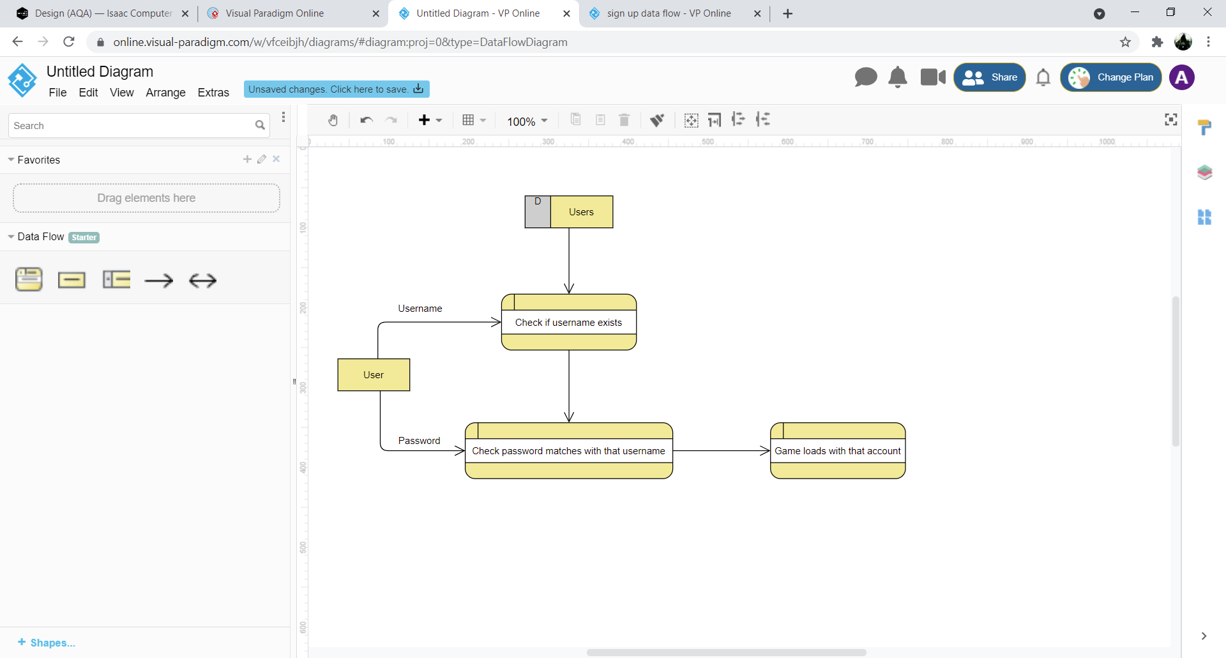

# Design

## Main Menu, Student, and teacher menu

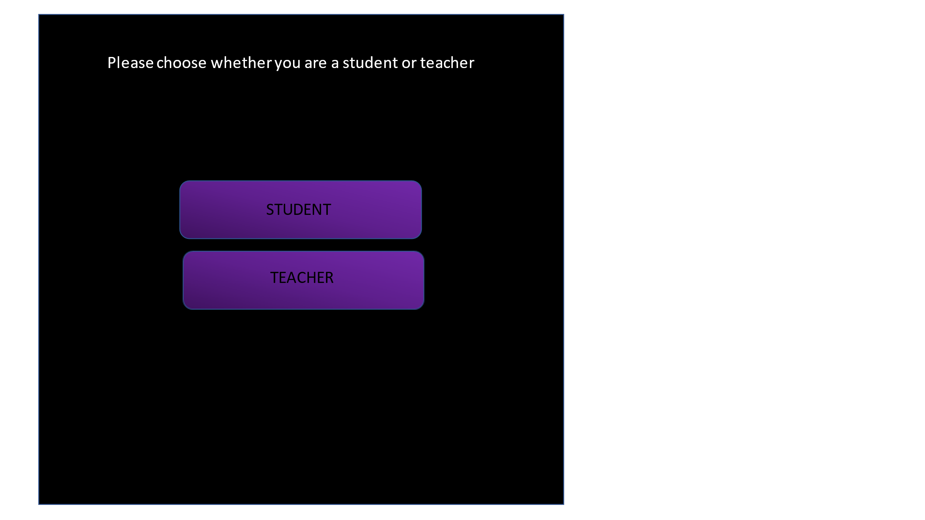

When the user first loads the game, they will be presented with the screen on the left which is the main menu, clicking exit will close the program. Whilst clicking start will take the user to the page on the right where they will be able to choose whether they are a student or a teacher. If the user chooses that they are a teacher they will be taken to different screens after logging in, rather than playing the game they will be able to select a level and add questions to that level. If they choose student after logging in, they will be able to view the leaderboard as well as play the game.

## 

## Register Page

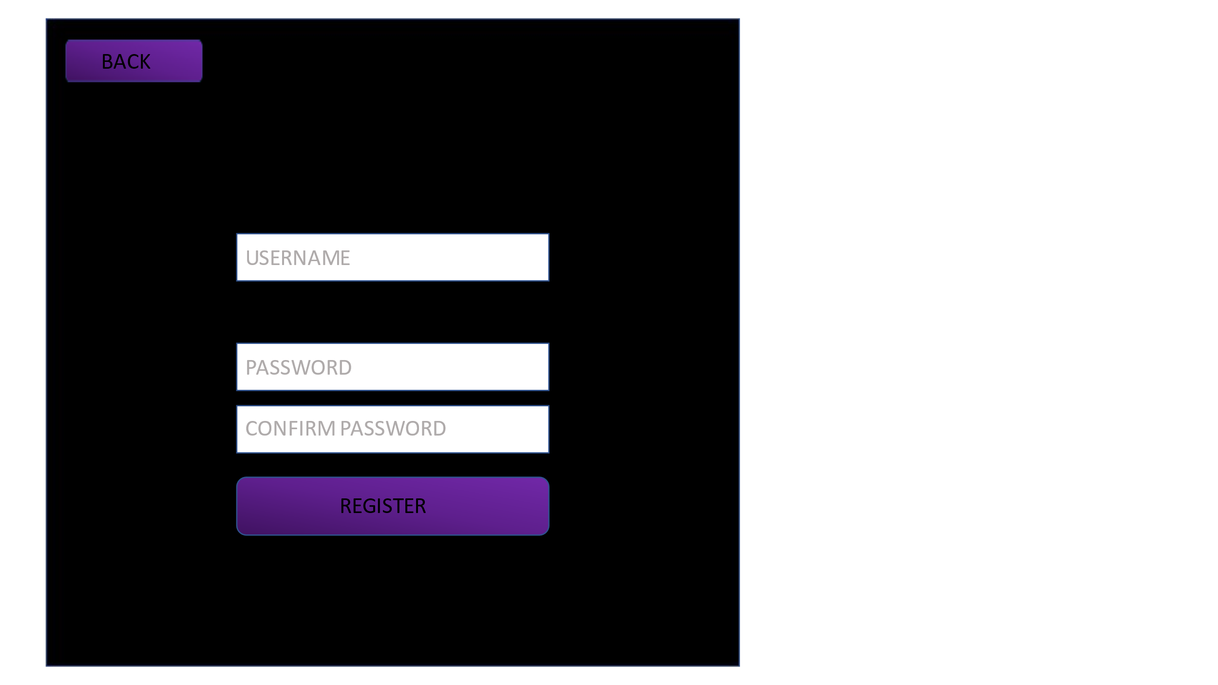

If the user does not have a login, they will need to register an account, they will need to pick a unique username that has not already been registered. The username will need to be at least 3 characters and less than 10 characters. If the username does not meet these requirements, or if a username or password is not entered, they will be presented with an error. The user is also asked to confirm their password to make sure they have entered the desired password correctly. Once the user has registered their username and password will be stored in a database.

## Login System

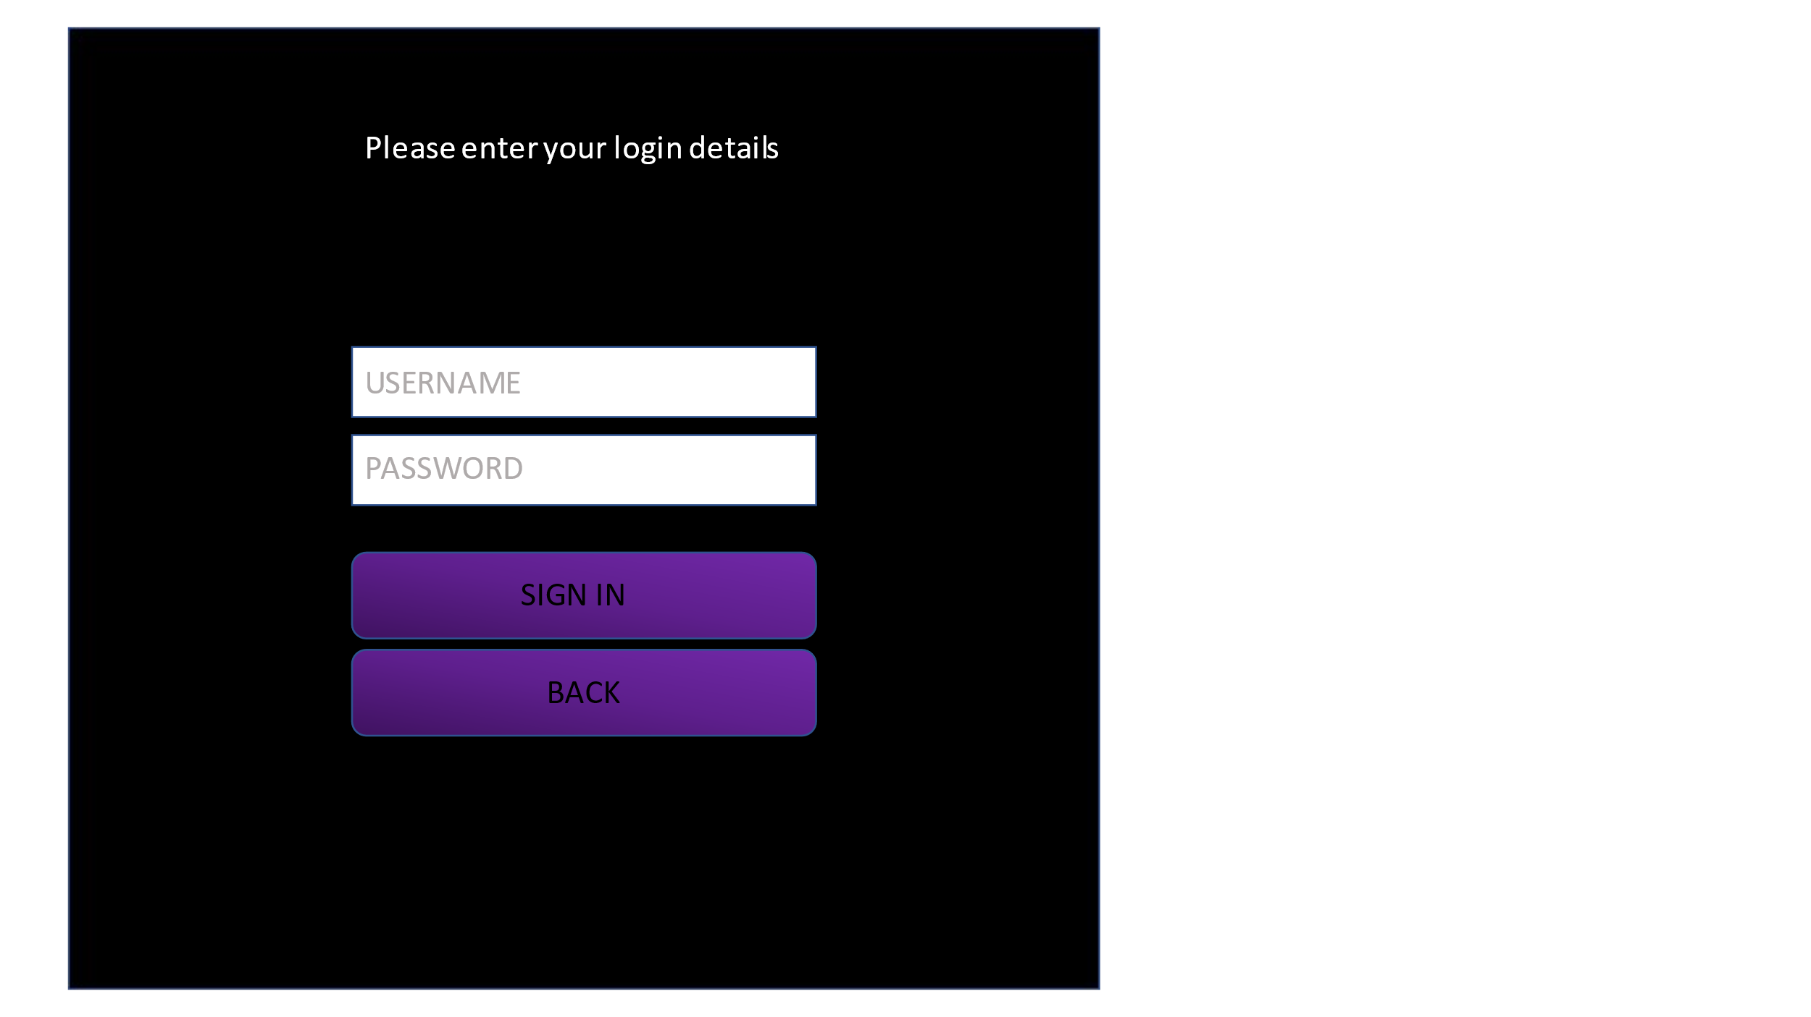

The user will need to input the username and password of an account that has been registered. If any of them have been entered incorrectly and error message will be displayed. Once the user has logged in, they will be taken to another page according to whether they are a student or a teacher. Pressing the back button will return the user to the previous screen.

## Score Leader board

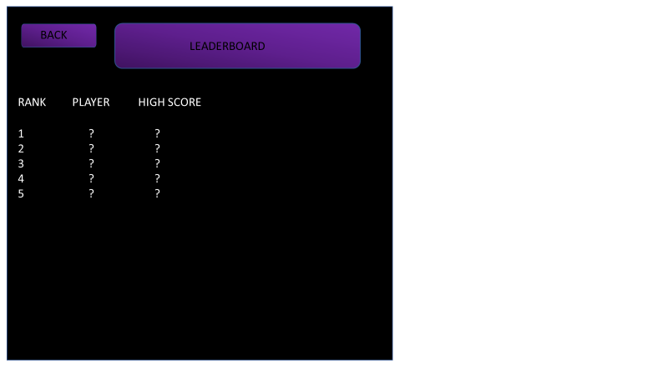

The user will be shown the top 10 players, the player rankings will be determined depending on who has a higher score. The leader board will show their position in the scoreboard, their player’s name which will be their username and it will show their highest score. Each time the user clicks the leader board button and is sent to this page the scores of all the users in the database is checked to see if any adjustments to the rankings need to be made. Clicking back will return you to the previous screen.

## Add question

If the user is a teacher once they login they will be shown the screen on the left where they will be able to proceed to add a question. Once the user clicks add question they will be sent to the screen on the right where the user will be able to pick the level, they wish to add the question to.

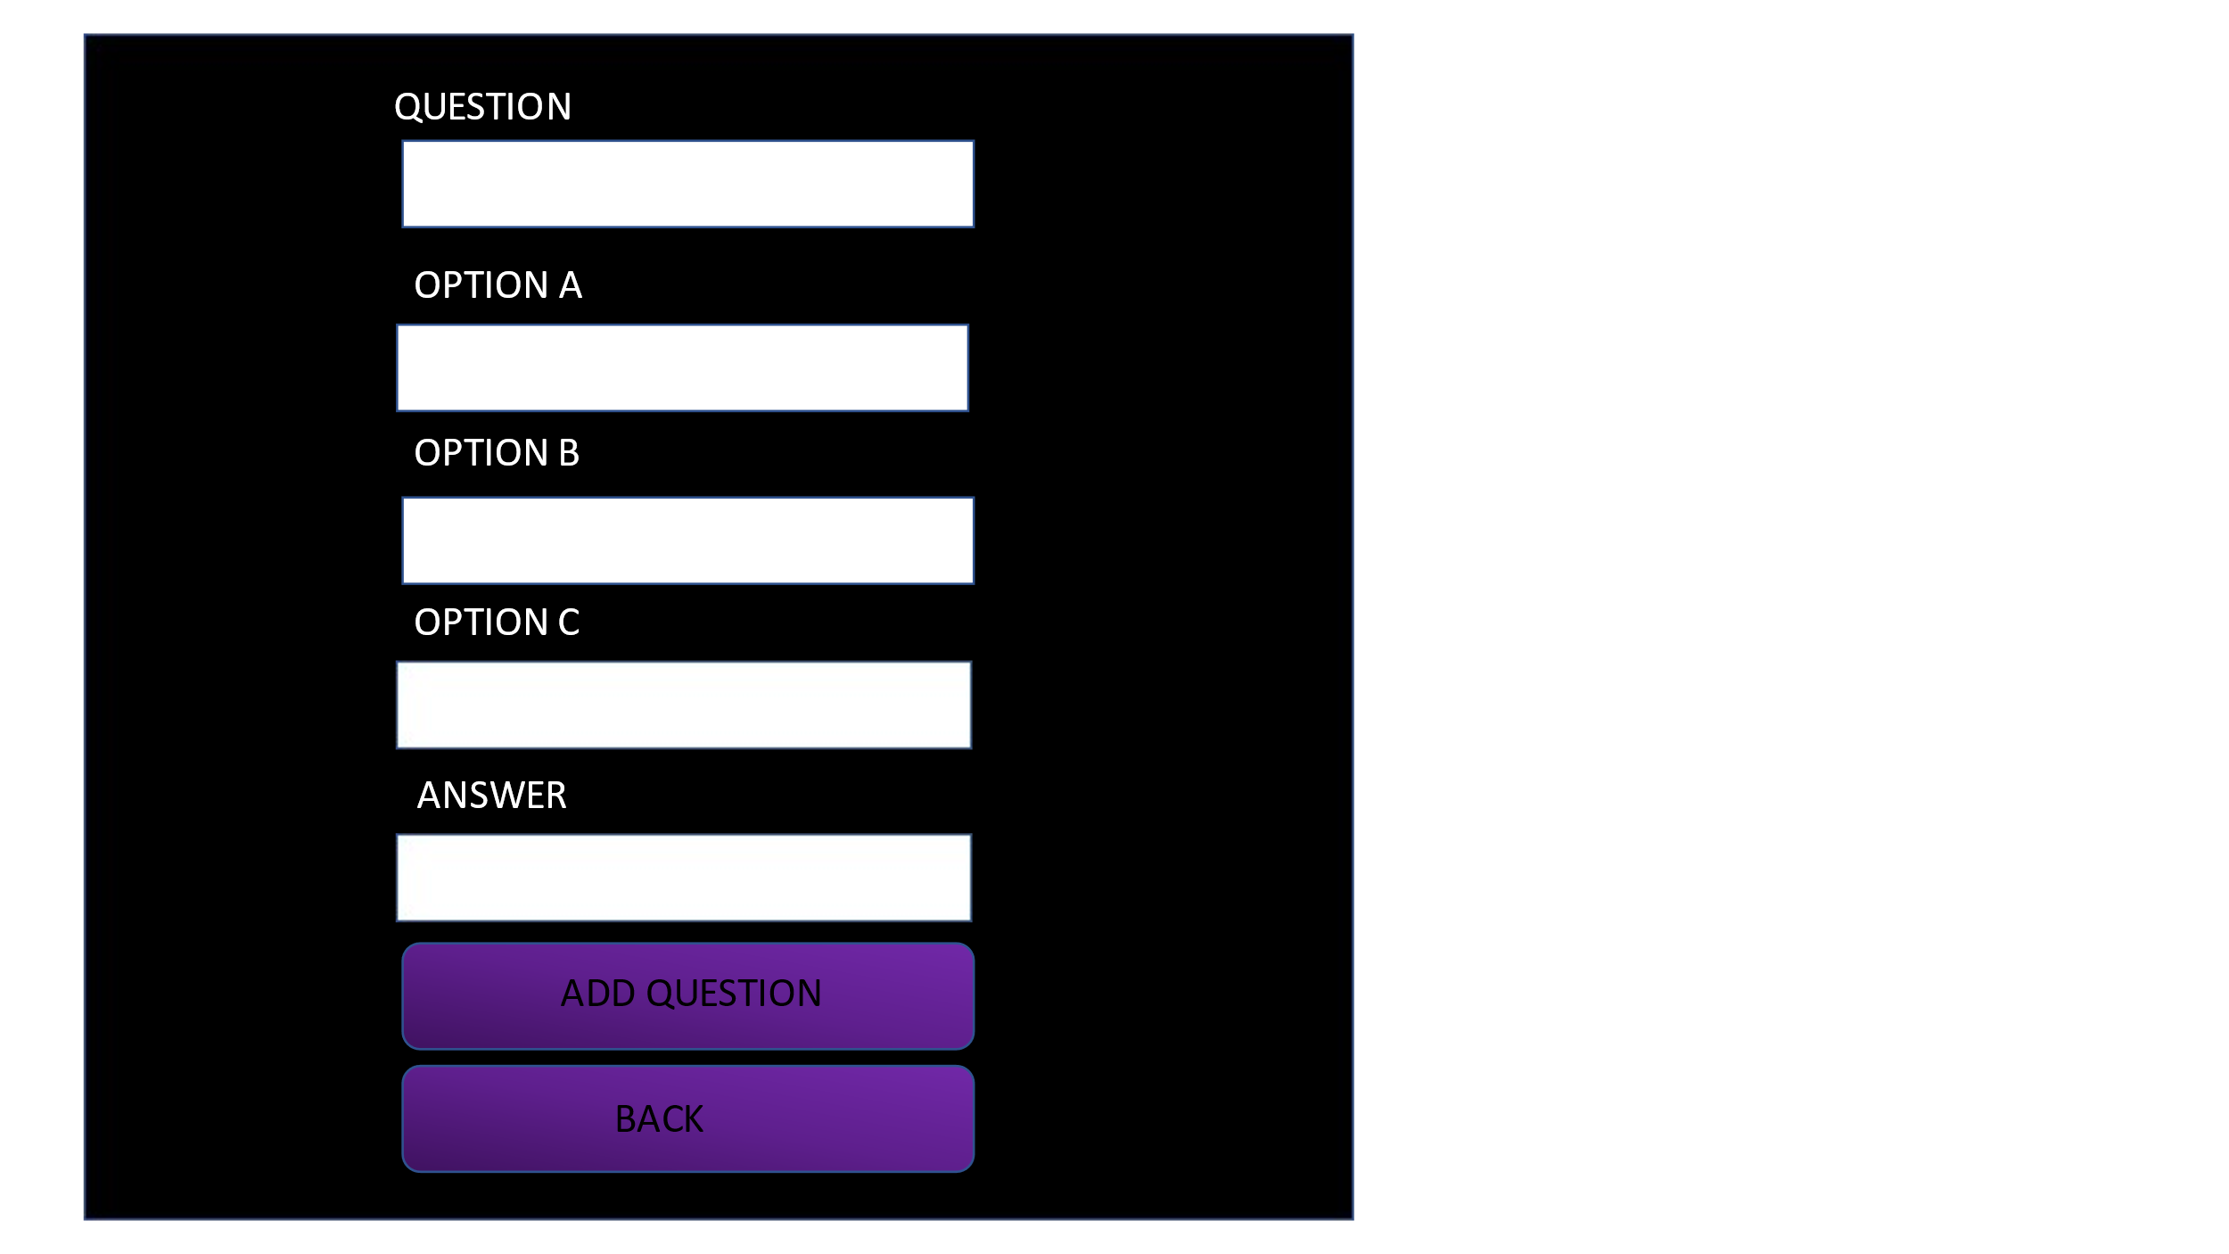Once the user has selected the level, they will have to enter the question text and the 3 possible answers for the question as options, the user will then have to enter the password for the question, if it is A B or C. If any of these boxes are left blank, then an error will occur. Once the user clicks add question all the details of the question will then be stored in the database which will be retrieved when playing the game.

## Pause menu

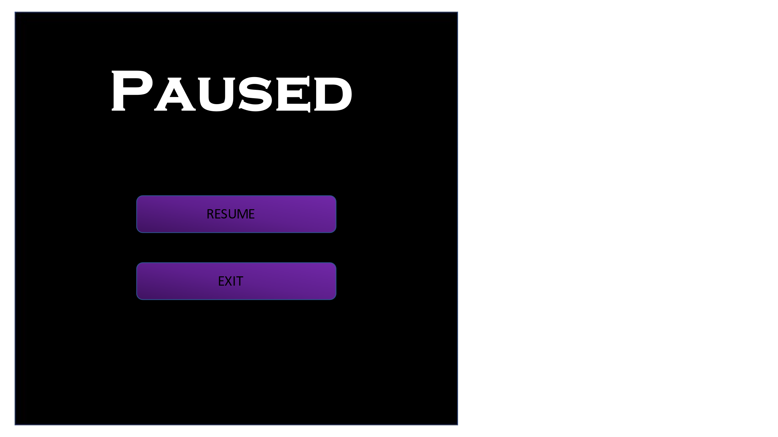

If the user presses Esc whilst playing the game a pause menu will appear, while the pause menu is on screen everything in the game will be paused and will be unable to move until the resume button is clicked and the user will be taken back to the game. If the exit button is clicked the user will be returned to the main menu.

## 

## Game over screen

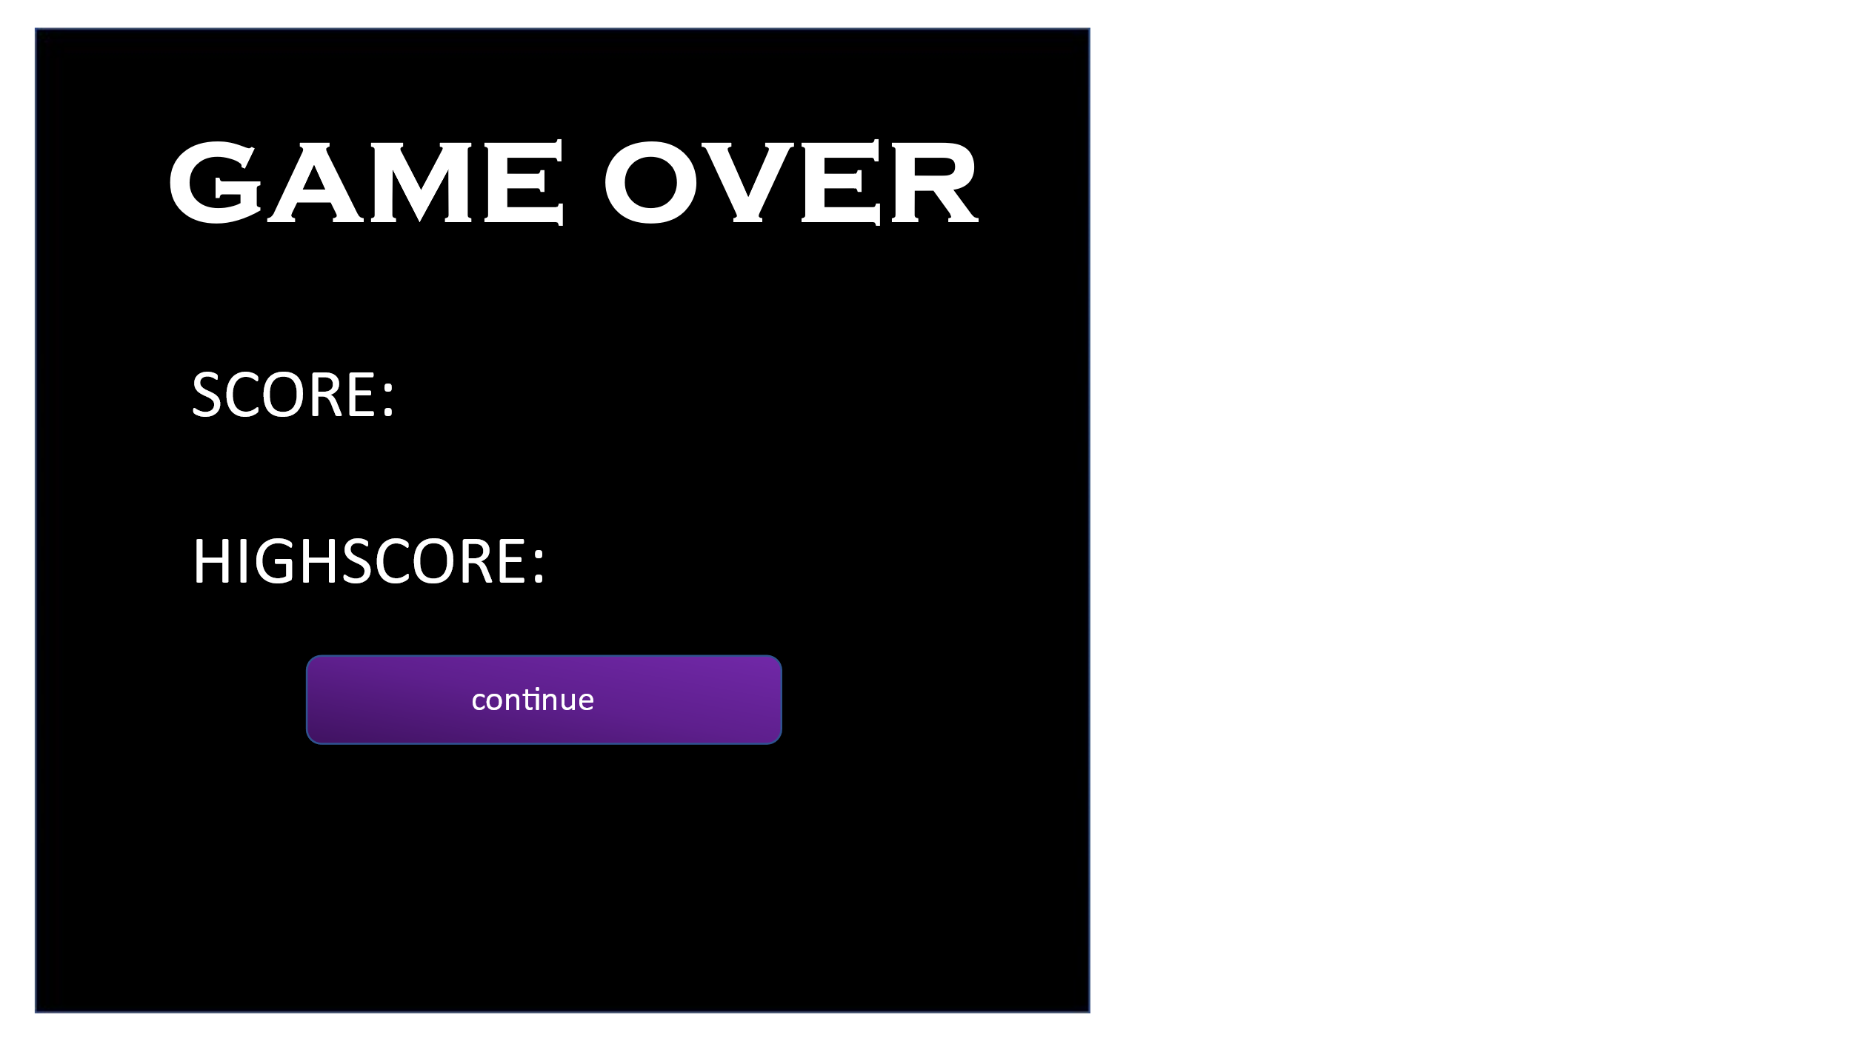

Once the player’s health reaches 0, they will be shown this game over screen where they will be able to see the score, they had gotten that game as well as their high score they had previously earned. Once the user clicks continue the user will be sent back to the student screen where they will be able to play again or check the leader board to see if they have made it into the top 10

## 

## Images

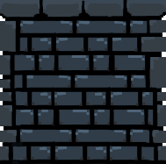

I had discussed with my client what type of style he wanted the level to look like, and we came up with the idea of some sort of dungeon place. So, I used GIMP to design a base tile set which I can then use to create platforms that will be based off this tile set. You can cut up this tile set into 9 different pieces, and I will be able to pick which piece I need to create the platforms. GIMP has a function that lets you add a grid to divide an image into pieces making it easy to edit each tile of the tileset and compare them to each other and see where changes need to be made

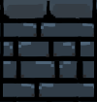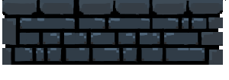

Using the tile set I was able to create platforms such as these that will be placed through out the level, some platforms will be longer than others not just horizontally but also vertically.



I also created a key which is used for the puzzle. The puzzle will be about assymetric encyrption since it uses public and private keys I thought It would be best to design a key so that it is easier for the students to visualise what is happening.

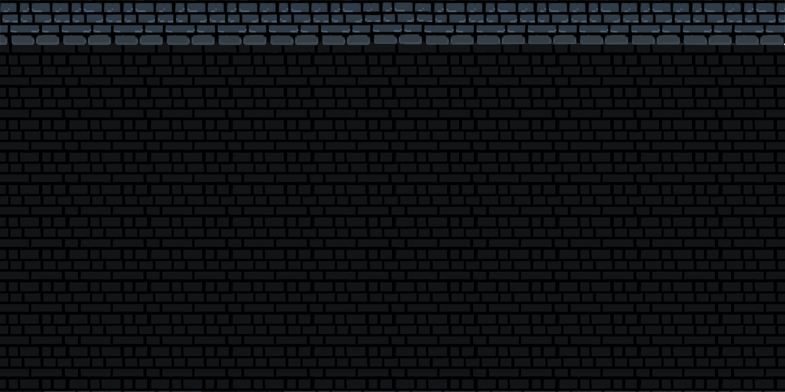

I also used the tile set to create a ceiling in the level that the user will not be able to go passed and was able to use the tile set to make a background. For the background I took a part of the tile set changed the colour of it to a darker grey and change how some of the tiles are placed. I created a small chunk of the background like I did with the tile set and using GIMP I copied it to a clip board and was able to paste it on the whole canvas. This was especially useful to see if the bricks where tessellating nicely and helped me find out what needed to be improved.

## Sprites

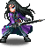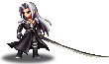

1st sprite - <https://www.spriters-resource.com/mobile/finalfantasybraveexvius/sheet/95474/>

2nd sprite - <https://www.spriters-resource.com/mobile/finalfantasybraveexvius/sheet/87187/>

One of the objectives that I had discussed with the client is that he wanted detailed sprites that had detailed animations as well as a character that multiple attack animations and would fit the dungeon style of game. I had found these 2 sprites in the links above, the sprite on the left is the character that the user will control and the sprite on the left is the sprite of the enemy. Due to time limitations, I will not be able to make a detailed sprite like the one the client wanted so I had showed him these 2 sprites and their animations, and he was satisfied with it

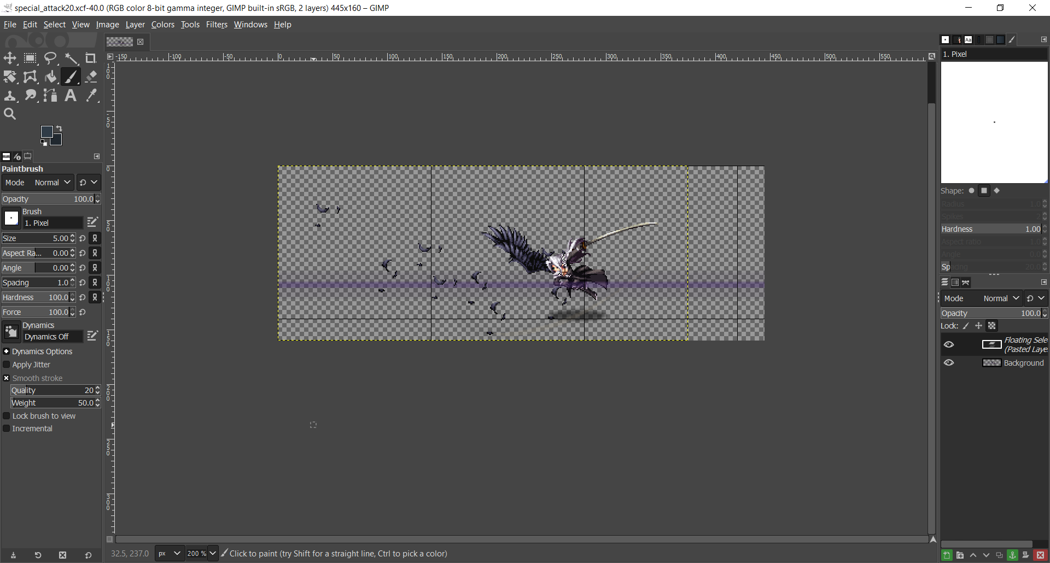

After obtaining all the images of each animation I had to save each frame of each animation separately. I had to then measure the how big each frame of an animation is so that I can set the canvas of that animation. The canvas for the idle animation would be much smaller compared to the canvas of the ultimate attack animation. The reason that I must make sure that the canvas for each frame in an animation has the same size is because when it is loaded into pygame I will be scaling the image of each frame as it is going through the animation and the canvas size of the image will be scaled. If the canvas sizes are not the same, then when it is put on to the screen with pygame some images will be bigger than others. Another important factor of when placing the image is its coordinates, GIMP has a feature that lets u see the X and Y coordinates of an image as well as add some grid lines to an image. This is very useful for making the animation as I must make sure that each animation is perfectly placed and need to make sure that each frame of the animation is in the same spot as the previous frame and then moved when needed. Being able to use grid lines makes it easier to remember which part of the canvas the frame needs to be placed and helps keep track of the frames X and Y coordinates. Another useful part of GIMP is the feature on the right which lets me add layers, in theses layers I can add the previous frames for that animation to see whether when the animation is played that the animation is smooth and nothing irregular is happening. You can change the opacity of one layer so that you are able to see the previous frame faintly whilst being able to see the frame you are currently editing and place the new frame in the correct position based off the previous frame this is a technique that animation artists used called “onion skin” technique.

## Game overview flowchart

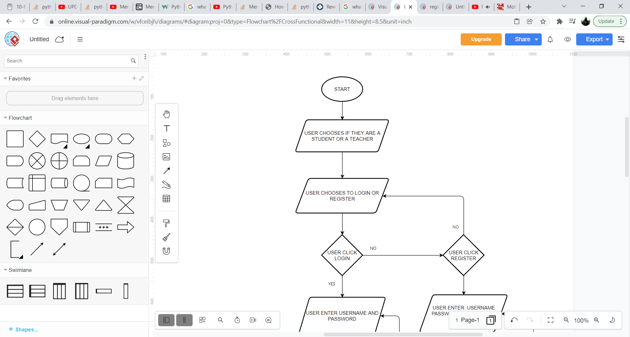

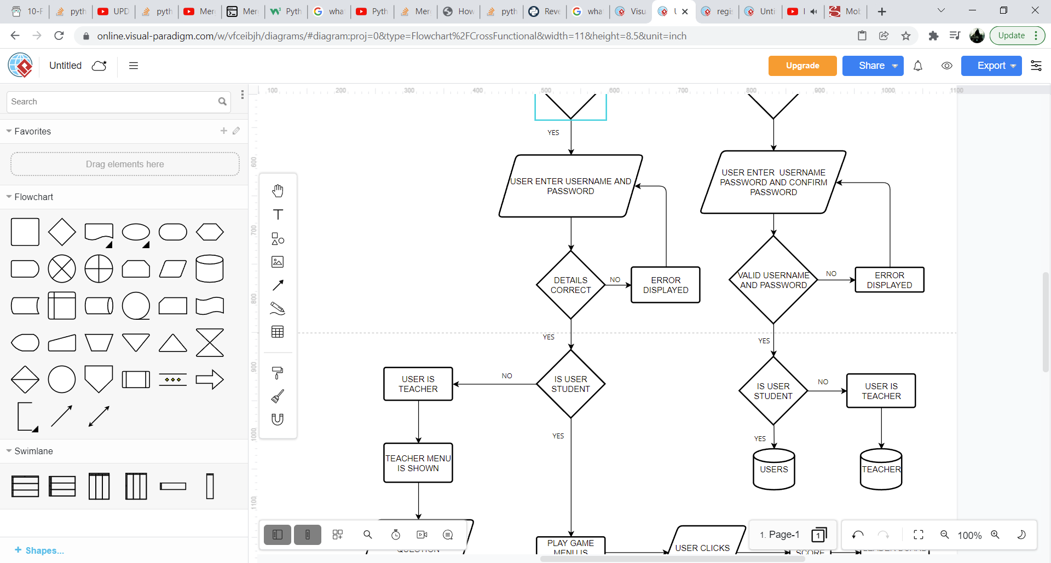

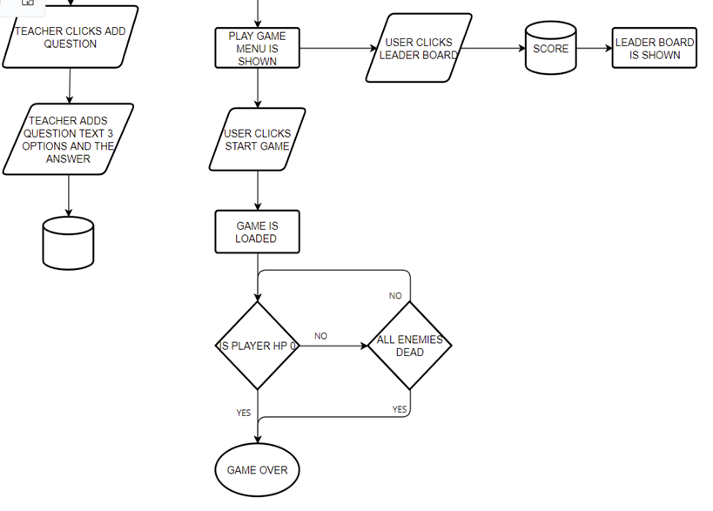

## 

## login flowchart

When the user clicks login, the database will be checked to see if that username exists in the database, if it does it will check the password from that table that relates to that username if what has been entered matches what is stored in the database then they will be logged in.

## 

## Register flowchart

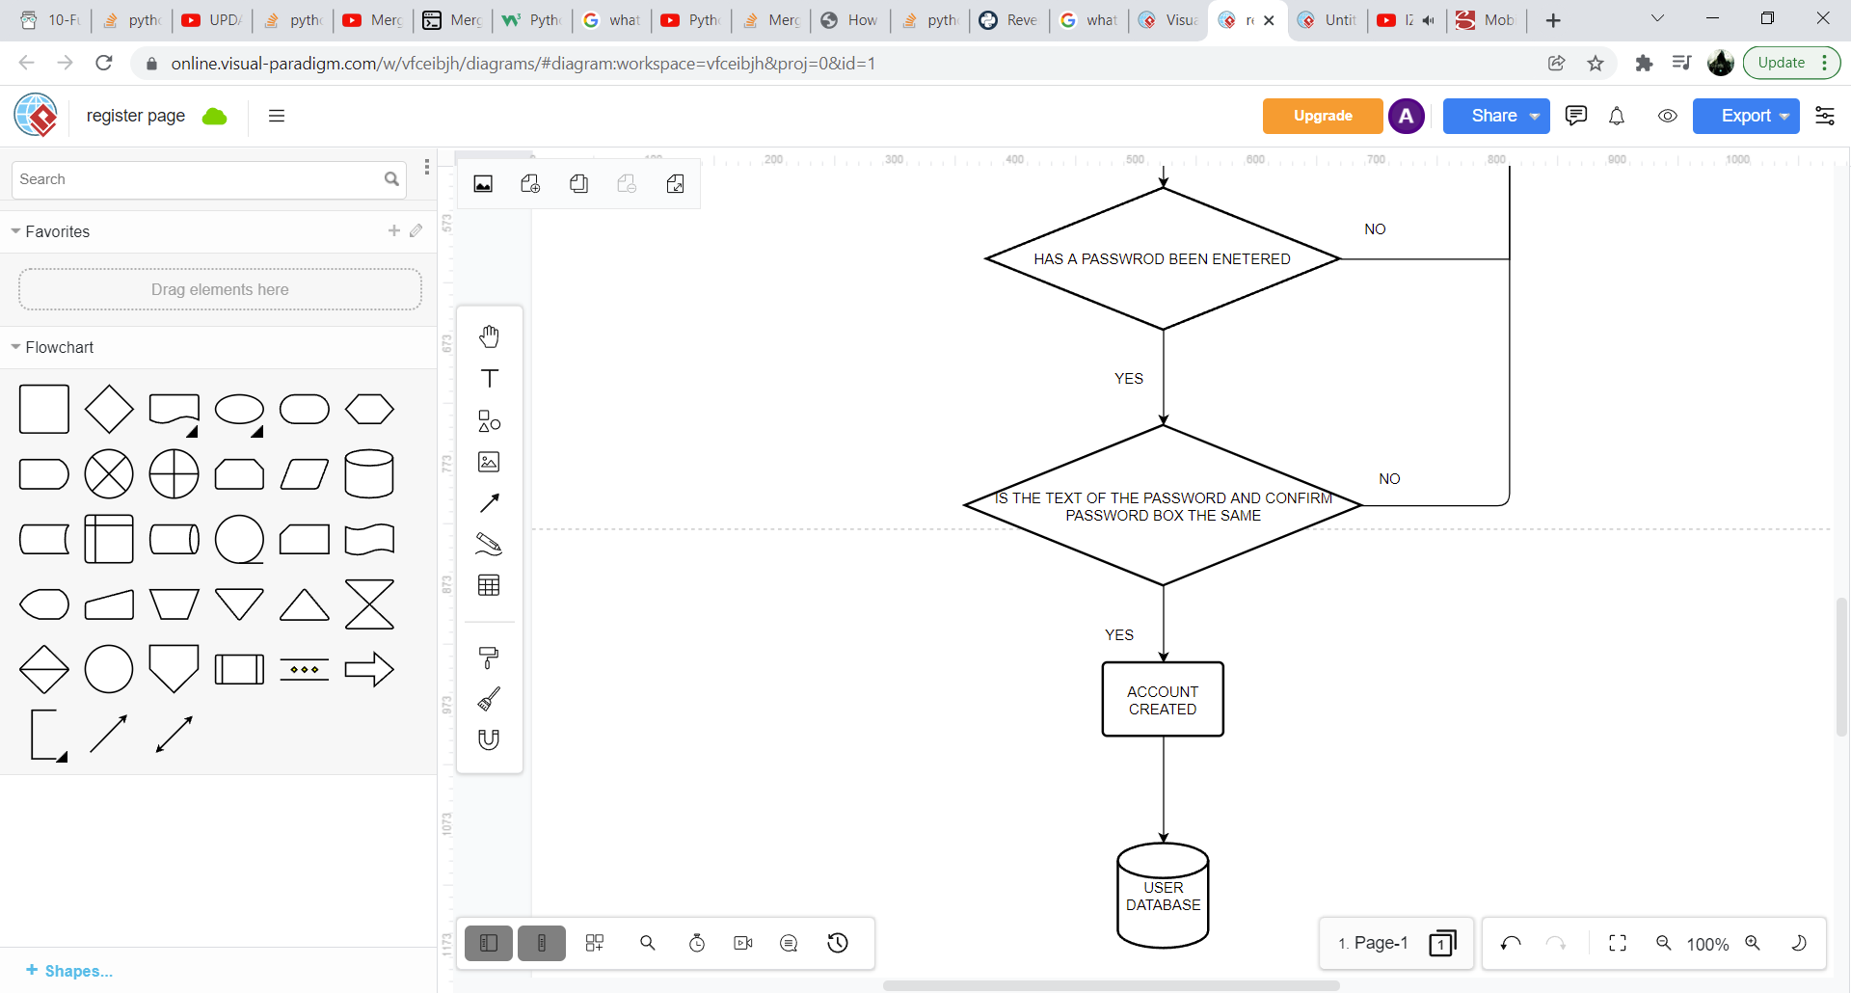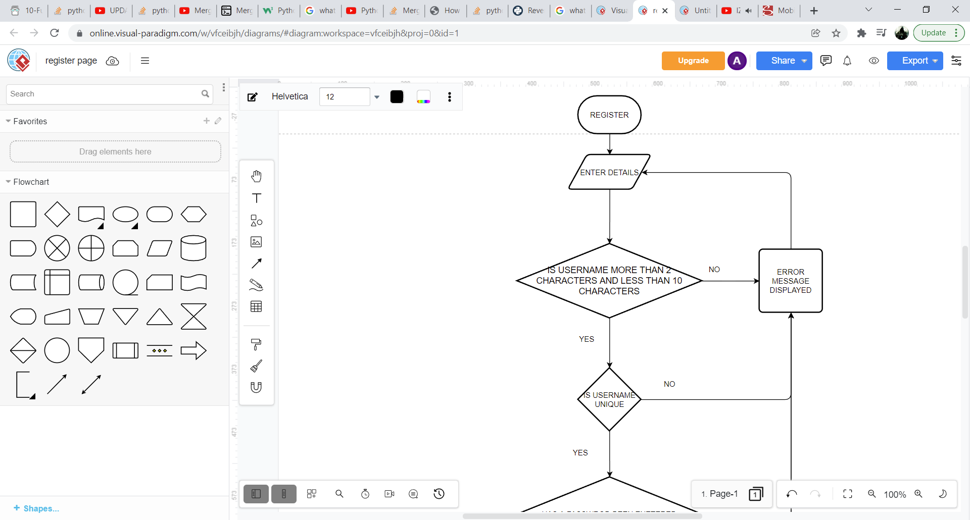

When the user is trying to register, they must enter in a username that is longer than 2 characters but less than 10 characters and any type of password. Also, when they are registering their username, the database will be checked to see if the username they have entered is already stored in the database so that no 2 users can have the same username

## game flowchart

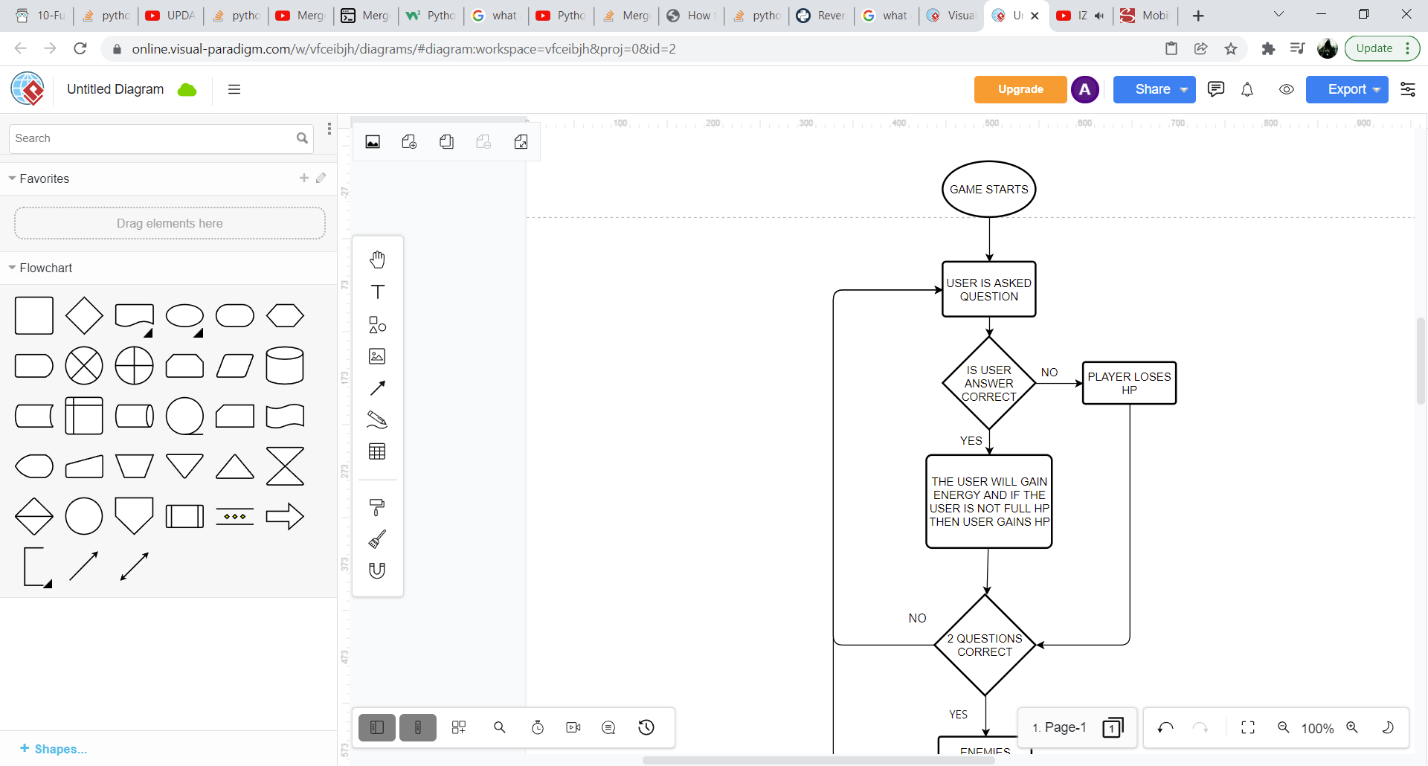

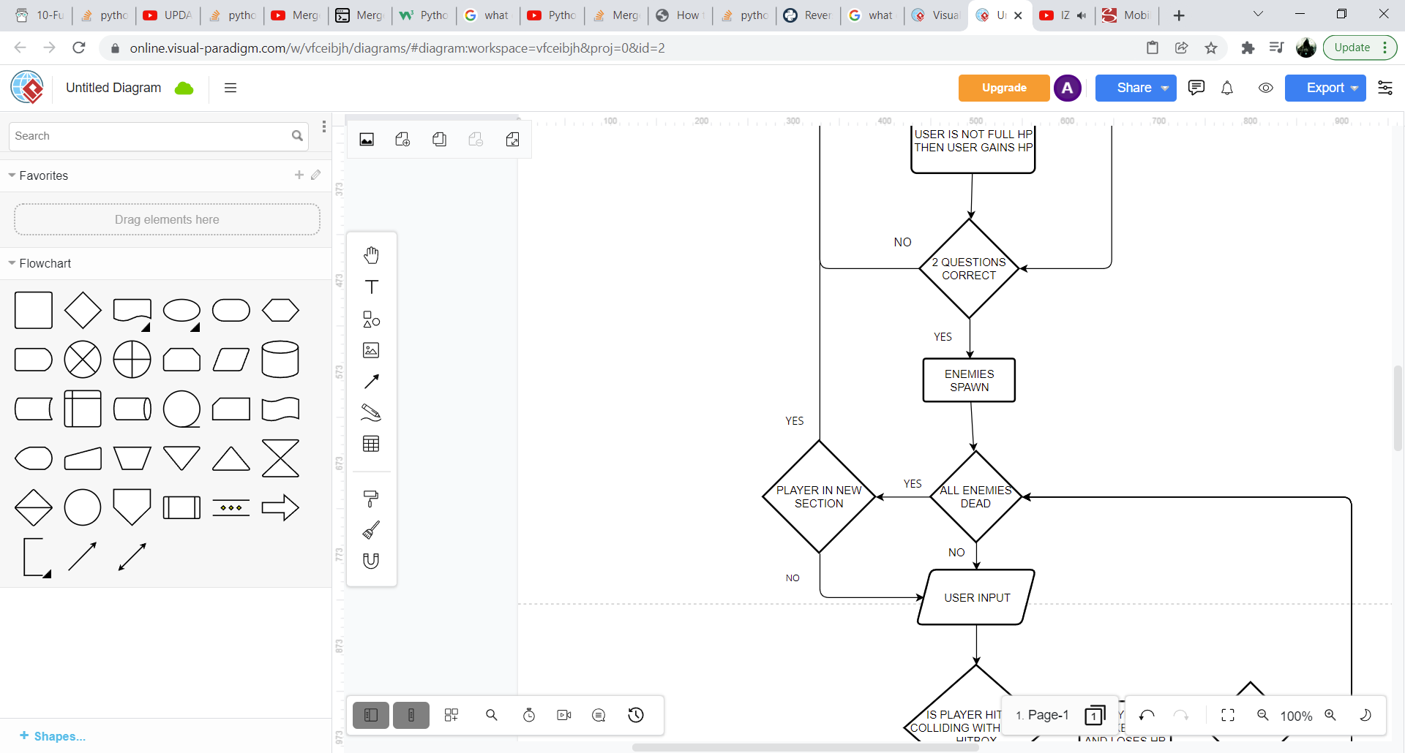

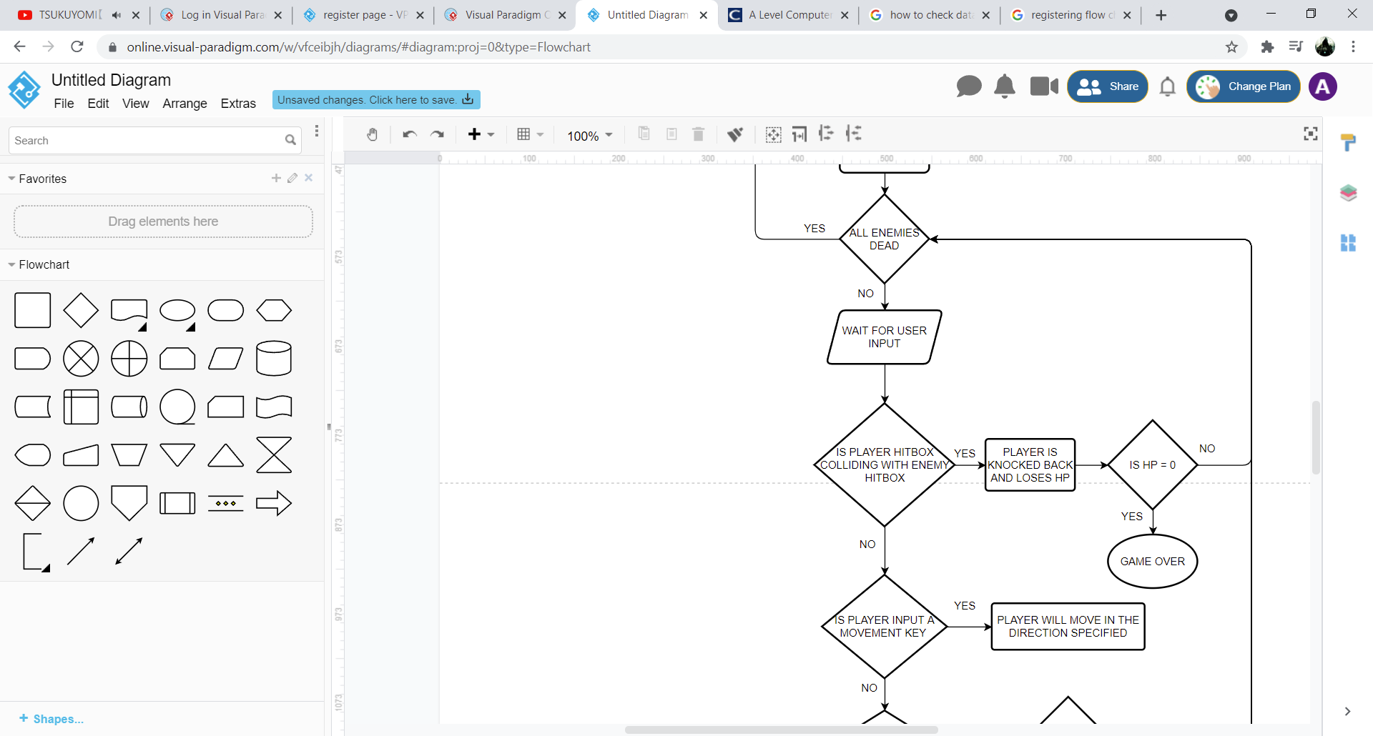

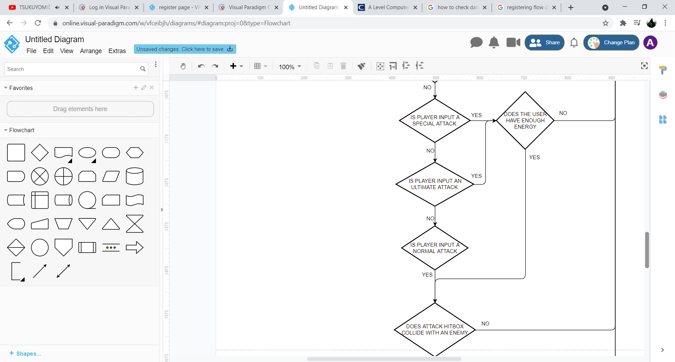

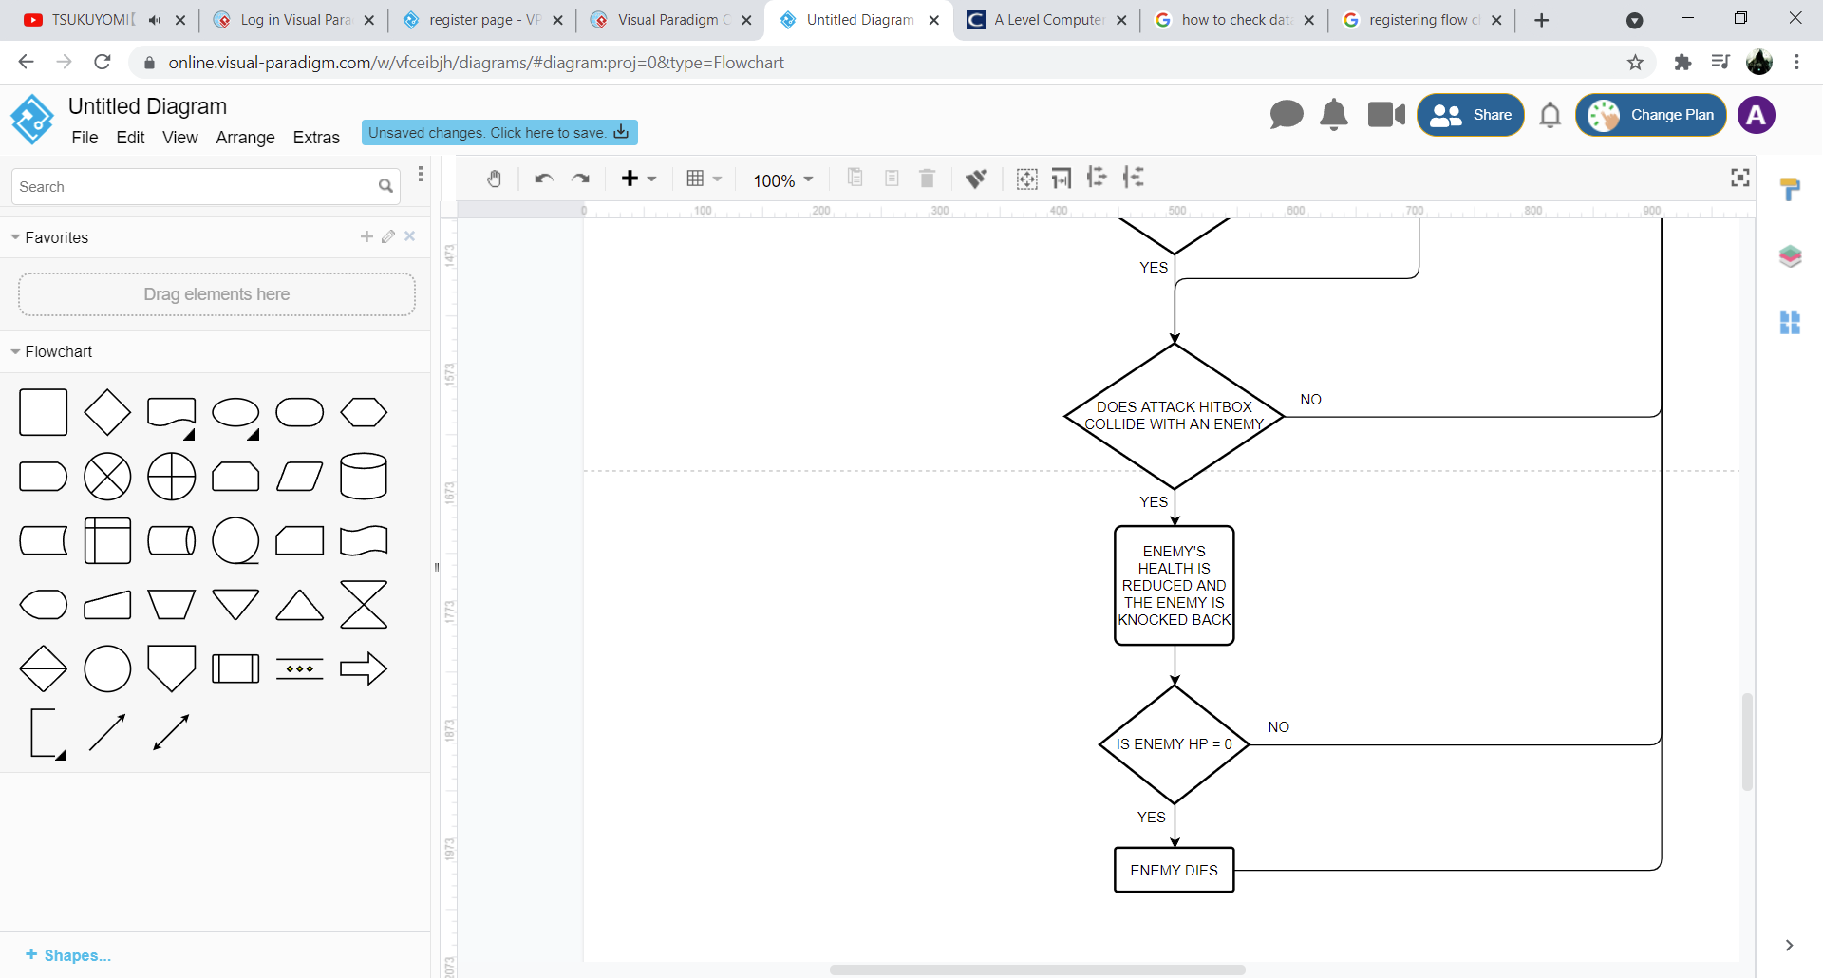

## 

Once the game starts, I will use the classes to create objects for the player, enemy and all the platforms. I will need to make each platform, player, and enemy their own individual object as the x and y coordinates will need to be changed separately and each object will be calling methods at different times. I can also create a while loop the whole time the program is running that will use encapsulation and call all the methods and procedures needed. Furthermore since it will be in a while loop the whole time the game is open they will be recursive functions as shown above constantly being called until the player dies or completes the level, this is because pygame will need to constantly be updating the x and y coordinates of the player as the player will constantly be moving not only that it will need to keep checking for any inputs by the user to attack or to jump as well as to see if there are any collisions

## Animations

FUNCTION animation(self)

IF self.collision == False THEN

current_time = pygame.time.get_ticks ()

IF current_time - self.last_updated > self.animation_speed THEN

self.last_updated = current_time

self.idle_animation_frame +=1

END IF

IF self.special_attacking == True or self.normal_attacking == True THEN

self.attack_animation_frame +=1

END IF

IF self.ultimate_attacking == True THEN

self.ultimate_attack_animation_frame +=1

END IF

IF self.player_dying == True THEN

IF self.player_dead_animation_frame == 0 THEN

self.player_dead_animation_frame += 1

END IF

END IF

END IF

END FUNCTION

This is the pseudocode of the algorithm I will be using to create the animations during the game. Pygame.time.get_ticks() will get the time that has passed since pygame has opened in Millie seconds and it minus itself from the last time the last frame in an animation has been updated, if I make the animation speed set to 300 then for 300 Millie seconds one frame of the animation will be displayed onto the screen and after this time has passed the next frame will be displayed

dead = [pygame.image.load("images/player/player_dead/dead0.xcf"),pygame.image.load("images/player/player_dead/dead1.xcf")]

Like the list above each animation will be stored in a list in another file called animations and each element in the list will use pygame to load one frame of the animation and the animation frame will be used to iterate through this list and once it reaches the end of the list the animation frame number will reset so that it can iterate through the list from the beginning again

## Leader board

FUNCTION mergesort(highscores_list)

IF len(highscores_list) > 1 THEN

left_half = highscores_list[:len(highscores_list)//2]

right_half = highscores_list[len(highscores_list)//2:]

mergesort(left_half)

mergesort(right_half)

x = 0

y = 0

k = 0

WHILE x < len(left_half) and y < len(right_half) DO

IF left_half[x] < right_half[y] THEN

highscores_list[z] = left_half[x]

x += 1

ELSE

highscores_list[z] = right_half[y]

y += 1

END IF

z += 1

END WHILE

WHILE x < len(left_half) DO

highscores_list[z] = left_half[x]

x += 1

z += 1

END WHILE

WHILE y < len(right_half) DO

highscores_list[z] = right_half[y]

y += 1

z += 1

END WHILE

last_10 = highscores_list[-10:]

To create the leader board, I will need to use SQL statements to select all the scores recorded in the database I will then use a merge sort to sort all the scores from smallest to largest and take the last 10 items in the list as they will be the top 10 highest scores recorded in the database. How the merge sort will work is it will be using divide and conquer and will keep breaking up each item in the list until they are on their own and while sorting out the list the values of each item will be compared and will be placed in the list in the new order being smallest to largest.

## Camera

FUNCTION scroll_background(self)

IF player.x < 500 and player.moving_left == True THEN

player.x += self.camera_shift

enemy.x += self.camera_shift

stone_platform.x += self.camera_shift

self.world_shift += self.camera_shift

END IF

IF player.x > 1000 and player.moving_right == True THEN

player.x -= self.camera_shift

enemy.x -= self.camera_shift

stone_platform.x -= self.camera_shift

self.world_shift -= self.camera_shift

END IF

END FUNCTION

How the camera will work is that when the player reaches the right side of the screen it will create an illusion that there is a camera moving along with the player as the X coordinate of every object will move to the left at the same speed as the camera moving. When the player reaches the left side of the screen then then X coordinate of every object will move to the right at the same speed as the camera. Self.world_shift will also record how much the camera has shifter since its original starting position so that when the camera reaches where a platform should be it will only be displayed then when it needs to. I will make it so that the platform will only be displayed when the camera has shifted a certain amount so that if the player is not even near the platform that object is not being called and being displayed for no reason adding an unnecessary load to pygame which will decrease the frames per second by a lot and make the game feel very clunky and slow

## Collisions

FUNCTION horizontal_collision(self)

IF self.stone_platform_rect.colliderect(player.rect) THEN

IF player.speed > 0 THEN

self.stone_platform_rect.left = player.rect.right

player.x -= player.speed

END IF

IF player.speed < 0 THEN

self.stone_platform_rect.right = player.rect.left

player.x -= player.speed

END IF

END IF

END FUNCTION

FUNCTION vertical_collision(self)

IF self.stone_platform_rect.colliderect(player.rect) THEN

IF player.y + 65 <= self.stone_platform_rect.y +10 THEN

IF player.y_speed < 0 THEN

self.stone_platform_rect.top = player.rect.bottom

player.player_in_air = False

player.speed = 0

END IF

END IF

IF player.y - 65 >= self.stone_platform_rect.y +40 THEN

IF player.y_speed > 0 THEN

self.stone_platform_rect.bottom = player.rect.top

player.jump = False

player.jump_height = 0

player.y += 2

player.speed = 0

END IF

END IF

END IF

END FUNCTION

For the collisions between the player and the platform I created my own algorithm to make it so that the player cannot jump through the platform and will hit or land on the platform. I will create separate functions for the collisions, one that will deal with the horizontal collisions and one that will deal with the vertical collisions. If the player speed > 0 that means that the player is moving to the right so I will need to make it so that when the player is hitting the platform, they are not moving past the platform by making player.x -= player.speed and make it so that the left side of the platform rectangle x coordinates will be the same as the right side of the player’s rectangle x coordinate. It will do the same thing for when the player speed < 0 which means they are moving to the left but instead of looking at the left side of the rectangle I will look at the right side of it and the left side of the player rectangle.

For the vertical collisions it will be looking at player.y + 65 because I will make it so that the y coordinate of the player rectangle will be the middle of the rectangle and the rectangle will have a width of 130 so added 65 will look at the bottom part of the player’s rectangle and will check if the player is on the same y coordinate of the stone platform + 10 and it will check if the 2 rectangles are colliding. It will then make it so that player in air is no longer false as the player would have had to jump up and land back down on the platform to and making player in air false it will make it so that the player’s y coordinate is no longer decreasing, and the player is no longer falling. It will also be looking at player.y – 65 which is the top part of the player rectangle and for the top part of the player to hit the bottom part of the rectangle the player will need to jump so when the player hits the platform rectangle jump will become false and the y coordinate of the player will increase falling the player back down, the jump height also resets so that when the player jumps again they will jump at the normal height again.

## File structures

For my game I will be using 2 different types of file structures, I will be using binary files and a database. Binary files are a collection of bytes, and when binary files are opened, they are processed byte by byte. The bytes in a binary file can represent executable files, sound, and images. The main use for binary files in my game will be for the images. The image files will be able to store the colours of each pixel. Each pixel colour will be decided according to the RGB model and the amount of red, blue, green in the pixel will be decided according to the binary number.

To create the animations each frame in the animation will have its own image. I will keep the images in a file called images and separate each image according to the animation they are associated with. Pygame will load each image and put them onto the screen in quick succession to make it seem like an animation is playing. For example, if the player wanted to do a normal attack pygame will go to the images file then to the player file then to the normal attack file and load the image it needs to from that file. This will be done for each animation.

I will also be using a database as I will easily be able to store records of important information and be able to retrieve them easily. In my data base I will need to store the information of each user’s account details so that when they want to sign in later the database will have their details recorded and the program will be able to identify each user and log them in. Since each user will be unique, they will have their own unique information such as their account details as well as their high score and rank in game, this information needs to be stored to load the correct information related to each user.

## Data Base design

### ER diagram

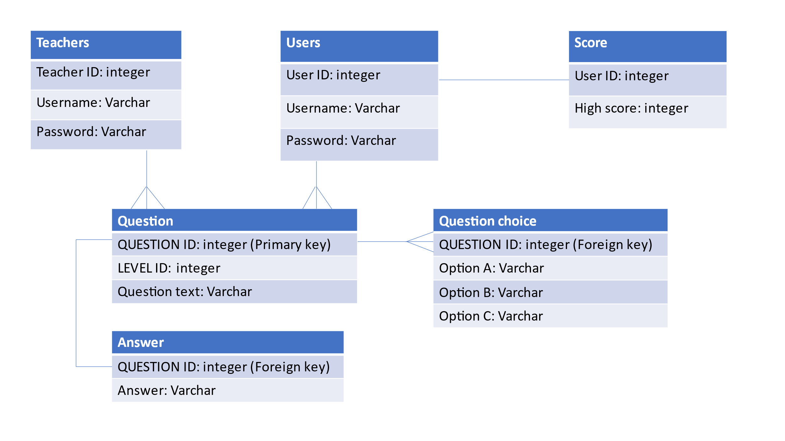

### Table user

|  |  |  |  |
| --- | --- | --- | --- |
| Field name | Data type | Description | validation |
| User ID | Integer | Unique identifier for each user.  It is the primary key for this table | This must be unique, and no user ID can be the same |
| Username | Text | If when signing up the username has already been registered an error will appear saying to choose another username. It will also be used for when logging in to check whether the username exists in the database and will be used in the leader board to display the username | The username needs to be a unique username, the username must also be more than 2 characters and less than 10 characters  NOT NULL – the user must enter a username and it cannot be left blank |
| Password | Text | The password will be used for the login system as well as the register system | When the username is entered the correct password that is linked to that user id and username must be entered  NOT NULL –  The user must enter a password and it cannot be left blank |

### Table score

|  |  |  |  |
| --- | --- | --- | --- |
| Field name | Data type | Description | Validation/Restrictions |
| User ID | Integer | Unique identifier for each user. It is the foreign key for this table. | This must be unique, and no user ID can be the same |
| High score | Integer | Once the user finishes the game if the score is higher than the high score the high score will be replaced with the score | If the score is lower than the high score the high score will not be updated and will remain the same  NOT NULL – when the user first registers an account their high score is automatically set to 0 |
| score | Integer | When the user finishes the game, their score will be updated here and will then be checked to see if it is higher than their previous high score | NOT NULL – when the user first registers an account their score is automatically set to 0 |

## Table teachers

|  |  |  |  |
| --- | --- | --- | --- |
| Field name | Data type | Description | validation |
| Teacher ID | Integer | Unique identifier for each user.  It is the primary key for this table | This must be unique, and no teacher can have the same teacher ID can be the same |
| Username | Text | If when signing up the username has already been registered an error will appear saying to choose another username. It will also be used for when logging in to check whether the username exists in the database | The username needs to be a unique username, the username must also be more than 2 characters and less than 10  NOT NULL – the user must enter a username and it cannot be left blank |
| Password | Text | The password will be used for the login system to as well as the register system | When the username is entered the correct password that is linked to that teacher id and username must be entered  NOT NULL – the user must enter a password and it cannot be left blank |

### 

### Table questions

|  |  |  |  |
| --- | --- | --- | --- |
| Field name | Data type | Description | Validation/Restrictions |
| Question ID | Integer | Unique identifier for each user. It is the primary key for this table. | This must be unique, and no question can have the same Question ID can be the same |
| Level ID | Integer | Used to keep track of the id for each level so that when questions are added they are added to the correct level that corresponds to this level Id | No 2 levels can have the same level id  NOT NULL- every question must be having the level id of the level it is related to |
| Question text | Text | This is used to store the question that will be asked to the user |  |

### Table Question choice

|  |  |  |  |
| --- | --- | --- | --- |
| Variable name | Data type | description | Validation / restriction |
| Question ID | Integer | Unique identifier for each user. It is the foreign key for this table. | This must be unique, and no question can have the same Question ID can be the same |
| Option A | Text | When the user is asked a question, they will be shown this as the first possible answer to the question | NOT NULL – the question must have an option A |
| Option B | Text | When the user is asked a question, they will be shown this as the second possible answer to the question | NOT NULL – the question must have an option B |
| Option c | Text | When the user is asked a question, they will be shown this as the third possible answer to the question | NOT NULL – the question must have an option C |

### Table answer

|  |  |  |  |
| --- | --- | --- | --- |
| Variable name | Data type | Description | Validation/restriction |
| Question ID | Integer | Unique identifier for each user. It is the foreign key for this table. | This must be unique, and no question can have the same Question ID can be the same |
| answer | text | This will be the answer that is related to a specific question and what choice the user picks will be compared to the answer to the question | NOT NULL – every question must have an answer |

### SQL statements

#### Register page

- ("SELECT username FROM users WHERE username = (?) ", (username_info,) ) . fetchall()

- ("SELECT username FROM teachers WHERE username = (?)”, (username_info,)).fetchall()

These 2 SQL statements will be used to see whether the username the user has entered already exists in the database. It does this by selecting all the usernames from the table that is the same as the one the user has entered and putting those usernames in a list if the list is empty that means that the username does not exist, but if there is a username in the list then that means that username has been registered and cannot be used again

- ("INSERT INTO users(username,password)VALUES(?, ?)",(username_info,password_info))

- ("INSERT INTO teachers(username,password)VALUES(?, ?)",(username_info,password_info))

When these SQL statements are executed a new user or teacher will be created in their respective tables and each user will have their own user id, the username and password the user has entered will then be stored into the database

- ("INSERT INTO score(USER_ID,score,highscore)VALUES(?,0,0)",(get_username_id[0][0],))

When the user registers an account this SQL statement will make it so that their account score and high score will automatically be set to 0

#### Login Page

- ("SELECT username FROM users WHERE username = (?)",(username_info,)).fetchall()

- ("SELECT password FROM users WHERE username = (?)",(username_info,)).fetchall()

- ("SELECT username FROM teachers WHERE username = (?)",(username_info,)).fetchall()

- ("SELECT password FROM teachers WHERE username = (?)",(username_info,)).fetchall()

These 1st and 3rd SQL statements will be used to see whether the username the user has entered already exists in the database. It does this by selecting all the usernames from the table that is the same as the one the user has entered and putting those usernames in a list if the list has a username in it that means the user has entered a valid username if not an error will be displayed to the user. Once the 1st or 3rd SQL statements have been executed the 2nd or 4th one will play, they will check the username the user has entered and search for it in the database it will then look at the password that is related to it. If the password in the database matches what they have written, then they will be able to login

#### Add question

- ("INSERT INTO question(LEVEL_ID,Question_text)VALUES(?, ?)",(level_id,add_question_info))

- ("SELECT QUESTION_ID FROM question ORDER BY rowid DESC LIMIT 1").fetchall()

- ("INSERT INTO question_choice(QUESTION_ID,option_A,option_B,option_C)VALUES(?, ?, ?, ?)",

(get_question_id[0][0],option_a_info,option_b_info,option_c_info))

- ("INSERT INTO answer(QUESTION_ID,answer)VALUES(?, ?)",(get_question_id[0][0],answer_info))

The 1st SQL statement will take the question text the user has inputted and store it in the question table, also before you add the question you select the level you want to add it to and the level you select will be the level id. The 2nd SQL statement will get the question ID of the newly added question in the question table as the question id is the foreign key in the question choice table and when creating the question choices, they will need to have the same question ID. The 3rd SQL statement will take the 3 options the user has inputted and store it in the question choice table in the correct fields. The 4th SQL statement will take the answer the user has inputted and store it in the answer table using the question ID gotten from the 2nd SQL statement as question ID is also the foreign key for the answer table

#### Leader board

- ("SELECT USER_ID FROM score WHERE highscore = (?)",(last_10_ranks[i],)).fetchall()

- ("SELECT username FROM users WHERE USER_ID = (?)",(select_last_10_users_score[0][0],)).fetchall()

- ("SELECT highscore FROM score WHERE USER_ID = (?)",(select_last_10_users_score[0][0],)).fetchall()

For the 1st SQL statement last_10_ranks will be a list containing the 10 top highest the [i] is there because it will need to be placed in a for loop so that python will be able to iterate through the list and found out the user id of each player in the top 10. The 2nd SQL statement will use the user IDs found out in the 1st SQL statement to get the username of each player in the top 10. The 3rd SQL statement will use the user IDs from the 1st SQL statement to get the high score of everyone.

#### Selecting questions in game

- ("SELECT Question_text FROM question WHERE LEVEL_ID = (?)",(level_id)).fetchall()

- ("SELECT Question_ID FROM question WHERE Question_text = (?)",(level_questions,)).fetchall()

- ("SELECT option_A,option_B,option_C FROM question_choice WHERE QUESTION_ID = (?)",(question_id,)).fetchall()

- ("SELECT answer FROM answer WHERE QUESTION_ID = (?)",(question_id,)).fetchall()

The 1st SQL statement will get a list of all the questions that are stored in the database related to the level the user is on. In the 2nd SQL statement, I will have a variable called level question which will randomly pick a question from the list of questions found from the 1st SQL statement, then the question ID of the question that has been picked will be retrieved from the database. The 3rd SQL statement will get all the options related to the question ID found from the 2nd SQL statement. The 4th SQL statement will get the answer that is linked to the question ID found from the 2nd SQL statement.

#### Game over screen

- ("SELECT USER_ID FROM users WHERE username = (?)",(username_info,)).fetchall()

- ("UPDATE score SET score = (?) WHERE USER_ID = (?)",(player_score,get_username_id[0][0])).fetchall()

- ("SELECT score FROM score WHERE USER_ID = (?)",(get_username_id[0][0],)).fetchall()

- ("SELECT highscore FROM score WHERE USER_ID = (?)",(get_username_id[0][0],)).fetchall()

- ("UPDATE score SET highscore = (?) WHERE USER_ID = (?)",(player_score,get_username_id[0][0])).fetchall()

The 1st SQL statement will retrieve the User ID of the account the user has logged in with. The 2nd SQL statement will look through the score table to find the user id that matches the one found in the 1st SQL statement and will update the field called score with the score achieved whilst the user was playing. The 3rd and 4th SQL statement will look through the score table to find the user id that matches the one found in the 1st SQL statement and will select the new score that has just been updated as well as the high score form the score table which will be the highest score they had previously earned. If the new score is higher than the high score, they had previously earned then the 5th SQL statement will be executed and the high score of the user will be updated and replaced with the new score the user had achieved whilst playing.

## UML Diagram

## Data dictionary

### Player

|  |  |  |
| --- | --- | --- |
| Variable name | Data type | Description |
| Health | Integer | It will store the players health |
| dead | Boolean | This value will be true when the player’s health reaches 0 , the death animation will be played and the player will not be able to perform any actions |
| X_coordinate | Integer | This will be used to track the x coordinates of the player on the screen |
| Y_coordinate | Integer | This will be used to track the y coordinates of the player on the screen |
| Moving_right | Boolean | When the D key is pressed this value will be true and the player will need to move right |
| Moving_left | Boolean | When the A key is pressed this value will be true and the player will need to move left |
| damage | Integer | This will store the damage the player will deal with each move |
| speed | Integer | This value will be added to the player’s X coordinate when moving right or moving left is true for the player to move. This value will be positive or negative depending on the direction the player wants to move |
| jump | Boolean | When this value is true the player will jump |
| Jump_height | integer | When the player jumps the value will increase until it reaches a certain number. Once it reaches this value the player will fall back down, and the value will reset to 0 |
| In_air | Boolean | This will be used to see if the player is in the air and is not jumping, if they are then the player will fall back down to the ground |
| Y_speed | Integer | When the variable jump is true the Y speed will be added to the y coordinate |
| Energy | Integer | This will allow the player to use special moves depending on how much energy the player has earned, as these moves will deal more damage than normal attacks |
| Facing_right | Boolean | This will be used to keep track of which way the player is facing to make sure the animations are performed in the correct direction |
| Normal_attacking | Boolean | This will be used to see if the normal attack animation will need to be played and to indicate that the normal attack hitbox should be used |
| Special_attacking | Boolean | This will be used to see if the special attack animation will need to be played and to indicate that the special attack hitbox should be used |
| Ultimate_attacking | Boolean | This will be used to see if the ultimate attack animation will need to be played and to indicate that the ultimate attack hitbox should be used |
| Animation_speed | integer | This will be used to control how long each frame of the animation should be on screen for |
| Normal_attack animation_frame | integer | This will be used to keep track of which frame of the normal attack animation is being shown. This value will keep increasing until it reaches the last frame of the animation and will the frame number will increase according to the animation speed set |
| Special_attack animation_frame | integer | This will be used to keep track of which frame of the special attack animation is being shown. This value will keep increasing until it reaches the last frame of the animation and will the frame number will increase according to the animation speed set |
| Ultimate_attack_animation_frame | integer | This will be used to keep track of which frame of the ultimate attack animation is being shown. This value will keep increasing until it reaches the last frame of the animation and will the frame number will increase according to the animation speed set |
| Idle_animation_frame | integer | This will be used to keep track of which frame of the idle animation is being shown. This value will keep increasing until it reaches the last frame of the animation and will the frame number will increase according to the animation speed set |
| Idle_rectangle |  | This will be a rectangle that will be created around the player during the player’s idle animation. It will act as the hitbox for the player when he is idle |
| Normal_attack_rectangle |  | This will be a rectangle that will be created around the player during the player’s normal attack animation. It will act as the hitbox for the player when he is performing a normal attack |
| Special_attack_rectangle |  | This will be a rectangle that will be created around the player during the player’s special attack animation. It will act as the hitbox for the player when he is performing a special attack |
| Ultimate_attack_rectangle |  | This will be a rectangle that will be created around the player during the player’s ultimate attack animation. It will act as the hitbox for the player when he is performing an ultimate attack |
| Player_score | integer | This will be used to keep track of the player’s score that will be displayed in the top right. The score will increase if an enemy is defeated and if a question is answered correctly |
| Dead_animation_frame | integer | This will be used to keep track of which frame of the dying animation is being shown. This value will keep increasing until it reaches the last frame of the animation and will the frame number will increase according to the animation speed set |
| Pickup | Boolean | This will be used to see if the player wants to pick up something. If the player is on top of a key or message text, then the player will pick it up |
| Player_rectangle |  | This will act as a hitbox for the player and will change depending on the actions of the player. It will be used to see if the player has collided with an enemy hitbox and depending on what action is being performed the player will deal or receive damage |
| collision | Boolean | This will be used to see if the player’s hitbox has collided with the enemy’s hitbox. It is also used to see if the player has collided with any of the platforms in the level |

### Enemy

The enemy will have the same variables as the player, and they will perform the same purpose except for a few exceptions. It will also have some new variables.

|  |  |  |
| --- | --- | --- |
| Variable name | Data type | Description |
| score | Integer | This will be used to see how much score the player will earn for defeating this enemy |
| Moving_right | Boolean | This value will be true when the player is on the right side of the enemy, and will cause the enemy to move right |
| Moving_left | Boolean | This value will be true when the player is on the left side of the enemy, and will cause the enemy to move left |
| Attack_range |  | There will be a hitbox around the enemy to indicate its attack range, if the player’s hitbox is within this attack range, then the enemy will automatically attack them. |
| Attacked | Boolean | This will be true when the player is attacking, and the player’s hitbox will collide with the enemy hitbox. When it is true the enemy will not be able to attack and will be knocked back |

### 

### Level

|  |  |  |
| --- | --- | --- |
| Variable name | Data type | Description |
| X_coordinate | Integer | This will be used to store which x coordinate a platform should be placed |
| Y_coordinate | Integer | This will be used to store which y coordinate a platform should be placed |
| width | Integer | This will be used to store how wide the platform is |
| height | Integer | This will be used to store how tall the platform is |
| Platform_rectangle |  | This will be a rectangle around the platform on the screen and will be used to detect collisions between the player and the platform |
| paused | Boolean | If the game is paused, then no actions will be able to be performed. The player will not be able to move or attack etc |
| Delete_key | Boolean | This will be true once the user picks up the key the key will no longer be shown onto the screen until this is false again |
| clicked | Boolean | This will be true once the user hovers the mouse above an option that can be clicked and clicks it |
| Game_over | Boolean | This value will be true once the user has died or completes the game, they will be shown the game over screen and if they click continue this value will be true and the game will close |
| text | text | This will store the text of the buttons that are displayed on the pause menu and the game over screen |
| Key_rectangle |  | This will be a rectangle around the key once the player’s hitbox collides with the key rectangle it will check if the player wants to pick up something if it does the key will be picked up |
| Message_rectangle |  | This will be a rectangle around the message text so that if the player’s hitbox is colliding with this rectangle and the player wants to pick it up it will be picked up by the player |
| Recipient_rectangle |  | This will be a rectangle around the recipient’s area so that once the message has been encrypted the message can be dropped here to the recipient. It will be used to detect collisions between the message text and itself |
| Delete_message | Boolean | If the player picks up the message this will become true, and the message will disappear |
| Drop | Boolean | If the player wants to drop what he has picked up this value will become true and what ever he picked up will now reappear at the player’s location |
| Encrypt_message | Boolean | If the recipients public key rectangle collides with the message text this will become true, and the message text will now become encrypted and change |
| Decrypt_message | Boolean | If message_recieved is true, then if you pick up the recipient’s private key and drop it on the encrypted message this will become true and the message will be decrypted |
| Message_recieved | Boolean | If the message has been encrypted and is then picked up and dropped in the recipient rectangle this will become true |
| Instruction_text | Text | In the middle of the puzzle, it will tell the user what to do and how to pick up and drop items |
| Message_text | Text | This will be the message the user is trying to encrypt and send to the recipient who will then decrypt it |
| Player_collision | Boolean | This will be used to detect whether the player is colliding with a platform |
| Ceiling_rectangle |  | There will constantly be a rectangle at the top of the screen indicating the ceiling so that wherever the player is if they hit the ceiling, they will fall back down |

### 

### Questions

|  |  |  |
| --- | --- | --- |
| Variable name | Data type | Description |
| Select_level_Questions | list | All the questions related to the level are selected from the database and put into a list |
| Select_question | Text | A random question from the list of questions for that level is selected |
| Option_A | text | This is the first option of the selected question the user can select |
| Option_B | text | This is the second option of the selected question the user can select |
| Option_C | text | This is the third option of the selected question the user can select |
| answer | text | This will be the correct answer to the question |
| Number_of_correct_answers | Integer | This value will keep track of the number of correct answers as when the number of correct is 2 then questions no longer need to be shown in that area |
| Answer_correct | Boolean | If the answer that the user has chosen is correct this value will be true, and the number of correct answers will increase as well |
| New_question | Boolean | If the user picks one of the options to the question, then this value will be true, and a new question will need to be picked |
| Option_A_rectangle |  | There will be a rectangle around option A to be able to check whether the mouse is hovering on option A and when it is clicked |
| Option_B_rectangle |  | There will be a rectangle around option B to be able to check whether the mouse is hovering on option B and when it is clicked |
| Option_C_rectangle |  | There will be a rectangle around option C to be able to check whether the mouse is hovering on option C and when it is clicked |

## Event, procedure, and description

|  |  |  |
| --- | --- | --- |
| Event name | Event Procedure | Event Description |
| Login button  (Mouse left click) | click | If the user clicks the login button, they will go to the login page and will be able to login |
| Register button  (Mouse left click) | click | If the user clicks the register button, they will go to the register page and will be able to register |
| Back button  (Mouse left click) | click | If the user clicks the back button, they will be taken back to the previous page they were on |
| Start button  (Mouse left click) | click | If the user clicks the start button the game will load |
| Exit button  (Mouse left click) | click | If the user clicks the exit button the game will close |
| leader board button  (Mouse left click) | click | If the scoreboard button is clicked the user will be taken to the leader board page |
| Username box  (Mouse left click) | click | If the username box is clicked the user will be able to type their username in the box |
| Password box  (Mouse left click) | click | If the password box is clicked the user will be able to type their password in the box |
| Confirm password box  (Mouse left click) | Click | If the confirm password box is clicked the user will be able to retype their password and if what is written in this box does not match the password box an error will occur |
| Student button  (Mouse left click) | Click | If the student button is clicked the user will be recognised as a student |
| Teacher button  (Mouse left click) | Click | If the teacher button is clicked the user will be recognised as a teacher |
| Question box  (Mouse left click) | Click | If this box is clicked the user will be able to type in a question to add |
| Option A box  (Mouse left click) | Click | If this box is clicked the user will be able to type in the first option to the question |
| Option B box  (Mouse left click) | Click | If this box is clicked the user will be able to type in the second option to the question |
| Option C box  (Mouse left click) | click | If this box is clicked the user will be able to type in the third option to the question |
| Answer box  (Mouse left click) | click | If the answer box is clicked, they will be able to type in their answer for the question |
| Pause menu  (Esc key pressed) | Key press | If the Esc key is pressed the game will be paused and the pause menu will appear |
| Resume button  (Mouse left click) | Click | If the resume button is pressed on the pause menu the game will resume and will no longer be paused |
| Move right  (D key pressed) | Key press | If the D key is pressed the player will move right until they key is released |
| Move left  (A key pressed) | Key press | If the A key is pressed the player will move left until they key is released |
| Jump  (Spacebar pressed) | Key press | If Spacebar is pressed the player will jump once, meaning the player will not be able to jump again unless they touch the ground |
| Normal attack  (J key pressed) | Key press | If the J key is pressed the player will do one normal attack and will not be able to attack again until the animation has finished |
| Special attack  (K key pressed) | Key press | If the J key is pressed the player will do one special attack and will not be able to attack again until the animation has finished |
| Ultimate attack  (L key pressed) | Key press | If the J key is pressed the player will do one ultimate attack and will not be able to attack again until the animation has finished |
| Pickup  (F key pressed) | Key press | If the F key is pressed when the player is standing on top of a key or a message text, the player will pick up that key or message text and cause it to disappear |
| Drop  (G key pressed) | Key press | If the G key is pressed and the player has picked up a key or a message text, the player will drop it causing it to reappear at the player’s location |

## Test plan

|  |  |  |  |
| --- | --- | --- | --- |
| Test number | description | Input/test data | Expected result |
| 1 | Click start will take you to the screen to select if you are a student or teacher | Click start button | User is taken to the screen to choose if they are a teacher or student |
| 2 | Click student or teacher takes you to the screen to register or login | Click student or teacher | User is taken to the login or register screen |
| 3 | Click login takes the user to the login screen | Click login button | User is taken to the login screen |
| 4 | Click register takes the user to the register screen | Click register | User is taken to the register screen |
| 5 | Test register validation by inputting a username that is registered | An existing username  “abu” | An error message is displayed telling the user that username is being used |
| 6 | Test register validation by inputting a username less than 3 characters and more than 10 characters | “hi” – less than 2 characters  “helloworld1”  -more than 10 characters | An error message is displayed telling the user that the username can only be less than 10 characters and more than 2 characters |
| 7 | Test register validation by inputting text that is not the same in the password and confirm password box | “123”-password box  “1234” – confirm password box | An error message is displayed telling the user that the password and confirm password box must match |
| 8 | Test login page by inputting a username that does not exist | “abu123”-username | An error message is displayed telling the user that the username does not exist |
| 9 | Test login page by inputting an incorrect password | “abu”-username  “1234” - password | An error message is displayed telling the user that they have entered the incorrect password |
| 10 | If the user has chosen student when they click login, they are taken to the play game screen | “abu” – username  “123”-password | The user is taken to the play game screen and is shown 3 options to play game, leader board and return to main menu |
| 11 | If the user has chosen teacher when they click login, they are taken to the teacher screen | “abu1”-username  “1”-password | The user is taken to the teacher page and is shown 2 options to add a question and to return to main menu |
| 12 | If the user clicks add question, they are then asked to select a level and is then taken to a screen where they can a add question | Click add question then click level 1 | When the user clicks add question, they are asked to select a level when they select the level, they are taken to a screen to add a question |
| 13 | If the user does not enter a question, 3 options and an answer an error message is displayed | Blank question text, blank option a, blank option b, blank option c | If the user does not input a question or option a or option b or option c an error message is displayed saying it cannot be left blank.  An error message is shown that you can only enter a b or c in the answer box |
| 14 | Clicking the play game button opens the game | Click play game | The game will open using pygame |
| 15 | Clicking the leader board button will display the leader board and the top 10 ranking players | Click leader board button | The leader board will be shown with the top 10 ranking players |
| 16 | When the user presses the D key the players x coordinate will increase by 2. When the user presses the A key the players x coordinate will decrease by 2. When the user releases one of these keys the player will stop moving | D and A key pressed | When the D key is pressed and held, the player will move to the right and when the A key is pressed and held the player will move to the left. If the user is not pressing any keys on the keyboard the player will not move |
| 17 | When the player moves a running animation will be played in the direction, he is running | D and A key pressed | When the player moves using the A or D key a running animation will play |
| 18 | When the user is not pressing anything on the keyboard the player will perform idle animation | The player is standing still and not performing any actions | When the user is not pressing any key on the keyboard the player will be standing still and an idle animation is played |
| 19 | If the player is on the far-right side of the screen and is moving the camera will follow him. If the player is on the far left of the screen and is moving the camera will follow him | A and D key pressed | When the player reaches the right side of the screen the camera will follow him . when the player reaches the left side of the screen the camera will follow him |
| 20 | If the J key is pressed the player will perform a normal attack animation, if the player is facing the right the player will do a normal attack on his right side if the player is facing the left the player will do a normal attack on his left side | J key pressed | When the J key is pressed the player will perform a normal attack animation |
| 21 | If the K key is pressed the player will perform a special attack animation, if the player is facing the right the player will do a special attack on his right side if the player is facing the left the player will do a special attack on his left side | K key pressed | When the K key is pressed the player will perform a special attack animation |
| 22 | If the L key is pressed the player will perform an ultimate attack animation, if the player is facing the right the player will do an ultimate attack on his right side if the player is facing the left the player will do an ultimate attack on his left side | L key pressed | When the L key is pressed the player will perform an ultimate attack animation |
| 23 | When the player is on the left side of the enemy the enemy will move to the left which is towards the player, when the player is on the right side of the enemy the enemy will move to the right which is towards the player. When the enemy moves to the right, he his x coordinates increase by 2. When the enemy moves to the left his x coordinates decrease by 2 | The player is on the left side and then the right side of the enemy | When the player is on the left side of the enemy the enemy will move to the left towards the player, when the player is on the right side of the enemy the enemy will move to the right towards the player |
| 24 | When the enemy is moving towards the player a running animation will be played | The player is on the left side and then the right side of the enemy | When the enemy is moving towards the player the enemy will perform a running animation |
| 25 | When the player is above the enemy the enemy will not move anymore which means no action is being performed so an idle animation will play | The player is above the enemy | The enemy idle animation will be played when the player is above the enemy and the enemy is no longer moving |
| 26 | A rectangle will be around the enemy to indicate the enemy’s attack range. When the player’s hitbox collides with this rectangle this will mean the player is within attack range and the enemy will attack, if the enemy is facing the right the enemy will do an attack on his right side if the enemy is facing the left the enemy will do an attack on his left side | Player is within attack range | When the player is within a certain distance from the enemy the enemy will attack the player |
| 27 | The hitbox of the player will change depending on what keys are pressed and what action is being performed. The hitbox will change depending on whether the player is idle, running, normal attacking, special attacking, or ultimate attacking | A, D, J, K, L keys are pressed | An invisible rectangle will appear around the player which will be the player’s hitbox. The size of the rectangle will change depending on the player’s action, which means the hitbox is changing |
| 28 | The hitbox of the enemy will change depending on whether the enemy is idle, running or attacking, | Enemy attacks , and the enemy moves towards the player | An invisible rectangle will appear around the enemy which will be the enemy’s hitbox. The size of the rectangle will change depending on the enemy’s action, which means the hitbox is changing |
| 29 | Each attack of the player will do different damage, the damage the player will do depends on which attack key the user presses | J, K, L keys are pressed | Each attack of the player will do different damage reducing the enemy’s hp |
| 30 | The enemy will have a default damage already assigned to it so If the player runs into the enemy the enemy will deal damage. If the enemy attacks the damage the enemy deals will change | Player runs into enemy and player gets within enemy attack range | When the enemy runs into the player while the player is not attacking the enemy will deal damage and when the enemy attacks the player will take damage |
| 31 | When the game starts a blue energy bar will appear underneath the health bar and next to the energy bar the amount of energy the player has will be displayed. To perform a special or ultimate attack the user will need a certain amount of energy | K, L key pressed | If the player has enough energy for a special attack, then the player will perform a special attack. If the player has enough energy for an ultimate attack, then the player will perform an ultimate attack. |
| 32 | Each attack of the player has a different knockback, the knockback will be stronger depending on which attack is being performed. | J, K, L key pressed | If the player attacks and the attack hitboxes of the player collide with the enemy hitbox the enemy will be knocked back a certain distance depending on the attack being performed |
| 33 | If the enemy’s hitbox collides with the player hitbox the player will be knocked back, the knock back will be stronger depending on the action being performed. | Player gets within attack range, enemy runs into player | If the enemy attack hitbox collides with the player hitbox the player will be knocked back and if the enemy runs into the player, the player will also be knocked back. When the player is knocked back the player will lose hp |
| 34 | When the spacebar is pressed the y coordinate of the player will continuously decrease by 3, when the player reaches a certain height, the player will fall back down, and the y coordinates of the player will continuously increase by 3 until the player reaches the ground | Spacebar pressed | When the spacebar is pressed the player will jump up and then fall back down |
| 35 | When the player jumps, and the player’s head hits the platform the player will fall back down. When the player lands on top of a platform they will be able to stand and move on it | A and D key and spacebar pressed | The player can land on top of platforms and the platforms will stop the player from jumping higher and causes the player to fall back down |
| 36 | When the player’s health reaches 0 a death animation is played | Player hp reaches 0 | The player will die, and a death animation will be played |
| 37 | When the Esc key is pressed the game is paused and the player and enemy cannot perform any actions. Also, a pause menu will appear and will be able to exit the game and resume the game. Resuming the game will make the game to no longer be paused and the player and enemy will be able to move | Esc key pressed | When the Esc key is pressed a pause menu will appear and the user will be shown menu options to choose from. If the resume button is clicked the resume menu will disappear and the player and enemy will be able to move |
| 38 | When the game starts a question is randomly picked and displayed and when the user answers a question a new question is randomly picked | Start the game and answer a question | A different question is shown when the game starts and when the user answers a question a new question is displayed |
| 39 | If the user clicks the wrong answer, they are told they are incorrect and they will lose hp and score | Click wrong answer | Incorrect message will be shown and hp decrease and score decreases |
| 40 | If the user clicks the correct answer, they are told they are correct and gain score and energy | Click correct answer | Correct message will be displayed, and score and energy will increase |
| 41 | If the user presses the F key, they will pick up the key or message text. If the user presses the G key, they will drop the key or message text | F and G key pressed | If the user presses F on a key or message text it will disappear. If the user then presses G the key or message text will reappear |
| 42 | If the user picks up the recipient’s public key and drops it on the message text, the recipient’s public key will go back to its original spot and the message text will change and become encrypted | F and G key pressed | If the user drops the recipients public key on the message text, the message will become encrypted and will change. The recipients public key will return to its original spot |
| 43 | If the user picks up the encrypted message text and drops it in the recipient’s box, the box will turn green | F and G key pressed | If the user drops the encrypted message in the recipient’s box, the box will turn green |
| 44 | If the recipient’s private key is dropped on the encrypted message inside the recipient’s box, the message will no longer be encrypted and the original message will appear, and the private key will go back to its original spot | F and G key pressed | If the recipient’s private key is dropped on the encrypted message inside the recipient’s box, the original message will appear, and the private key will go back to its original spot |
| 45 | Once the player enters one of the question sections of the level, they will be asked random questions again | Enter a question section | If the player enters a question section a question will appear on the screen |
| 46 | Once the player has entered another question section and they have answered it correctly the enemies for that section will spawn | Enter a question section and answer question correctly | If the questions are answered correctly the enemies for that section will spawn |
| 47 | If the player falls off the map or if the player hp reaches 0 or if the player defeats all the enemies in the level a game over screen is shown where they will see their score and previous high score | Player falls off map, player hp goes to 0 and player defeats all enemies | The player will be shown a game over screen and will be shown their score and previous high score |

# Technical solution

## Animations.py

import pygame

#this is the file where each frame of every animation is stored in a list

#each frame will be selected one by one and displayed on to the screen when needed and the methods in the player and enemy class will

#iterate throgh theses lists when they are needed

#each file is loaded by using pygame and the file path is specified

#this list stores each frame in the enemy running animation

enemy_run = [pygame.image.load("images/enemy/run_right/run_right0.xcf"),pygame.image.load("images/enemy/run_right/run_right1.xcf"),

             pygame.image.load("images/enemy/run_right/run_right2.xcf"),pygame.image.load("images/enemy/run_right/run_right3.xcf"),

             pygame.image.load("images/enemy/run_right/run_right4.xcf"),pygame.image.load("images/enemy/run_right/run_right5.xcf")]

#this list stores each frame in the enemy special attack animation

enemy_special_attack = [pygame.image.load("images/enemy/special_attack/special_attack0.xcf"),pygame.image.load("images/enemy/special_attack/special_attack0.xcf"),

                        pygame.image.load("images/enemy/special_attack/special_attack0.xcf"),pygame.image.load("images/enemy/special_attack/special_attack1.xcf"),

                        pygame.image.load("images/enemy/special_attack/special_attack1.xcf"),pygame.image.load("images/enemy/special_attack/special_attack1.xcf"),

                        pygame.image.load("images/enemy/special_attack/special_attack0.xcf"),pygame.image.load("images/enemy/special_attack/special_attack0.xcf"),

                        pygame.image.load("images/enemy/special_attack/special_attack0.xcf"),pygame.image.load("images/enemy/special_attack/special_attack1.xcf"),

                        pygame.image.load("images/enemy/special_attack/special_attack1.xcf"),pygame.image.load("images/enemy/special_attack/special_attack1.xcf"),

                        pygame.image.load("images/enemy/special_attack/special_attack2.xcf"),pygame.image.load("images/enemy/special_attack/special_attack2.xcf"),

                        pygame.image.load("images/enemy/special_attack/special_attack2.xcf"),pygame.image.load("images/enemy/special_attack/special_attack3.xcf"),

                        pygame.image.load("images/enemy/special_attack/special_attack3.xcf"),pygame.image.load("images/enemy/special_attack/special_attack4.xcf"),

                        pygame.image.load("images/enemy/special_attack/special_attack5.xcf"),pygame.image.load("images/enemy/special_attack/special_attack6.xcf"),

                        pygame.image.load("images/enemy/special_attack/special_attack7.xcf")]

#this list stores each frame in the enemy attack animation

enemy_attack = [pygame.image.load("images/enemy/attack/attack0.xcf"),pygame.image.load("images/enemy/attack/attack1.xcf"),

                pygame.image.load("images/enemy/attack/attack2.xcf"),pygame.image.load("images/enemy/attack/attack3.xcf"),

                pygame.image.load("images/enemy/attack/attack4.xcf")]

#this list stores each frame in the enemy idle animation

enemy_idle = [pygame.image.load("images/enemy/idle/idle0.xcf"),pygame.image.load("images/enemy/idle/idle1.xcf"),pygame.image.load("images/enemy/idle/idle2.xcf"),

              pygame.image.load("images/enemy/idle/idle3.xcf"),pygame.image.load("images/enemy/idle/idle4.xcf"),pygame.image.load("images/enemy/idle/idle5.xcf"),

              pygame.image.load("images/enemy/idle/idle6.xcf"),pygame.image.load("images/enemy/idle/idle7.xcf"),pygame.image.load("images/enemy/idle/idle8.xcf"),

              pygame.image.load("images/enemy/idle/idle9.xcf"),pygame.image.load("images/enemy/idle/idle10.xcf"),pygame.image.load("images/enemy/idle/idle11.xcf")]

#this list stores each frame in the enemy dead animation

enemy_dead = [pygame.image.load("images/enemy/dead/dead0.xcf"),pygame.image.load("images/enemy/dead/dead1.xcf")]

#this list stores each frame in the player idle animation

idle = [pygame.image.load("images/player/idle/idle0.xcf"),pygame.image.load("images/player/idle/idle1.xcf"),

        pygame.image.load("images/player/idle/idle2.xcf"),pygame.image.load("images/player/idle/idle3.xcf")]

#this list stores each frame in the player dead animation

dead = [pygame.image.load("images/player/player_dead/dead0.xcf"),pygame.image.load("images/player/player_dead/dead1.xcf")]

#this list stores each frame in the player ultimate attack animation

special_attack = [pygame.image.load("images/player/special_attack/special_attack0.xcf"),pygame.image.load("images/player/special_attack/special_attack1.xcf"),

                  pygame.image.load("images/player/special_attack/special_attack2.xcf"),pygame.image.load("images/player/special_attack/special_attack3.xcf"),

                  pygame.image.load("images/player/special_attack/special_attack4.xcf"),pygame.image.load("images/player/special_attack/special_attack5.xcf"),

                  pygame.image.load("images/player/special_attack/special_attack6.xcf"),pygame.image.load("images/player/special_attack/special_attack7.xcf"),

                  pygame.image.load("images/player/special_attack/special_attack8.xcf"),pygame.image.load("images/player/special_attack/special_attack9.xcf"),

                  pygame.image.load("images/player/special_attack/special_attack10.xcf"),pygame.image.load("images/player/special_attack/special_attack11.xcf"),

                  pygame.image.load("images/player/special_attack/special_attack12.xcf"),pygame.image.load("images/player/special_attack/special_attack13.xcf"),

                  pygame.image.load("images/player/special_attack/special_attack14.xcf"),pygame.image.load("images/player/special_attack/special_attack15.xcf"),

                  pygame.image.load("images/player/special_attack/special_attack16.xcf"),pygame.image.load("images/player/special_attack/special_attack17.xcf"),

                  pygame.image.load("images/player/special_attack/special_attack18.xcf"),pygame.image.load("images/player/special_attack/special_attack19.xcf"),

                  pygame.image.load("images/player/special_attack/special_attack20.xcf"),pygame.image.load("images/player/special_attack/special_attack21.xcf"),

                  pygame.image.load("images/player/special_attack/special_attack22.xcf"),pygame.image.load("images/player/special_attack/special_attack23.xcf"),

                  pygame.image.load("images/player/special_attack/special_attack24.xcf"),pygame.image.load("images/player/special_attack/special_attack25.xcf"),

                  pygame.image.load("images/player/special_attack/special_attack32.xcf"),pygame.image.load("images/player/special_attack/special_attack33.xcf"),

                  pygame.image.load("images/player/special_attack/special_attack34.xcf"),pygame.image.load("images/player/special_attack/special_attack35.xcf"),

                  pygame.image.load("images/player/special_attack/special_attack36.xcf"),pygame.image.load("images/player/special_attack/special_attack37.xcf"),

                  pygame.image.load("images/player/special_attack/special_attack38.xcf"),pygame.image.load("images/player/special_attack/special_attack39.xcf"),

                  pygame.image.load("images/player/special_attack/special_attack40.xcf"),pygame.image.load("images/player/special_attack/special_attack41.xcf"),

                  pygame.image.load("images/player/special_attack/special_attack42.xcf"),pygame.image.load("images/player/special_attack/special_attack26.xcf"),

                  pygame.image.load("images/player/special_attack/special_attack27.xcf"),pygame.image.load("images/player/special_attack/special_attack28.xcf"),

                  pygame.image.load("images/player/special_attack/special_attack29.xcf"),pygame.image.load("images/player/special_attack/special_attack30.xcf"),

                  pygame.image.load("images/player/special_attack/special_attack31.xcf")]

#this list stores each frame in the player normal attack and player special attack animation

attack = [pygame.image.load("images/player/attack/attack0.xcf"),pygame.image.load("images/player/attack/attack1.xcf"),

          pygame.image.load("images/player/attack/attack2.xcf"),pygame.image.load("images/player/attack/attack3.xcf"),

          pygame.image.load("images/player/attack/attack4.xcf"),pygame.image.load("images/player/attack/attack5.xcf"),

          pygame.image.load("images/player/attack/attack6.xcf"),pygame.image.load("images/player/attack/attack7.xcf"),

          pygame.image.load("images/player/attack/attack8.xcf"),pygame.image.load("images/player/attack/attack9.xcf"),

          pygame.image.load("images/player/attack/attack10.xcf"),pygame.image.load("images/player/attack/attack11.xcf"),

          pygame.image.load("images/player/attack/attack12.xcf"),pygame.image.load("images/player/attack/attack13.xcf"),

          pygame.image.load("images/player/attack/attack14.xcf"),pygame.image.load("images/player/attack/attack15.xcf"),

          pygame.image.load("images/player/attack/attack16.xcf"),pygame.image.load("images/player/attack/attack17.xcf"),

          pygame.image.load("images/player/attack/attack18.xcf"),pygame.image.load("images/player/attack/attack19.xcf"),

          pygame.image.load("images/player/attack/attack20.xcf"),pygame.image.load("images/player/attack/attack21.xcf"),

          pygame.image.load("images/player/attack/attack22.xcf"),pygame.image.load("images/player/attack/attack23.xcf"),

          pygame.image.load("images/player/attack/attack24.xcf"),pygame.image.load("images/player/attack/attack25.xcf")]

## database.py

import sqlite3

#used to create a connection between sqlite and my database

database = sqlite3.connect("NEA database.db")

#used to interact with the database through sql commands to create tables etc

cursor = database.cursor()

#creates a table called users that has the fields USER_ID,username and password

#USER ID will be the primary key of this table

cursor.execute("""CREATE TABLE IF NOT EXISTS users(

                  USER_ID integer NOT NULL PRIMARY KEY,

                  username text NOT NULL,

                  password text NOT NULL)""")

database.commit()

#creates a table called teachers that has the fields TEACHER_ID,username and password

#TEACHER_ID will be the primary key of this table

cursor.execute("""CREATE TABLE IF NOT EXISTS teachers(

                  TEACHER_ID integer NOT NULL PRIMARY KEY,

                  username text NOT NULL,

                  password text NOT NULL)""")

database.commit()

#creates a table called score that has the fields USER_ID,score and highscore

#USER_ID will be the foreign key in this table

cursor.execute("""CREATE TABLE IF NOT EXISTS score(

        USER_ID integer NOT NULL,

        score integer NOT NULL,

        highscore integer NOT NULL,

        FOREIGN KEY(USER_ID) REFERENCES users(USER_ID))""")

database.commit()

#creates a table called question which has the fields QUESTION_ID,LEVEL_ID and Question_text

#QUESTION_ID will be the primary key in this table

cursor.execute("""CREATE TABLE IF NOT EXISTS question(

        QUESTION_ID integer PRIMARY KEY,

        LEVEL_ID integer NOT NULL,

        Question_text text NOT NULL)""")

database.commit()

#creates a table called question_choice which has the fields QUESTION_ID,option_A,option_B,option_C

#QUESTION_ID will be the foreign key of this table

cursor.execute("""CREATE TABLE IF NOT EXISTS question_choice(

        QUESTION_ID integer,

        option_A text NOT NULL,

        option_B text NOT NULL,

        option_C text NOT NULL,

        FOREIGN KEY(QUESTION_ID) REFERENCES question(QUESTION_ID))""")

database.commit()

#creates a table called answers which has the fields QUESITON_ID and answer_text

#QUESTION_ID will be the foreign key of this table

cursor.execute("""CREATE TABLE IF NOT EXISTS answer(

        QUESTION_ID integer,

        answer_text NOT NULL,

        FOREIGN KEY(QUESTION_ID) REFERENCES question(QUESTION_ID))""")

database.commit()

## Main.py

from tkinter import *

from PIL import ImageTk,Image

from database import *

screen = Tk()

screen.geometry("1500x750")

screen.title("BladeStorm")

#This will load and place the background image of the game menu

background = ImageTk.PhotoImage(Image.open("images/background2.jpg"))

Label(image = background).place(x=0,y=0)

class menu():

    def __init__(self):

        self.teacher = False

        self.student = False

        self.valid_username = False

        self.correct_details = False

        self.valid_answer = False

    #This method is used to create the main menu and will display a start button and exit button

    def main_menu(self):

        self.start_button = Button(text = "Start",font =("Franklin Gothic Demi Cond",30),bg="#3d3d3d",command = lambda:[self.destroy_main_menu(),self.student_or_teacher_menu()])

        self.start_button.pack(pady=(150,50))

        self.exit_button =Button(text = "Exit",font =("Franklin Gothic Demi Cond",30),bg = "#3d3d3d",command = screen.destroy)

        self.exit_button.pack(pady=50)

    #This method is used to delete the main menu so that a new menu can be displayed

    def destroy_main_menu(self):

        self.start_button.destroy()

        self.exit_button.destroy()

    #This mehod is used to create a start menu which will give the user the option to login,register or go back

    def start_menu(self):

        self.welcome_text = Label(text = "Welcome",font =("Franklin Gothic Demi Cond",30),bg = "#3d3d3d")

        self.welcome_text.pack(pady = (20,0))

        self.login_button = Button(text = "Login",font =("Franklin Gothic Demi Cond",30),bg = "#3d3d3d",command = lambda:[self.destroy_start_menu(),self.login()])

        self.login_button.pack(pady = (100,50))

        self.register_button = Button(text = "Register",font =("Franklin Gothic Demi Cond",30),bg = "#3d3d3d",command = lambda:[self.destroy_start_menu(),self.register()])

        self.register_button.pack(pady = 50)

        self.back_button = Button(text = "Back",command = lambda:[self.destroy_start_menu(),self.main_menu()], font =("Franklin Gothic Demi Cond",30),bg = "#3d3d3d")

        self.back_button.pack(pady = 50)

    #This method is used to delete the start menu so that a new menu can be displayed

    def destroy_start_menu(self):

        self.welcome_text.destroy()

        self.login_button.destroy()

        self.register_button.destroy()

        self.back_button.destroy()

    #This method is used to create the login page where the user will be able to enter their username and password and go back

    def login(self):

        self.request_text = Label(text = "Please enter your login details",font =("Franklin Gothic Demi Cond",30),bg = "#3d3d3d")

        self.request_text.pack(pady = (20,0))

        self.username_text = Label(text = "Username",font =("Franklin Gothic Demi Cond",20),bg = "#3d3d3d")

        self.username_text.pack(pady = (100,0))

        self.username_entry = Entry(textvariable = self.username_text)

        self.username_entry.pack(pady = (10,0))

        self.password_text = Label(text = "Password",font =("Franklin Gothic Demi Cond",20),bg = "#3d3d3d")

        self.password_text.pack(pady = (50,0))

        self.password_entry = Entry(textvariable = self.password_text)

        self.password_entry.pack(pady = (10,0))

        self.login_button = Button(text = "Login", font =("Franklin Gothic Demi Cond",30),bg = "#3d3d3d", command = self.check_login_details)

        self.login_button.pack(pady = 50)

        self.back_button = Button(text = "Back",command = lambda:[self.destroy_login_menu(),self.start_menu()], font =("Franklin Gothic Demi Cond",30),bg = "#3d3d3d")

        self.back_button.pack()

    #This method is used to delete the login menu so that a new menu can be displayed

    def destroy_login_menu(self):

        self.request_text.destroy()

        self.username_text.destroy()

        self.password_text.destroy()

        self.login_button.destroy()

        self.username_entry.destroy()

        self.password_entry.destroy()

        self.back_button.destroy()

    #This method is used to determine whether the user is a student or teacher

    def student_or_teacher_menu(self):

        self.request_text = Label(text = "Please choose whether you are a student or teacher",font =("Franklin Gothic Demi Cond",30),bg = "#3d3d3d")

        self.request_text.pack(pady = (100,0))

        self.student_button = Button(text = "Student",command = lambda:[self.destroy_student_or_teacher_menu(),self.start_menu(),self.student_chosen()], font =("Franklin Gothic Demi Cond",30),bg = "#3d3d3d")

        self.student_button.pack(pady = 50)

        self.teacher_button = Button(text = "Teacher",command = lambda:[self.destroy_student_or_teacher_menu(),self.start_menu(),self.teacher_chosen()], font =("Franklin Gothic Demi Cond",30),bg = "#3d3d3d")

        self.teacher_button.pack(pady = 50)

    #These 2 methods are used to store whether or not the user is a teacher or a student

    def teacher_chosen(self):

        self.teacher = True

        self.student = False

    def student_chosen(self):

        self.student = True

        self.teacher = False

    #This method is used to delete the student or teacher menu so that a new menu can be displayed

    def destroy_student_or_teacher_menu(self):

        self.request_text.destroy()

        self.student_button.destroy()

        self.teacher_button.destroy()

    #This will create the register page where the user will be able to enter a username password and will be asked to confirm their password

    def register(self):

        #These values  will have the default value of an empty string "" so that what the user enters will be stored as a string

        self.username = StringVar()

        self.password = StringVar()

        self.confirm_password = StringVar()

        self.request_text = Label(text = "Please enter your login details",font =("Franklin Gothic Demi Cond",30),bg = "#3d3d3d")

        self.request_text.pack(pady = (20,0))

        self.username_text = Label(text = "Username",font =("Franklin Gothic Demi Cond",20),bg = "#3d3d3d")

        self.username_text.pack(pady = (100,0))

        self.username_entry = Entry(textvariable = self.username)

        self.username_entry.pack(pady = (10,0))

        self.password_text = Label(text = "Password",font =("Franklin Gothic Demi Cond",20),bg = "#3d3d3d")

        self.password_text.pack(pady = (50,0))

        self.password_entry = Entry(textvariable = self.password)

        self.password_entry.pack(pady = (10,0))

        self.confirm_password_text = Label(text = "Confirm Password",font =("Franklin Gothic Demi Cond",20),bg = "#3d3d3d")

        self.confirm_password_text.pack(pady = (30,0))

        self.confirm_password_entry = Entry(textvariable = self.confirm_password)

        self.confirm_password_entry.pack(pady = (10,0))

        self.register_button = Button(text = "Register",font =("Franklin Gothic Demi Cond",30),bg = "#3d3d3d",

                                      command = lambda :[self.check_registration_details()])

        self.register_button.pack(pady = 50)

        self.back_button = Button(text = "Back",command = lambda:[self.destroy_register_menu(),self.start_menu()], font =("Franklin Gothic Demi Cond",30),bg = "#3d3d3d")

        self.back_button.pack()

    #This method is used to delete the register menu so that a new menu can be displayed

    def destroy_register_menu(self):

        self.request_text.destroy()

        self.username_text.destroy()

        self.password_text.destroy()

        self.confirm_password_text.destroy()

        self.register_button.destroy()

        self.username_entry.destroy()

        self.password_entry.destroy()

        self.confirm_password_entry.destroy()

        self.back_button.destroy()

    #When the user clicks the register button the code will validate what the user has entered through this method

    #elif statements are used to make sure the details entered pass every validation check

    def check_registration_details(self):

        self.username_info = self.username_entry.get()

        self.password_info = self.password_entry.get()

        self.confirm_password_info = self.confirm_password_entry.get()

        #This will validate the username by selecting all the stored usernames in the user and teacher table that is equal to what the user has written

        if self.student == True:

            self.username_check = cursor.execute("SELECT username FROM users WHERE username = (?)",(self.username_info,)).fetchall()

        if self.teacher == True:

            self.username_check = cursor.execute("SELECT username FROM teachers WHERE username = (?)",(self.username_info,)).fetchall()

        #if it is more than 0 then that means this username already exists and an error is displayed to the user

        if len(self.username_check) > 0:

            self.error_text = Label(text = "Username already exists",font =("Franklin Gothic Demi Cond",20),bg = "#3d3d3d")

            self.error_text.place(x=625,y=100)

            self.error_text.after(3000,self.error_text.destroy)

            self.valid_username = False

        #this will check if the username is less than 3 characters or more than 10 characters if so an error is displayed

        elif len(self.username_info)< 3 or len(self.username_info) > 10:

            self.error_text = Label(text = "Username can only be between 3 and 10 characters",font =("Franklin Gothic Demi Cond",20),bg = "#3d3d3d")

            self.error_text.place(x=500,y=100)

            self.error_text.after(3000,self.error_text.destroy)

            self.valid_username = False

        elif self.password_info == "":

            self.error_text = Label(text = "You must enter a password",font =("Franklin Gothic Demi Cond",20),bg = "#3d3d3d")

            self.error_text.place(x=500,y=100)

            self.error_text.after(3000,self.error_text.destroy)

            self.valid_username = False

        #this will check if what the user has written in the password box is the same as what is written in the confirm password box

        elif self.confirm_password_info != self.password_info:

            self.error_text = Label(text = "Password and confirm password must match",font =("Franklin Gothic Demi Cond",20),bg = "#3d3d3d")

            self.error_text.place(x=500,y=100)

            self.error_text.after(3000,self.error_text.destroy)

            self.valid_username = False

        else:

            #if the user's details passes all theses checks then that means the user has entered their details correctly

            self.valid_username = True

        if self.valid_username == True:

            #this will store the username and password in the user or teacher table

            if self.student == True:

                cursor.execute("INSERT INTO users(username,password)VALUES(?, ?)",(self.username_info,self.password_info))

                database.commit()

                #when the user registers they are given a user id so that user id is retrieved and the users score and highscore will automatically be set to 0

                self.get_username_id = cursor.execute("SELECT USER_ID FROM users WHERE username = (?)",(self.username_info,)).fetchall()

                database.commit()

                cursor.execute("INSERT INTO score(USER_ID,score,highscore)VALUES(?,0,0)",(self.get_username_id[0][0],))

                database.commit()

            if self.teacher == True:

                cursor.execute("INSERT INTO teachers(username,password)VALUES(?, ?)",(self.username_info,self.password_info))

                database.commit()

            self.registered_text = Label(text = "You have successfully registered",font =("Franklin Gothic Demi Cond",20),bg = "#3d3d3d")

            self.registered_text.place(x=500,y=100)

            self.registered_text.after(3000,self.registered_text.destroy)

    #this method will validate the user's login details

    #elif statements are used to make sure the details entered pass every validation check

    def check_login_details(self):

        self.username_info = self.username_entry.get()

        self.password_info = self.password_entry.get()

        #this will check if what the user has entered exists in the user or teachers table

        if self.student == True:

            self.username_check = cursor.execute("SELECT username FROM users WHERE username = (?)",(self.username_info,)).fetchall()

            self.password_check = cursor.execute("SELECT password FROM users WHERE username = (?)",(self.username_info,)).fetchall()

        if self.teacher == True:

            self.username_check = cursor.execute("SELECT username FROM teachers WHERE username = (?)",(self.username_info,)).fetchall()

            self.password_check = cursor.execute("SELECT password FROM teachers WHERE username = (?)",(self.username_info,)).fetchall()

        # it is 0 then that means that username has not been registered yet

        if len(self.username_check) == 0:

            self.error_text = Label(text = "Username does not exist",font =("Franklin Gothic Demi Cond",20),bg = "#3d3d3d")

            self.error_text.place(x=625,y=100)

            self.error_text.after(3000,self.error_text.destroy)

            self.correct_details = False

        #this will check the password the user has entered matches the password stored in the database that corresponds to the username they have entered

        elif  self.password_check[0][0] != self.password_info:

            self.error_text = Label(text = "Incorrect password",font =("Franklin Gothic Demi Cond",20),bg = "#3d3d3d")

            self.error_text.place(x=625,y=100)

            self.error_text.after(3000,self.error_text.destroy)

            self.correct_details = False

        else:

            self.correct_details = True

        #if the user is a student they will be taken to the play game menu where they will be able to start the game and view the leaderboard

        if self.correct_details == True and self.student == True:

            self.play_game_menu()

            self.destroy_login_menu()

        #if the user is a teacher they will be taken to the teacher menu where they will be able to add questions to different levels

        if self.correct_details == True and self.teacher == True:

            self.teacher_menu()

            self.destroy_login_menu()

    #this will create the teacher menu and will display an add question button and an option to return to the main menu

    def teacher_menu(self):

        if self.teacher == True:

            self.add_question_button = Button(text = "Add Question",font =("Franklin Gothic Demi Cond",30),bg="#3d3d3d",

                                              command = lambda :[self.destroy_teacher_menu(),self.select_level()])

            self.add_question_button.pack(pady=(150,50))

            self.main_menu_button = Button(text = "Return to main menu",font =("Franklin Gothic Demi Cond",30),bg = "#3d3d3d",

                                           command = lambda :[self.destroy_teacher_menu(),self.main_menu()])

            self.main_menu_button.pack(pady=50)

    #This method is used to delete the teacher menu so that a new menu can be displayed

    def destroy_teacher_menu(self):

        self.add_question_button.destroy()

        self.main_menu_button.destroy()

    #this will create the play game menu which will display an option to play the game, view the leader board or return to the main menu

    def play_game_menu(self):

        if self.student == True:

            self.play_game_button = Button(text = "Play Game",font =("Franklin Gothic Demi Cond",30),bg="#3d3d3d",command = run_game)

            self.play_game_button.pack(pady=(150,50))

            self.leader_board_button = Button(text = "Leader board",font =("Franklin Gothic Demi Cond",30),bg = "#3d3d3d",command = lambda:[self.destroy_play_game_menu(),self.leaderboard_menu()])

            self.leader_board_button.pack(pady=50)

            self.main_menu_button = Button(text = "Return to main menu",font =("Franklin Gothic Demi Cond",30),bg = "#3d3d3d",command = lambda :[self.destroy_play_game_menu(),self.main_menu()])

            self.main_menu_button.pack(pady=50)

    #this method is used to delete the play game menu so that a new menu can be displayed

    def destroy_play_game_menu(self):

        self.play_game_button.destroy()

        self.leader_board_button.destroy()

        self.main_menu_button.destroy()

    #this willl create the leader board screen and will show the rank, username and high score of the top 10 players

    def leaderboard_menu(self):

            self.leaderboard_text = Label(text = "Leaderboard",font =("Franklin Gothic Demi Cond",20),bg = "#3d3d3d")

            self.leaderboard_text.pack(pady = (30,0))

            self.back_button = Button(text = "Back",font =("Franklin Gothic Demi Cond",30),bg = "#3d3d3d",command = lambda :[self.destroy_leaderboard_menu(),self.play_game_menu()])

            self.back_button.place(x=50,y=30)

            self.leaderboard_ranking_text = Label(text = "Rank",font =("Franklin Gothic Demi Cond",20),bg = "#3d3d3d")

            self.leaderboard_ranking_text.place(x = 175,y = 120)

            self.leaderboard_username_text = Label(text = "Username",font =("Franklin Gothic Demi Cond",20),bg = "#3d3d3d")

            self.leaderboard_username_text.place(x = 375,y = 120)

            self.leaderboard_highscore_text = Label(text = "Highscore",font =("Franklin Gothic Demi Cond",20),bg = "#3d3d3d")

            self.leaderboard_highscore_text.place(x = 575,y = 120)

            #this SQL statemnt will retrieve all the highscores from the score table

            self.all_highscores = cursor.execute("SELECT highscore FROM score").fetchall()

            database.commit()

            self.highscores_list = []

            #this will take all the high scores and put them into a list

            for i in range(len(self.all_highscores)):

                           self.new_highscores = self.all_highscores[i][0]

                           self.highscores_list.append(self.new_highscores)

            #this will perform a mergesort on the list of all the high scores

            mergesort(self.highscores_list)

            #the mergesort will get the scores from smallest to largest so the list needs to be reversed so that it will now show largest to smallest

            last_10.reverse()

            #this for loop will go through each highscore in the list get the user id that score and get the username and the highscore and display it

            #it will also show the ranks between all the players

            for i in range(len(last_10)):

                self.rank_text = [i+1]

                self.select_last_10_users_score = cursor.execute("SELECT USER_ID FROM score WHERE highscore = (?)",(last_10[i],)).fetchall()

                database.commit()

                self.select_last_10_users_score_username = cursor.execute("SELECT username FROM users WHERE USER_ID = (?)",(self.select_last_10_users_score[0][0],)).fetchall()

                database.commit()

                self.select_last_10_users_highscore = cursor.execute("SELECT highscore FROM score WHERE USER_ID = (?)",(self.select_last_10_users_score[0][0],)).fetchall()

                database.commit()

                self.username_text = Label(text = self.select_last_10_users_score_username,font =("Franklin Gothic Demi Cond",15),bg = "#3d3d3d")

                self.username_text.place(x = 400 , y = [170 + i*50])

                self.ranks_text = Label(text = self.rank_text,font =("Franklin Gothic Demi Cond",15),bg = "#3d3d3d")

                self.ranks_text.place(x = 200 , y = [170 + i*50])

                self.highscores_ranks_text = Label(text = self.select_last_10_users_highscore,font =("Franklin Gothic Demi Cond",15),bg = "#3d3d3d")

                self.highscores_ranks_text.place(x = 600 , y = [170 + i*50])

    #this method will destroy the leader board screen so that a new screen can be displayed

    def destroy_leaderboard_menu(self):

        self.leaderboard_text.destroy()

        self.back_button.destroy()

        self.leaderboard_ranking_text.destroy()

        self.leaderboard_username_text.destroy()

        self.leaderboard_highscore_text.destroy()

        self.username_text.destroy()

        self.ranks_text.destroy()

        self.highscores_ranks_text.destroy()

    #when the teacher is trying to add a question they are sent here to select the level they want add that question to

    def select_level(self):

            self.select_level_text = Label(text = "Please select a level",font =("Franklin Gothic Demi Cond",20),bg = "#3d3d3d")

            self.select_level_text.pack(pady = (100,0))

            self.level_1_button = Button(text = "Level 1",font =("Franklin Gothic Demi Cond",30),bg="#3d3d3d",

                                         command = lambda:[self.destroy_select_level_menu(),self.level_id_1(),self.add_question_menu()])

            self.level_1_button.pack(pady= (100,0))

            self.level_2_button = Button(text = "Level 2",font =("Franklin Gothic Demi Cond",30),bg = "#3d3d3d",

                                         command = lambda:[self.destroy_select_level(),self.level_id_2(),self.add_question_menu()])

            self.level_2_button.pack(pady=(100,0))

    def level_id_1(self):

        self.level_id = 1

    def level_id_2(self):

        self.level_id = 2

    def destroy_select_level_menu(self):

        self.level_1_button.destroy()

        self.level_2_button.destroy()

        self.select_level_text.destroy()

    #once the user selects a level they will be taken to this menu and will be asked to enter a question, 3 options and an answer

    #ther will also be a submit button which will call another method to check if the question has been enetered correctly

    #and a back button which will return you to the previous screen.

    def add_question_menu(self):

        self.add_question = StringVar()

        self.option_a = StringVar()

        self.option_b = StringVar()

        self.option_c = StringVar()

        self.answer = StringVar()

        self.add_question_text = Label(text = "Add a question",font =("Franklin Gothic Demi Cond",20),bg = "#3d3d3d")

        self.add_question_text.pack(pady = (60,0))

        self.add_question_entry = Entry(textvariable = self.add_question,width = 100)

        self.add_question_entry.pack(pady = (10,0))

        self.option_a_text = Label(text = "Option A",font =("Franklin Gothic Demi Cond",20),bg = "#3d3d3d")

        self.option_a_text.pack(pady = (50,0))

        self.option_a_entry = Entry(textvariable = self.option_a,width=100)

        self.option_a_entry.pack(pady = (10,0))

        self.option_b_text = Label(text = "Option B",font =("Franklin Gothic Demi Cond",20),bg = "#3d3d3d")

        self.option_b_text.pack(pady = (50,0))

        self.option_b_entry = Entry(textvariable = self.option_b,width = 100)

        self.option_b_entry.pack(pady = (10,0))

        self.option_c_text = Label(text = "Option C",font =("Franklin Gothic Demi Cond",20),bg = "#3d3d3d")

        self.option_c_text.pack(pady = (50,0))

        self.option_c_entry = Entry(textvariable = self.option_c,width =100)

        self.option_c_entry.pack(pady = (10,0))

        self.answer_text = Label(text = "Answer",font =("Franklin Gothic Demi Cond",20),bg = "#3d3d3d")

        self.answer_text.pack(pady = (50,0))

        self.answer_entry = Entry(textvariable = self.answer)

        self.answer_entry.pack(pady = (10,0))

        self.submit_button = Button(text = "Submit", font =("Franklin Gothic Demi Cond",30),bg = "#3d3d3d",

                                    command = lambda:[self.check_valid_answer(),self.add_question_database()])

        self.submit_button.place(x=600,y=650)

        self.back_button = Button(text = "Back",command = lambda:[self.destroy_add_question_menu(),self.teacher_menu()], font =("Franklin Gothic Demi Cond",30),bg = "#3d3d3d")

        self.back_button.place(x=800,y=650)

    #this method is used to check if the teacher has created a question incorrectly

    def check_valid_answer(self):

        self.add_question_info = self.add_question_entry.get()

        self.option_a_info = self.option_a_entry.get()

        self.option_b_info = self.option_b_entry.get()

        self.option_c_info = self.option_c_entry.get()

        self.answer_info = self.answer_entry.get()

        #this if statement will check if what is in the answer box is one of the 3 options, if it is not an error will be displayed

        if self.answer_info not in ["a","b","c"]:

            self.valid_answer = False

            self.error_text = Label(text = "answer must be lowercase a or b or c",font =("Franklin Gothic Demi Cond",20),bg = "#3d3d3d")

            self.error_text.place(x=600,y=10)

            self.error_text.after(3000,self.error_text.destroy)

        #this elif statement will check if question or the 3 options are left blank if so then an error will be displayed

        elif self.option_a_info == "" or self.option_b_info == "" or self.option_c_info == "" or self.add_question_info == "":

            self.valid_answer = False

            self.error_text = Label(text = "add question and option a or b or c cannot be left blank",font =("Franklin Gothic Demi Cond",20),bg = "#3d3d3d")

            self.error_text.place(x=600,y=10)

            self.error_text.after(3000,self.error_text.destroy)

        else:

            #if it passes all the above checks that means that the question has been created correctly

            self.valid_answer = True

    #this method is used to store the question and its details into the database

    def add_question_database(self):

        if self.valid_answer == True:

            #this will insert into the databse the question and the level id of the question inot the question table

            cursor.execute("INSERT INTO question(LEVEL_ID,Question_text)VALUES(?, ?)",(self.level_id,self.add_question_info))

            database.commit()

            #the question id of the question eneter is then retrieved with this SQL statement

            self.get_question_id = cursor.execute("SELECT QUESTION_ID FROM question ORDER BY rowid DESC LIMIT 1").fetchall()

            database.commit()

            #then the options for the question is stored in the question choice table with the correct question id

            cursor.execute("INSERT INTO question_choice(QUESTION_ID,option_A,option_B,option_C)VALUES(?, ?, ?, ?)",

                           (self.get_question_id[0][0],self.option_a_info,self.option_b_info,self.option_c_info))

            database.commit()

            #then the answer to the question is stored in the answer table

            cursor.execute("INSERT INTO answer(QUESTION_ID,answer)VALUES(?, ?)",(self.get_question_id[0][0],self.answer_info))

            database.commit()

            self.validation_text = Label(text = "You have successfully added a question",font =("Franklin Gothic Demi Cond",20),bg = "#3d3d3d")

            self.validation_text.place(x=600,y=100)

            self.validation_text.after(3000,self.validation_text.destroy)

            self.destroy_add_question_menu()

            self.teacher_menu()

    #this will destroy the add question screen so that a new screen can be displayed

    def destroy_add_question_menu(self):

        self.add_question_text.destroy()

        self.add_question_entry.destroy()

        self.option_a_text.destroy()

        self.option_a_entry.destroy()

        self.option_b_text.destroy()

        self.option_b_entry.destroy()

        self.option_c_text.destroy()

        self.option_c_entry.destroy()

        self.answer_text.destroy()

        self.answer_entry.destroy()

        self.submit_button.destroy()

        self.back_button.destroy()

#when the leader board is being checked a mergesort of all the high scores will be performed

def mergesort(highscores_list):

                global last_10

                #this will divide the list into 2 halves so that each item in each halves can be compared

                if len(highscores_list) > 1:

                    left_half = highscores_list[:len(highscores_list)//2]

                    right_half = highscores_list[len(highscores_list)//2:]

                    mergesort(left_half)

                    mergesort(right_half)

                    x = 0

                    y = 0

                    z = 0

                    #if x is less than the how many is in the left half of the list or if y is less than how many is in the right half of the list

                    #this while loop will keeep being called

                    while x < len(left_half) and y < len(right_half):

                        if left_half[x] < right_half[y]:

                            #if x is less than y then the first item in the new list will be x as it is sorting it from smallest to largets

                            highscores_list[z] = left_half[x]

                            x += 1

                        else:

                            #if x is not less than y that means y is less x and z will need to be y

                            highscores_list[z] = right_half[y]

                            y += 1

                        z += 1

                    while x < len(left_half):

                        highscores_list[z] = left_half[x]

                        x += 1

                        z += 1

                    while y < len(right_half):

                        highscores_list[z] = right_half[y]

                        y += 1

                        z += 1

                #each time a the smallest value for the next item in the list is found they are all incremented by one so that the next value can be checked

                last_10 = highscores_list[-10:]

                #this will keep the last 10 highscores in the sorted list of high scores

menu = menu()

menu.main_menu()

from animations import *

import pygame

import random

def run_game():

        #this will create the game window and set its height and width and the background image of the game

        pygame.init()

        screen_width = 1500

        screen_height = 750

        screen = pygame.display.set_mode((screen_width ,screen_height))

        pygame.display.set_caption("BladeStorm")

        Background = (pygame.image.load("images/level/dungeon_background2.xcf"))

        font = pygame.font.SysFont('comicsansms', 40, True)

        paused = False

        game_over1 = False

        #this class will be the character that the user will control and will respond to user inputs

        class player():

                def __init__(self,x,y,health):

                        self.x = x

                        self.y = y

                        self.health = health

                        self.old_health = 0

                        self.energy  = 0

                        self.speed = 0

                        self.score = 0

                        self.last_updated = 0

                        self.animation_speed = 175

                        self.scale = 2

                        #self.damage = 0

                        self.jump_height = 0

                        #self.y_speed = 0

                        self.facing_right = False

                        self.player_in_air = False

                        self.moving_right = False

                        self.moving_left = False

                        self.jump = False

                        self.normal_attacking = False

                        self.special_attacking = False

                        self.ultimate_attacking = False

                        self.player_dying = False

                        self.collision = False

                        self.pickup = False

                        self.idle_animation_frame = 0

                        self.run_animation_frame = 0

                        self.attack_animation_frame = 0

                        self.ultimate_attack_animation_frame = 0

                        self.player_dead_animation_frame = 0

                #this method will be creating all the rectangles that will be around the player that will act as a hitbox and be used to detect collisions

                #each action that the player can perform have their own rectangle and hitbox

                def rectangle(self):

                    self.rect = pygame.Rect(self.x,self.y,90,130)

                    self.rect.center = (self.x,self.y)

                    self.player_rect = self.rect

                    self.special_attacking_rect = self.attack_image.get_rect()

                    self.special_attacking_rect.center = (self.x-25,self.y-40)

                    self.special_attacking_right_rect = self.attack_right_image.get_rect()

                    self.special_attacking_right_rect.center = (self.x+25,self.y-40)

                    self.ultimate_attacking_rect = self.special_attack_image.get_rect()

                    self.ultimate_attacking_rect.center = (self.x-105,self.y-70)

                    self.ultimate_attacking_right_rect = self.special_right_attack_image.get_rect()

                    self.ultimate_attacking_right_rect.center = (self.x+128,self.y-70)

                #this method will display the player's healthbar on the top right of the screen

                def healthbar(self):

                    self.health_rect = pygame.Rect(1050,20,self.health*2,50)

                    pygame.draw.rect(screen,(100,0,0),(1050,20,400,50))

                    pygame.draw.rect(screen,(0,75,0),self.health_rect)

                    health_text = font.render(str(self.health),1,(0,75,0))

                    screen.blit(health_text,(960,15))

                #this method will display the player's score on the top left of the screen

                def display_score(self):

                    self.score_text = font.render("score:",1,(255,255,255))

                    screen.blit(self.score_text,(0,15))

                    self.show_score = font.render(str(self.score),1,(255,255,255))

                    screen.blit(self.show_score,(150,15))

                #this method will display the player's energy bar underneath the health bar

                def energy_bar(self):

                    #this if statement will make sure that the max amount of energy the player can have will not exceed 200

                    if self.energy > 200:

                        self.energy = 200

                    self.energy_rect = pygame.Rect(1050,80,self.energy*2,50)

                    pygame.draw.rect(screen,(0,0,0),(1050,80,400,50))

                    pygame.draw.rect(screen,(0,41,98),self.energy_rect)

                    energy_text = font.render(str(self.energy),1,(0,41,98))

                    screen.blit(energy_text,(960,80))

                #this method will get the image of the player moving and scale the image to be bigger

                def move(self):

                    self.moving_left_image = pygame.image.load("images/player/moving/move.xcf")

                    self.moving_left_image = pygame.transform.scale(self.moving_left_image,(int(self.moving_left_image.get_width() * self.scale),

                                                                                            int(self.moving_left_image.get_height() * self.scale)))

                    #this will flip the image to be in the oppostie direction

                    self.moving_right_image = pygame.transform.flip(self.moving_left_image,True,False)

                #this method is used to keep track of the idle animation and is responsible of holding each frame

                def idle_animation(self):

                        #this if statemnt is used to check if the idle animation has reached its last frame of the animtaion if it has the animation frame will

                        #reset to 0 which restarts the animation

                        if self.idle_animation_frame > 3:

                            self.idle_animation_frame = 0

                        self.idle_image = idle[self.idle_animation_frame]

                        self.idle_image = pygame.transform.scale(self.idle_image,(int(self.idle_image.get_width() * self.scale), int(self.idle_image.get_height() * self.scale)))

                        #this will flip the image to be in the oppostie direction

                        self.idle_right_image = pygame.transform.flip(self.idle_image,True,False)

                #when the player wants to do a special attack this method will be called

                #it will reset the animtaion frames of the attack and assign the player damage to become the damage of the special attack

                #it will also make it so that no other attack can be performed as every other attack is False

                def special_attack(self):

                    self.attack_animation_frame = 0

                    self.damage = 75

                    if self.player_in_air == False:

                            self.ultimate_attack_animation_frame = 0

                            self.special_attacking = True

                            self.ultimate_attacking = False

                            self.normal_attacking = False

                #this method will deal with the normal and special attack animations it will load each frame of the animation

                def attack_animation(self):

                        if self.special_attacking == True:

                                #this if statemnt is used to check if the special attack animation has reached its last frame of the animtaion if it has the animation frame will

                                #reset to 0 which restarts the animation

                                if self.attack_animation_frame > 25:

                                    self.attack_animation_frame = 0

                                    #it makes special attacking animation false so that once the animation is finsihed the player will not automatically attack again

                                    self.special_attacking = False

                                    #this will take away the player's energy

                                    self.energy -= 75

                                    #since the attack is going to stop that means the enemy's are no longer being attacked and will be able to move again

                                    #if the enemy has been attacked he wont move back to the player again until he has finished attacking

                                    enemy1.attacked = False

                                    enemy2.attacked = False

                                    enemy3.attacked = False

                                    enemy4.attacked = False

                                    enemy5.attacked = False

                                    enemy6.attacked = False

                        if self.normal_attacking == True:

                                 #this if statemnt is used to check if the normal attack animation has reached its last frame of the animtaion if it has the animation frame will

                                 #reset to 0 which restarts the animation

                                 if self.attack_animation_frame > 7:

                                    self.attack_animation_frame = 0

                                    #it makes special attacking animation false so that once the animation is finsihed the player will not automatically attack again

                                    #since the attack is going to stop that means the enemy's are no longer being attacked and will be able to move again

                                    #if the enemy has been attacked he wont move back to the player again until he has finished attacking

                                    self.normal_attacking = False

                                    enemy1.attacked = False

                                    enemy2.attacked = False

                                    enemy3.attacked = False

                                    enemy4.attacked = False

                                    enemy5.attacked = False

                                    enemy6.attacked = False

                        #this variable will be responsible for loading the specific frame from the animation list

                        self.attack_image = attack[self.attack_animation_frame]

                        #this will scale the image

                        self.attack_image = pygame.transform.scale(self.attack_image,(int(self.attack_image.get_width() * self.scale), int(self.attack_image.get_height() * self.scale)))

                        #this will flip the image to be in the oppostie direction

                        self.attack_right_image = pygame.transform.flip(self.attack_image,True,False)

                #when the player wants to do a special attack this method will be called

                #it will reset the animtaion frames of the attack and assign the player damage to become the damage of the normal attack

                #it will also make it so that no other attack can be performed as every other attack is False

                def normal_attack(self):

                    self.attack_animation_frame = 0

                    self.damage = 25

                    if self.player_in_air == False:

                            self.ultimate_attack_animation_frame = 0

                            self.normal_attacking = True

                            self.ultimate_attacking = False

                            self.special_attacking = False

                #when the player wants to do a special attack this method will be called

                #it will reset the animtaion frames of the attack and assign the player damage to become the damage of the ultimate attack

                #it will also make it so that no other attack can be performed as every other attack is False

                def ultimate_attack(self):

                    self.ultimate_attack_animation_frame = 0

                    self.damage = 200

                    if self.player_in_air == False:

                            self.attack_animation_frame = 0

                            self.ultimate_attacking = True

                            self.special_attacking = False

                            self.normal_attacking = False

                def ultimate_attack_animation(self):

                        #this if statemnt is used to check if the special attack animation has reached its last frame of the animtaion if it has the animation frame will

                        #reset to 0 which restarts the animation

                        if self.ultimate_attack_animation_frame > 42:

                            self.ultimate_attack_animation_frame= 0

                            #it makes special attacking animation false so that once the animation is finsihed the player will not automatically attack again

                            #since the attack is going to stop that means the enemy's are no longer being attacked and will be able to move again

                            #if the enemy has been attacked he wont move back to the player again until he has finished attacking

                            #it also takes the players energy

                            self.ultimate_attacking = False

                            self.energy -= 150

                            enemy1.attacked = False

                            enemy2.attacked = False

                            enemy3.attacked = False

                            enemy4.attacked = False

                            enemy5.attacked = False

                            enemy6.attacked = False

                        self.special_attack_image = special_attack[self.ultimate_attack_animation_frame]

                        self.special_attack_image = pygame.transform.scale(self.special_attack_image,(int(self.special_attack_image.get_width() * self.scale),

                                                                                                      int(self.special_attack_image.get_height() * self.scale)))

                       #this will flip the image to be in the oppostie direction

                        self.special_right_attack_image = pygame.transform.flip(self.special_attack_image,True,False)

                #this will be taking each frame from the player dead animation list and scaling the image

                def player_dead_animation(self):

                        self.player_dead_image = dead[self.player_dead_animation_frame]

                        self.player_dead_image = pygame.transform.scale(self.player_dead_image,(int(self.player_dead_image.get_width() * self.scale),

                                                                                                int(self.player_dead_image.get_height() * self.scale)))

                        #this will flip the image to be in the oppostie direction

                        self.player_dead_right_image = pygame.transform.flip(self.player_dead_image,True,False)

                def player_death(self):

                        if self.player_in_air == False:

                                self.player_dying = True

                                self.animation_speed = 800

                #this method is used to increment the frames of the animation that is being played

                def animation(self):

                    #if the player is not bbeing hit then an animation will be played

                    if self.collision == False:

                            #this will get the current time since the game has been opened

                            current_time = pygame.time.get_ticks()

                            #last updated would be the last time the frame in the animation had changed and the animation speed will control how long

                            #each frame is shown on the screen

                            if current_time - self.last_updated > self.animation_speed:

                                self.last_updated = current_time

                                self.idle_animation_frame +=1

                                if self.special_attacking == True or self.normal_attacking == True:

                                    self.attack_animation_frame +=1

                                if self.ultimate_attacking == True:

                                    self.ultimate_attack_animation_frame +=1

                                if self.player_dying == True:

                                        if self.player_dead_animation_frame == 0:

                                              self.player_dead_animation_frame += 1

                #this method is called when the player presses space bar

                def player_jump(self):

                        if self.player_in_air == False:

                                self.jump = True

                def movement(self):

                        #it will check if the player is not dead and is not attacking then it will check if the player wants to jump or move

                        if self.normal_attacking == False and self.special_attacking == False and self.ultimate_attacking == False and self.player_dying == False:

                                if self.moving_right == True and self.collision == False:

                                        #this will make the player constantly increase the x coordinates for as long as they press the D key

                                        self.speed = 2.5

                                        self.x += self.speed

                                        self.facing_right = True

                                if self.moving_left == True and self.collision == False:

                                    #this will make the player constantly decrease the x coordinate for as long as they press the A key

                                        self.speed = -2.5

                                        self.x += self.speed

                                        self.facing_right = False

                                if self.jump == True:

                                        #this will make it so that when the player jumps he will increase his y coordinate until it is no longer true

                                        self.y_speed = 3

                                        self.y -= self.y_speed

                                        self.jump_height += 1

                                        #once the player has travelled a certain height it will need to be tracked and the player will then need to fall back down

                                        if self.jump_height == 100:

                                                #jump is now false as the player cannot go any height anymore

                                                self.jump = False

                                                self.jump_height = 0

                                                self.player_in_air = True

                                #this will make the player fall down and the y coordinates will decrease until is no longer true

                                if self.player_in_air == True:

                                        self.y_speed = -3

                                        self.y -= self.y_speed

                #this method is responsible for keeping tracking of what actions the player is performing and diaplaying them to the user at the player's coordinates

                #this method will also be responsible for changing the hitbox of the player to whatever action the player is performing on the screen

                def draw_image(self):

                    if self.moving_right == True and self.special_attacking == False and self.normal_attacking == False and self.ultimate_attacking == False and self.player_dying == False and self.collision == False:

                        self.player_rect = self.rect

                        screen.blit(self.moving_right_image,(self.x-170,self.y-47))

                    if self.moving_left == True and self.special_attacking == False and self.normal_attacking == False and self.ultimate_attacking == False and self.player_dying == False and self.collision == False:

                        self.player_rect = self.rect

                        screen.blit(self.moving_left_image,(self.x-50,self.y-47))

                    if self.special_attacking == True and self.player_dying == False and self.collision == False or self.normal_attacking == True and self.player_dying == False and self.collision == False:

                        if self.facing_right == False:

                                screen.blit(self.attack_image,(self.x-250,self.y-183))

                                self.player_rect = self.special_attacking_rect

                        if self.facing_right == True:

                                self.player_rect = self.special_attacking_right_rect

                                screen.blit(self.attack_right_image,(self.x-200,self.y-183))

                    if self.ultimate_attacking == True and self.player_dying == False and self.collision == False:

                        if self.facing_right == False:

                                screen.blit(self.special_attack_image,(self.x-550,self.y-225))

                                self.player_rect = self.ultimate_attacking_rect

                        if self.facing_right == True:

                                screen.blit(self.special_right_attack_image,(self.x-317,self.y-225))

                                self.player_rect = self.ultimate_attacking_right_rect

                    if self.player_dying == True or self.collision == True:

                        self.player_rect = self.rect

                        if self.facing_right == False:

                                screen.blit(self.player_dead_image,(self.x-125,self.y-25))

                        if self.facing_right == True:

                                screen.blit(self.player_dead_right_image,(self.x-65,self.y-25))

                    if self.moving_left == False and self.moving_right == False and self.normal_attacking == False and self.special_attacking == False and self.ultimate_attacking == False and self.player_dying == False and self.collision == False:

                        if self.facing_right == False:

                                self.player_rect = self.rect

                                screen.blit(self.idle_image,self.player_rect)

                        if self.facing_right == True:

                                screen.blit(self.idle_right_image,(self.x-150,self.y-65))

                                self.player_rect = self.rect

                #this will call all the player methods that need to be called for player object to peform actions

                def call_player_methods(self):

                        self.ultimate_attack_animation()

                        self.attack_animation()

                        self.player_dead_animation()

                        self.idle_animation()

                        self.move()

                        self.rectangle()

                        self.movement()

                        self.healthbar()

                        self.energy_bar()

                        self.display_score()

                        self.animation()

                        self.draw_image()

        #this class will be creating the enemy that will try and kill the player the enemy will automatically move on its own and attack the player

        class enemy():

                def __init__(self,x,y,health):

                        self.x = x

                        self.y = y

                        self.health = health

                        self.old_health = 0

                        self.last_updated = 0

                        self.speed = 0

                        self.scale = 2

                        self.enemy_animation_speed = 175

                        self.damage = 0

                        self.collision = False

                        self.attacked = False

                        self.enemy_dying = False

                        self.enemy_idle_animation_frame = 0

                        self.enemy_special_attack_animation_frame = 0

                        self.enemy_attack_animation_frame = 0

                        self.enemy_dead_animation_frame = 0

                        self.enemy_run_animation_frame = 0

                        self.moving_right = False

                        self.moving_left = False

                        self.facing_right = False

                        self.facing_left = False

                        self.enemy_special_attacking = False

                        self.enemy_attacking = False

                        self.enemy_dying = False

                #this method will create all the hitboxes of the enemies using rectangles as well as the attack range of the enemy

                def enemy_rectangle(self):

                    self.rect = self.enemy_idle_image.get_rect()

                    self.rect.center = (self.x,self.y+10)

                    self.enemy_attacking_rect = self.enemy_attack_image.get_rect()

                    self.enemy_attacking_rect.center = (self.x-70,self.y)

                    self.enemy_attack_right_rect  = self.enemy_attack_right_image.get_rect()

                    self.enemy_attack_right_rect.center = (self.x+80,self.y)

                    self.enemy_special_attacking_rect = self.enemy_special_attack_image.get_rect()

                    self.enemy_special_attacking_rect.center = (self.x,self.y)

                    self.enemy_attack_range_rect = pygame.Rect(self.x-125,self.y,250,10)

                #this method will create a healthbar above the enemy

                def healthbar(self):

                    self.health_rect = pygame.Rect(self.x - 50,self.y - 70,self.health / 2,10)

                    pygame.draw.rect(screen,(100,0,0),(self.x -50,self.y-70,100,10))

                    pygame.draw.rect(screen,(0,75,0),self.health_rect)

                #this method is used how the hitbox of the enemy works and it will control how far back the enemy is knocked back from the player's attacks

                def hitbox(self):

                        if player.collision == False:

                                #during these frames of the attack animation the player will perform a slash attack

                                if player.attack_animation_frame >= 4 or player.ultimate_attack_animation_frame >= 20:

                                    if self.rect.colliderect(player.player_rect):

                                                self.collision = True

                                                self.attacked = True

                                    #if the player and enemy hitbox collide and the player is attacking the enemy will be knocked back

                                    if self.collision == True:

                                        if self.enemy_rect.centerx < player.rect.centerx:

                                                    self.x -= 1.7

                                        if self.enemy_rect.centerx > player.rect.centerx:

                                                    self.x += 1.7

                                        #this will control how far back the enemy is knocked back from a special attack

                                        if player.special_attacking == True:

                                                    if self.enemy_rect.centerx > player.player_rect.centerx + 400 or self.enemy_rect.centerx< player.player_rect.centerx - 400:

                                                                self.collision = False

                                                                self.old_health = self.health

                                        #this will control how far back the enemy is knocked back from a notmal attack

                                        if player.normal_attacking == True:

                                                    if self.enemy_rect.centerx > player.player_rect.centerx + 300 or self.enemy_rect.centerx< player.player_rect.centerx - 300:

                                                                self.collision = False

                                                                self.old_health = self.health

                                                    else:

                                                                if self.enemy_rect.centerx < player.rect.centerx:

                                                                            self.x -= 2

                                                                if self.enemy_rect.centerx > player.rect.centerx:

                                                                            self.x += 2

                                         #this will control how far back the enemy is knocked back from an ultimate attack

                                        if player.ultimate_attacking == True:

                                            if self.enemy_rect.centerx > player.player_rect.centerx + 520 or self.enemy_rect.centerx < player.player_rect.centerx - 520:

                                                            self.collision = False

                                                            self.old_health = self.health

                                    #this will make sure if the hitboxes collide the enemy's hp is reduced only once during the collision

                                    if self.health == self.old_health:

                                                            self.health = self.health - player.damage

                                    #this will be checking for when the enemy's hp falls below 0

                                    if self.health <= 0:

                                            self.health = 0

                                            self.enemy_dying = True

                                            self.animation_speed = 800

                #this will control the player's hitbox and how far back he is knocked back by the enemy

                def player_hitbox(self):

                    #it will first check if the 2 hitboxes are colliding

                    if player.normal_attacking == False and player.special_attacking == True and player.ultimate_attacking == True:

                          if player.player_rect.colliderect(self.enemy_rect):

                                   player.collision == True

                    if player.normal_attacking == True and self.enemy_attacking == True and player.special_attacking == False and player.ultimate_attacking == False and player.player_dying == False:

                        if player.player_rect.colliderect(self.enemy_rect):

                                    player.collision = True

                    if player.normal_attacking == False and player.special_attacking == False and player.ultimate_attacking == False and player.player_dying == False:

                        if player.player_rect.colliderect(self.enemy_rect):

                                    player.collision = True

                    #if the hitboxes are colliding and the player is not ultimate or special attacking he will be knocked back

                    if player.collision == True:

                                    if player.player_rect.centerx < self.rect.centerx:

                                               player.x -= 1

                                    if player.player_rect.centerx > self.rect.centerx:

                                                player.x += 1

                                    if player.health == player.old_health:

                                                    player.health = player.health - self.damage

                    #this will control how far the player is knocked back for running into the enemy

                    if self.enemy_special_attacking == False and self.enemy_attacking == False:

                                if player.player_rect.centerx +45 < self.enemy_rect.centerx -151 or player.player_rect.centerx -45 > self.enemy_rect.centerx + 151:

                                       player.collision = False

                                       player.old_health = player.health

                    #this will control how far the player is knocked back by the enemy attack

                    if self.enemy_attacking == True :

                                 if player.player_rect.centerx +45 < self.enemy_rect.centerx -234 or player.player_rect.centerx -45 > self.enemy_rect.centerx + 234:

                                       player.collision = False

                                       player.old_health = player.health

                    #this will control how far the player is knocked back by the enemy special attack

                    if self.enemy_special_attacking == True:

                                if player.player_rect.centerx +45 < self.enemy_rect.centerx -400 or player.player_rect.centerx -45 > self.enemy_rect.centerx + 400:

                                       player.collision = False

                                       player.old_health = player.health

                    #this will be checking to see if the player's health falls below 0 meaning he has died

                    if player.health <= 0:

                                player.health = 0

                                player.player_dying = True

                                player.animation_speed = 800

               #this method will control the animation to make sure it is reset when the final frame is reached

                def enemy_run_animation(self):

                        if self.enemy_run_animation_frame > 5:

                            self.enemy_run_animation_frame = 0

                        self.enemy_run_right_image = enemy_run[self.enemy_run_animation_frame]

                        self.enemy_run_right_image = pygame.transform.scale(self.enemy_run_right_image,(int(self.enemy_run_right_image.get_width() * self.scale),

                                                                                                        int(self.enemy_run_right_image.get_height() * self.scale)))

                        #this will flip the image to be in the oppostie direction

                        self.enemy_run_left_image = pygame.transform.flip(self.enemy_run_right_image,True,False)

                #this method will control if the enemy's x coordinates will increase or decrease depending on which direction the enemy wants to travel

                def enemy_movement(self):

                        if self.moving_right == True and self.enemy_attacking == False and self.enemy_special_attacking == False:

                                self.facing_right = True

                                self.facing_left = False

                                self.speed = 1.3

                                self.x += self.speed

                        if self.moving_left == True and self.enemy_attacking == False and self.enemy_special_attacking == False:

                                self.facing_left = True

                                self.facing_right = False

                                self.speed = 1.3

                                self.x -= self.speed

                #this method will be checking if the player is on the right side of the enemy or the left side of the enemy

                #if he is on the left side the enemy will move left if he is on the right side the enemy will move to the right

                def AI(self):

                    if resume.paused == False:

                        if player.x + 90 < self.x and player.collision == False and self.attacked == False and self.enemy_dying == False:

                                self.moving_left = True

                        elif player.x - 90 > self.x and player.collision == False and self.attacked == False and self.enemy_dying == False:

                                self.moving_right = True

                        else:

                                self.moving_right = False

                                self.moving_left = False

                #if the player gets within the enemy attack range the enemy will attack

                def attack_AI(self):

                        if self.enemy_attack_range_rect.colliderect(player.rect) and player.player_in_air == False and self.enemy_dying == False :

                                self.enemy_attacking = True

                #this will control the enemy idle animation making sure the frame of the animation resets when needed

                def enemy_idle_animation(self):

                        if self.enemy_idle_animation_frame > 11:

                                self.enemy_idle_animation_frame = 0

                        self.enemy_idle_image = enemy_idle[self.enemy_idle_animation_frame]

                        self.enemy_idle_image = pygame.transform.scale(self.enemy_idle_image,(int(self.enemy_idle_image.get_width() * self.scale),

                                                                                              int(self.enemy_idle_image.get_height() * self.scale)))

                        #this will flip the image to be in the oppostie direction

                        self.enemy_idle_right_image = pygame.transform.flip(self.enemy_idle_image,True,False)

                def enemy_special_attack(self):

                    self.enemy_special_attacking = True

                    self.enemy_attacking = False

                #this will control the special attack animation and making sure the frame of the animation resets when needed

                def special_attack_animation(self):

                        if self.enemy_special_attack_animation_frame > 20:

                            self.enemy_special_attack_animation_frame = 0

                            self.enemy_special_attacking = False

                        self.enemy_special_attack_image = enemy_special_attack[self.enemy_special_attack_animation_frame]

                        self.enemy_special_attack_image = pygame.transform.scale(self.enemy_special_attack_image,(int(self.enemy_special_attack_image.get_width() * self.scale),

                                                                                                                  int(self.enemy_special_attack_image.get_height() * self.scale)))

                def enemy_attack(self):

                    self.enemy_attacking = True

                    self.enemy_special_attacking = False

                #this mehod is used to control the attack animation of the enemy making sure the frame of the animation resets when needed

                def attack_animation(self):

                        if self.enemy_attack_animation_frame > 4:

                            self.enemy_attack_animation_frame = 0

                            self.enemy_attacking = False

                        self.enemy_attack_image = enemy_attack[self.enemy_attack_animation_frame]

                        self.enemy_attack_image = pygame.transform.scale(self.enemy_attack_image,(int(self.enemy_attack_image.get_width() * self.scale),

                                                                                                  int(self.enemy_attack_image.get_height() * self.scale)))

                        #this will flip the image to be in the oppostie direction

                        self.enemy_attack_right_image = pygame.transform.flip(self.enemy_attack_image,True,False)

                def enemy_dead_animation(self):

                        self.enemy_dead_image = enemy_dead[self.enemy_dead_animation_frame]

                        self.enemy_dead_image = pygame.transform.scale(self.enemy_dead_image,(int(self.enemy_dead_image.get_width() * self.scale),

                                                                                              int(self.enemy_dead_image.get_height() * self.scale)))

                def enemy_death(self):

                        self.enemy_dying = True

                        self.enemy_animation_speed = 800

                #this will be responsible for incrementing each animation frame by 1 and making sure that each frame is displayed for a certain amount of time

                def animation(self):

                    current_time = pygame.time.get_ticks()

                    if current_time - self.last_updated > self.enemy_animation_speed:

                        self.last_updated = current_time

                        self.enemy_idle_animation_frame += 1

                        if self.moving_right == True or self.moving_left == True:

                                self.enemy_run_animation_frame +=1

                        if self.enemy_special_attacking == True:

                            self.enemy_special_attack_animation_frame +=1

                        if self.enemy_attacking == True:

                            self.enemy_attack_animation_frame +=1

                        if self.enemy_dying == True:

                                #if the enemy dies the player's score and energy will increase

                                player.score += 500

                                player.energy += 20

                                if self.enemy_dead_animation_frame == 0:

                                       self.enemy_dead_animation_frame += 1

                #this method will be responsible for displaying the images of the enemy and its actions on to the screen

                #it will also change the hitbox of the enemy to whatever action they area performing

                def draw_enemy_image(self):

                    if self.moving_right == True and self.enemy_attacking == False and self.enemy_special_attacking == False and self.enemy_dying == False and self.collision == False:

                        screen.blit(self.enemy_run_right_image,(self.x-60,self.y-55))

                        self.enemy_rect = self.rect

                    if self.moving_left == True and self.enemy_attacking == False and self.enemy_special_attacking == False and self.enemy_dying == False and self.collision == False:

                            screen.blit(self.enemy_run_left_image,(self.x-80,self.y-55))

                            self.enemy_rect = self.rect

                    if self.moving_right == False and self.moving_left == False and self.enemy_special_attacking == False and self.enemy_attacking == False and self.enemy_dying == False and self.collision == False:

                            if self.facing_left == True:

                                    screen.blit(self.enemy_idle_image,(self.rect))

                            if self.facing_right == True:

                                    screen.blit(self.enemy_idle_right_image,(self.rect))

                            self.enemy_rect = self.rect

                            self.damage = 10

                    if self.enemy_special_attacking == True and self.collision == False:

                        screen.blit(self.enemy_special_attack_image,(self.x-300,self.y-75))

                        self.enemy_rect = self.enemy_special_attacking_rect

                        self.damage = 40

                    if self.enemy_attacking == True and self.collision == False:

                        if self.facing_left == True:

                                screen.blit(self.enemy_attack_image,(self.x-205,self.y-50))

                                self.enemy_rect = self.enemy_attacking_rect

                        if self.facing_right == True:

                                screen.blit(self.enemy_attack_right_image,(self.x-50,self.y-50))

                                self.enemy_rect = self.enemy_attack_right_rect

                        self.damage = 25

                    if self.enemy_dying == True or self.collision == True:

                        self.enemy_rect = self.rect

                        screen.blit(self.enemy_dead_image,(self.x-90,self.y-25))

                #this method will call all the other methods needed for the object to perform its needed actions

                #since i will be creating many enemy's as object instead of calling every method every time i only need to call this method which

                #will call all the other needed methods

                def call_enemy_methods(self):

                        self.enemy_idle_animation()

                        self.enemy_run_animation()

                        self.attack_animation()

                        self.enemy_dead_animation()

                        self.special_attack_animation()

                        self.enemy_rectangle()

                        self.healthbar()

                        self.hitbox()

                        self.AI()

                        self.enemy_movement()

                        self.animation()

                        self.draw_enemy_image()

        #this method is used to create the illusion that there is a a camera that is following the player

        class camera():

            def __init__(self,camera_shift):

                self.camera_shift = camera_shift

                self.world_shift = 0

            #this method will keep track of how much the camera has moved and how much the world has been shifter by so that when the world has shifted

            #a certain amount then platforms will appear

            def scroll_background(self):

                if player.x < 30:

                    player.x -= player.speed

                #if the player is on the left side of the screen every objects x coordinate will increase shifting everything to the right

                #the player will not actually be but the world itself is just shift whist this is happeneing

                if player.x < 500 and player.moving_left == True:

                    player.x += self.camera_shift

                    floor.x += self.camera_shift

                    sender_public_key.x += self.camera_shift

                    sender_private_key.x += self.camera_shift

                    recipient_public_key.x += self.camera_shift

                    recipient_private_key.x += self.camera_shift

                    message.x += self.camera_shift

                    puzzles_text.x += self.camera_shift

                    senders_key_text.x += self.camera_shift

                    recipients_key_text.x += self.camera_shift

                    recipient.x += self.camera_shift

                    self.world_shift += self.camera_shift

                    enemy1.x += self.camera_shift

                    enemy2.x += self.camera_shift

                    enemy3.x += self.camera_shift

                    enemy4.x += self.camera_shift

                    enemy5.x += self.camera_shift

                    enemy6.x += self.camera_shift

                    stone_platform1.x += self.camera_shift

                    stone_platform2.x += self.camera_shift

                    stone_platform3.x += self.camera_shift

                    stone_platform4.x += self.camera_shift

                    stone_platform5.x += self.camera_shift

                    stone_platform6.x += self.camera_shift

                    stone_platform7.x += self.camera_shift

                    stone_platform8.x += self.camera_shift

                    stone_platform9.x += self.camera_shift

                    stone_platform10.x += self.camera_shift

                    stone_platform11.x += self.camera_shift

                    stone_platform12.x += self.camera_shift

                    stone_platform13.x += self.camera_shift

                    stone_platform14.x += self.camera_shift

                    stone_platform15.x += self.camera_shift

                    stone_platform16.x += self.camera_shift

                    stone_platform17.x += self.camera_shift

                    stone_platform18.x += self.camera_shift

                    stone_platform19.x += self.camera_shift

                    stone_platform20.x += self.camera_shift

                    stone_platform21.x += self.camera_shift

                    stone_platform22.x += self.camera_shift

                    stone_platform23.x += self.camera_shift

                    stone_platform24.x += self.camera_shift

                #if the player is on the right side of the screen every objects x coordinate will decrease shifting everything to the left

                #the player will not actually be but the world itself is just shift whist this is happeneing

                if player.x > 1000 and player.moving_right == True :

                    floor.x -= self.camera_shift

                    sender_public_key.x -= self.camera_shift

                    sender_private_key.x -= self.camera_shift

                    recipient_public_key.x -= self.camera_shift

                    recipient_private_key.x -= self.camera_shift

                    message.x -= self.camera_shift

                    puzzles_text.x -= self.camera_shift

                    senders_key_text.x -= self.camera_shift

                    recipients_key_text.x -= self.camera_shift

                    recipient.x -= self.camera_shift

                    self.world_shift -= self.camera_shift

                    player.x -= self.camera_shift

                    enemy1.x -= self.camera_shift

                    enemy2.x -= self.camera_shift

                    enemy3.x -= self.camera_shift

                    enemy4.x -= self.camera_shift

                    enemy5.x -= self.camera_shift

                    enemy6.x -= self.camera_shift

                    stone_platform1.x -= self.camera_shift

                    stone_platform2.x -= self.camera_shift

                    stone_platform3.x -= self.camera_shift

                    stone_platform4.x -= self.camera_shift

                    stone_platform5.x -= self.camera_shift

                    stone_platform6.x -= self.camera_shift

                    stone_platform7.x -= self.camera_shift

                    stone_platform8.x -= self.camera_shift

                    stone_platform9.x -= self.camera_shift

                    stone_platform10.x -= self.camera_shift

                    stone_platform11.x -= self.camera_shift

                    stone_platform12.x -= self.camera_shift

                    stone_platform13.x -= self.camera_shift

                    stone_platform14.x -= self.camera_shift

                    stone_platform15.x -= self.camera_shift

                    stone_platform16.x -= self.camera_shift

                    stone_platform17.x -= self.camera_shift

                    stone_platform18.x -= self.camera_shift

                    stone_platform19.x -= self.camera_shift

                    stone_platform20.x -= self.camera_shift

                    stone_platform21.x -= self.camera_shift

                    stone_platform22.x -= self.camera_shift

                    stone_platform23.x -= self.camera_shift

                    stone_platform24.x -= self.camera_shift

        #this class will be responsible for creating the platforms on the screen and the collisons for each platform

        class level():

                def __init__(self,x,y,width,height):

                        self.x = x

                        self.y = y

                        self.width = width

                        self.height = height

                        self.player_collision = False

                        self.stone_platform_rect = pygame.Rect(self.x,self.y,self.width,self.height)

                        self.public_key_rect = pygame.Rect(self.x,self.y,self.width,self.height)

                        self.message_rect = pygame.Rect(self.x,self.y,self.width,self.height)

                        self.recipient_rect = pygame.Rect(self.x,self.y,self.width,self.height)

                        self.starting_floor_rect = pygame.Rect(self.x,self.y,self.width,self.height)

                        self.ceiling_rect = pygame.Rect(self.x,self.y,self.width,self.height)

                        self.delete_key = False

                        self.delete_message = False

                        self.drop = False

                        self.encrypt_message = False

                        self.message_recieved = False

                        self.decrypt_message = False

               #this will create the rectangle around the starting floor

                def rectangle(self):

                        self.starting_floor_rect = pygame.Rect(self.x,self.y+10,self.width,self.height)

                #this will draw a long horizontal platform

                def draw_long_platform(self):

                        stone_platform = pygame.image.load("images/level/dungeon_platform1.xcf")

                        self.stone_platform_rect = pygame.Rect(self.x,self.y+10,self.width,self.height)

                        screen.blit(stone_platform,(self.x,self.y))

                #this will draw a medium sized horizontal platform

                def draw_medium_platform(self):

                        stone_platform = pygame.image.load("images/level/dungeon_platform3.xcf")

                        self.stone_platform_rect = pygame.Rect(self.x,self.y,self.width,self.height)

                        screen.blit(stone_platform,(self.x,self.y))

                def draw_small_platform(self):

                        stone_platform = pygame.image.load("images/level/dungeon_platform2.xcf")

                        self.stone_platform_rect = pygame.Rect(self.x,self.y,self.width,self.height)

                        #pygame.draw.rect(screen,(0,0,0),self.stone_platform_rect)

                        screen.blit(stone_platform,(self.x,self.y))

                def draw_long_vertical_platform_down(self):

                        stone_platform = pygame.image.load("images/level/dungeon_platform4.xcf")

                        self.stone_platform_rect = pygame.Rect(self.x,self.y+10,self.width,self.height)

                        #pygame.draw.rect(screen,(0,0,0),self.stone_platform_rect)

                        screen.blit(stone_platform,(self.x,self.y))

                def draw_long_vertical_platform_up(self):

                        stone_platform = pygame.image.load("images/level/dungeon_platform4.xcf")

                        stone_platform = pygame.transform.flip(stone_platform,False,True)

                        self.stone_platform_rect = pygame.Rect(self.x,self.y+15,self.width,self.height)

                        pygame.draw.rect(screen,(0,0,0),self.stone_platform_rect)

                        screen.blit(stone_platform,(self.x,self.y))

               #this will draw a key onto the screen

               #it will also create a rectangle so that it can be picked up and dropped

                def key(self):

                    public_key = pygame.image.load("images/level/key.xcf")

                    self.public_key_rect = pygame.Rect(self.x,self.y,self.width,self.height)

                    #pygame.draw.rect(screen,(255,255,255),self.public_key_rect)

                    screen.blit(public_key,(self.x,self.y,self.width,self.height))

                #this will help the user identify that this is the area that the encrypted message needs to be delivered to

                def recipient_text(self):

                    self.font = pygame.font.SysFont('franklingothicmedium', 40, True)

                    sender_keys_text = self.font.render("Recipient",1,(255,255,255))

                    screen.blit(sender_keys_text,(self.x+25,self.y-50))

                #this will create a rectangle which will be used to see if the encrypted message is delivered to the recipient

                def recipient_box(self):

                    self.recipient_rect = pygame.Rect(self.x,self.y,self.width,self.height)

                    #pygame.draw.rect(screen,(255,255,255),(self.recipient_rect))

                    if self.message_recieved  == False:

                        pygame.draw.rect(screen,(255,255,255),(self.recipient_rect), 3)

                    if self.message_recieved == True:

                            pygame.draw.rect(screen,(0,75,0),(self.recipient_rect), 3)

                #this is used to show that the key is a public key

                def public_key_text(self):

                    self.font = pygame.font.SysFont('franklingothicmedium', 20, True)

                    public_key_text = self.font.render("public key",1,(255,255,255))

                    screen.blit(public_key_text,(self.x,self.y-15))

                #this is used to show that the key is a private key

                def private_key_text(self):

                    self.font = pygame.font.SysFont('franklingothicmedium', 20, True)

                    private_key_text = self.font.render("private key",1,(255,255,255))

                    screen.blit(private_key_text,(self.x,self.y-15))

                #this is used to display the text before and after it is encrypted

                #it will also create a rectangle so that it can be picked up and dropped

                def message_text(self):

                    self.font = pygame.font.SysFont('franklingothicmedium', 40, True)

                    message_text = self.font.render("hello",1,(255,255,255))

                    self.message_rect = pygame.Rect(self.x,self.y,self.width,self.height)

                    pygame.draw.rect(screen,(0,0,0),self.message_rect)

                    if self.encrypt_message == False:

                        screen.blit(message_text,(self.x,self.y))

                    if self.encrypt_message == True:

                        message_text = self.font.render("zhsyg",1,(255,255,255))

                        screen.blit(message_text,(self.x,self.y))

                #this is used to see if the message needs to be decrypted by the recipient

                #if it is decrypted then the user has completed the puzzle and their score will increase

                def decrypt_text(self):

                    if self.decrypt_message == True:

                        message_text = self.font.render("hello",1,(255,255,255))

                        screen.blit(message_text,(self.x,self.y))

                        player.score += 1000

                        self.encrypt_message = False

                        self.decrypt_message = False

                #this helps the user identify that the keys underneath this text is the sender's keys

                def sender_key_text(self):

                    self.font = pygame.font.SysFont('franklingothicmedium', 30, True)

                    sender_keys_text = self.font.render("Sender's Keys",1,(255,255,255))

                    screen.blit(sender_keys_text,(self.x,self.y))

                #this helps the user identify that the keys underneath this text is the recipient's keys

                def recipient_key_text(self):

                    self.font = pygame.font.SysFont('franklingothicmedium', 30, True)

                    recipient_keys_text = self.font.render("Recipient's Keys",1,(255,255,255))

                    screen.blit(recipient_keys_text,(self.x,self.y))

                #this is used to tell the user how to solve the puzzle

                def puzzle_text(self):

                    self.font = pygame.font.SysFont('franklingothicmedium', 30, True)

                    puzzle_instruction_text = self.font.render("Act out asymmetric encryption",1,(255,255,255))

                    screen.blit(puzzle_instruction_text,(self.x,self.y))

                    puzzle_instruction1_text = self.font.render("Use F to pick up the keys",1,(255,255,255))

                    screen.blit(puzzle_instruction1_text,(self.x+50,self.y+25))

                    puzzle_instruction2_text = self.font.render("Use G to drop the keys",1,(255,255,255))

                    screen.blit(puzzle_instruction2_text,(self.x+50,self.y+50))

                #this is used to see if the player wants to pickup the message

                def pickup_message(self):

                    if self.message_rect.colliderect(player.rect) and player.pickup == True:

                        self.delete_message = True

                #this is used to see if the player wants to drop the message

                def drop_message(self):

                    player.pickup = False

                    self.drop == True

                    if self.drop == True:

                            self.delete_message = False

                            self.x = player.x

                            self.y = player.y

                            self.drop = False

                #this will handle picking up the key

                def pickup_key(self):

                    if self.public_key_rect.colliderect(player.rect) and player.pickup == True:

                        self.delete_key = True

                #this will handle dropping the key

                def drop_key(self):

                    player.pickup = False

                    self.drop == True

                    if self.drop == True:

                            self.delete_key = False

                            self.x = player.x

                            self.y = player.y

                            self.drop = False

                #this will handle the horizontal collision of the platform

                #if the player hits the left or right side of the platform

                def horizontal_collision(self):

                        if self.stone_platform_rect.colliderect(player.rect):

                                if player.speed > 0:

                                        self.stone_platform_rect.left = player.rect.right

                                        player.x -= player.speed

                                if player.speed < 0:

                                        self.stone_platform_rect.right = player.rect.left

                                        player.x -= player.speed

                #this will handle vertical collisions of every platform

                #if the player lands on a platform or hits it with their head

                def vertical_collision(self):

                        if self.stone_platform_rect.colliderect(player.rect):

                                if player.y + 65 <= self.stone_platform_rect.y +10:

                                        if player.y_speed < 0:

                                                self.stone_platform_rect.top = player.rect.bottom

                                                player.player_in_air = False

                                                player.speed = 0

                                if player.y - 65 >= self.stone_platform_rect.y +50:

                                        if player.y_speed > 0:

                                                self.stone_platform_rect.bottom = player.rect.top

                                                player.jump = False

                                                player.jump_height = 0

                                                player.y += 2

                                                player.speed = 0

                #this will handle the collisions with the celing to see if the player hits their head on it they will not go thorugh it and will fall back down

                def ceiling_collision(self):

                        if self.ceiling_rect.colliderect(player.rect):

                                player.player_in_air = True

                                player.jump = False

                                player.jump_height = 0

                                player.y += 2

                #this will make it so that the player will not fall throught the starting floor

                def floor_collision(self):

                        if self.starting_floor_rect.colliderect(player.player_rect):

                                player.player_in_air = False

                        elif player.jump == False:

                                player.player_in_air = True

        class buttons():

            def __init__(self,colour,x,y,width,height,text = ""):

                self.colour = colour

                self.x = x

                self.y = y

                self.width = width

                self.height = height

                self.button_rect = pygame.draw.rect(screen,self.colour,(self.x,self.y,self.width,self.height))

                self.text = text

                self.clicked = False

                self.paused = False

                self.game_over = False

            #this is used to draw a button onto the screen

            def draw_button(self):

                pygame.draw.rect(screen,(128,128,128),(self.x-2,self.y-2,self.width+4,self.height+4))

                self.button_rect = pygame.draw.rect(screen,self.colour,(self.x,self.y,self.width,self.height))

                self.font = pygame.font.SysFont('franklingothicmedium', 70, True)

                button_text = self.font.render(str(self.text),1,(0,0,0))

                screen.blit(button_text,(self.x+50,self.y-5))

             #this will keep track of the mouse on the screen and see if it hovers above the button and clikcs it

            def click_button(self):

                pos = pygame.mouse.get_pos()

                if self.button_rect.collidepoint(pos):

                    if self.clicked == True:

                        if self.paused == True:

                            self.paused = False

                        elif exit_button.clicked == True:

                                pygame.quit()

                        else:

                                game_over1 = True

        #this class will display the questions on to the screen for the user to answer and keep randomly pciking different questions

        class questions():

                def __init__(self):

                        self.level_id = 1

                        self.clicked = False

                        self.number_of_correct_answers = 0

                        self.click_time = 0

                        #self.current_time = 0

                        self.pos = pygame.mouse.get_pos()

                        self.answer_correct = False

                        self.new_question = False

                #this will randomly pick a question from the questions stored in the data base

                def select_level_questions(self):

                    self.select_level_question = (cursor.execute("SELECT Question_text FROM question WHERE LEVEL_ID = (?)",(str(self.level_id))).fetchall())

                    database.commit()

                    self.random_question_select = random.choice(range(1,len(self.select_level_question)))

                    self.level_questions = self.select_level_question[self.random_question_select-1][0]

                 #this will get the question id of the selected question

                def get_question_id(self):

                    self.get_question_id1 = cursor.execute("SELECT Question_ID FROM question WHERE Question_text = (?)",(self.level_questions,)).fetchall()

                    database.commit()

                    self.question_id = self.get_question_id1[0][0]

               #this will get the options of the selected question

                def select_options(self):

                    self.select_question_options = cursor.execute("SELECT option_A,option_B,option_C FROM question_choice WHERE QUESTION_ID = (?)",(self.question_id,)).fetchall()

                    database.commit()

                    self.option_a = self.select_question_options[0][0]

                    self.option_b = self.select_question_options[0][1]

                    self.option_c = self.select_question_options[0][2]

                #this will display the question chosen onto the screen

                def display_questions(self):

                        pygame.draw.rect(screen,(128,128,128),(198,148,1004,79))

                        self.question_rect = pygame.draw.rect(screen,(0,0,0),(200,150,1000,75))

                        self.font = pygame.font.SysFont('franklingothicmedium', 20, True)

                        self.show_question = self.font.render("Question:",1,(255,255,255))

                        screen.blit(self.show_question,(210,155))

                        self.question_text = self.font.render(self.level_questions,1,(255,255,255))

                        screen.blit(self.question_text,(210,185))

                #this will display the first option to the question onto the screen

                def display_option_a(self):

                        pygame.draw.rect(screen,(128,128,128),(198,273,1004,79))

                        self.option_a_rect = pygame.draw.rect(screen,(0,0,0),(200,275,1000,75))

                        self.font = pygame.font.SysFont('franklingothicmedium', 20, True)

                        self.show_question = self.font.render("A)",1,(255,255,255))

                        screen.blit(self.show_question,(210,280))

                        self.option_a_text = self.font.render(self.option_a,1,(255,255,255))

                        screen.blit(self.option_a_text,(235,280))

                #this will display the second option to the question onto the screen

                def display_option_b(self):

                        pygame.draw.rect(screen,(128,128,128),(198,398,1004,79))

                        self.option_b_rect = pygame.draw.rect(screen,(0,0,0),(200,400,1000,75))

                        self.font = pygame.font.SysFont('franklingothicmedium', 20, True)

                        self.show_question = self.font.render("B)",1,(255,255,255))

                        screen.blit(self.show_question,(210,405))

                        self.option_b_text = self.font.render(self.option_b,1,(255,255,255))

                        screen.blit(self.option_b_text,(235,405))

                #this will display the third option to the question onto the screen

                def display_option_c(self):

                        pygame.draw.rect(screen,(128,128,128),(198,523,1004,79))

                        self.option_c_rect = pygame.draw.rect(screen,(0,0,0),(200,525,1000,75))

                        self.font = pygame.font.SysFont('franklingothicmedium', 20, True)

                        self.show_question = self.font.render("C)",1,(255,255,255))

                        screen.blit(self.show_question,(210,530))

                        self.option_c_text = self.font.render(self.option_c,1,(255,255,255))

                        screen.blit(self.option_c_text,(235,530))

                #this will keep track of the the mouse to see which option the user hovers on and clicks

                def click_option(self):

                        if self.clicked == False:

                                self.click_time = pygame.time.get_ticks()

                                self.pos = pygame.mouse.get_pos()

                        if self.option_a_rect.collidepoint(self.pos) or self.option_b_rect.collidepoint(self.pos) or self.option_c_rect.collidepoint(self.pos):

                            if self.clicked == True:

                                self.check_answer_correct()

                 #this method will see which option the user chose and compare it to the answer stored in the database and will tell them if

                  # they are correct or incorrect

                def check_answer_correct(self):

                        self.get_answer = cursor.execute("SELECT answer FROM answer WHERE QUESTION_ID = (?)",(self.question_id,)).fetchall()

                        database.commit()

                        self.answer = self.get_answer[0][0]

                        self.font = pygame.font.SysFont('franklingothicmedium', 50, True)

                        self.correct_answer = self.font.render("Correct",1,(255,255,255))

                        self.incorrect_answer = self.font.render("incorrect",1,(255,255,255))

                        if self.option_a_rect.collidepoint(self.pos):

                                if self.answer == "a":

                                        self.answer_correct = True

                                        screen.blit(self.correct_answer,(210,75))

                                        self.new_question = True

                                        self.generate_new_question()

                                else:

                                        screen.blit(self.incorrect_answer,(210,75))

                                        self.new_question = True

                                        self.generate_new_question()

                        if self.option_b_rect.collidepoint(self.pos):

                                if self.answer == "b":

                                        self.answer_correct = True

                                        screen.blit(self.correct_answer,(210,75))

                                        self.new_question = True

                                        self.generate_new_question()

                                else:

                                        screen.blit(self.incorrect_answer,(210,75))

                                        self.new_question = True

                                        self.generate_new_question()

                        if self.option_c_rect.collidepoint(self.pos):

                                if self.answer == "c":

                                        self.answer_correct = True

                                        screen.blit(self.correct_answer,(210,75))

                                        self.new_question = True

                                        self.generate_new_question()

                                else:

                                        screen.blit(self.incorrect_answer,(210,75))

                                        self.new_question = True

                                        self.generate_new_question()

                #after the question is answered it will reamin on the screen for about 3 seconds telling the user if they are correct or not and then a new question is

                #picked and the question and its choices are shown

                def generate_new_question(self):

                        self.current_time = pygame.time.get_ticks()

                        if self.current_time - self.click_time > 3000:

                                self.clicked = False

                                if self.new_question == True:

                                        self.select_level_questions()

                                        self.get_question_id()

                                        self.select_options()

                                        self.new_question = False

                                #this will keep track of how many questions the user has gotten corect in the sections and increase their score and energy

                                #for getting the question correct or making them lose score and hp

                                if self.answer_correct == True:

                                        player.score += 300

                                        player.energy += 25

                                        self.number_of_correct_answers +=1

                                        self.answer_correct = False

                                else:

                                        player.score -= 200

                                        player.health -= 10

        #when the game is paused no movement will be allowed

        #this function will restrict all movement and attacks from the player and the enemy

        def pause_game():

                player.moving_left = False

                player.moving_right = False

                player.jump = False

                player.attacking = False

                player.normal_attacking = False

                player.special_attacking = False

                enemy1.moving_right = False

                enemy1.moving_left = False

                enemy1.enemy_attacking = False

                enemy1.enemy_special_attacking = False

                enemy2.moving_right = False

                enemy2.moving_left = False

                enemy2.enemy_attacking = False

                enemy2.enemy_special_attacking = False

                enemy3.moving_right = False

                enemy3.moving_left = False

                enemy3.enemy_attacking = False

                enemy3.enemy_special_attacking = False

                enemy4.moving_right = False

                enemy4.moving_left = False

                enemy4.enemy_attacking = False

                enemy4.enemy_special_attacking = False

                enemy5.moving_right = False

                enemy5.moving_left = False

                enemy5.enemy_attacking = False

                enemy5.enemy_special_attacking = False

                enemy6.moving_right = False

                enemy6.moving_left = False

                enemy6.enemy_attacking = False

                enemy6.enemy_special_attacking = False

        #once the player dies,falls off the map or defeats  all the enemies the game over screen will be shown

        #it will show their score and previous high score and if their new score is higher than the previous high score the new

        #high score will be recorded in the database

        def game_over_screen():

                paused = True

                font = pygame.font.SysFont('franklingothicmedium',100, True)

                game_over_text = font.render("GAME OVER",1,(255,255,255))

                screen.blit(game_over_text,(400,150))

                font = pygame.font.SysFont('franklingothicmedium',50, True)

                score_text = font.render("Score:",1,(255,255,255))

                screen.blit(score_text,(600,300))

                score_number_text = font.render(str(player.score),1,(255,255,255))

                screen.blit(score_number_text,(800,300))

                high_score_text = font.render("High Score:",1,(255,255,255))

                screen.blit(high_score_text,(600,400))

                get_username_id = cursor.execute("SELECT USER_ID FROM users WHERE username = (?)",(menu.username_info,)).fetchall()

                database.commit()

                cursor.execute("UPDATE score SET score = (?) WHERE USER_ID = (?)",(player.score,get_username_id[0][0])).fetchall()

                database.commit()

                select_input_score = cursor.execute("SELECT score FROM score WHERE USER_ID = (?)",(get_username_id[0][0],)).fetchall()

                database.commit()

                select_high_score = cursor.execute("SELECT highscore FROM score WHERE USER_ID = (?)",(get_username_id[0][0],)).fetchall()

                database.commit()

                high_score_number_text = font.render(str(select_high_score[0][0]),1,(255,255,255))

                screen.blit(high_score_number_text,(950,400))

                if select_input_score[0][0] > select_high_score[0][0]:

                                new_score = cursor.execute("UPDATE score SET highscore = (?) WHERE USER_ID = (?)",(player.score,get_username_id[0][0])).fetchall()

                                database.commit()

##        this is used to display the game's fps

##        def show_fps():

##                fps_counter = str(int((clock.get_fps())))

##                fps_text = font.render(fps_counter, 1,(255,255,255))

##                screen.blit(fps_text,(100,100))

# this is where all the objects for every class is created

#every enemy and platform have their own objects as they will be doing different things at differnt times at different coordinates

        resume = buttons((25,0,50),500,200,400,75,"RESUME")

        exit_button = buttons((25,0,50),500,350,400,75,"EXIT")

        game_over = buttons((25,0,50),500,550,500,75,"CONTINUE")

        camera = camera(2.5)

        player = player(250,320,200)

        enemy1 = enemy(1400,600,210)

        enemy2 = enemy(1400,600,200)

        enemy3 = enemy(6600,600,200)

        enemy4 = enemy(5700,370,200)

        enemy5 = enemy(6670,155,200)

        enemy6 = enemy(7800,600,200)

        floor = level(200,650,925,120)

        ceiling = level(0,0,1500,80)

        sender_public_key = level(3300,250,90,50)

        sender_private_key = level(3500,250,90,50)

        recipient_public_key = level(4300,250,90,50)

        recipient_private_key = level(4500,250,90,50)

        message = level(3400,600,100,50)

        senders_key_text = level(3350,175,0,0)

        recipients_key_text = level(4350,175,0,0)

        recipient = level(4250,430,250,200)

        puzzles_text = level(3700,75,0,0)

        question = questions()

        question2 = questions()

        question3 = questions()

        FPS = 144

        clock = pygame.time.Clock()

        question.select_level_questions()

        question.get_question_id()

        question.select_options()

        question2.select_level_questions()

        question2.get_question_id()

        question2.select_options()

        question3.select_level_questions()

        question3.get_question_id()

        question3.select_options()

        stone_platform1 = level(200,650,1220,90)#long platform

        stone_platform2 = level(800,400,80,90)#small platform

        stone_platform3 = level(400,300,80,90)#small platform

        stone_platform4 = level(1800,650,80,90)#small platform

        stone_platform5 = level(2300,650,80,90)#small platform

        stone_platform6 = level(2800,650,80,90)#small platform

        stone_platform7 = level(3300,650,1220,90)#long platform

        stone_platform8 = level(3300,300,290,90)#medium platform

        stone_platform9 = level(3800,400,290,90)#medium platform

        stone_platform10 = level(4300,300,290,90)#medium platform

        stone_platform11 = level(4800,400,80,90)#small platform

        stone_platform12 = level(5200,500,80,90)#small platform

        stone_platform24 = level(5400,657,80,90)#small platform

        stone_platform13 = level(5500,85,80,440)#long vertical platform facing down

        stone_platform14 = level(5500,650,1220,90)#long platform

        stone_platform15 = level(5598,425,290,80)#medium platform

        stone_platform16 = level(5890,425,290,80)#medium platform

        stone_platform17 = level(6182,425,290,80)#medium platform

        stone_platform18 = level(6670,200,80,440)#long vertical platform facing up

        stone_platform19 = level(5800,215,290,80)#medium platform

        stone_platform20 = level(6090,215,290,80)#medium platform

        stone_platform21 = level(6380,215,290,80)#medium platform

        stone_platform22 = level(6760,650,1220,90)#long platform

        stone_platform23 = level(7270,400,290,80)#medium platform

        #this while loop will be happening the whole time the game is running to keep track of the new coordinates of every object and the actions

        #being peformed constantly so they the methods will need to constantly be called thorught the playing time

        running = True

        while running:

            screen.blit(Background,(0,0))

            #show_fps()

            if paused == True:

                    pause_game()

            player.call_player_methods()

         #this will make sure the user has to answer 3 questions correctly to move on

            if question.number_of_correct_answers == 3:

                paused = False

                if enemy1.enemy_dead_animation_frame != 1:

                        enemy1.call_enemy_methods()

                        enemy1.player_hitbox()

                elif enemy1.enemy_dead_animation_frame > 0 and enemy2.enemy_dead_animation_frame != 1:

                        enemy2.call_enemy_methods()

                        enemy2.player_hitbox()

            if camera.world_shift < - 4500 and question2.number_of_correct_answers == 3:

                paused = False

                if enemy3.enemy_dead_animation_frame != 1:

                        enemy3.call_enemy_methods()

                        enemy3.player_hitbox()

                elif enemy4.enemy_dead_animation_frame != 1 and player.y < 440:

                        enemy4.call_enemy_methods()

                        enemy4.player_hitbox()

                elif enemy5.enemy_dead_animation_frame != 1 and player.y < 215:

                        enemy5.call_enemy_methods()

                        enemy5.player_hitbox()

            if camera.world_shift < -6000 and question3.number_of_correct_answers == 3:

                        paused = False

                        if enemy6.enemy_dead_animation_frame != 1:

                                enemy6.call_enemy_methods()

                                enemy6.player_hitbox()

                        if enemy6.enemy_dead_animation_frame > 0:

                                game_over_screen()

                                game_over.draw_button()

                                game_over.click_button()

            floor.rectangle()

            floor.floor_collision()

            ceiling.ceiling_collision()

            #this will be used to spawn the puzzle once the player is nearby

            #it detects if the player is completing the steps properly

            #it is used to detect if the player is encrypting and decrypting the message correctly by using the keys and message's rectangles

            if camera.world_shift > -4600 and camera.world_shift < -1800:

                    senders_key_text.sender_key_text()

                    recipients_key_text.recipient_key_text()

                    puzzles_text.puzzle_text()

                    recipient.recipient_box()

                    recipient.recipient_text()

                    sender_public_key.pickup_key()

                    sender_private_key.pickup_key()

                    recipient_public_key.pickup_key()

                    recipient_private_key.pickup_key()

                    message.pickup_message()

                    sender_public_key.drop_key()

                    sender_private_key.drop_key()

                    recipient_public_key.drop_key()

                    recipient_private_key.drop_key()

                    message.drop_message()

                    if sender_public_key.delete_key == False:

                        sender_public_key.key()

                        sender_public_key.public_key_text()

                    if sender_private_key.delete_key == False:

                        sender_private_key.key()

                        sender_private_key.private_key_text()

                    if recipient_public_key.delete_key == False:

                        recipient_public_key.key()

                        recipient_public_key.public_key_text()

                    if recipient_private_key.delete_key == False:

                        recipient_private_key.key()

                        recipient_private_key.private_key_text()

                    if message.delete_message == False:

                        message.decrypt_text()

                        message.message_text()

                    if recipient_public_key.public_key_rect.colliderect(message.message_rect):

                        message.encrypt_message = True

                        recipient_public_key.x = recipient_private_key.x - 200

                        recipient_public_key.y = recipient_private_key.y

                    if message.encrypt_message == True:

                        if recipient.recipient_rect.colliderect(message.message_rect):

                            recipient.message_recieved = True

                    if recipient.message_recieved == True:

                        if recipient_private_key.public_key_rect.colliderect(message.message_rect):

                            message.decrypt_message = True

                            recipient_private_key.x = recipient_public_key.x + 200

                            recipient_private_key.y = recipient_public_key.y

           #thes if statements are used to spawn the platforms only when the player is near them so that they do not slow down the game for no reason

            if camera.world_shift > -1500:

                    stone_platform1.draw_long_platform()

                    stone_platform1.vertical_collision()

                    stone_platform1.horizontal_collision()

            if camera.world_shift > -900:

                    stone_platform2.draw_small_platform()

                    stone_platform2.vertical_collision()

                    stone_platform2.horizontal_collision()

            if camera.world_shift > -500:

                    stone_platform3.draw_small_platform()

                    stone_platform3.vertical_collision()

                    stone_platform3.horizontal_collision()

            if camera.world_shift > -2000 and camera.world_shift < -300:

                    stone_platform4.draw_small_platform()

                    stone_platform4.vertical_collision()

                    stone_platform4.horizontal_collision()

            if camera.world_shift > -2500 and camera.world_shift < -800:

                    stone_platform5.draw_small_platform()

                    stone_platform5.vertical_collision()

                    stone_platform5.horizontal_collision()

            if camera.world_shift > -3000 and camera.world_shift < -1300:

                    stone_platform6.draw_small_platform()

                    stone_platform6.vertical_collision()

                    stone_platform6.horizontal_collision()

            if camera.world_shift > -4600 and camera.world_shift < -1800:

                    stone_platform7.draw_long_platform()

                    stone_platform7.vertical_collision()

                    stone_platform7.horizontal_collision()

            if camera.world_shift > -3600 and camera.world_shift < -1800:

                    stone_platform8.draw_medium_platform()

                    stone_platform8.vertical_collision()

                    stone_platform8.horizontal_collision()

            if camera.world_shift > -4300 and camera.world_shift < -2200:

                    stone_platform9.draw_medium_platform()

                    stone_platform9.vertical_collision()

                    stone_platform9.horizontal_collision()

            if camera.world_shift > -4600 and camera.world_shift < -2800:

                    stone_platform10.draw_medium_platform()

                    stone_platform10.vertical_collision()

                    stone_platform10.horizontal_collision()

            if camera.world_shift > -4900 and camera.world_shift < -3300:

                    stone_platform11.draw_small_platform()

                    stone_platform11.vertical_collision()

                    stone_platform11.horizontal_collision()

            if camera.world_shift > -5300 and camera.world_shift < -3700:

                    stone_platform12.draw_small_platform()

                    stone_platform12.vertical_collision()

                    stone_platform12.horizontal_collision()

            if camera.world_shift > -5600 and camera.world_shift < -3800:

                    stone_platform24.draw_small_platform()

                    stone_platform24.vertical_collision()

                    stone_platform24.horizontal_collision()

            if camera.world_shift > -5600 and camera.world_shift < -4000:

                    stone_platform13.draw_long_vertical_platform_down()

                    stone_platform13.vertical_collision()

                    stone_platform13.horizontal_collision()

            if camera.world_shift > -6800 and camera.world_shift < -4000:

                    stone_platform14.draw_long_platform()

                    stone_platform14.vertical_collision()

                    stone_platform14.horizontal_collision()

            if camera.world_shift > -5900 and camera.world_shift < -4090:

                    stone_platform15.draw_medium_platform()

                    stone_platform15.vertical_collision()

                    stone_platform15.horizontal_collision()

            if camera.world_shift > -6200 and camera.world_shift < -4380:

                    stone_platform16.draw_medium_platform()

                    stone_platform16.vertical_collision()

                    stone_platform16.horizontal_collision()

            if camera.world_shift > -6500 and camera.world_shift < -4670:

                    stone_platform17.draw_medium_platform()

                    stone_platform17.vertical_collision()

                    stone_platform17.horizontal_collision()

            if camera.world_shift > -6800 and camera.world_shift < -5140:

                    stone_platform18.draw_long_vertical_platform_up()

                    stone_platform18.vertical_collision()

                    stone_platform18.horizontal_collision()

            if camera.world_shift > -6100 and camera.world_shift < -4300:

                    stone_platform19.draw_medium_platform()

                    stone_platform19.vertical_collision()

                    stone_platform19.horizontal_collision()

            if camera.world_shift > -6400 and camera.world_shift < -4590:

                    stone_platform20.draw_medium_platform()

                    stone_platform20.vertical_collision()

                    stone_platform20.horizontal_collision()

            if camera.world_shift > -6700 and camera.world_shift < -4880:

                    stone_platform21.draw_medium_platform()

                    stone_platform21.vertical_collision()

                    stone_platform21.horizontal_collision()

            if camera.world_shift > -8100 and camera.world_shift < -5200:

                    stone_platform22.draw_long_platform()

                    stone_platform22.vertical_collision()

                    stone_platform22.horizontal_collision()

            if camera.world_shift > -7600 and camera.world_shift < -5600:

                    stone_platform23.draw_medium_platform()

                    stone_platform23.vertical_collision()

                    stone_platform23.horizontal_collision()

            #this will make sure questions are being asked until 3 have been answered correctly

            if question.number_of_correct_answers < 3:

                paused = True

                question.display_questions()

                question.display_option_a()

                question.display_option_b()

                question.display_option_c()

                question.click_option()

            #this will be used to ask questions when the player reaches the 3rd section of the level

            if camera.world_shift < - 4700 and question2.number_of_correct_answers < 3:

                paused = True

                question2.display_questions()

                question2.display_option_a()

                question2.display_option_b()

                question2.display_option_c()

                question2.click_option()

            #this will be used to asked questions when the plyaer reaches the 4th section of the level

            if camera.world_shift < -6300 and question3.number_of_correct_answers < 3:

                paused = True

                question3.display_questions()

                question3.display_option_a()

                question3.display_option_b()

                question3.display_option_c()

                question3.click_option()

            #this will check if the player has fallen off the map or if the player's hp falls below 0

            #if these conditions are met then the gameover screen is displayed

            if player.y > 750 or player.health <= 0:

                    game_over_screen()

                    game_over.draw_button()

                    game_over.click_button()

            if resume.paused == True:

                paused = True

                pause_game()

                resume.draw_button()

                resume.click_button()

                exit_button.draw_button()

                exit_button.click_button()

            camera.scroll_background()

            #this is uesed to keep track of all the keyborad inputs the user presses and calls the correct methods to peform the correct actions for the player

            for event in pygame.event.get():

                if event.type == pygame.QUIT:

                    running = False

                if event.type == pygame.KEYDOWN:

                        if event.key == pygame.K_a:

                                player.moving_left = True

                                player.moving_right = False

                        if event.key == pygame.K_d:

                                player.moving_right = True

                                player.moving_left = False

                        if event.key == pygame.K_k:

                            if player.energy >= 75:

                                if player.attack_animation_frame == 0:

                                    player.special_attack()

                        if event.key == pygame.K_l:

                            if player.energy >= 150:

                                if player.ultimate_attack_animation_frame == 0:

                                    player.ultimate_attack()

                        if event.key == pygame.K_j:

                            if player.attack_animation_frame == 0:

                                player.normal_attack()

                        if event.key == pygame.K_SPACE:

                                player.player_jump()

                        if event.key == pygame.K_f:

                                player.pickup = True

                        if event.key == pygame.K_g:

                            if sender_public_key.delete_key == True:

                                sender_public_key.drop = True

                            if sender_private_key.delete_key == True:

                                sender_private_key.drop = True

                            if recipient_public_key.delete_key == True:

                                recipient_public_key.drop = True

                            if recipient_private_key.delete_key == True:

                                recipient_private_key.drop = True

                            if message.delete_message == True:

                                message.drop = True

                        if event.key == pygame.K_ESCAPE:

                            resume.paused = True

                if event.type == pygame.MOUSEBUTTONDOWN:

                    if event.button == 1:

                        question.clicked = True

                        question2.clicked = True

                        question3.clicked = True

                        resume.clicked = True

                        exit_button.clicked = True

                        game_over.clicked = True

                if event.type == pygame.MOUSEBUTTONUP:

                    if event.button == 1:

                        resume.clicked = False

                        exit_button.clicked = False

                        game_over.clicked = False

                if event.type == pygame.KEYUP:

                        if event.key == pygame.K_a:

                                player.moving_left = False

                        if event.key == pygame.K_d:

                                player.moving_right = False

                        if event.key == pygame.K_f:

                                player.pickup = False

            pygame.display.update()

            clock.tick(FPS)

        pygame.quit()

# Testing

|  |  |  |  |  |  |  |  |
| --- | --- | --- | --- | --- | --- | --- | --- |
| Test number | description | Data type | Input/test data | Expected result | Actual results | passed | correction |
| 1 | Click start will take you to the screen to select if you are a student or teacher | Normal | Click start button | User is taken to the screen to choose if they are a teacher or student | User is taken to the screen to choose if they are a teacher or student | yes | n/a |
| 2 | Click student or teacher takes you to the screen to register or login | Normal | Click student or teacher | User is taken to the login or register screen | User is taken to the login or register screen | yes | n/a |
| 3 | Click login takes the user to the login screen | Normal | Click login button | User is taken to the login screen | User is taken to the login screen | Yes | n/a |
| 4 | Click register takes the user to the register screen | Normal | Click register | User is taken to the register screen | User is taken to the register screen | yes | n/a |
| 5 | Test register validation by inputting a username that is registered | erroneous | An existing username  “abu” | An error message is displayed telling the user that username is being used | An error message is displayed telling the user that username is being used | yes | n/a |
| 6 | Test register validation by inputting a username less than 3 characters and more than 10 characters | erroneous | “hi” – less than 2 characters  “helloworld1”  -more than 10 characters | An error message is displayed telling the user that the username can only be less than 10 characters and more than 2 characters | An error message is displayed telling the user that the username can only be less than 10 characters and more than 2 characters | yes | n/a |
| 7 | Test register validation by inputting text that is not the same in the password and confirm password box | erroneous | “123”-password box  “1234” – confirm password box | An error message is displayed telling the user that the password and confirm password box must match | An error message is displayed telling the user that the password and confirm password box must match | yes | n/a |
| 8 | Test login page by inputting a username that does not exist | erroneous | “abu123”-username | An error message is displayed telling the user that the username does not exist | An error message is displayed telling the user that the username does not exist | yes | n/a |
| 9 | Test login page by inputting an incorrect password | erroneous | “abu”-username  “1234” - password | An error message is displayed telling the user that they have entered the incorrect password | An error message is displayed telling the user that they have entered the incorrect password | yes | n/a |
| 10 | If the user has chosen student when they click login, they are taken to the play game screen | Normal | “abu” – username  “123”-password | The user is taken to the play game screen and is shown 3 options to play game, leader board and return to main menu | The user is taken to the play game screen and is shown 3 options to play game, leader board and return to main menu | yes | n/a |
| 11 | If the user has chosen teacher when they click login, they are taken to the teacher screen | Normal | “abu1”-username  “1”-password | The user is taken to the teacher page and is shown 2 options to add a question and to return to main menu | The user is taken to the teacher page and is shown 2 options to add a question and to return to main menu | yes | n/a |
| 12 | If the user clicks add question, they are then asked to select a level and is then taken to a screen where they can a add question | Normal | Click add question then click level 1 | When the user clicks add question, they are asked to select a level when they select the level, they are taken to a screen to add a question | When the user clicks add question, they are asked to select a level when they select the level, they are taken to a screen to add a question | yes | n/a |
| 13 | If the user does not enter a question, 3 options and an answer an error message is displayed | Erroneous | Blank question text, blank option a, blank option b, blank option c | If the user does not input a question or option a or option b or option c an error message is displayed saying it cannot be left blank.  An error message is shown that you can only enter a b or c in the answer box | If the user does not input a question or option a or option b or option c an error message is displayed saying it cannot be left blank.  An error message is shown that you can only enter a b or c in the answer box | yes | n/a |
| 14 | Clicking the play game button opens the game | Normal | Click play game | The game will open using pygame | The game opens using pygame | yes | n/a |
| 15 | Clicking the leader board button will display the leader board and the top 10 ranking players | Normal | Click leader board button | The leader board will be shown with the top 10 ranking players | The leader board is shown with the top 10 ranking players | yes | n/a |
| 16 | When the user presses the D key the players x coordinate will increase by 2. When the user presses the A key the players x coordinate will decrease by 2. When the user releases one of these keys the player will stop moving | Normal | D and A key pressed | When the D key is pressed and held, the player will move to the right and when the A key is pressed and held the player will move to the left. If the user is not pressing any keys on the keyboard the player will not move | When the D key is pressed and held, the player moves to the right and when the A key is pressed and held the player moves to the left. If the user is not pressing any keys on the keyboard the player does not move | Yes | n/a |
| 17 | When the player moves a running animation will be played in the direction, he is running | normal | D and A key pressed | When the player moves using the A or D key a running animation will play | When the player moves using the A or D key a running animation is played | yes | n/a |
| 18 | When the user is not pressing anything on the keyboard the player will perform idle animation | Normal | The player is standing still and not performing any actions | When the user is not pressing any key on the keyboard the player will be standing still and an idle animation is played | When the user is not pressing any key on the keyboard the player is be standing still and an idle animation is played | Yes | n/a |
| 19 | If the player is on the far right side of the screen and is moving the camera will follow him. If the player is on the far left of the screen and is moving the camera will follow him | normal | A and D key pressed | When the player reaches the right side of the screen the camera will follow him . when the player reaches the left side of the screen the camera will follow him | When the player reaches the right side of the screen the camera follows him . when the player reaches the left side of the screen the camera follows him | Yes | n/a |
| 20 | If the J key is pressed the player will perform a normal attack animation, if the player is facing the right the player will do a normal attack on his right side if the player is facing the left the player will do a normal attack on his left side | normal | J key pressed | When the J key is pressed the player will perform a normal attack animation | When the J key is pressed the player performs a normal attack animation | yes | n/a |
| 21 | If the K key is pressed the player will perform a special attack animation, if the player is facing the right the player will do a special attack on his right side if the player is facing the left the player will do a special attack on his left side | normal | K key pressed | When the K key is pressed the player will perform a special attack animation | When the K key is pressed the player performs a special attack animation | Yes | n/a |
| 22 | If the L key is pressed the player will perform an ultimate attack animation, if the player is facing the right the player will do an ultimate attack on his right side if the player is facing the left the player will do an ultimate attack on his left side | normal | L key pressed | When the L key is pressed the player will perform an ultimate attack animation | When the L key is pressed the player performs an ultimate attack animation | Yes | n/a |
| 23 | When the player is on the left side of the enemy the enemy will move to the left which is towards the player, when the player is on the right side of the enemy the enemy will move to the right which is towards the player. When the enemy moves to the right, he his x coordinates increase by 2. When the enemy moves to the left his x coordinates decrease by 2 | normal | The player is on the left side and then the right side of the enemy | When the player is on the left side of the enemy the enemy will move to the left towards the player, when the player is on the right side of the enemy the enemy will move to the right towards the player | When the player is on the left side of the enemy the enemy moves to the left towards the player, when the player is on the right side of the enemy the enemy moves to the right towards the player | Yes | n/a |
| 24 | When the enemy is moving towards the player a running animation will be played | normal | The player is on the left side and then the right side of the enemy | When the enemy is moving towards the player the enemy will perform a running animation | When the enemy is moving towards the player the enemy performs a running animation | yes | n/a |
| 25 | When the player is above the enemy the enemy will not move anymore which means no action is being performed so an idle animation will play | normal | The player is above the enemy | The enemy idle animation will be played when the player is above the enemy and the enemy is no longer moving | The enemy’s idle animation is played when the player is above the enemy and the enemy is no longer moving | yes | n/a |
| 26 | A rectangle will be around the enemy to indicate the enemy’s attack range. When the player’s hitbox collides with this rectangle this will mean the player is within attack range and the enemy will attack, if the enemy is facing the right the enemy will do an attack on his right side if the enemy is facing the left the enemy will do an attack on his left side | Normal | Player is within attack range | When the player is within a certain distance from the enemy the enemy will attack the player | When the player is within a certain distance from the enemy the enemy attacks the player | yes | n/a |
| 27 | The hitbox of the player will change depending on what keys are pressed and what action is being performed. The hitbox will change depending on whether the player is idle, running, normal attacking, special attacking, or ultimate attacking | normal | A, D, J, K, L keys are pressed | An invisible rectangle will appear around the player which will be the player’s hitbox. The size of the rectangle will change depending on the player’s action, which means the hitbox is changing | An invisible rectangle appears around the player which is be the player’s hitbox. The size of the rectangle changes depending on the player’s action, which means the hitbox is changing | yes | n/a |
| 28 | The hitbox of the enemy will change depending on whether the enemy is idle, running or attacking, | normal | Enemy attacks , and the enemy moves towards the player | An invisible rectangle will appear around the enemy which will be the enemy’s hitbox. The size of the rectangle will change depending on the enemy’s action, which means the hitbox is changing | An invisible rectangle appears around the enemy which is be the enemy’s hitbox. The size of the rectangle changes depending on the enemy’s action, which means the hitbox is changing | Yes | n/a |
| 29 | Each attack of the player will do different damage, the damage the player will do depends on which attack key the user presses | normal | J, K, L keys are pressed | Each attack of the player will do different damage reducing the enemy’s hp | The hitboxes are constantly colliding so the damage is applied for as long as they are colliding when the player attacks, meaning when the player attacks the enemy instantly dies as it will constantly take damage until its hp is 0 | no | Added an algorithm to check when the player attacks and the hitboxes collide that if the enemy hp has changed. If it has not changed the hp will decrease, if it has changed then the hp will not decrease until a new attack is performed |
| 30 | The enemy will have a default damage already assigned to it so If the player runs into the enemy the enemy will deal damage. If the enemy attacks the damage the enemy deals will change | normal | Player runs into enemy and player gets within enemy attack range | When the enemy runs into the player while the player is not attacking the enemy will deal damage and when the enemy attacks the player will take damage | When the enemy runs into the player while the player is not attacking the enemy deals damage and when the enemy attacks the player takes damage | Yes | n/a |
| 31 | When the game starts a blue energy bar will appear underneath the health bar and next to the energy bar the amount of energy the player has will be displayed. To perform a special or ultimate attack the user will need a certain amount of energy | normal | K, L key pressed | If the player has enough energy for a special attack, then the player will perform a special attack. If the player has enough energy for an ultimate attack, then the player will perform an ultimate attack. | If the player has enough energy for a special attack, then the player performs a special attack. If the player has enough energy for an ultimate attack, then the player performs an ultimate attack. | yes | n/a |
| 32 | Each attack of the player has a different knockback, the knockback will be stronger depending on which attack is being performed. | normal | J, K, L key pressed | If the player attacks and the attack hitboxes of the player collide with the enemy hitbox the enemy will be knocked back a certain distance depending on the attack being performed | When the enemy is knocked back the enemy is stuck in the knocked back animation as it has not been fully knocked back since the enemy is only knocked back while the attack animation is being played | no | The knock back was made stronger and if they are in the knocked back animation they will keep moving back until they reach the correct distance |
| 33 | If the enemy’s hitbox collides with the player hitbox the player will be knocked back, the knock back will be stronger depending on the action being performed. | normal | Player gets within attack range, enemy runs into player | If the enemy attack hitbox collides with the player hitbox the player will be knocked back and if the enemy runs into the player, the player will also be knocked back. When the player is knocked back the player will lose hp | If the enemy attack hitbox collides with the player hitbox the player is knocked back and if the enemy runs into the player, the player is also knocked back. When the player is knocked back the player loses hp | yes | n/a |
| 34 | When the spacebar is pressed the y coordinate of the player will continuously decrease by 3, when the player reaches a certain height, the player will fall back down, and the y coordinates of the player will continuously increase by 3 until the player reaches the ground | normal | Spacebar pressed | When the spacebar is pressed the player will jump up and then fall back down | When the spacebar is pressed the player jumps up and then falls back down | yes | n/a |
| 35 | When the player jumps, and the player’s head hits the platform the player will fall back down. When the player lands on top of a platform they will be able to stand and move on it | normal | A and D key and spacebar pressed | The player can land on top of platforms and the platforms will stop the player from jumping higher and causes the player to fall back down | The player can land on top of platforms and the platforms stop the player from jumping higher and causes the player to fall back down | yes | n/a |
| 36 | When the player’s health reaches 0 a death animation is played | normal | Player hp reaches 0 | The player will die, and a death animation will be played | The player dies, and a death animation is played | yes | n/a |
| 37 | When the Esc key is pressed the game is paused and the player and enemy cannot perform any actions. Also, a pause menu will appear and will be able to exit the game and resume the game. Resuming the game will make the game to no longer be paused and the player and enemy will be able to move | normal | Esc key pressed | When the Esc key is pressed a pause menu will appear and the user will be shown menu options to choose from. If the resume button is clicked the resume menu will disappear and the player and enemy will be able to move | When the Esc key is pressed a pause menu appears and the user will be shown menu options to choose from. If the resume button is clicked the resume menu will disappear and the player and enemy will be able to move | Yes | n/a |
| 38 | When the game starts a question is randomly picked and displayed and when the user answers a question a new question is randomly picked | normal | Start the game and answer a question | A different question is shown when the game starts and when the user answers a question a new question is displayed | A different question is shown when the game starts and when the user answers a question a new question is displayed | Yes | n/a |
| 39 | If the user clicks the wrong answer, they are told they are incorrect and they will lose hp and score | normal | Click wrong answer | Incorrect message will be shown and hp decrease and score decreases | Incorrect message is shown and hp decrease and score decreases | Yes | n/a |
| 40 | If the user clicks the correct answer, they are told they are correct and gain score and energy | normal | Click correct answer | Correct message will be displayed, and score and energy will increase | Correct message is displayed, and score and energy will increase | yes | n/a |
| 41 | If the user presses the F key, they will pick up the key or message text. If the user presses the G key, they will drop the key or message text | Normal | F and G key pressed | If the user presses F on a key or message text it will disappear. If the user then presses G the key or message text will reappear | When the user presses F the key or message does disappear and if the user then presses G the key or message text does reappear | Yes | n/a |
| 42 | If the user picks up the recipient’s public key and drops it on the message text, the recipient’s public key will go back to its original spot and the message text will change and become encrypted | Normal | F and G key pressed | If the user drops the recipients public key on the message text, the message will become encrypted and will change. The recipients public key will return to its original spot | when the user drops the recipients public key on the message text, the message becomes encrypted and changes. The recipients public key then returns to its original spot | Yes | n/a |
| 43 | If the user picks up the encrypted message text and drops it in the recipient’s box, the box will turn green | Normal | F and G key pressed | If the user drops the encrypted message in the recipient’s box, the box will turn green | When the user drops the encrypted message in the recipient’s box the box turns green | Yes | n/a |
| 44 | If the recipient’s private key is dropped on the encrypted message inside the recipient’s box, the message will no longer be encrypted and the original message will appear, and the private key will go back to its original spot. The user’s score will also increase as they have completed the puzzle | Normal | F and G key pressed | If the recipient’s private key is dropped on the encrypted message inside the recipient’s box, the original message will appear, and the private key will go back to its original spot. The user’s score will also increase | When the recipient’s private key is dropped on the encrypted message inside the recipient’s box the original message appears, and the private key goes back to its original spot. The user’s score increases | Yes | n/a |
| 45 | Once the player enters one of the question sections of the level, they will be asked random questions again | Normal | Enter a question section | If the player enters a question section a question will appear on the screen | When the player enters a question section a question appears on the screen | Yes | n/a |
| 46 | Once the player has entered another question section and they have answered it correctly the enemies for that section will spawn | Normal | Enter a question section and answer question correctly | If the questions are answered correctly the enemies for that section will spawn | When the questions are answered correctly the enemies for the section spawn | yes | n/a |
| 47 | If the player falls off the map or if the player hp reaches 0 or if the player defeats all the enemies in the level a game over screen is shown where they will see their score and previous high score | normal | Player falls off map, player hp goes to 0 and player defeats all enemies | The player will be shown a game over screen and will be shown their score and previous high score | The player is shown a game over screen and is shown their score and previous high score | yes | n/a |

## Evidence for tests

Evidence for test 1

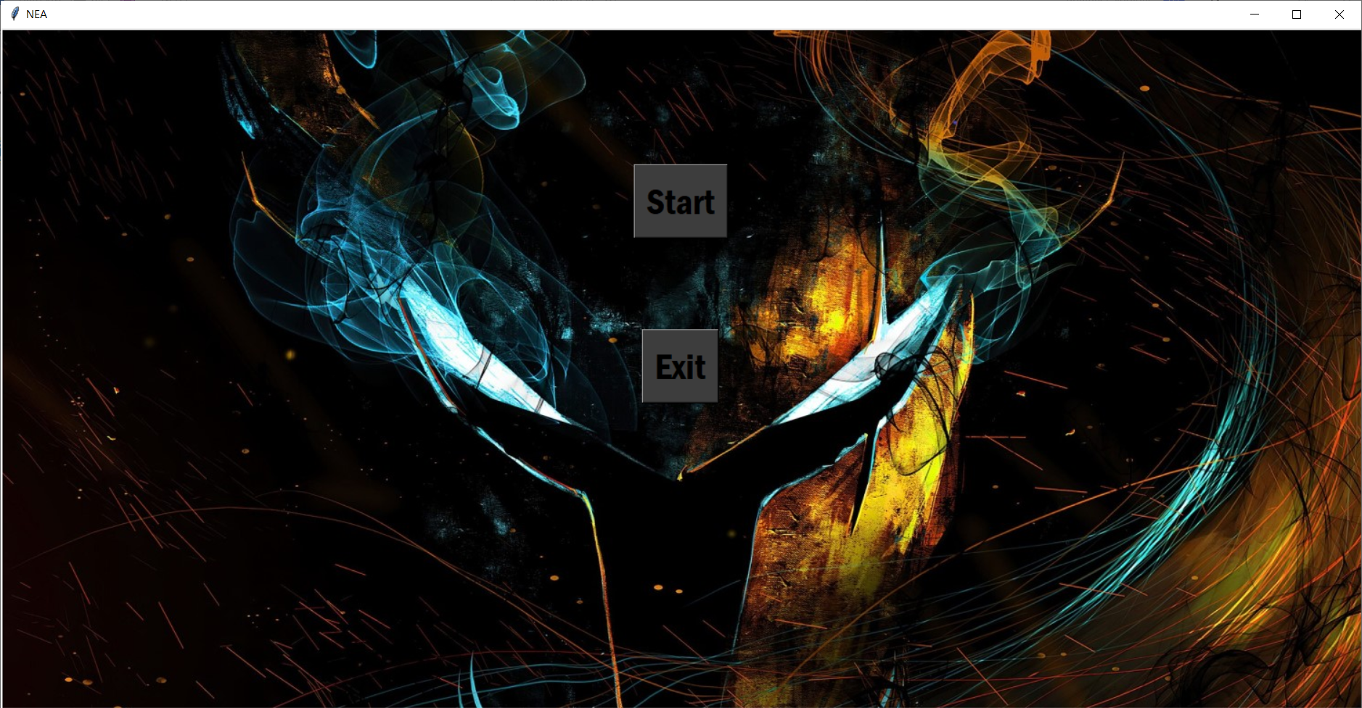

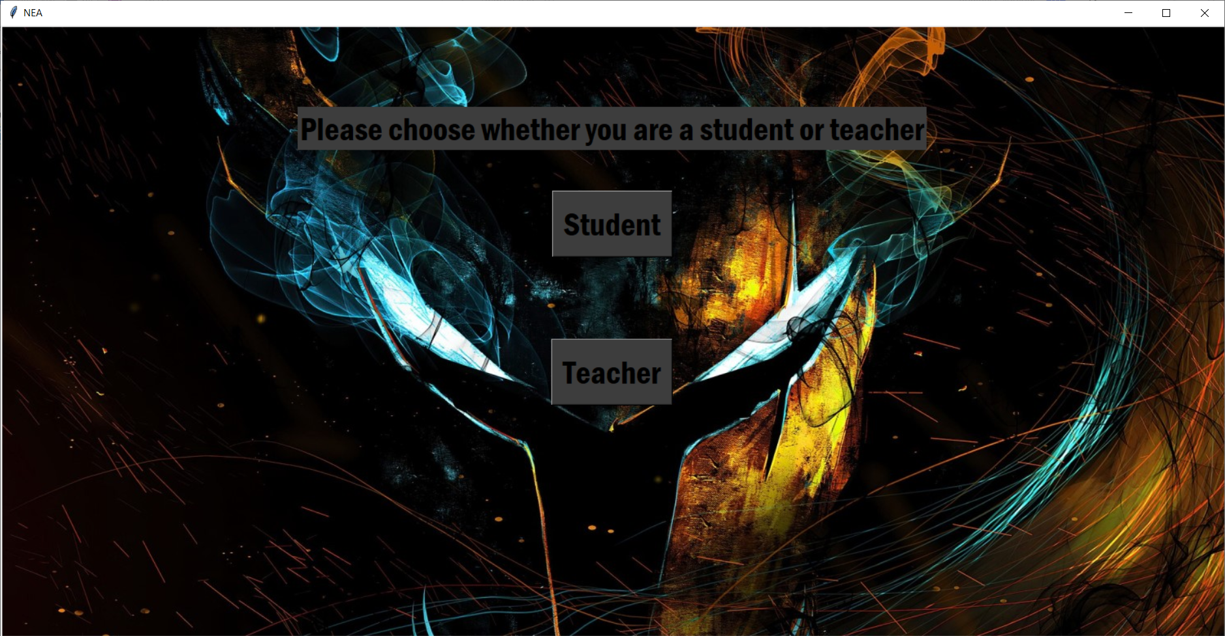

When the user first loads the game, they are shown the first screen and when they click start, they are shown the second screen

Evidence for test 2

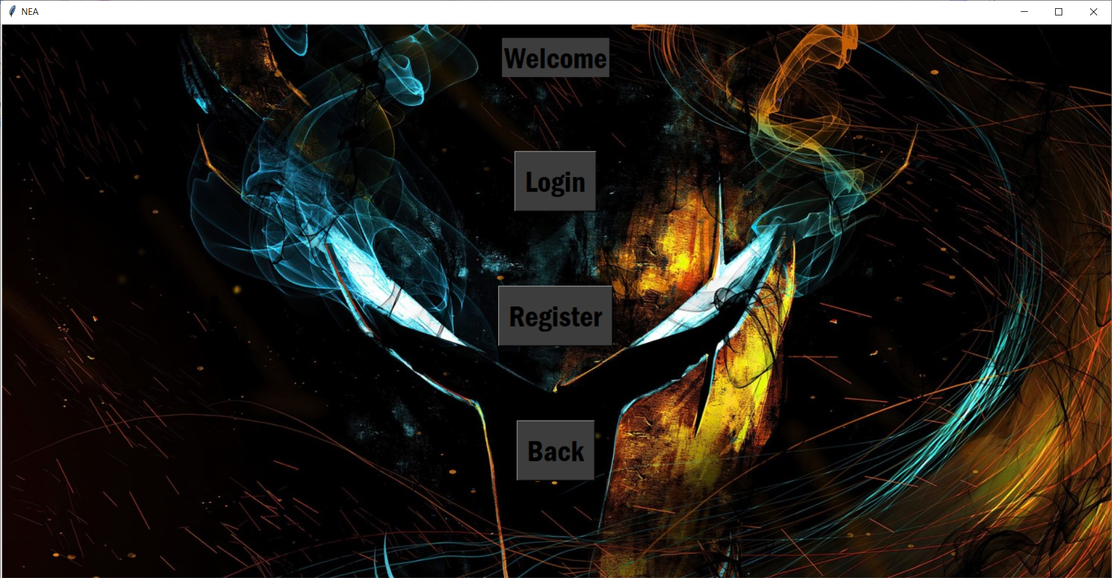

Evidence for test 3

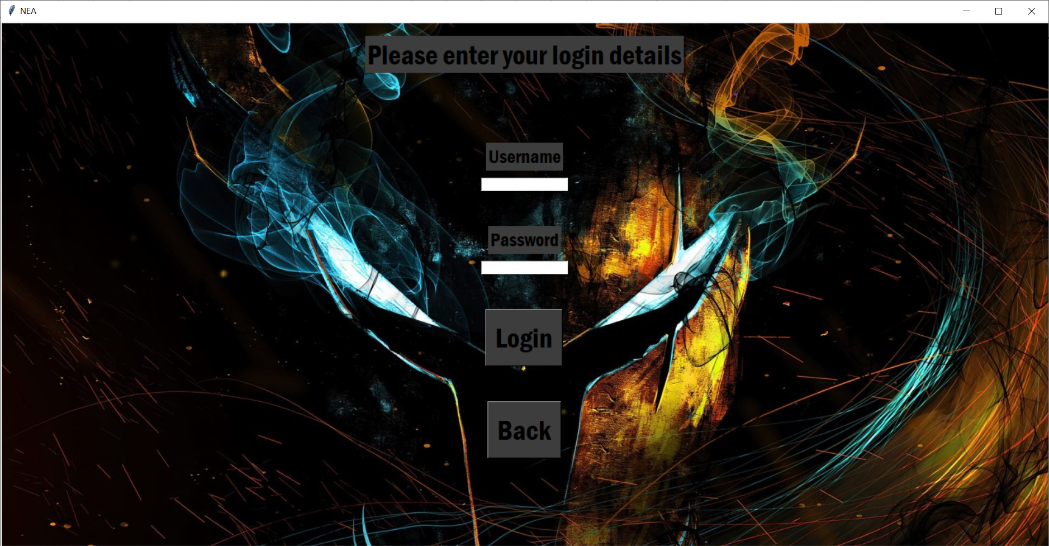

Evidence for test 4

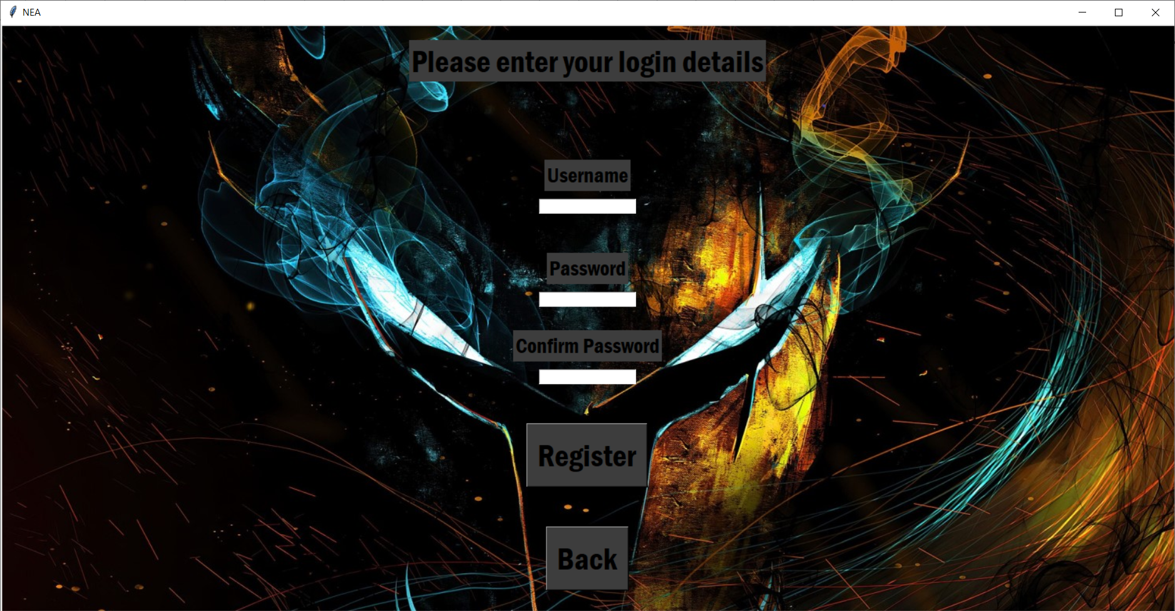

Evidence for test 5

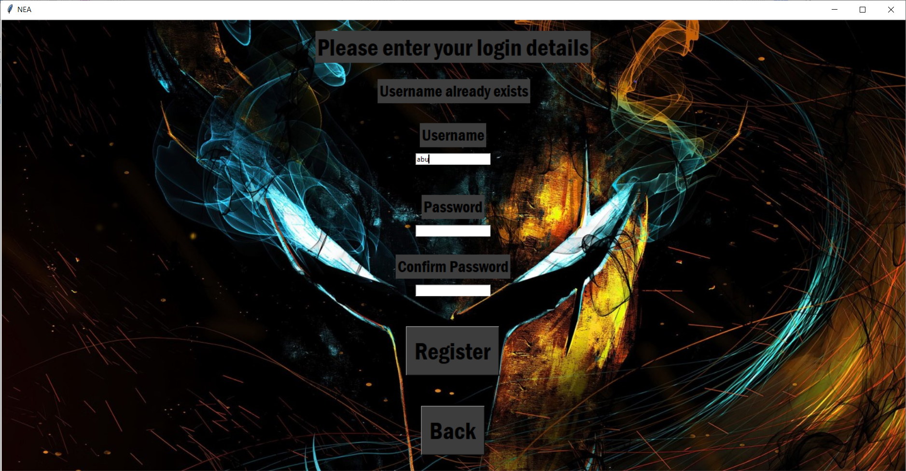

Evidence for test 6

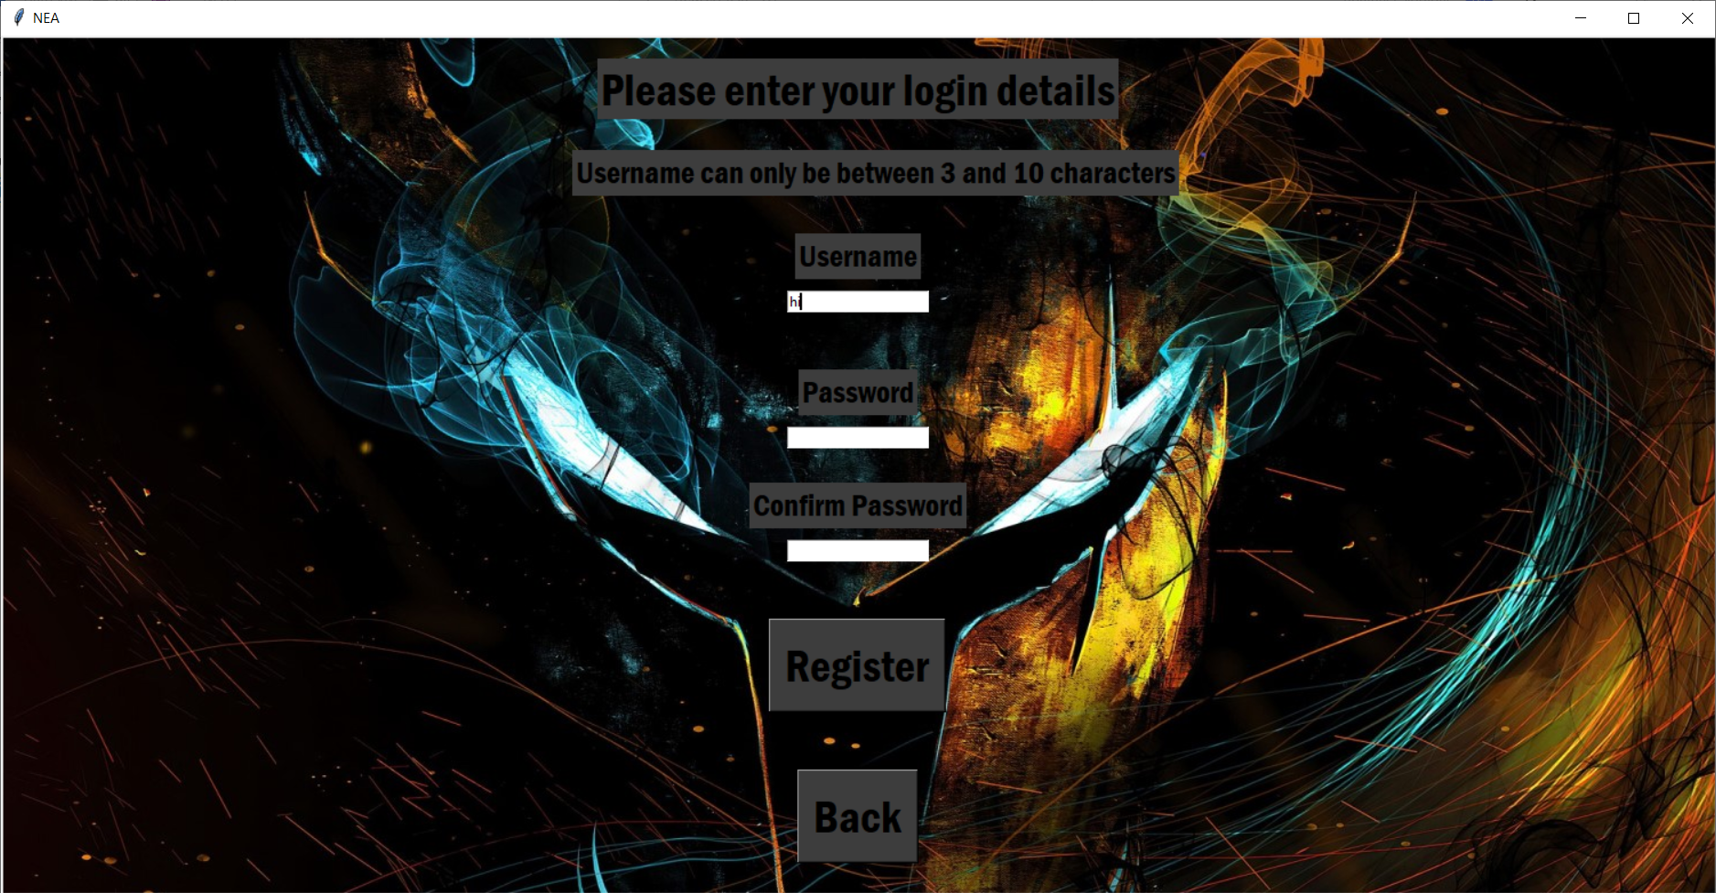

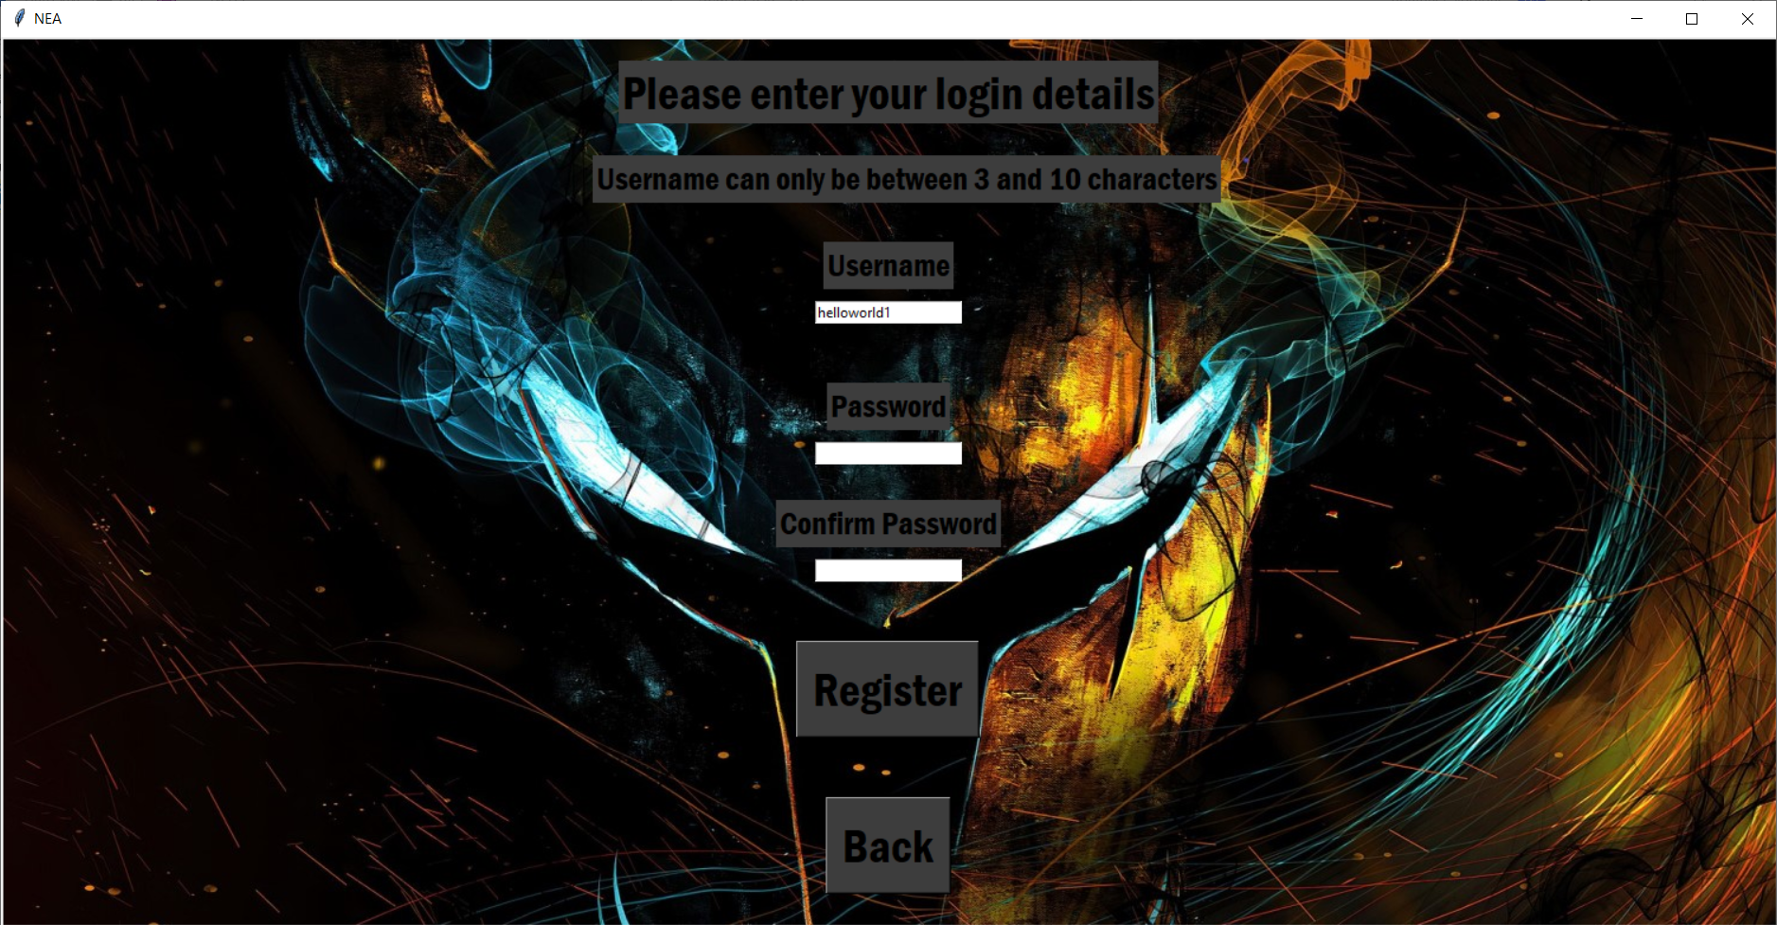

Evidence for test 7

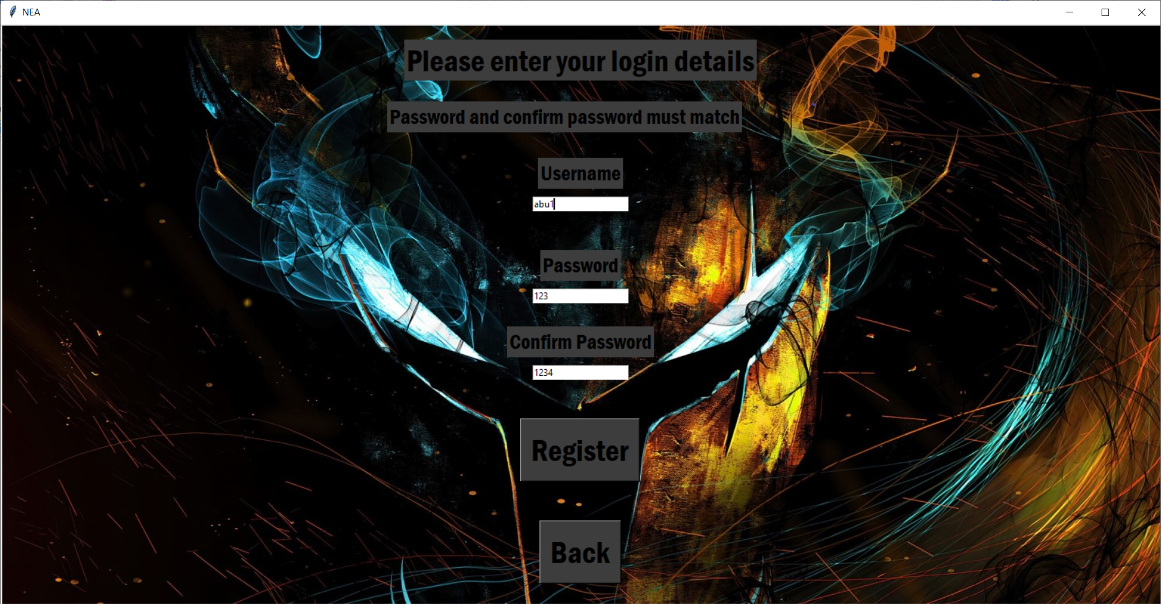

Evidence for test 8

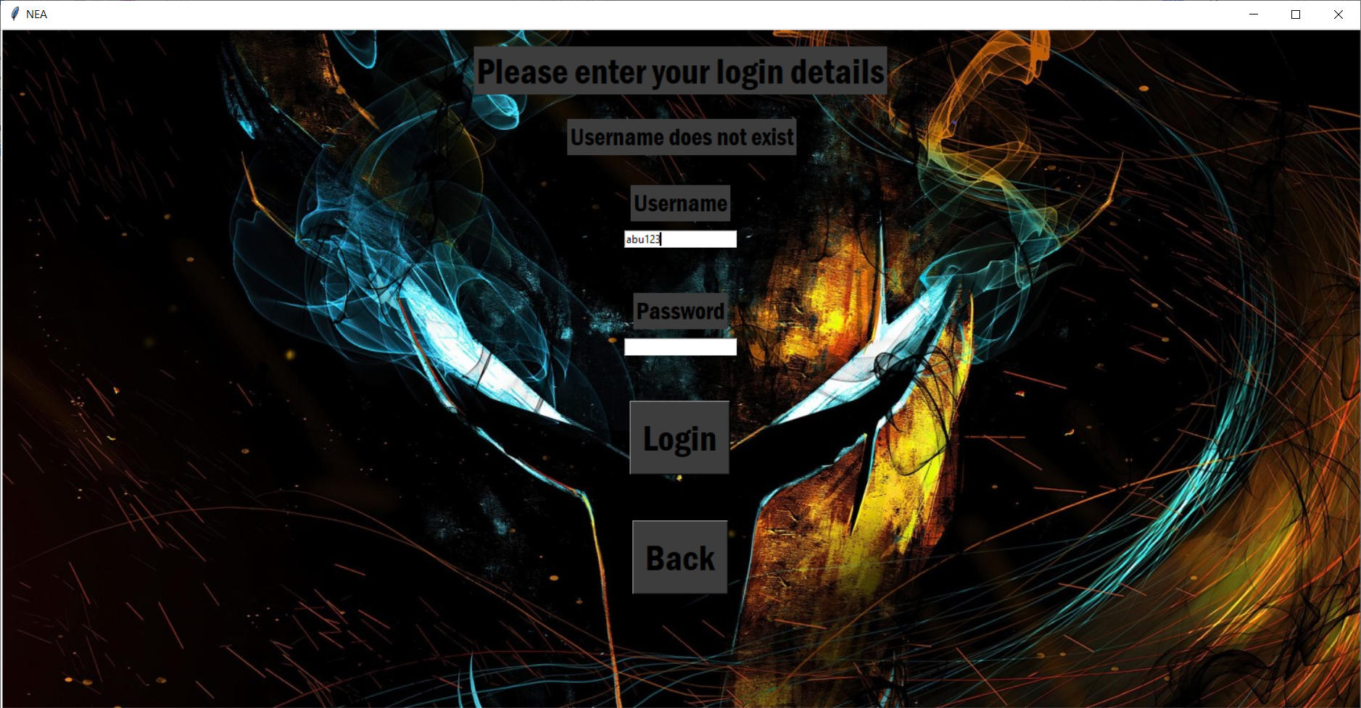

Evidence for test 9

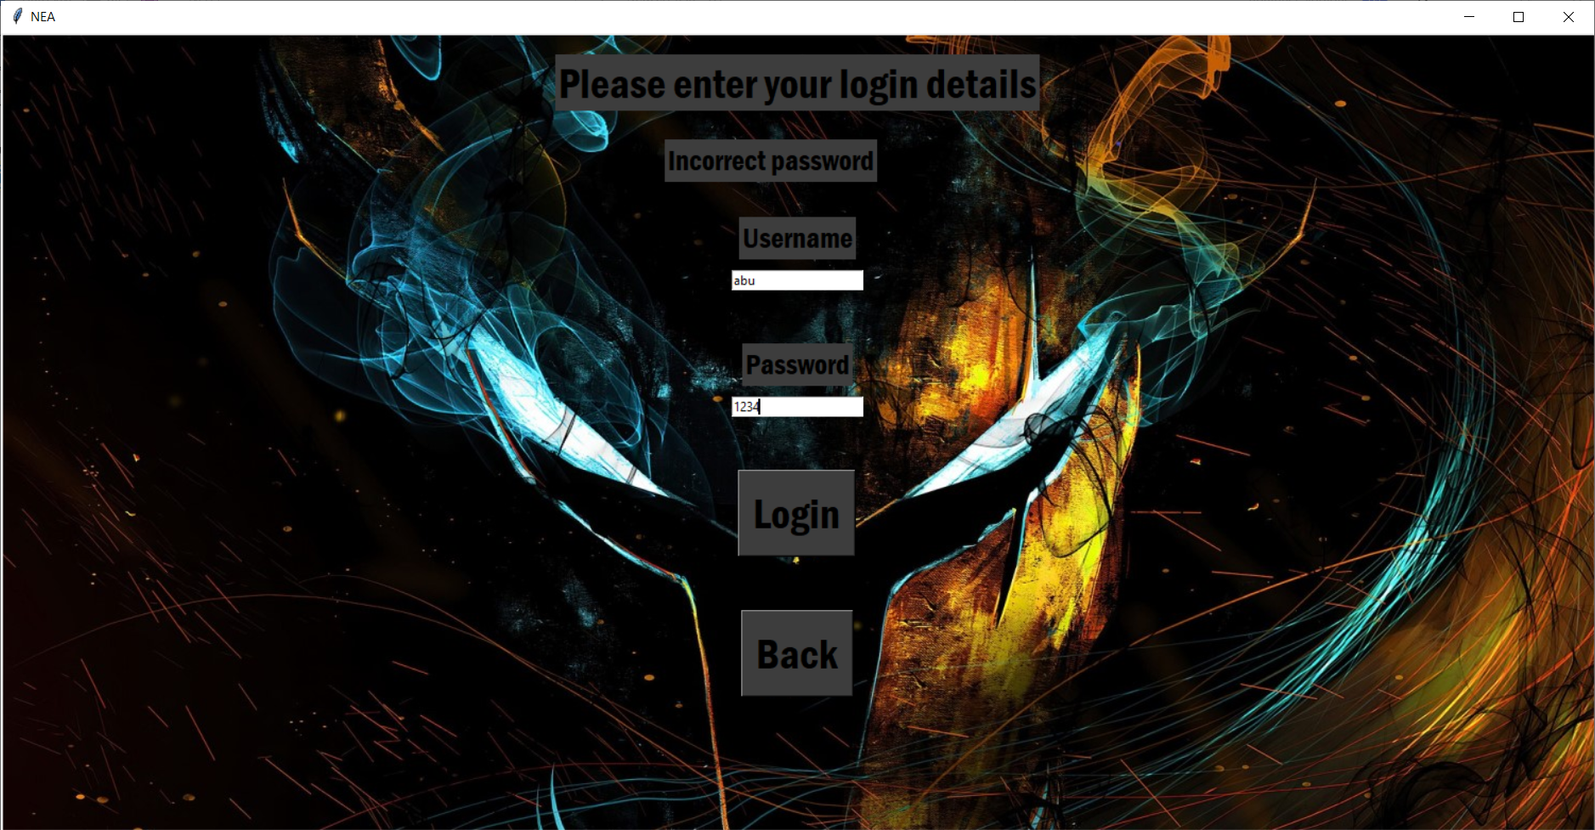

Evidence for test 10

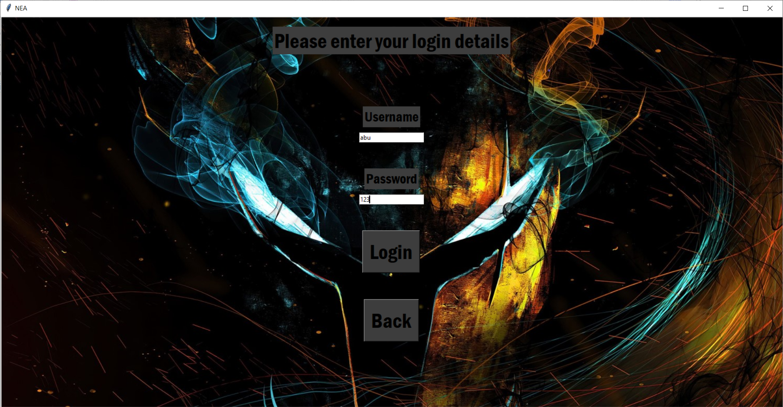

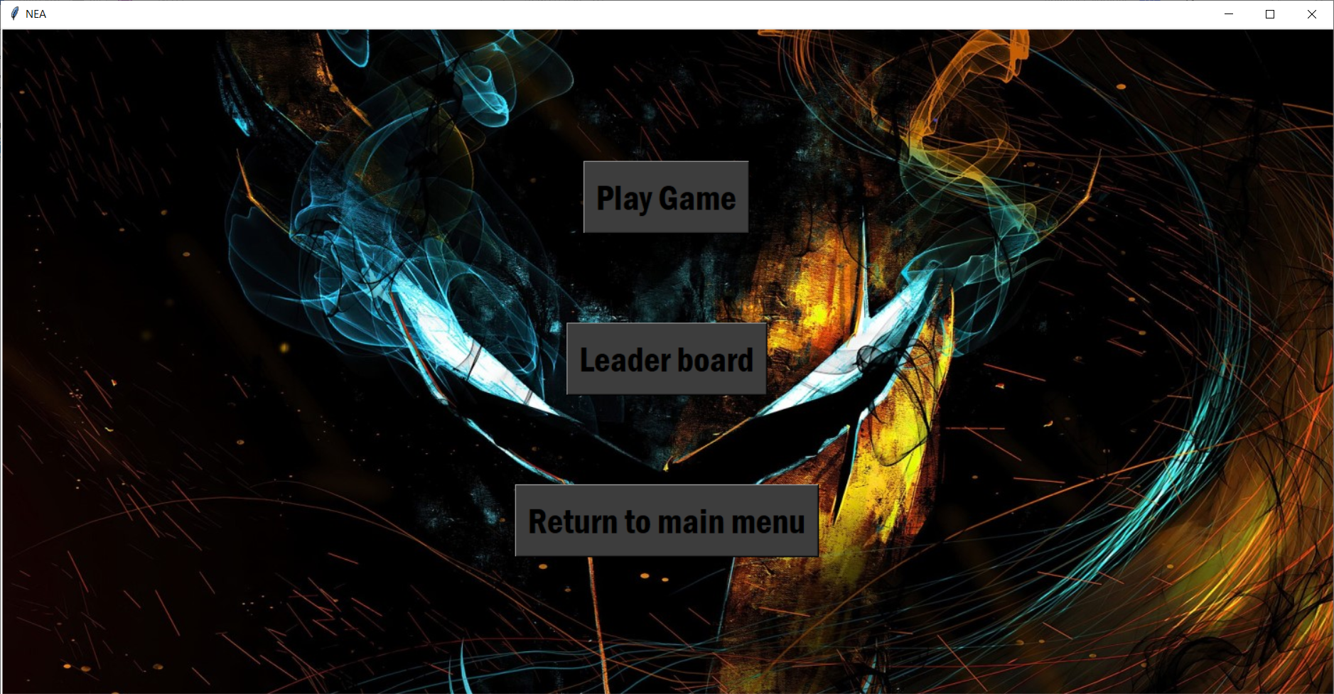

The username abu and password 123 is registered in the database and is a valid login so when the user clicks login, they are taken to the second screen

Evidence for test 11

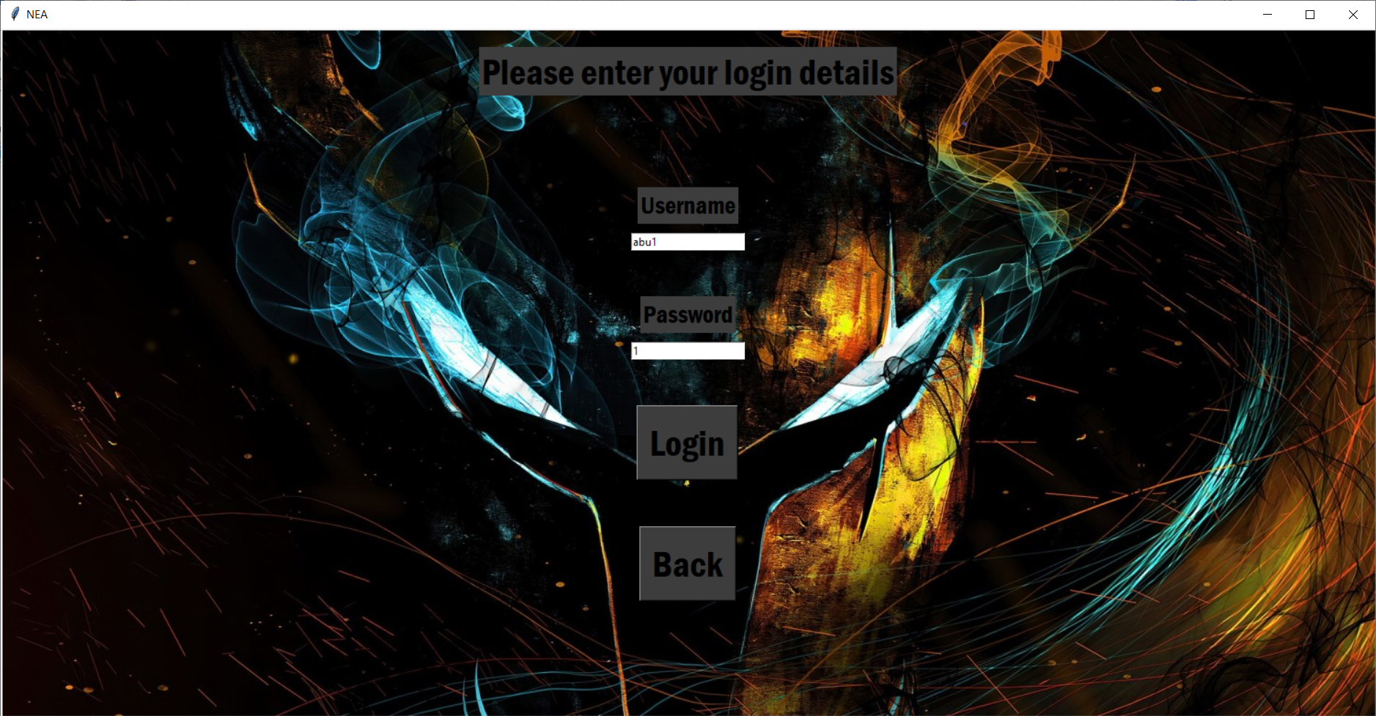

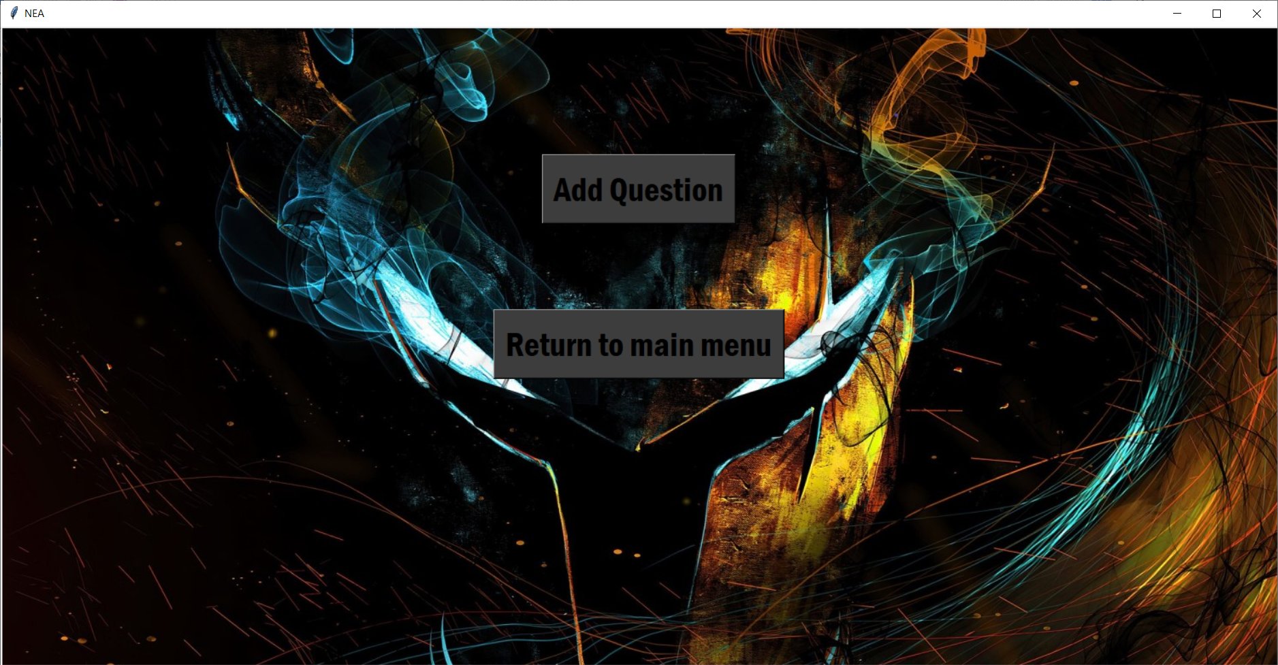

Evidence for test 12

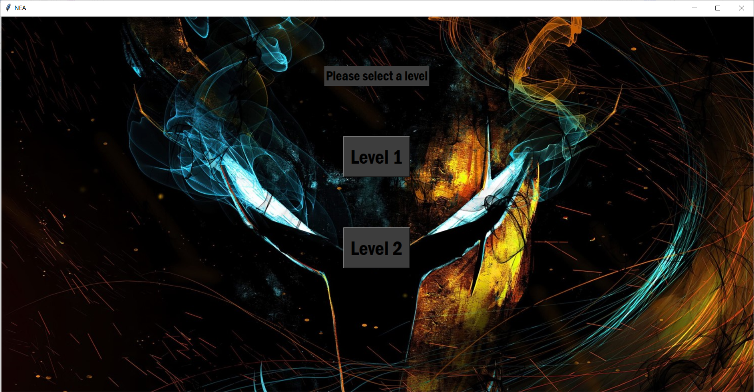

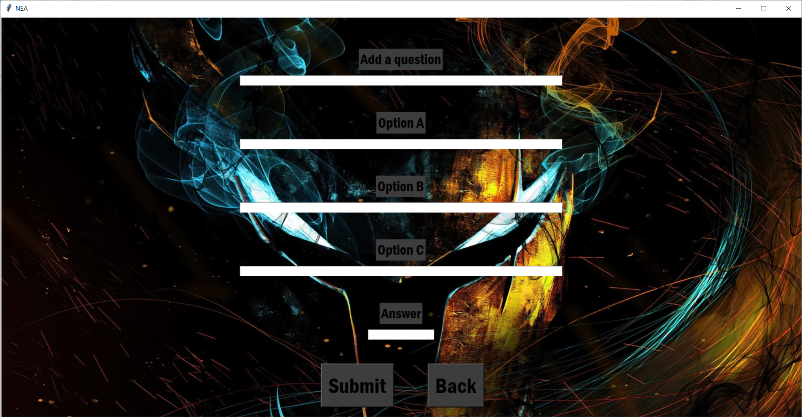

Once the user selects a level from the first screen, they are taken the second screen to add a question

Evidence for test 13

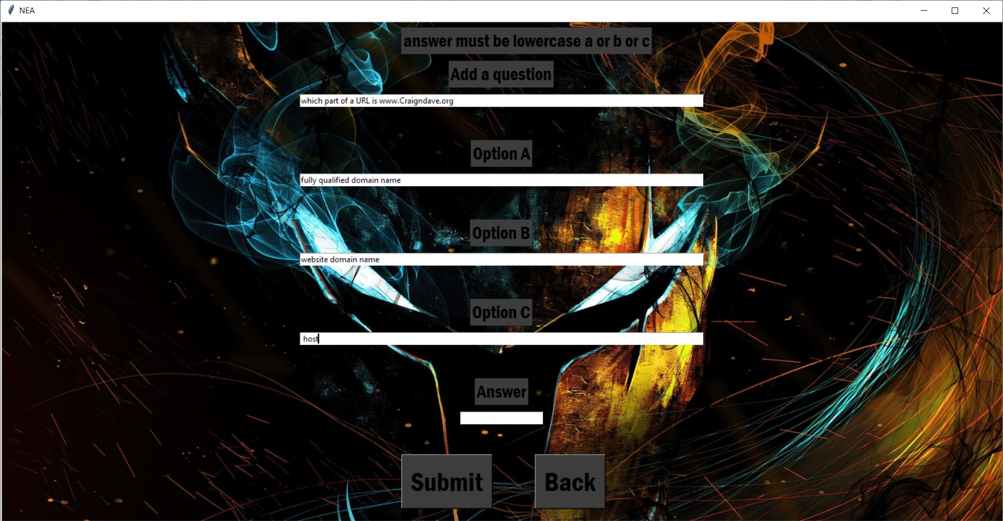

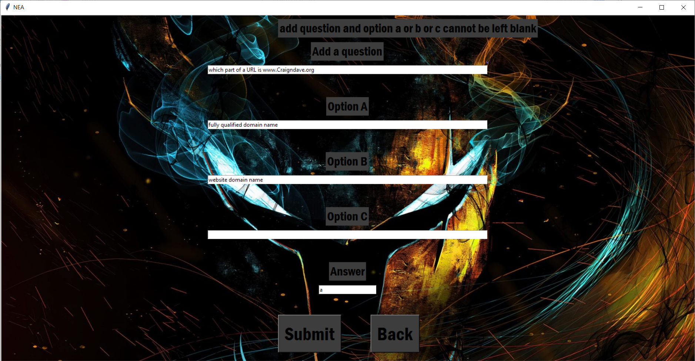

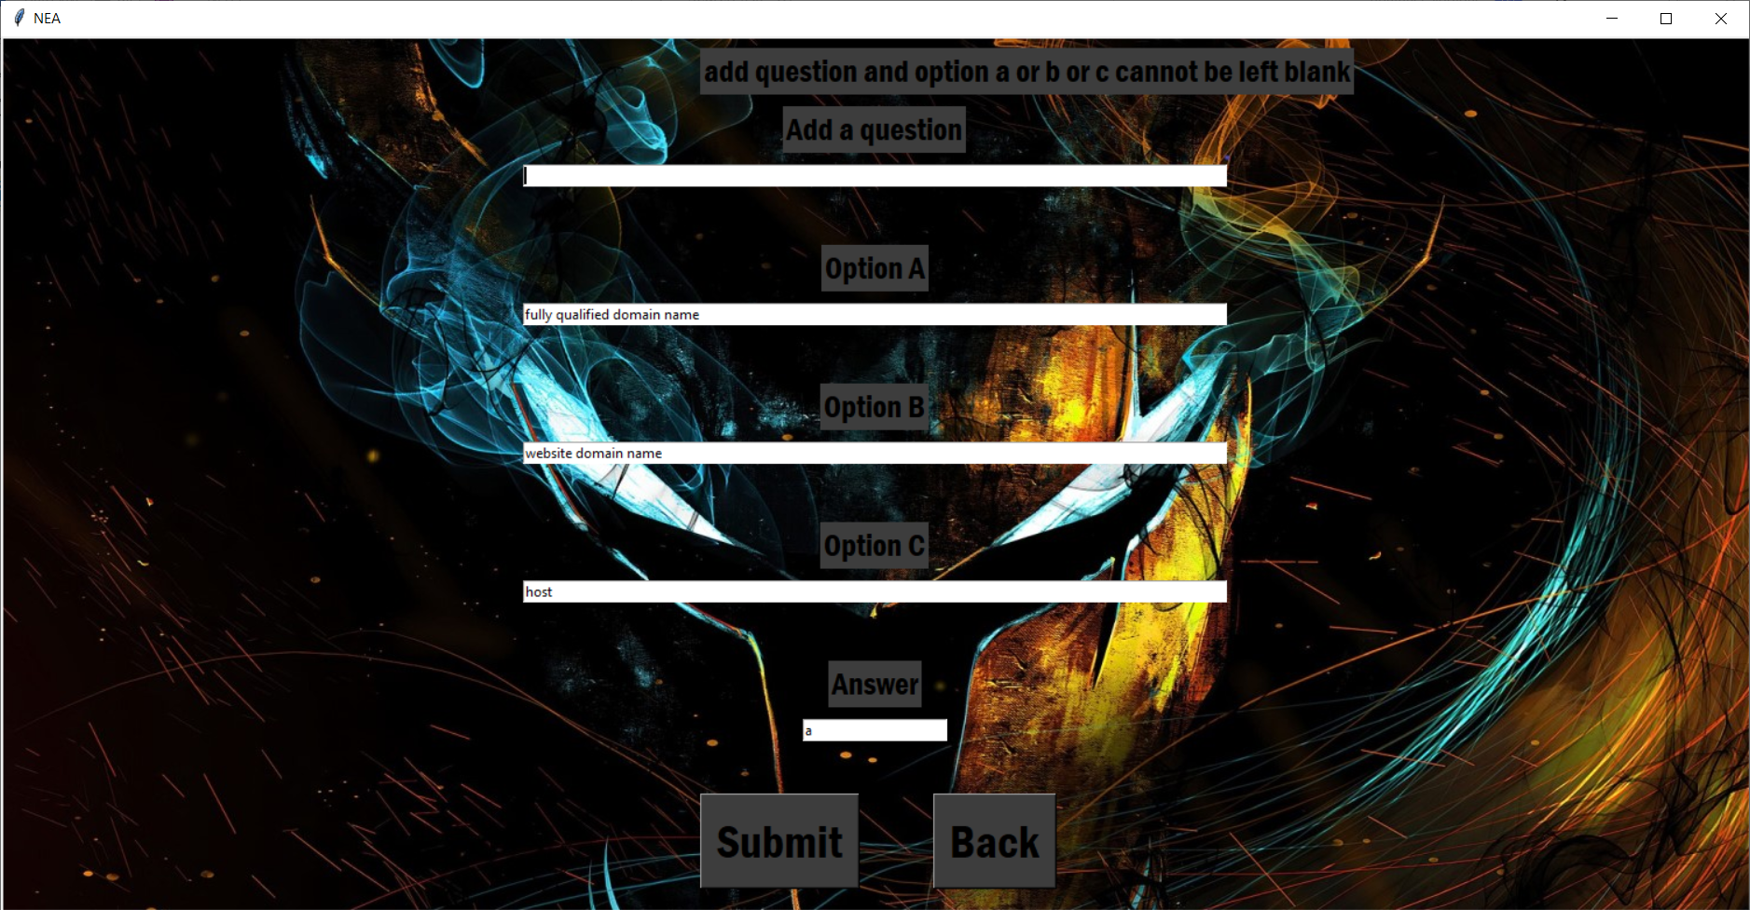

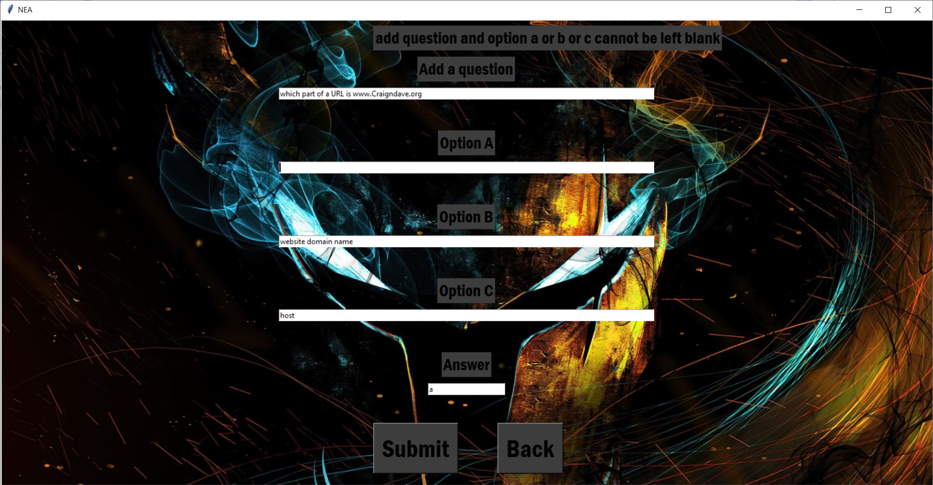

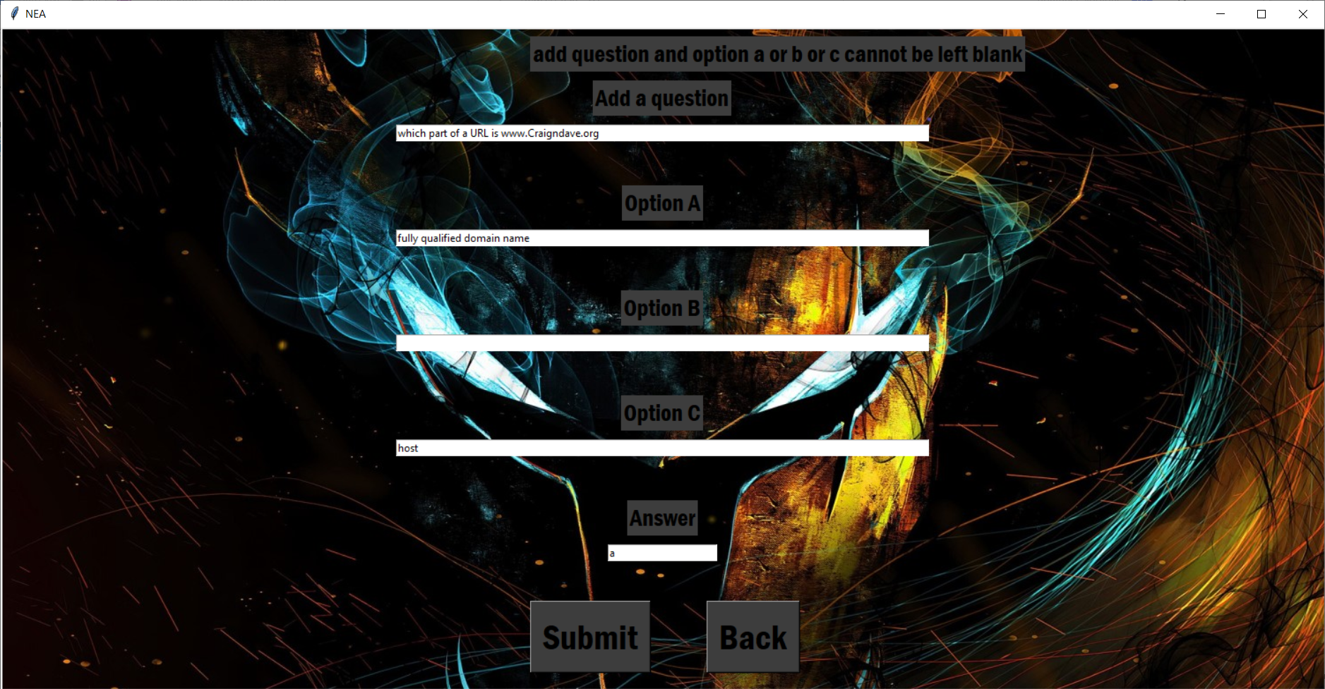

Evidence for test 14

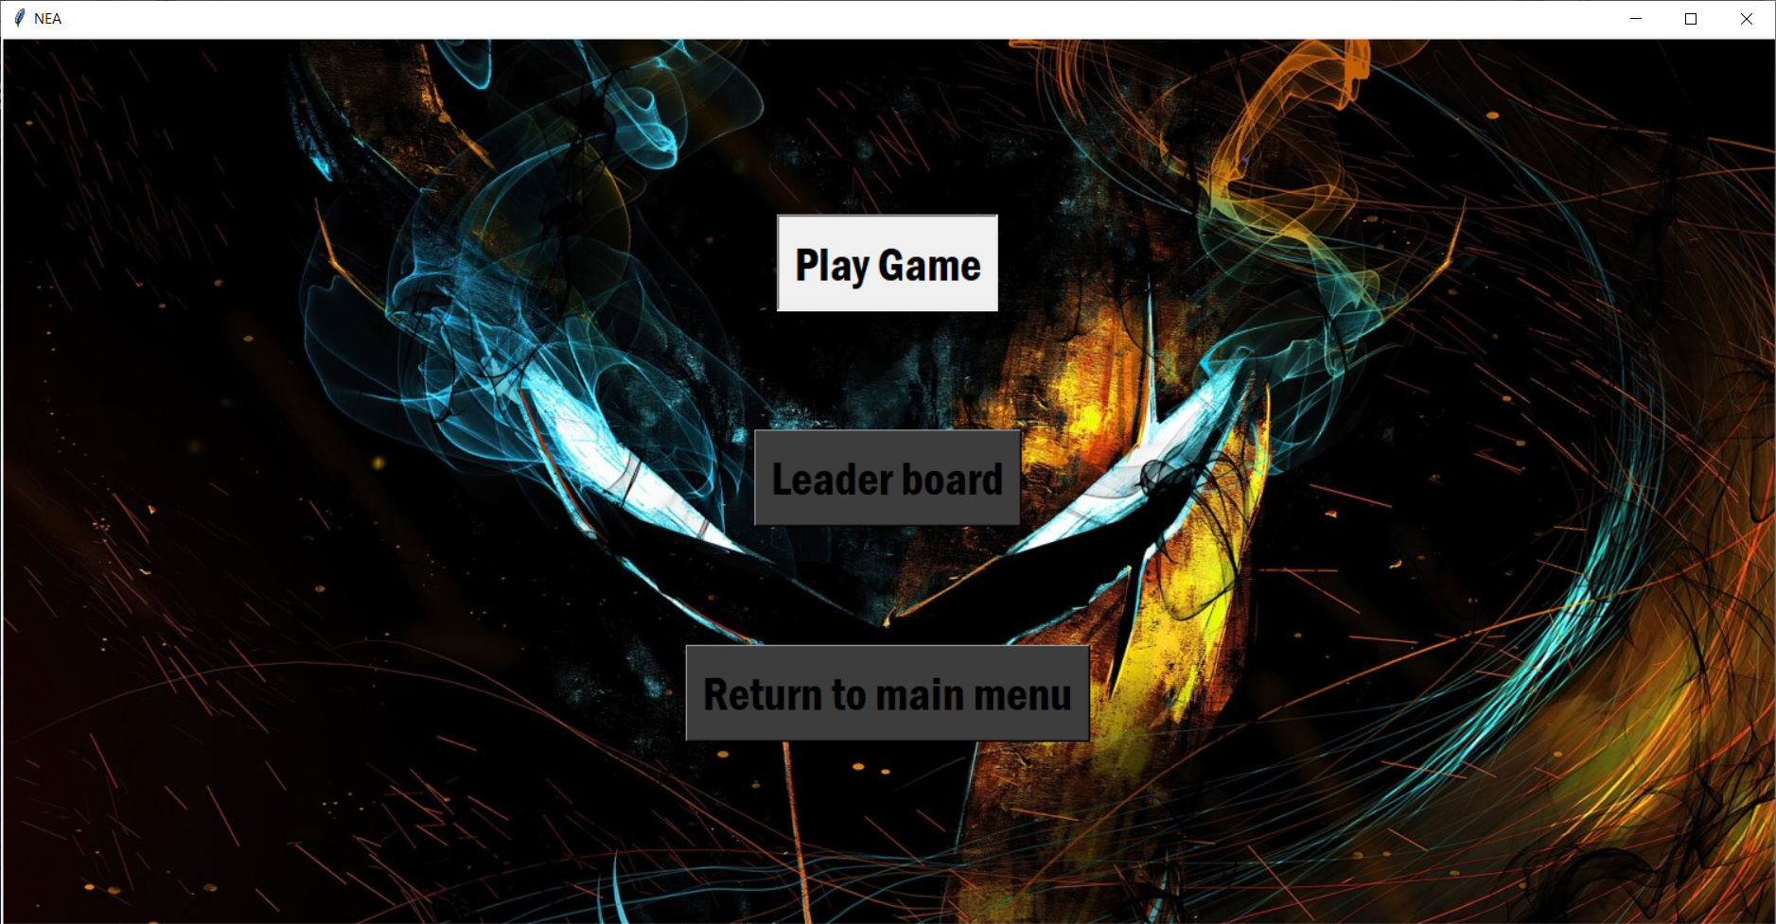

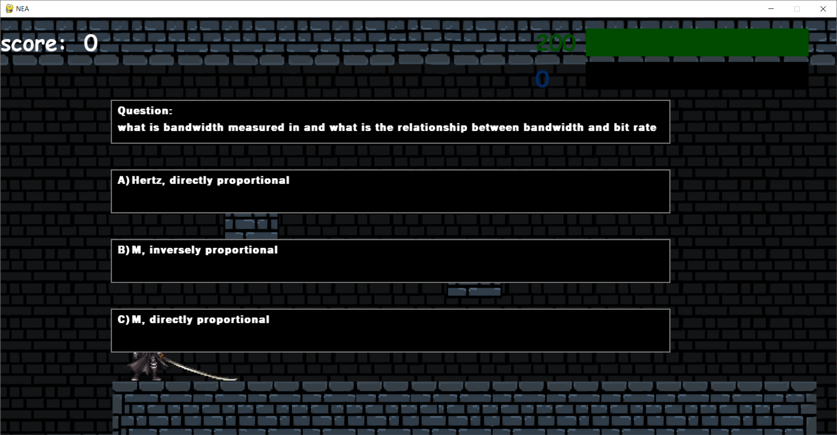

The first screen shows the play game button being clicked and the second screen is the game once it has loaded.

Evidence for test 15

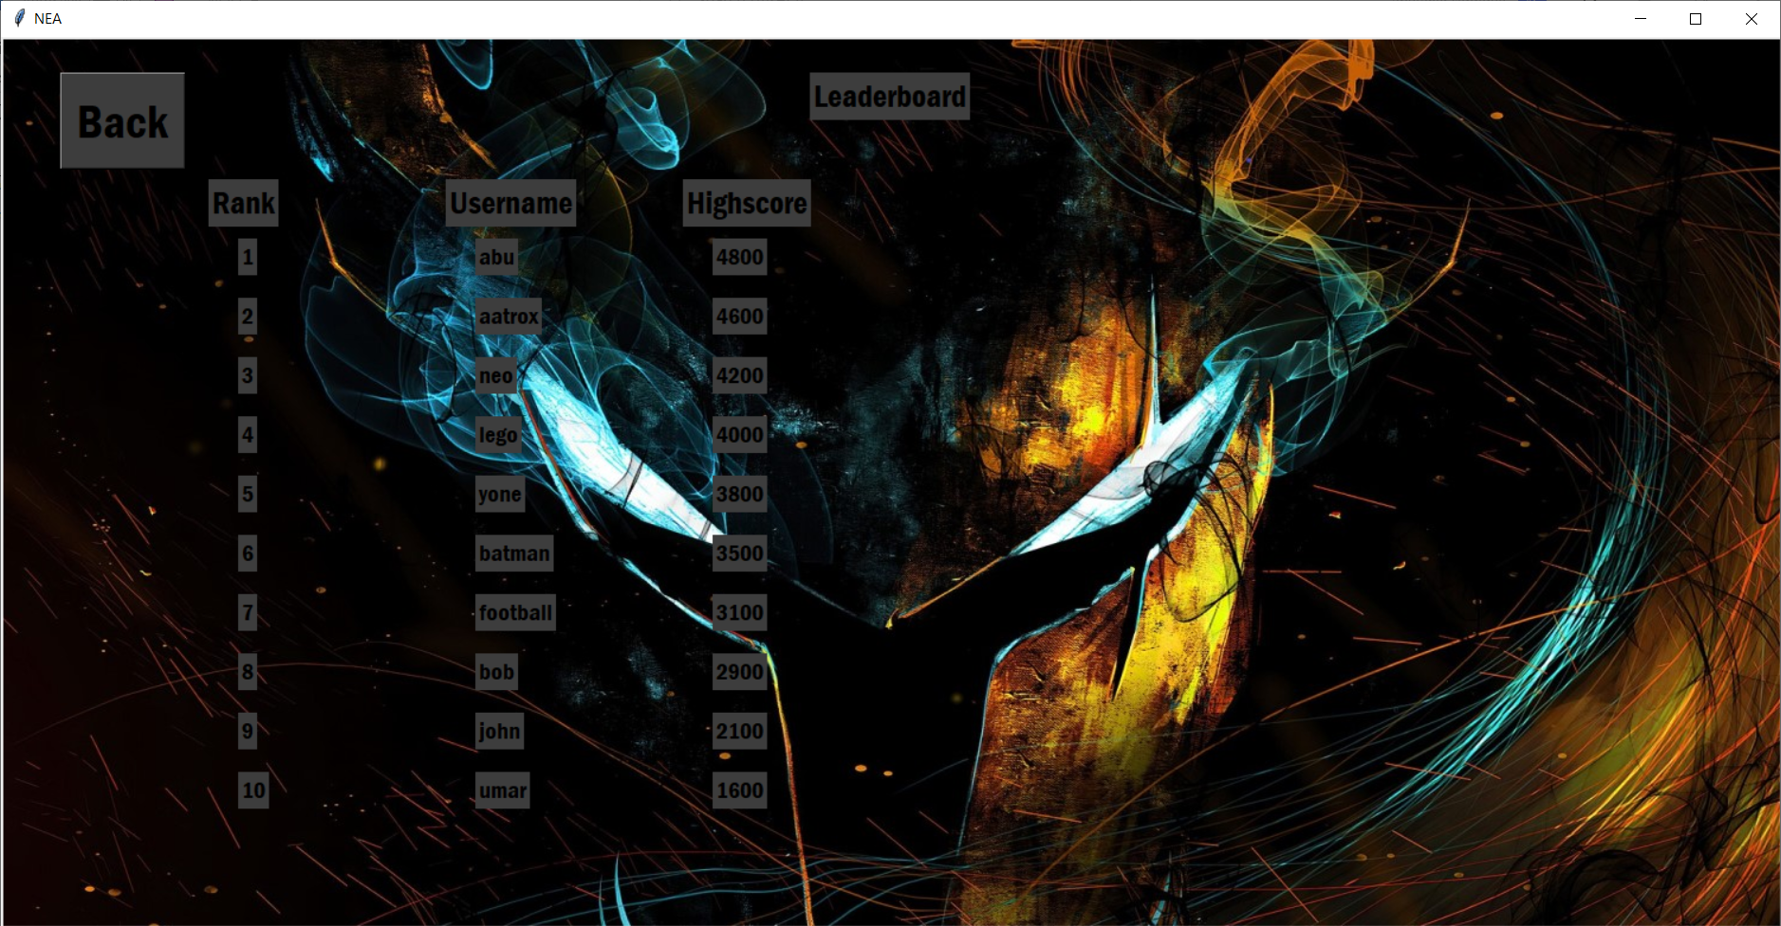

Evidence for test 16 and 17

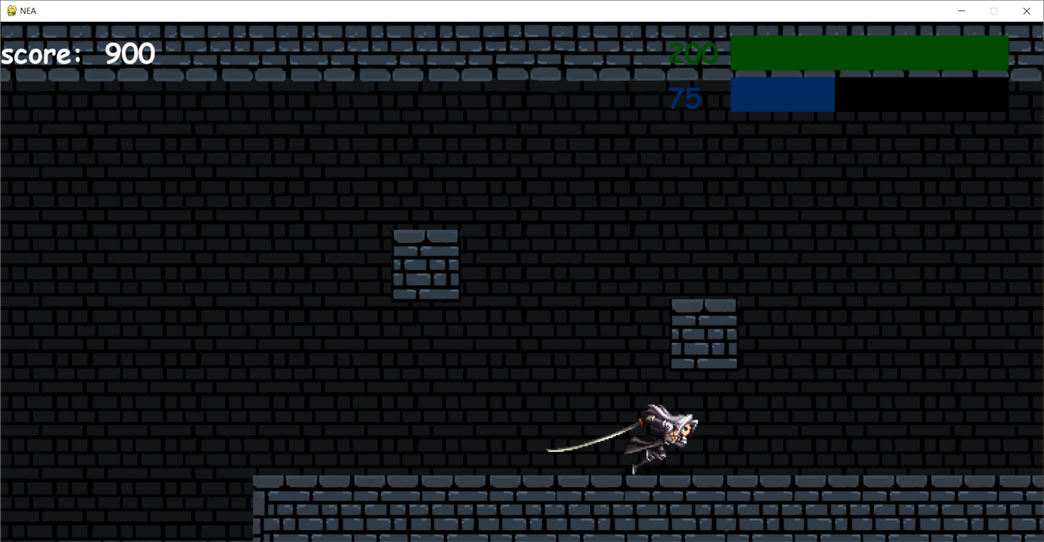

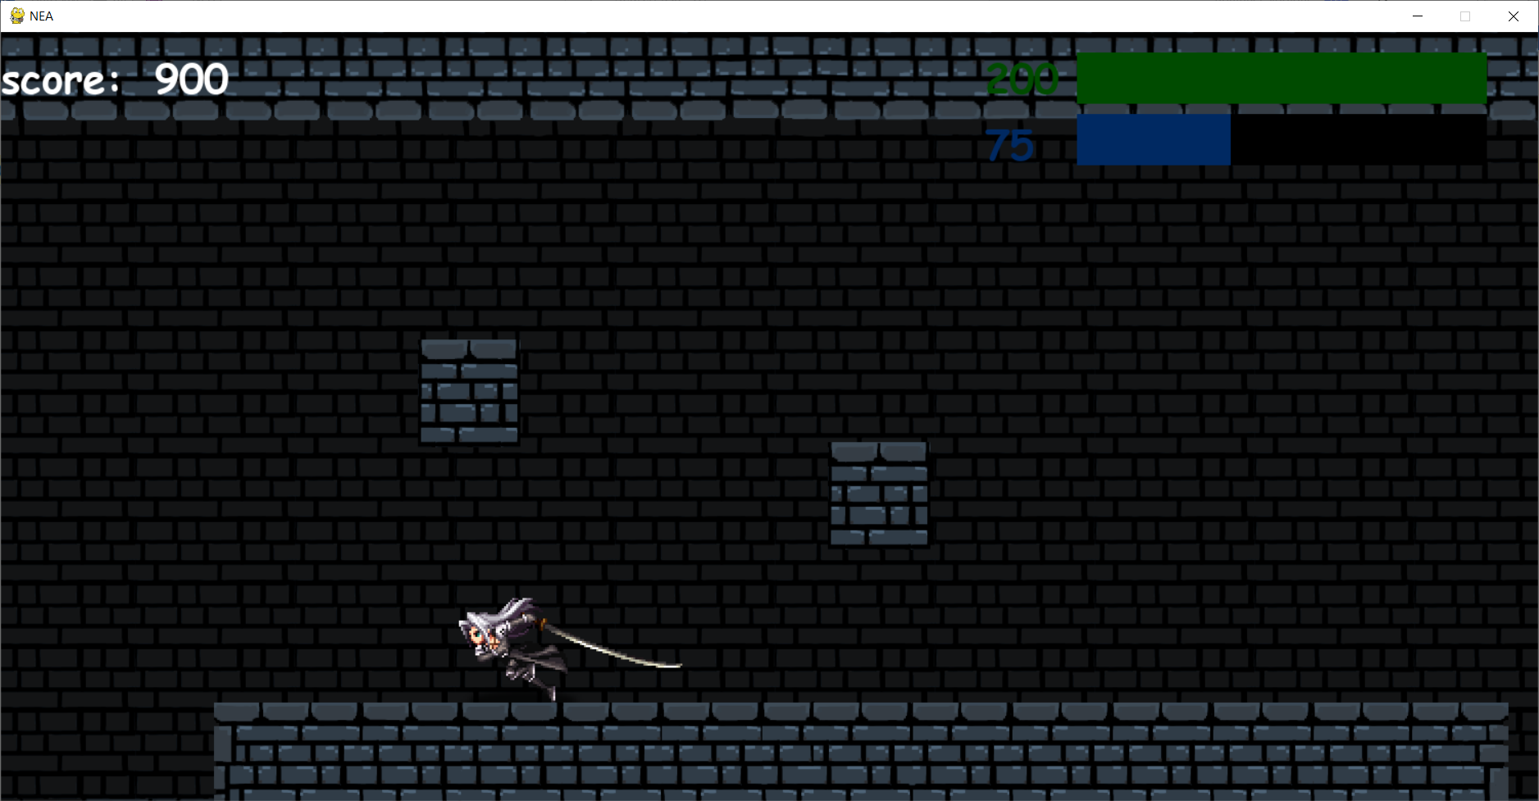

Evidence for test 18

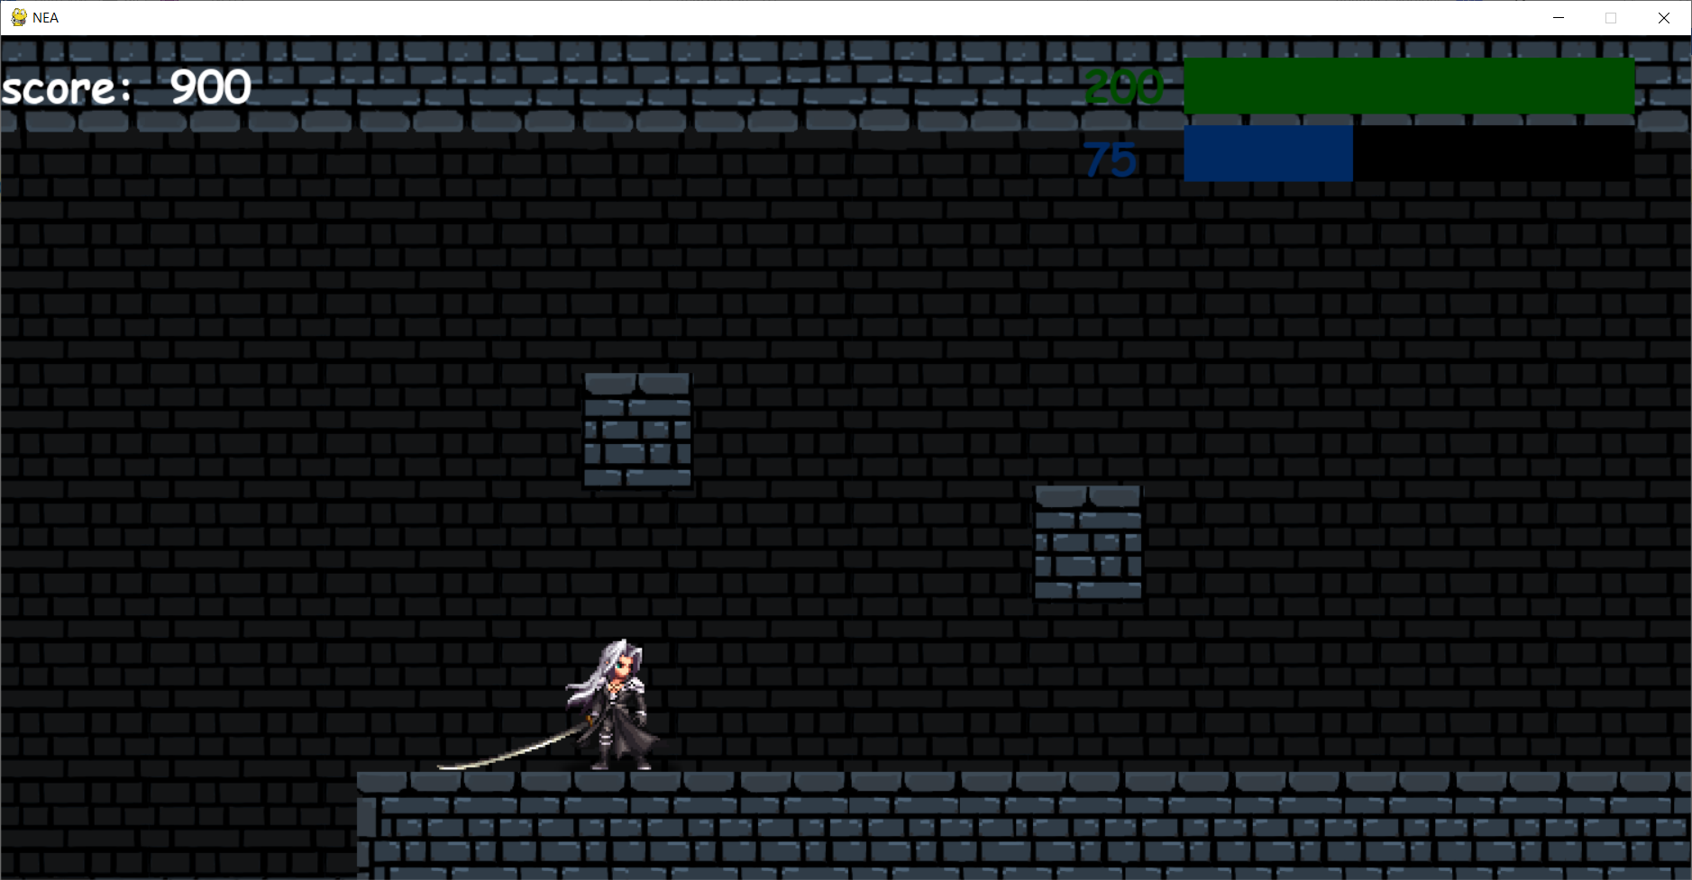

Evidence for test 19



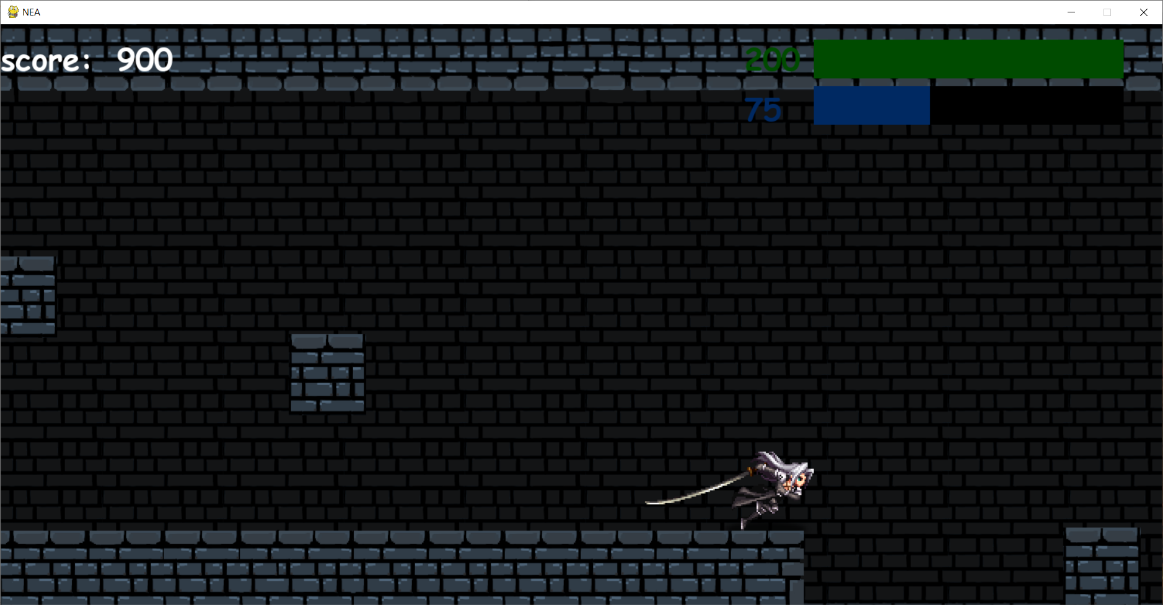

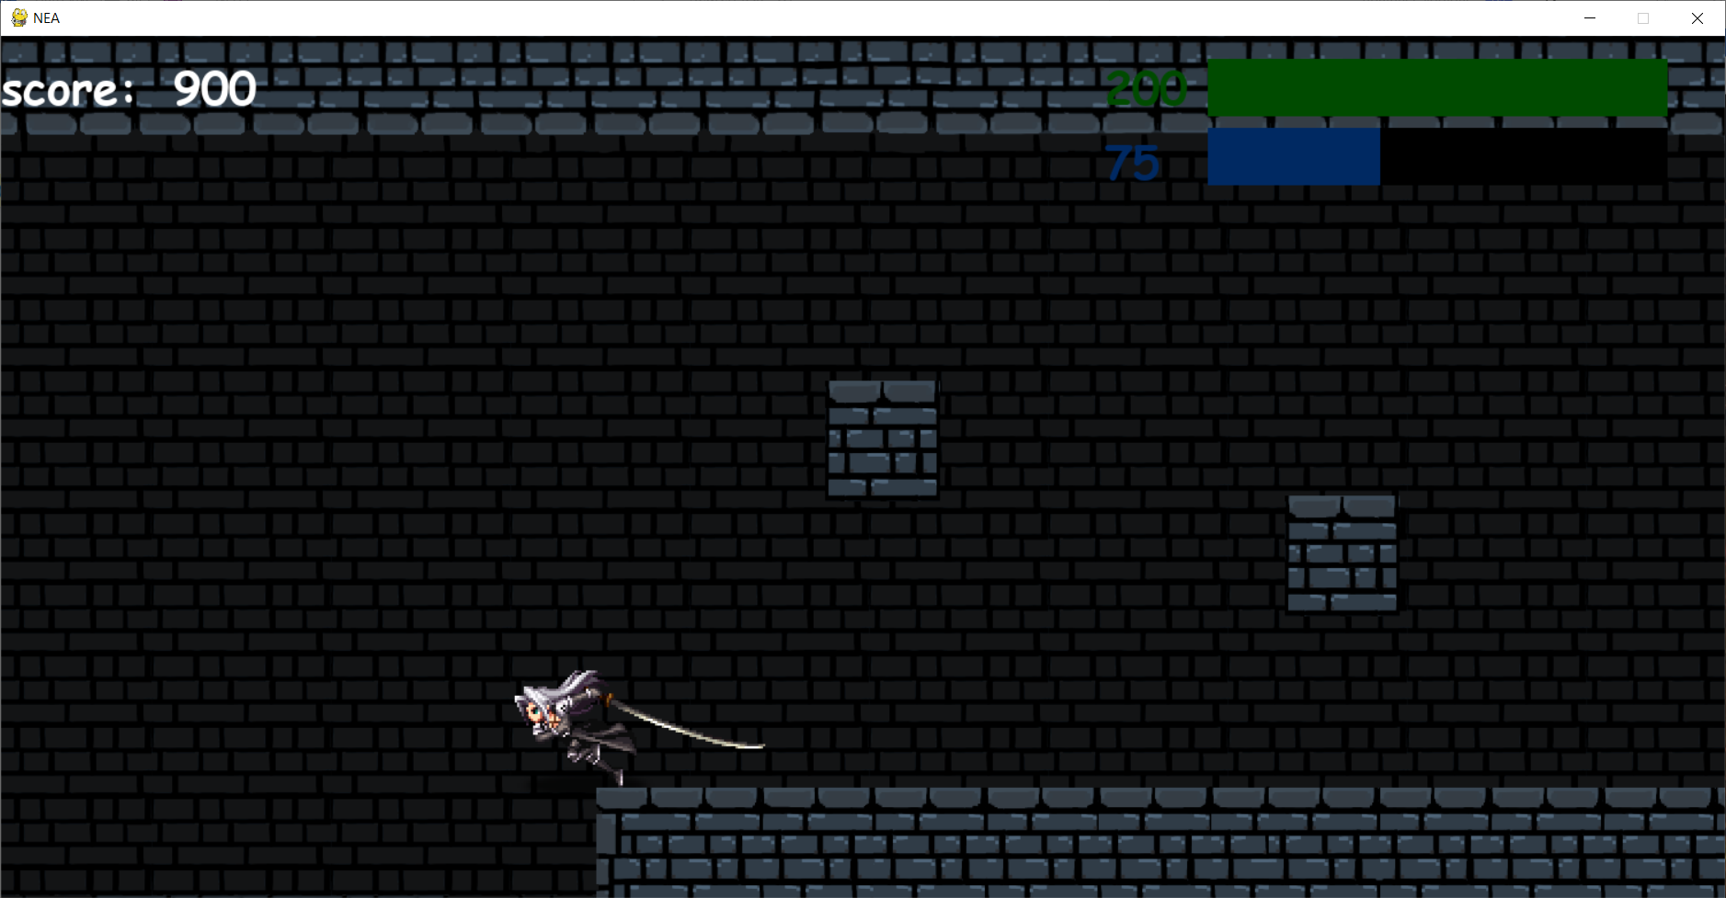

The first screen shot is when the camera has not moved. The second screenshot is when the character has reached the right side of the screen and is moving the camera will move and follow the player. The third screenshot is when the character has reached the left side of the screen and is moving the camera will move and follow the player.

Evidence for test 20

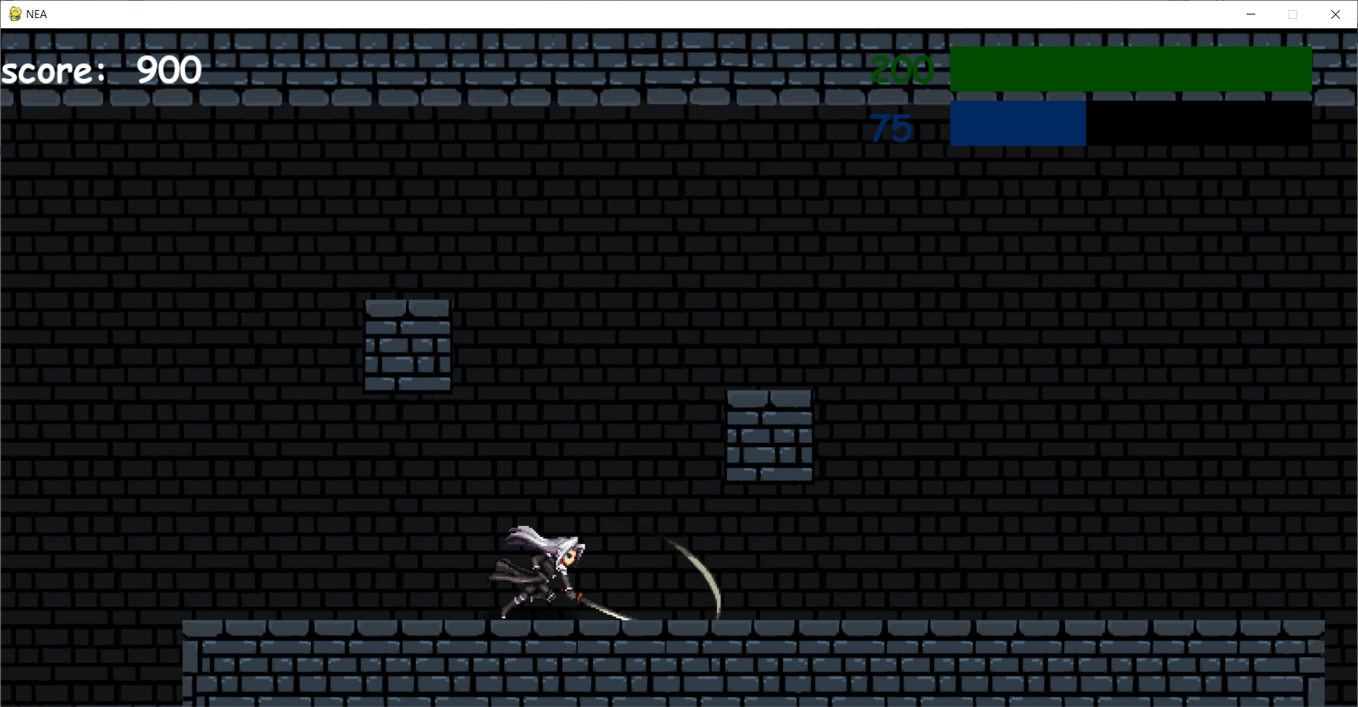

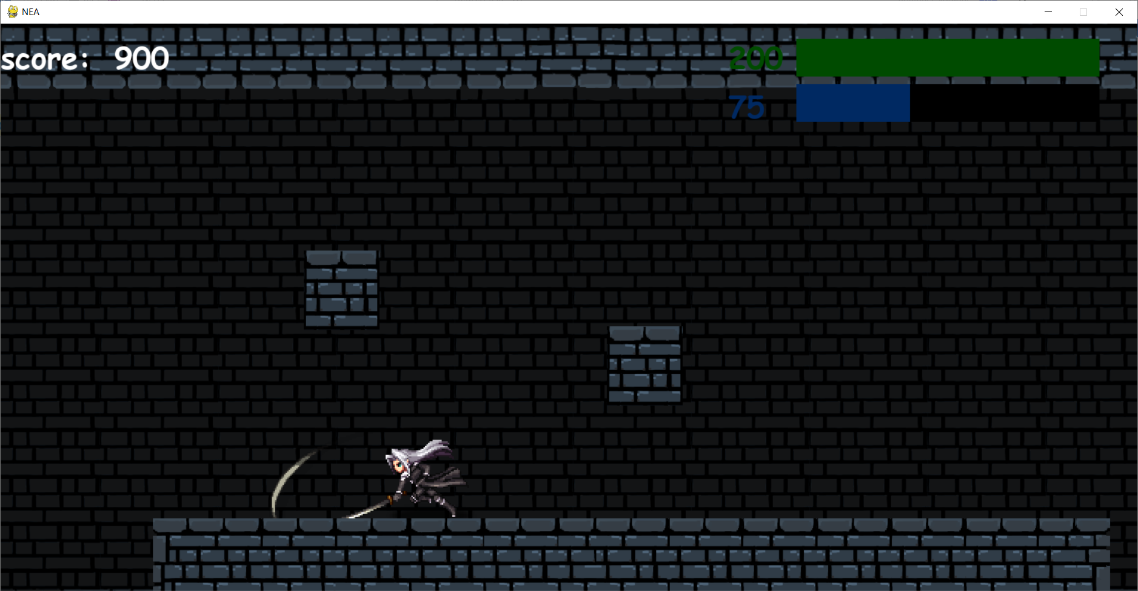

Evidence for test 21

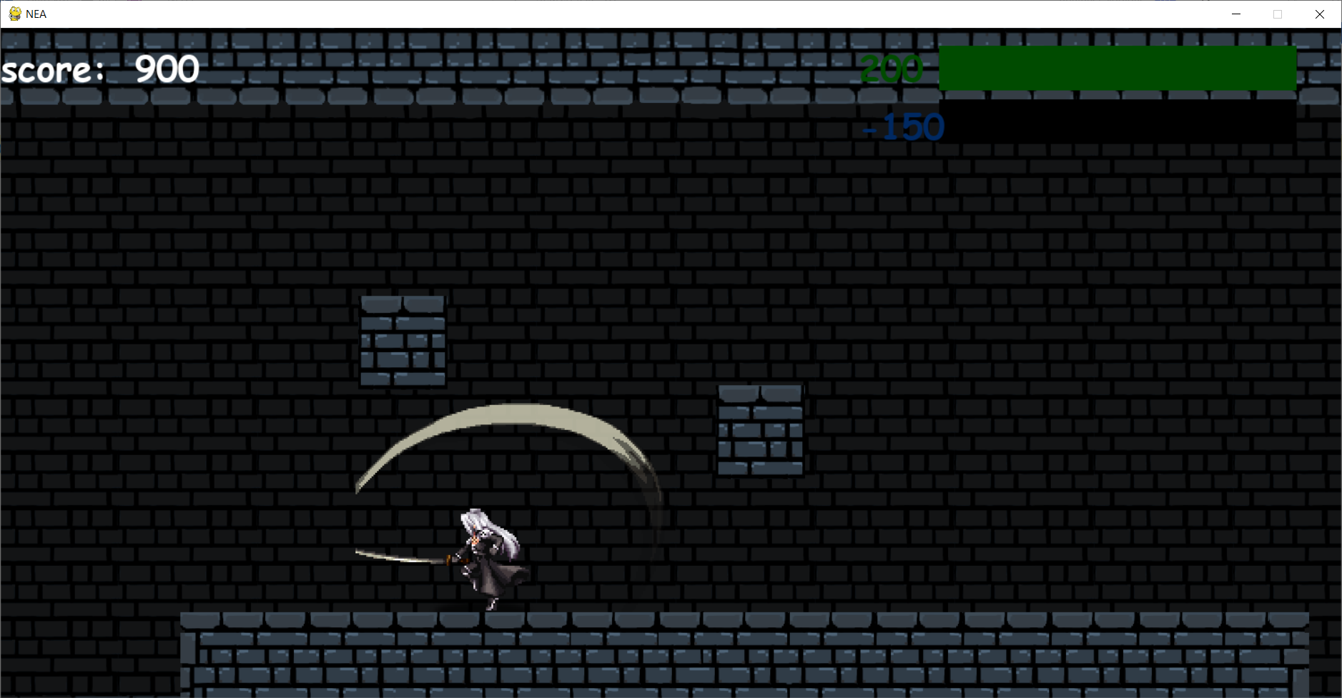

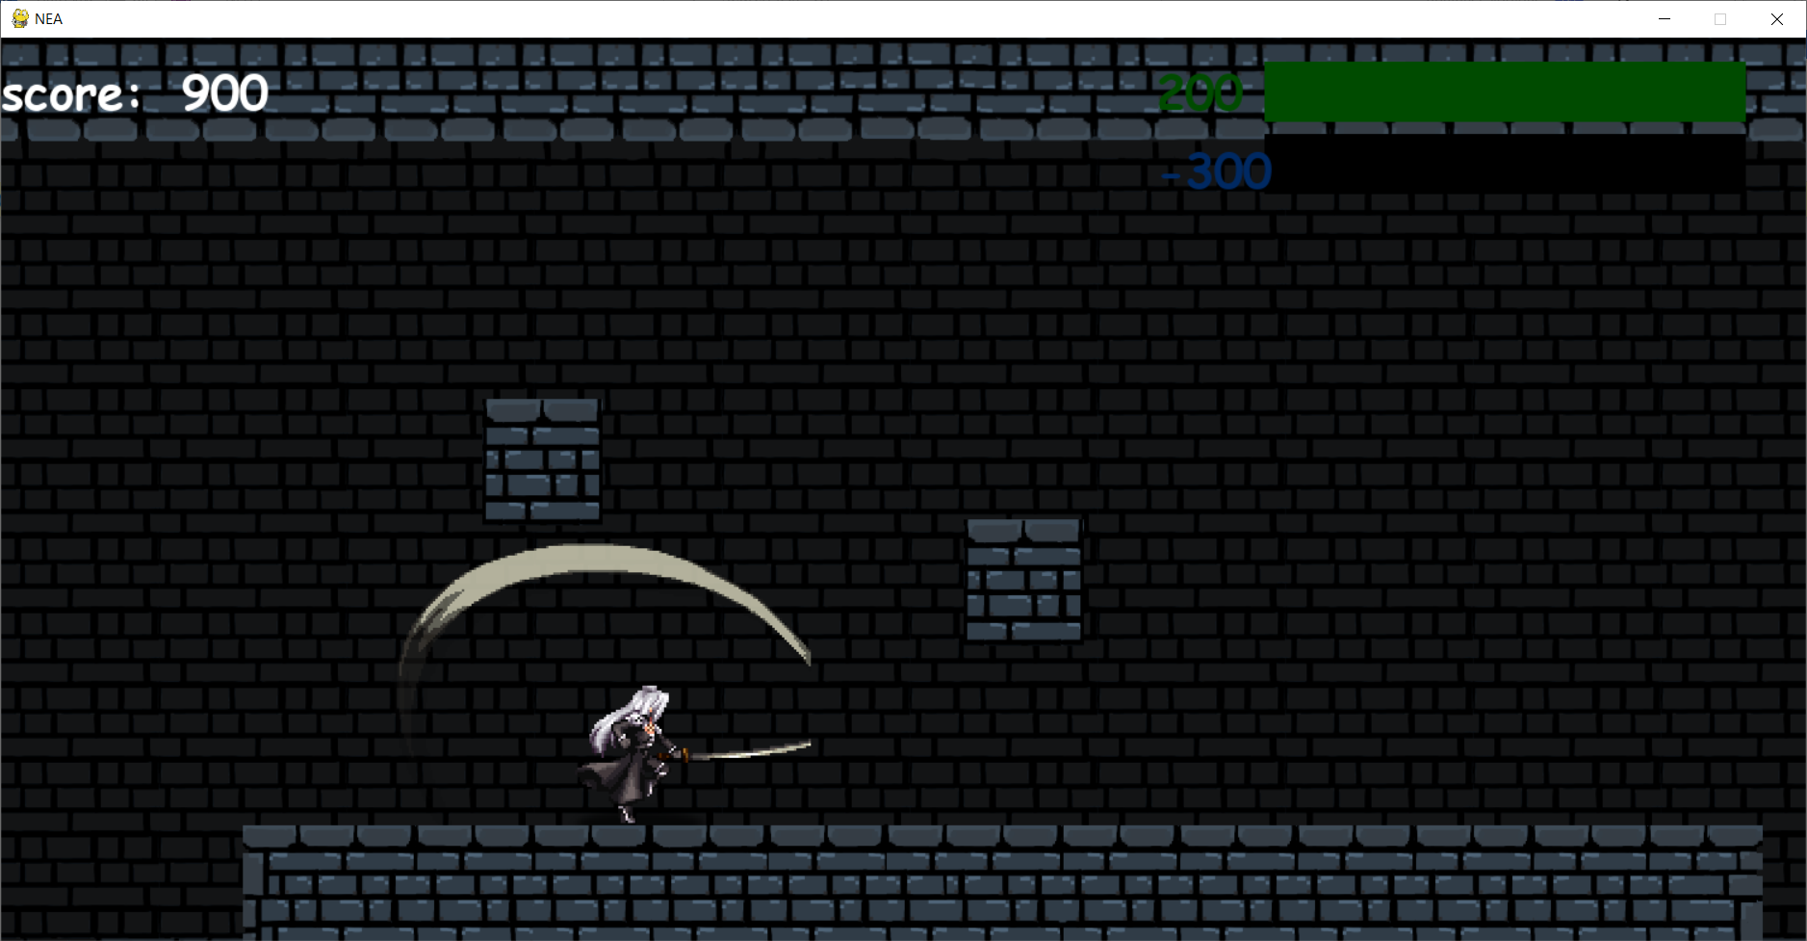

For test 21 and test 22 the player has negative energy because during testing I removed the restriction of needed energy to perform ultimate and special attacks to test and screenshot them easily. In the actual game the user will need a certain amount of energy as shown in test 31 below.

Evidence for test 22

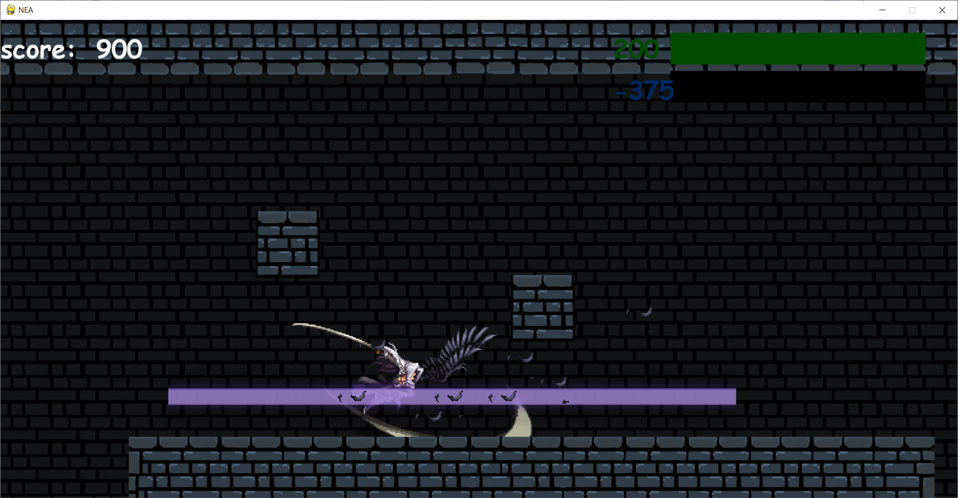

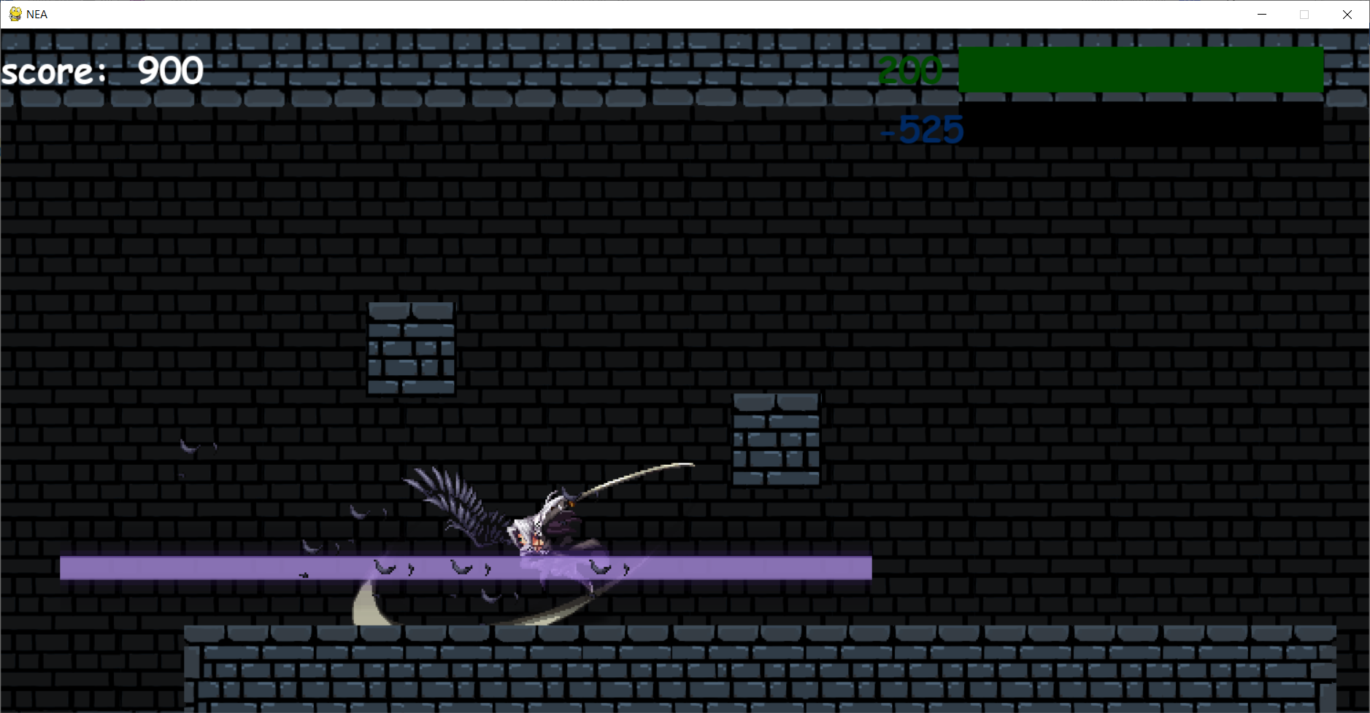

Evidence for test 23 and test 24

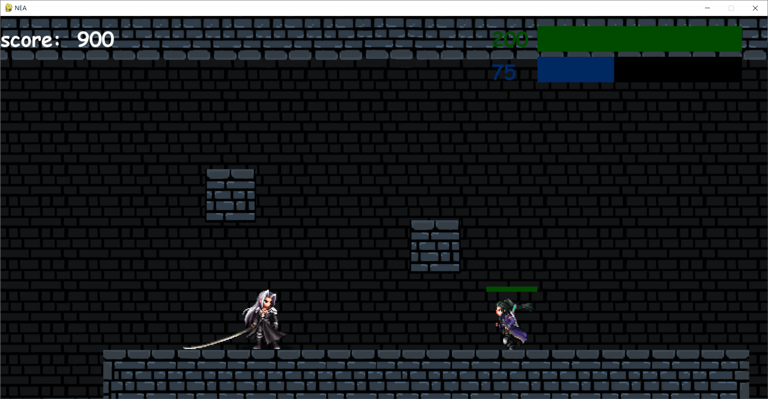

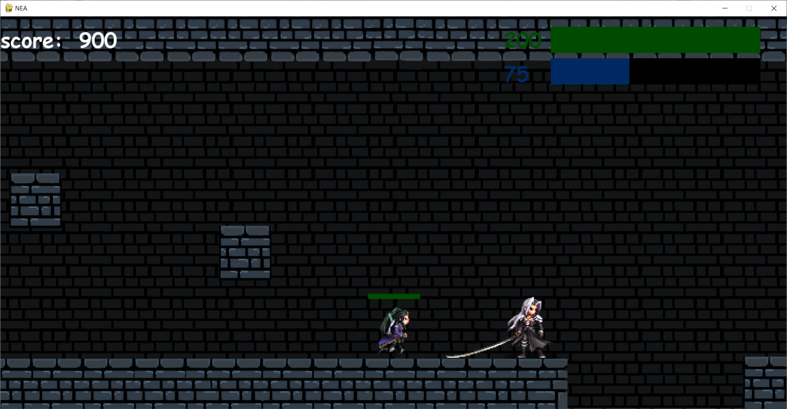

Evidence for test 25

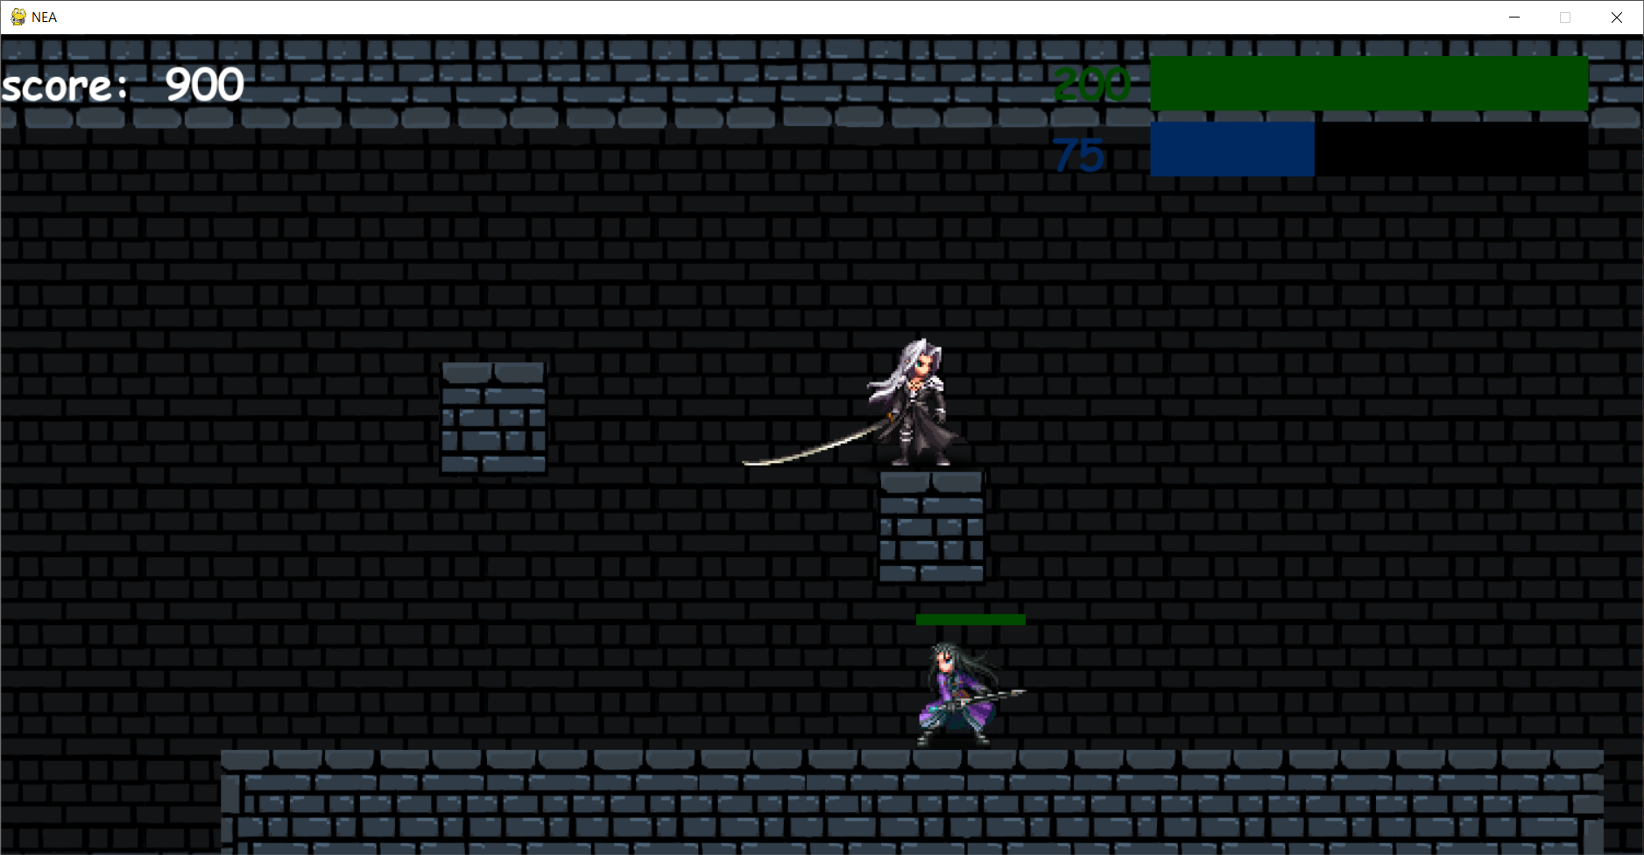

Evidence for test 26

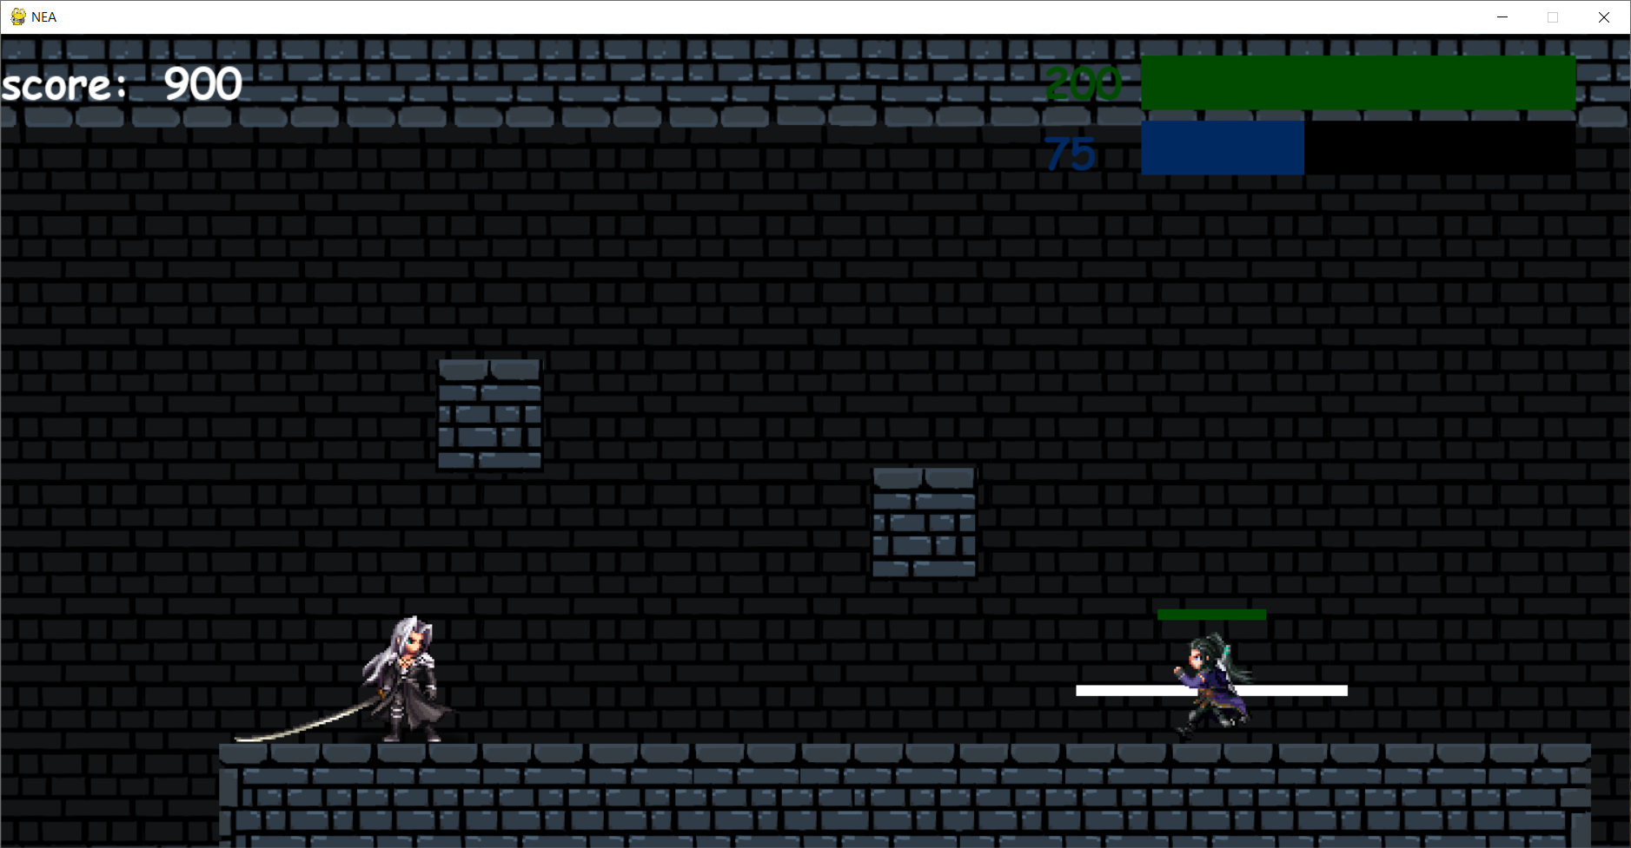

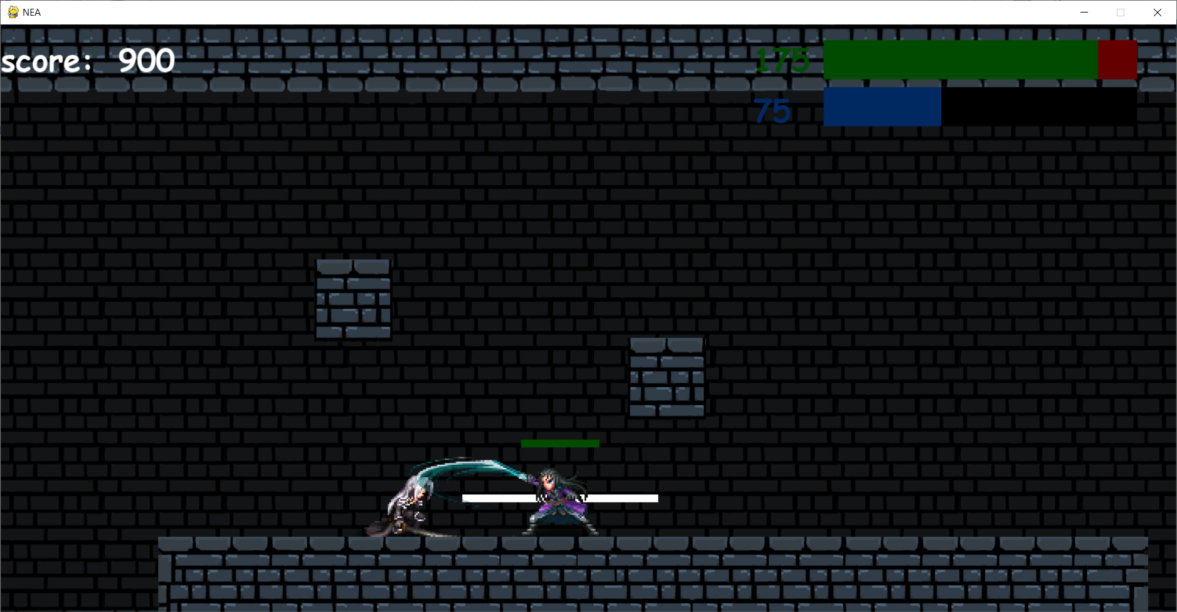

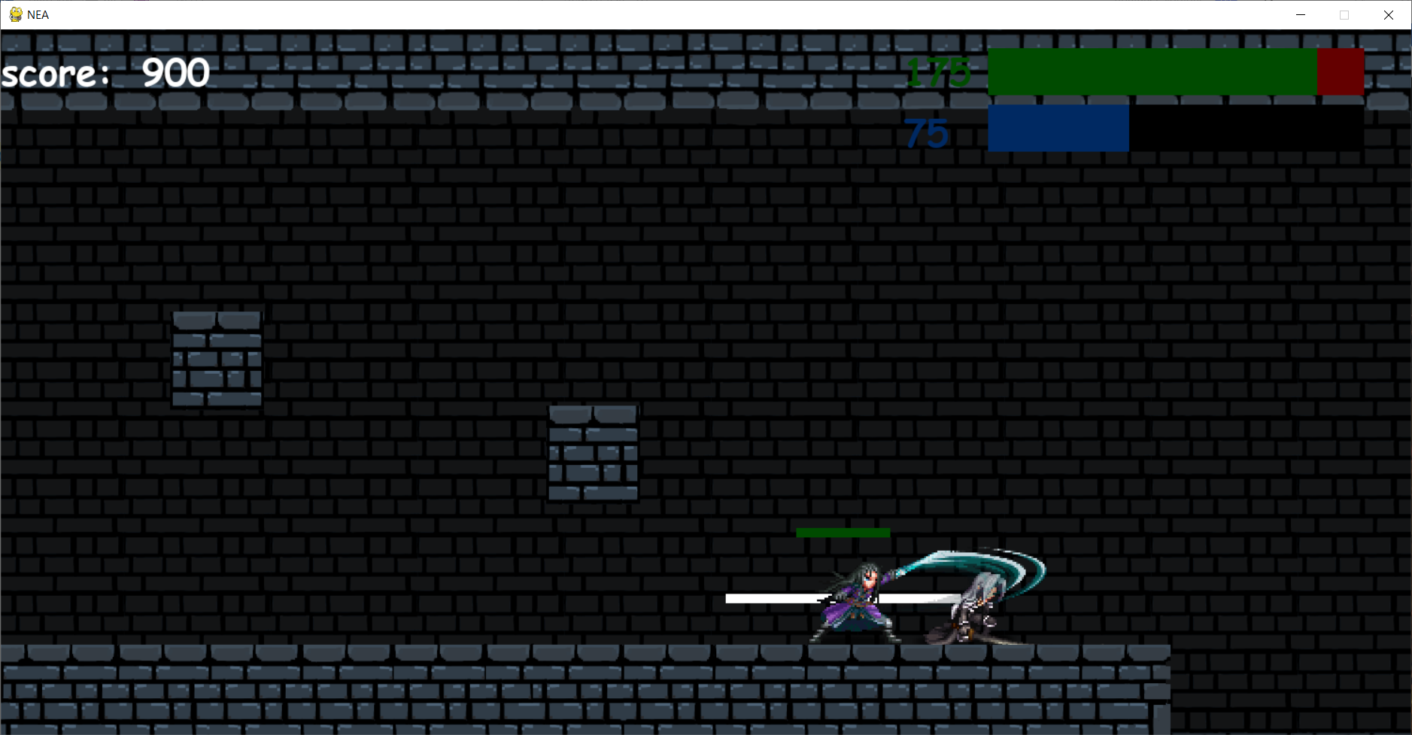

The rectangle around the enemy represents the attack range of the enemy when the user is playing it will not be shown, it is shown in the testing to show the attack range of the enemy more easily.

Evidence for test 27

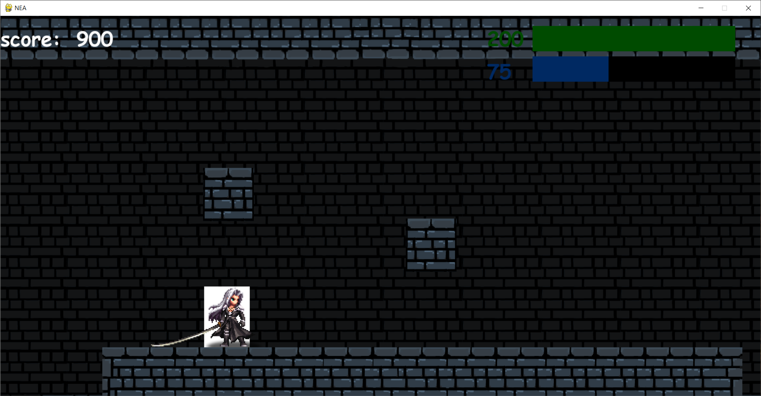

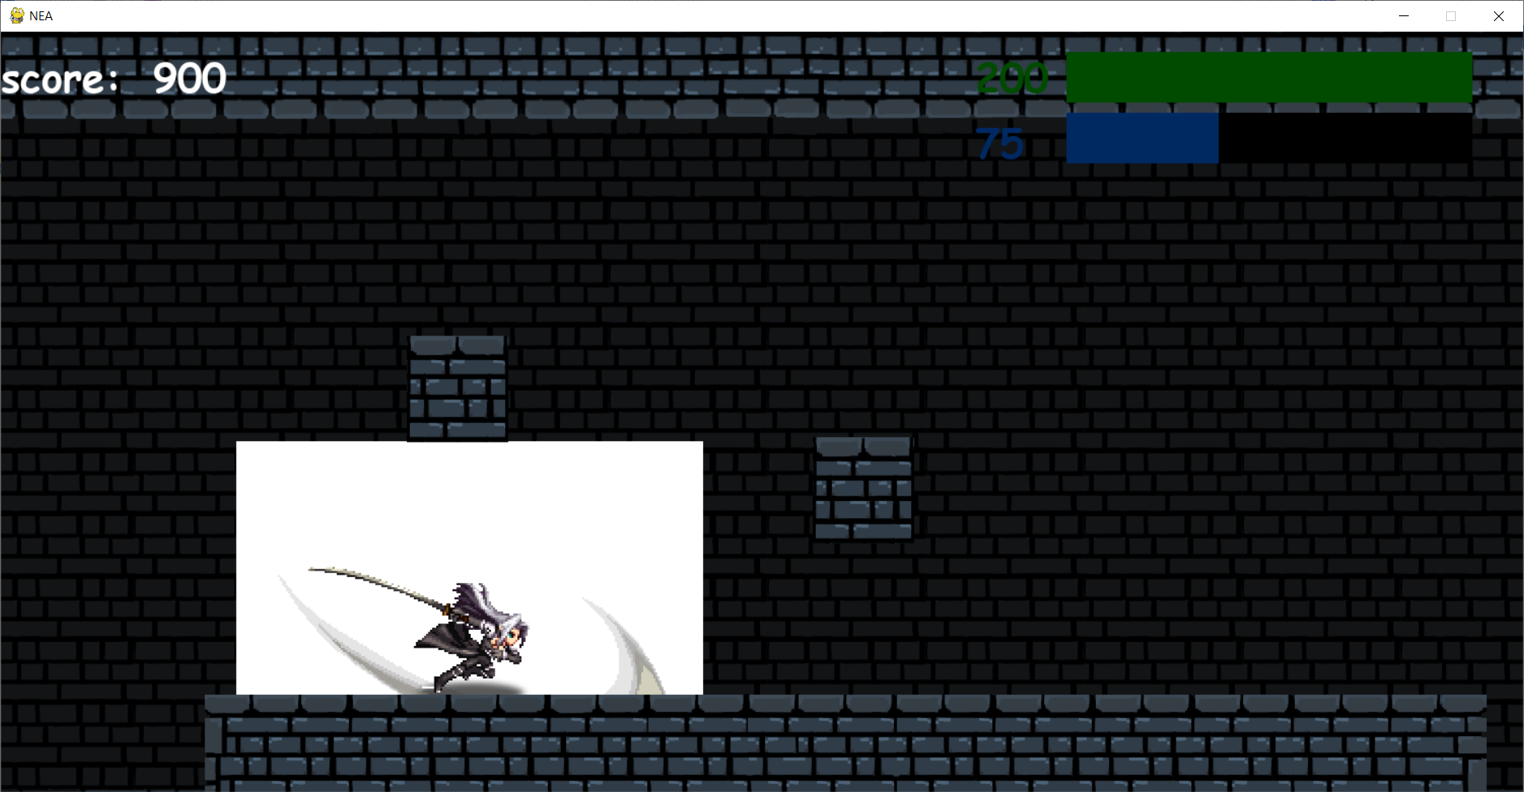

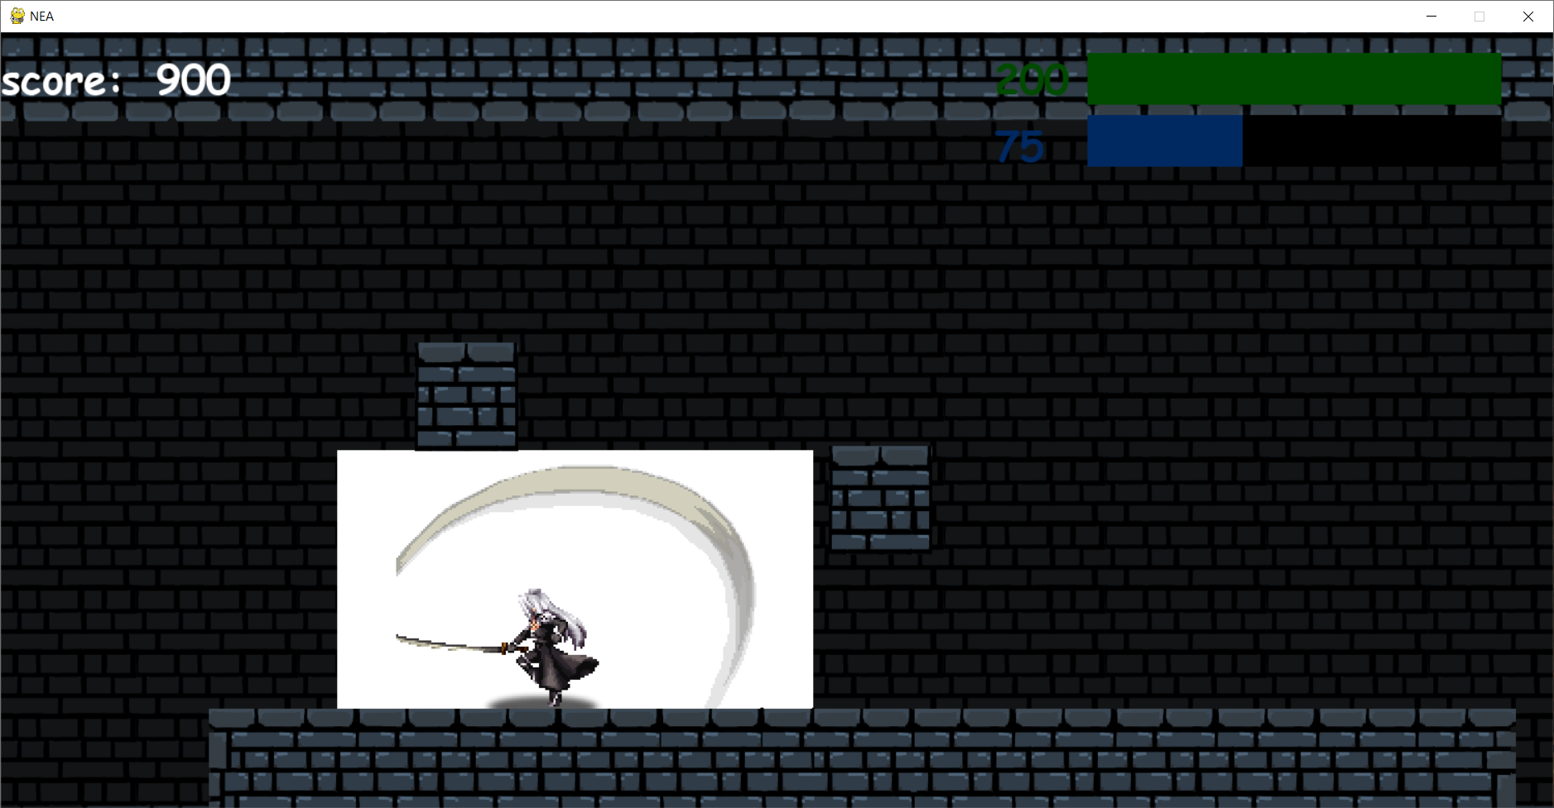

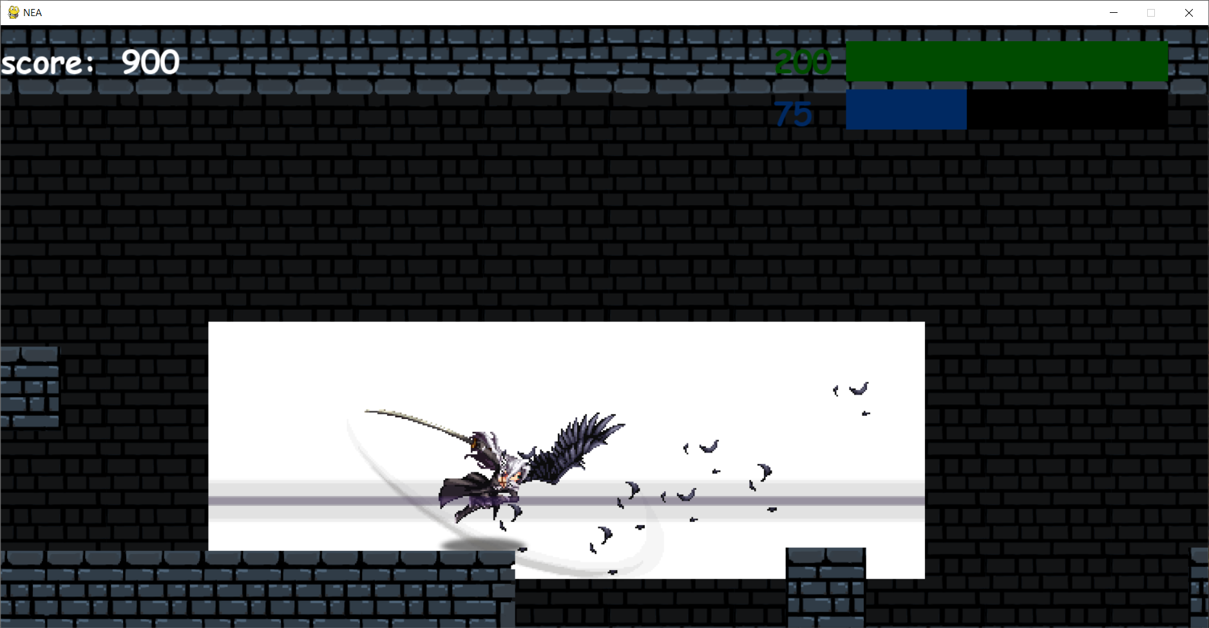

The first screenshot is the hitbox of the player when he is idle. The second screen shot is the hitbox of the player when he is performing a normal attack. The third screen shot is the hitbox of the player when he is performing a special attack. The fourth screen shot is the hitbox of the player when he is performing an ultimate attack.

Evidence for test 28

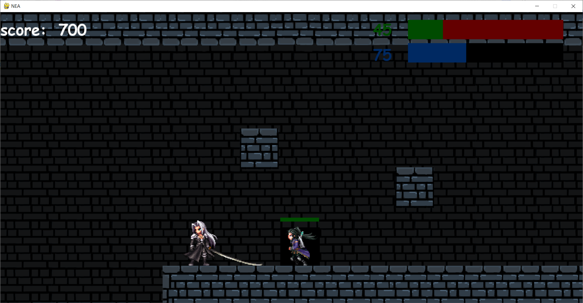

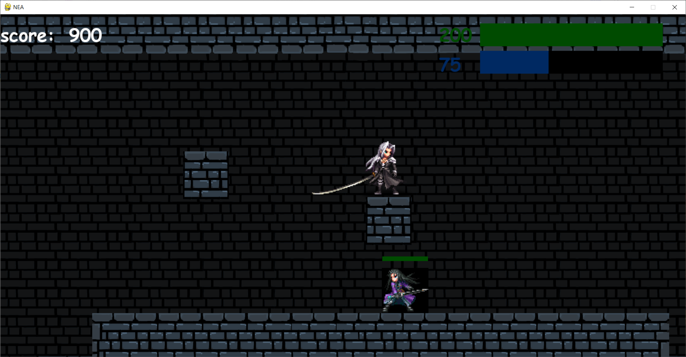

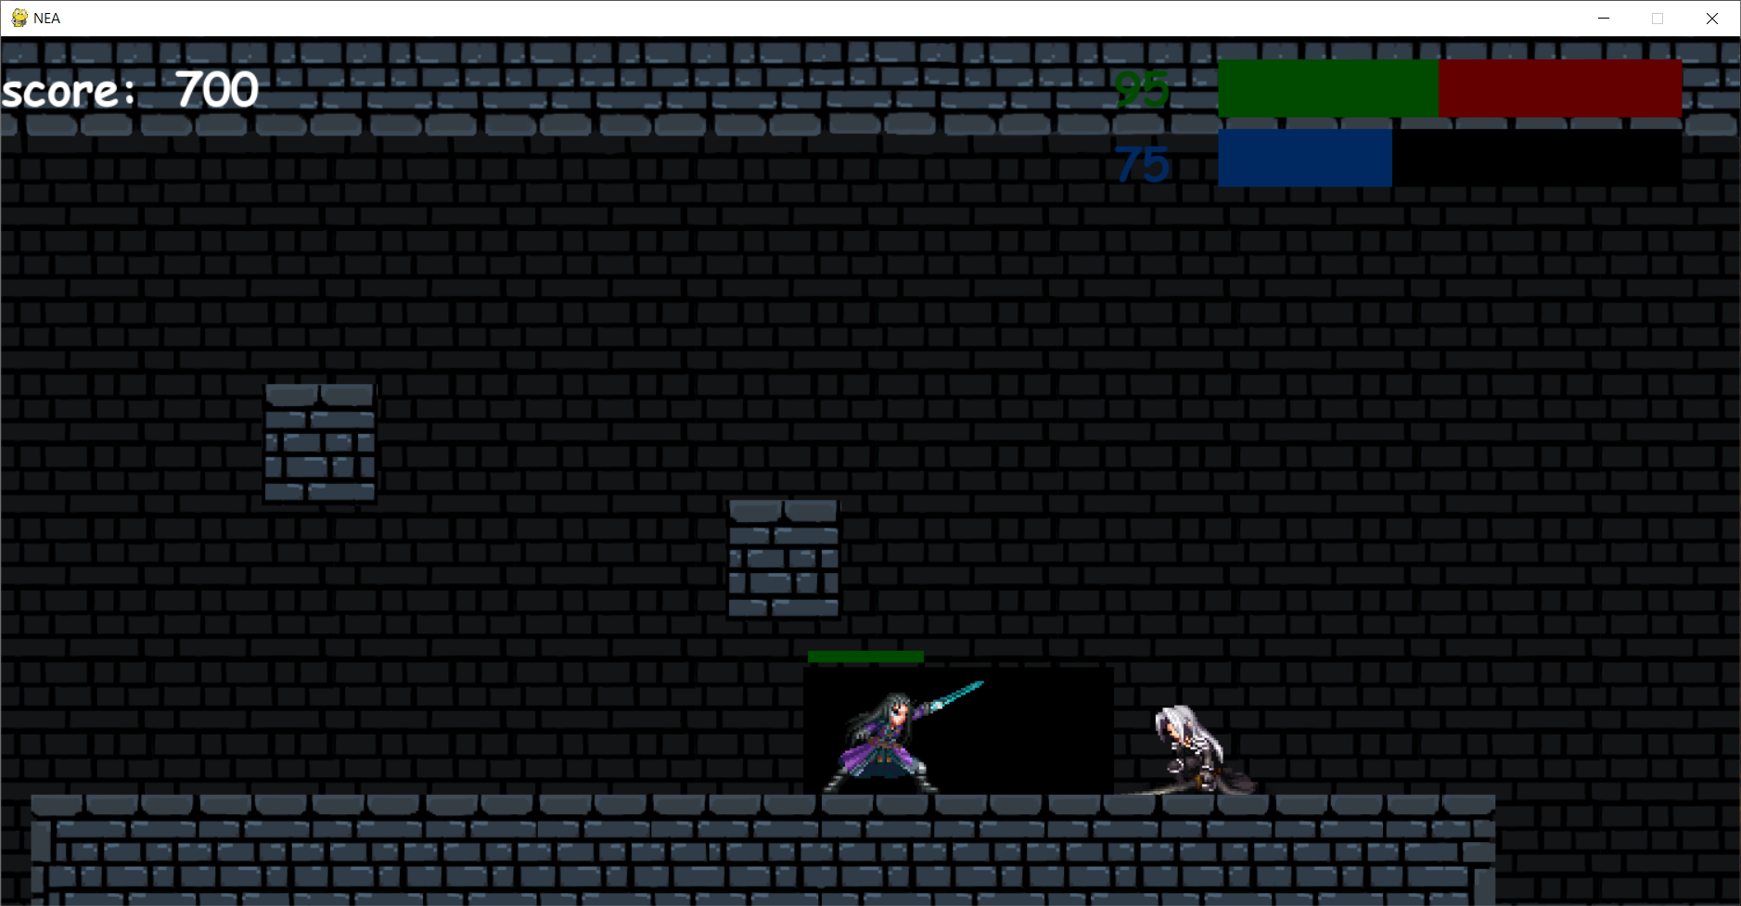

The first screen shot shows the hitbox of the enemy when he is running. The second screen shot shows the hitbox of the enemy when he is idle. The third screen shot shows the hitbox when the enemy is attacking

Evidence for test 29

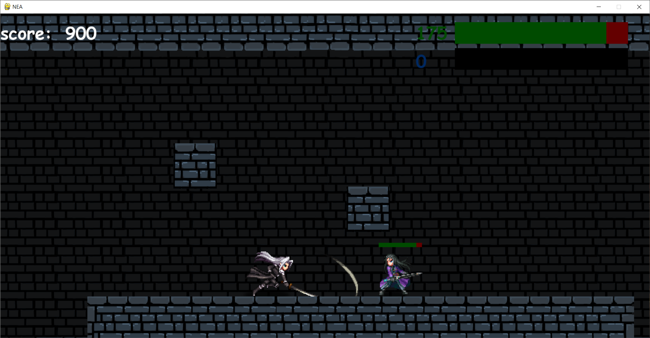

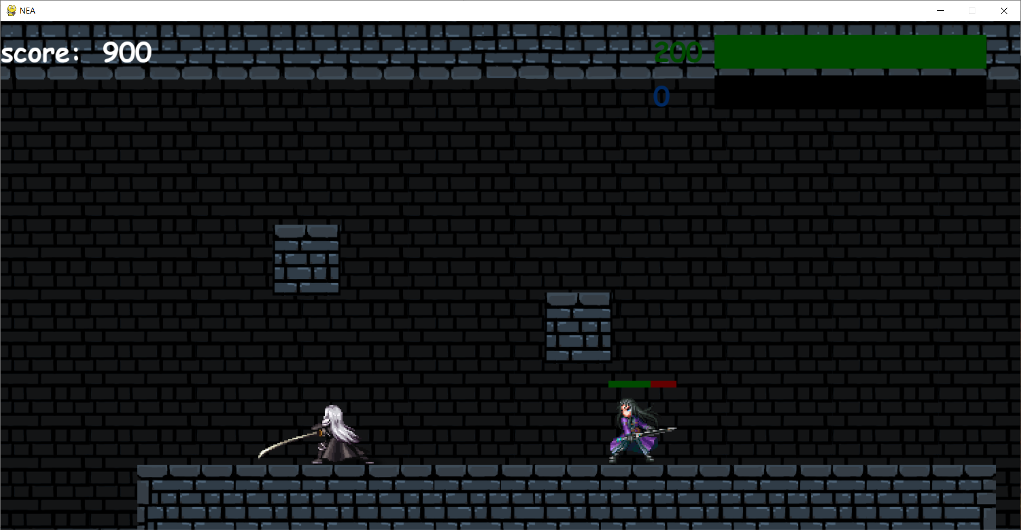

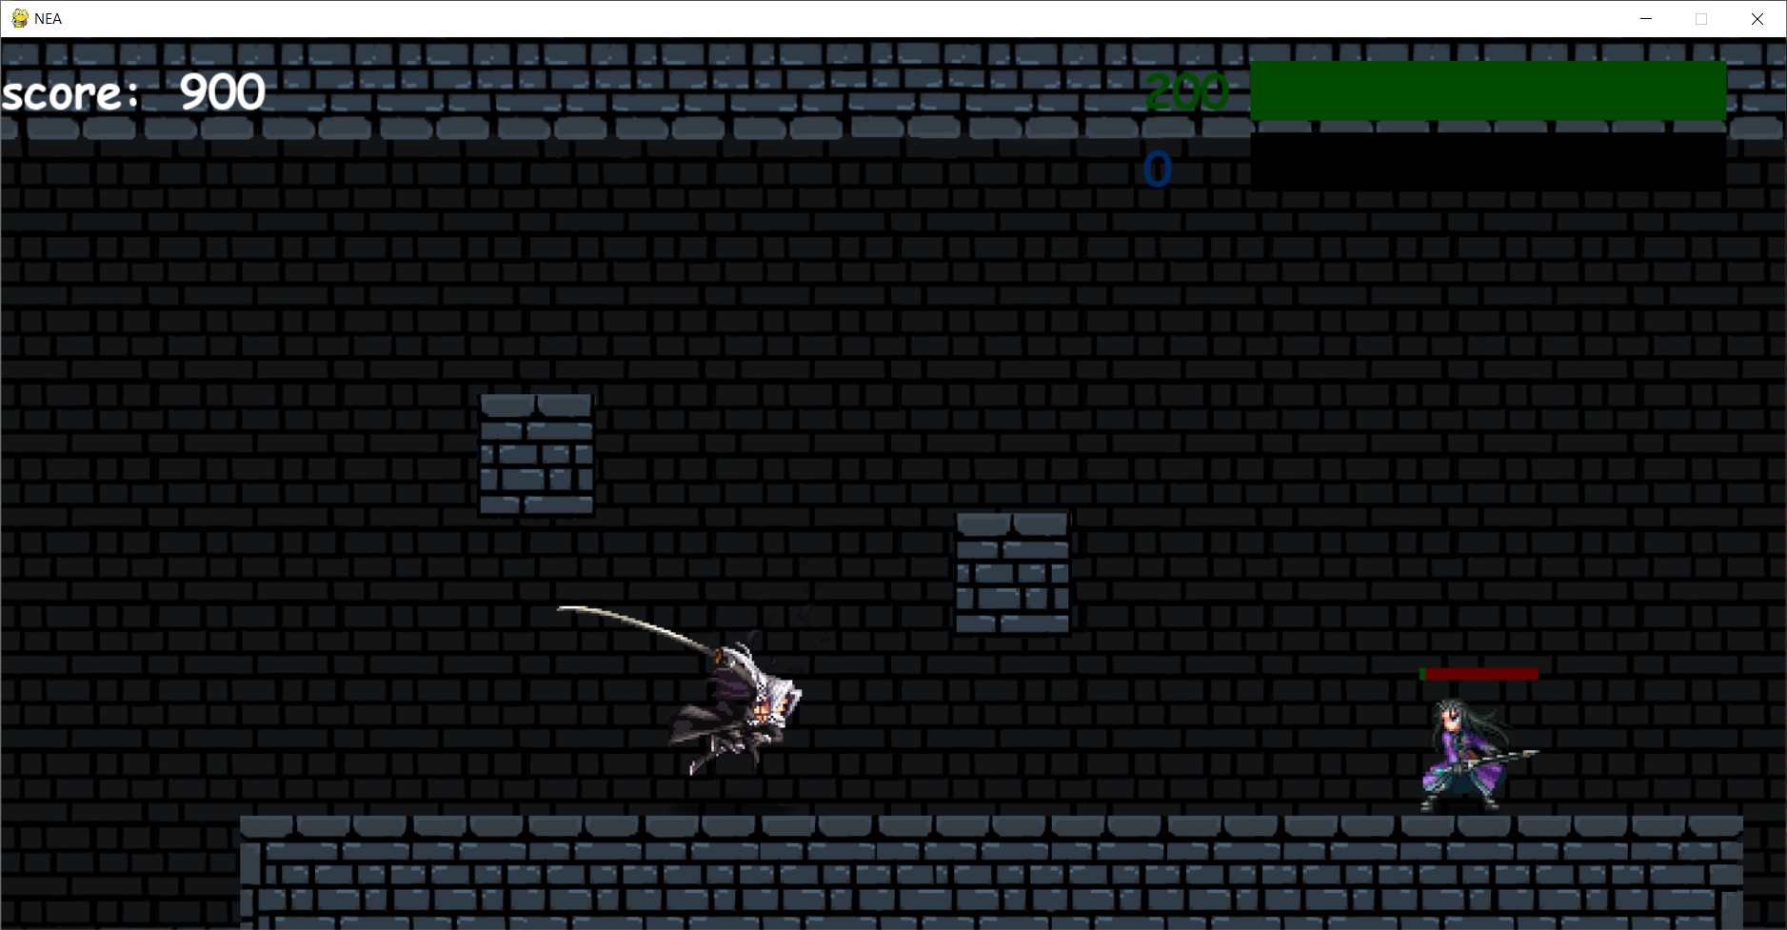

The first screen shot is the player doing a normal attack and is showing how much damage he has dealt using a normal attack which is 25 damage. The second screen shot is the player doing a special attack and is showing how much damage he has dealt using a special attack which is 75 damage. The third screen shot is the player doing an ultimate attack and is showing how much damage he has dealt using an ultimate attack which is 200 damage. In the actual game enemy will have 200 hp but I gave him 210 hp to demonstrate the enemy losing 200 hp from an ultimate attack.

Evidence for test 30

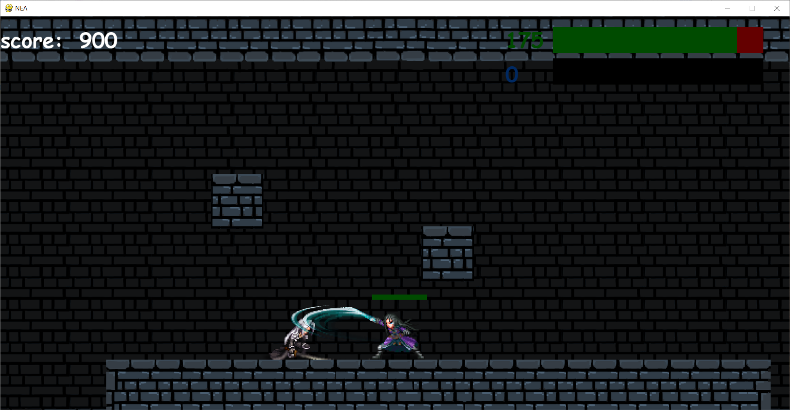 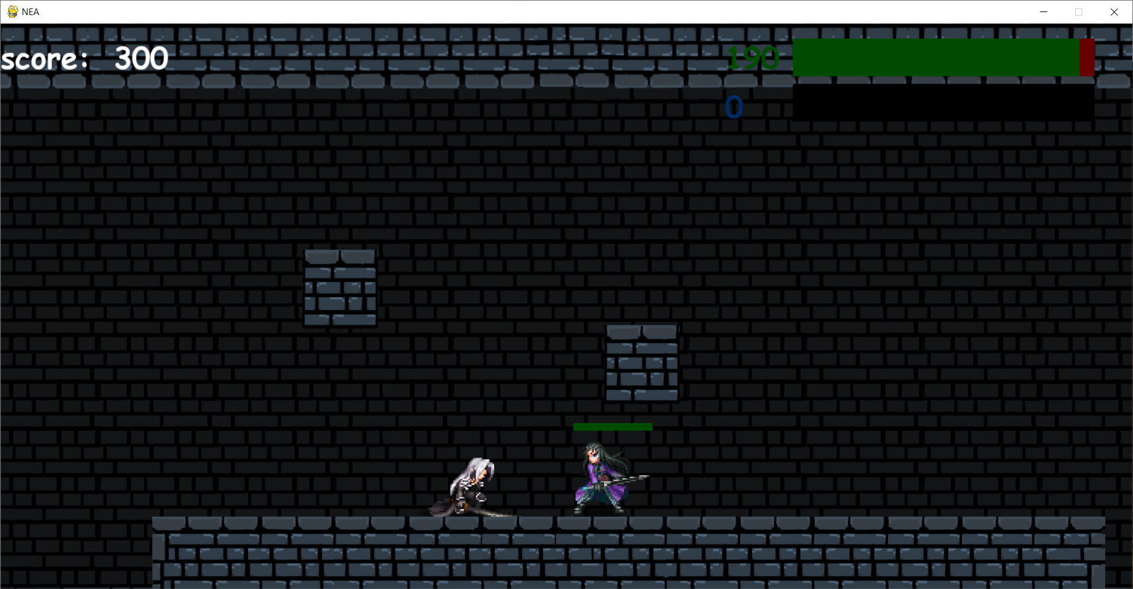

the first screen shot shows the enemy attacking and dealing 25 damage to the player the second screen shot is from the player running into the enemy and has been dealt 10 damage.

Evidence for test 31

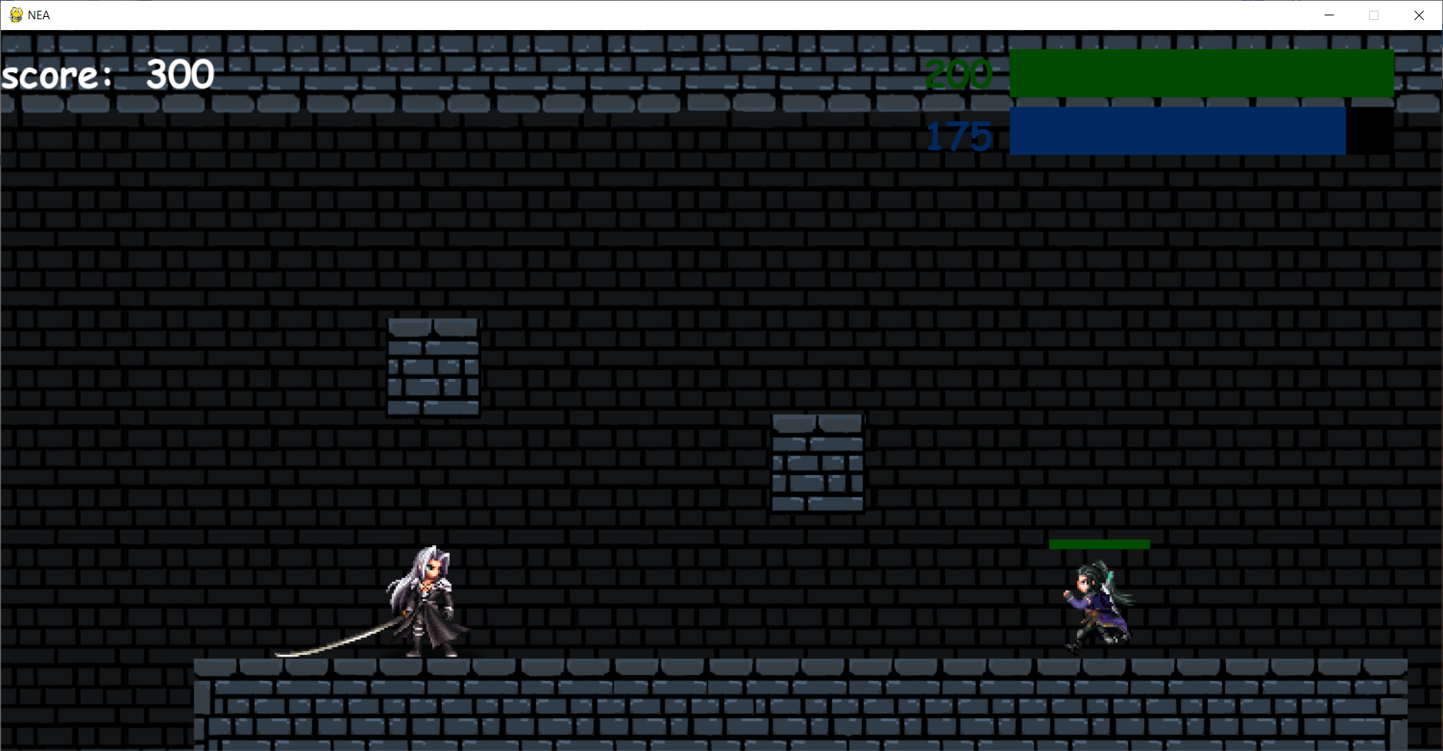

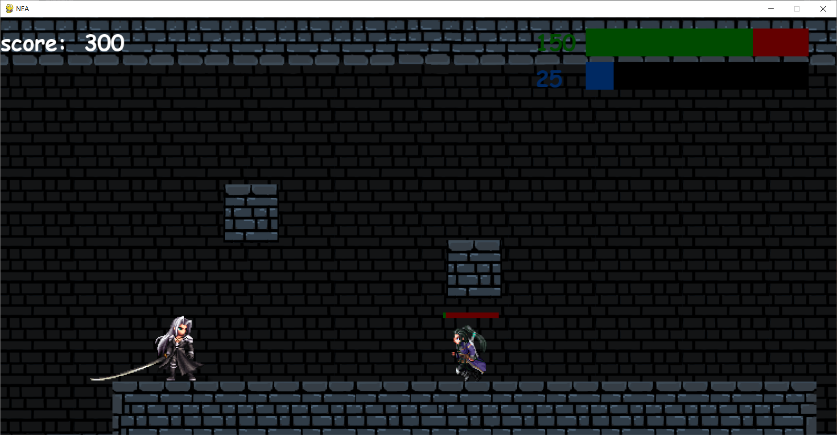

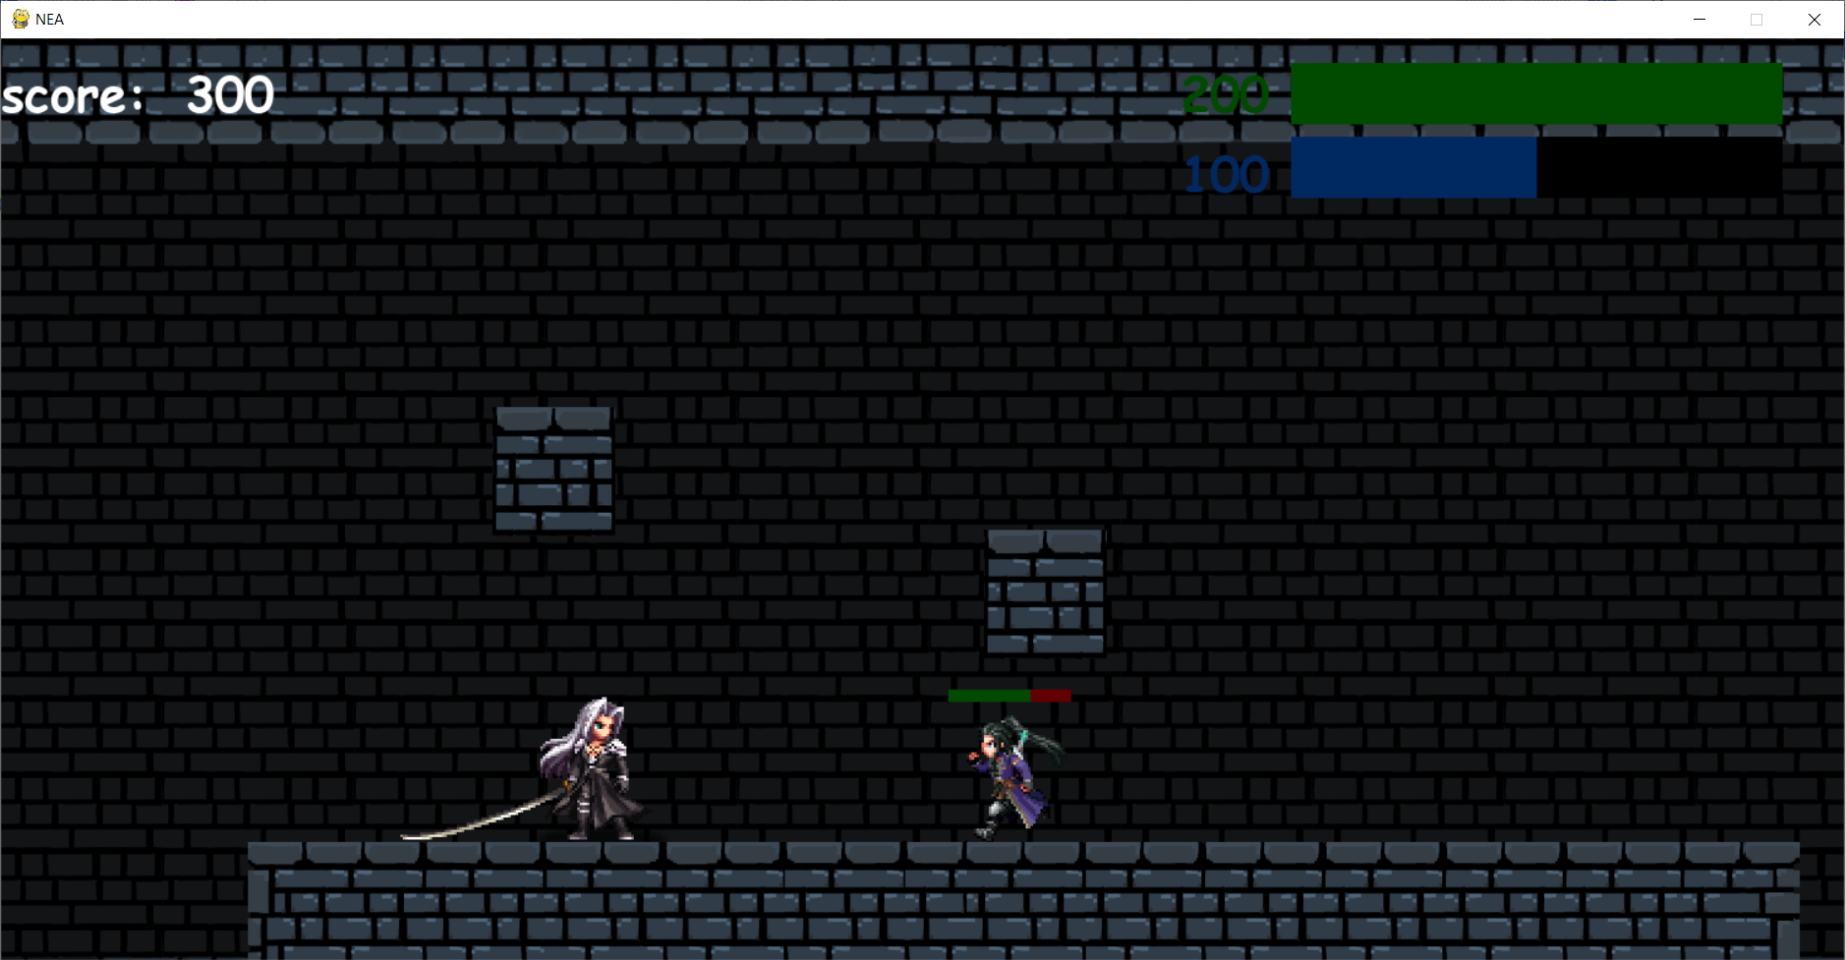

The first screen shot is when the player has 175 energy. The second screen shot shows how much energy is left after using an ultimate attack, an ultimate attack will use up 150 energy. The third screen shot shows how much energy is left after using a special attack, a special attack will use up 75 energy.

Evidence for test 32

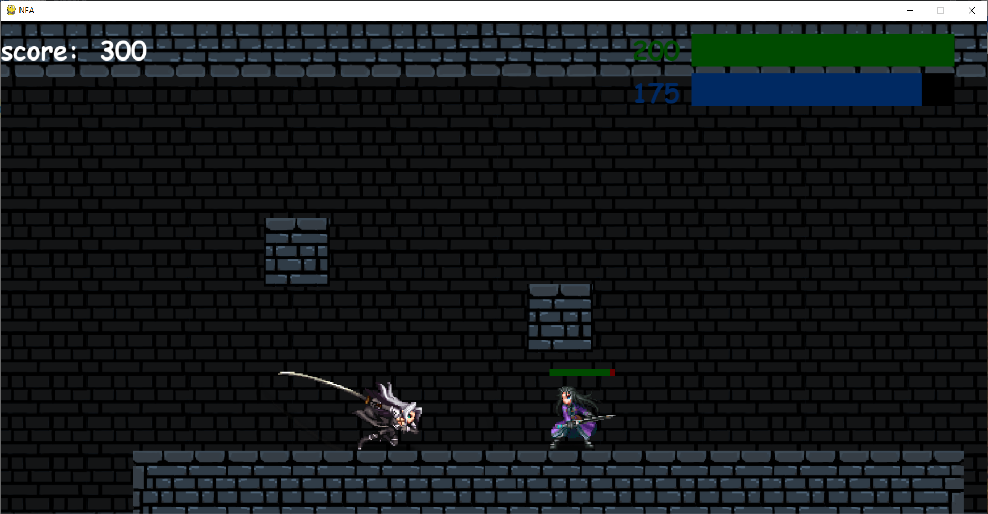

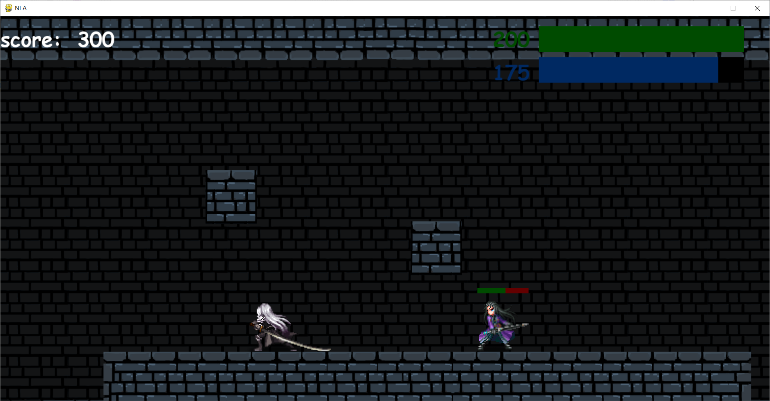

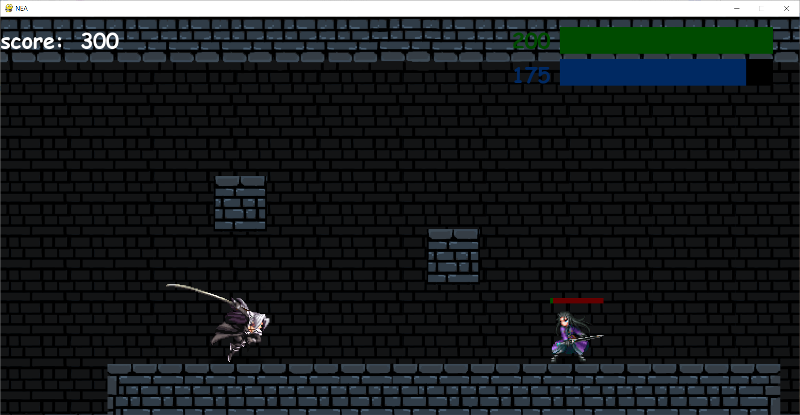

The first screen shot shows how far the enemy is knocked back by a normal attack. The second screen shot shows how far the enemy is knocked back by a special attack. The third screen shot shows how far the enemy is knocked back by an ultimate attack.

Evidence for test 33

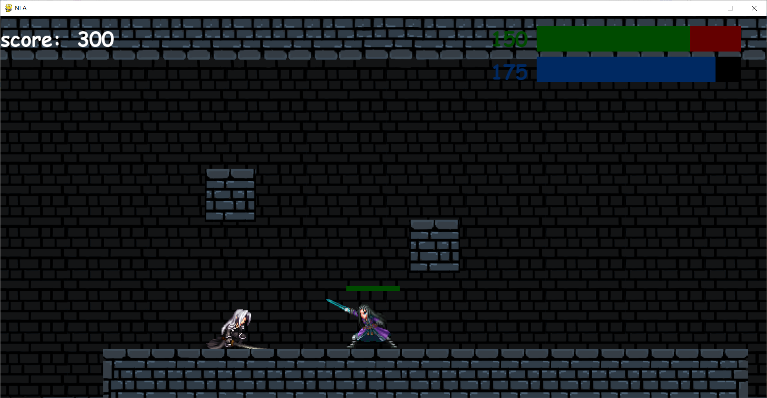

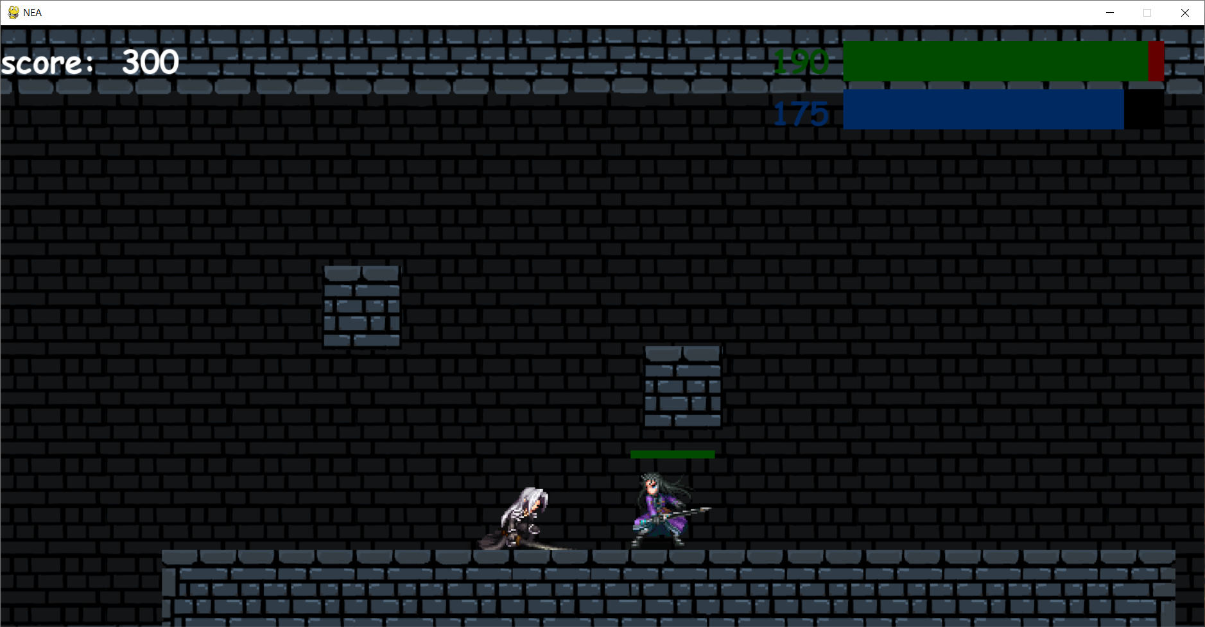

The first screen shot shows how far back the player is knocked back from the enemy attacking. The second screen shot shows how far back the player is knocked back from running into the enemy

Evidence for test 34

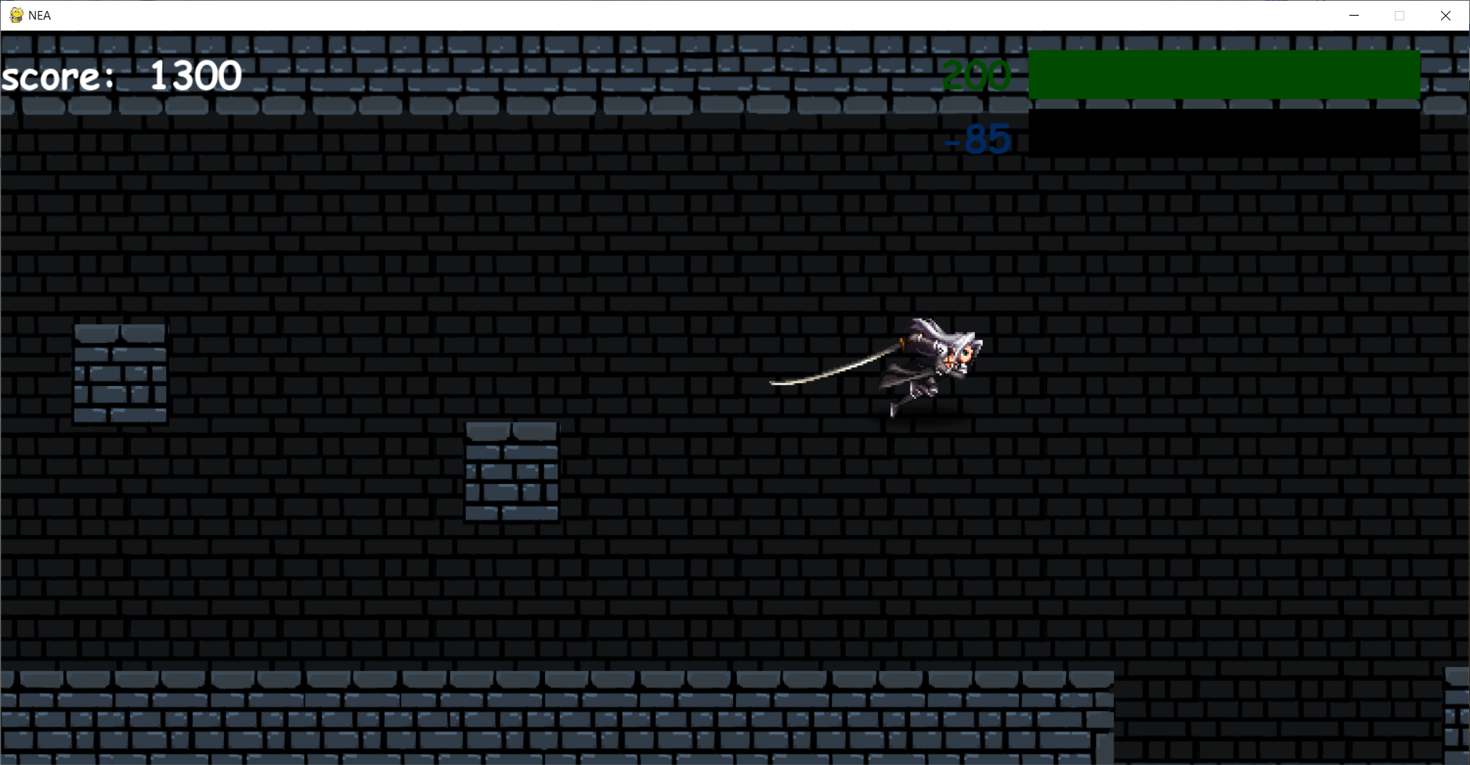

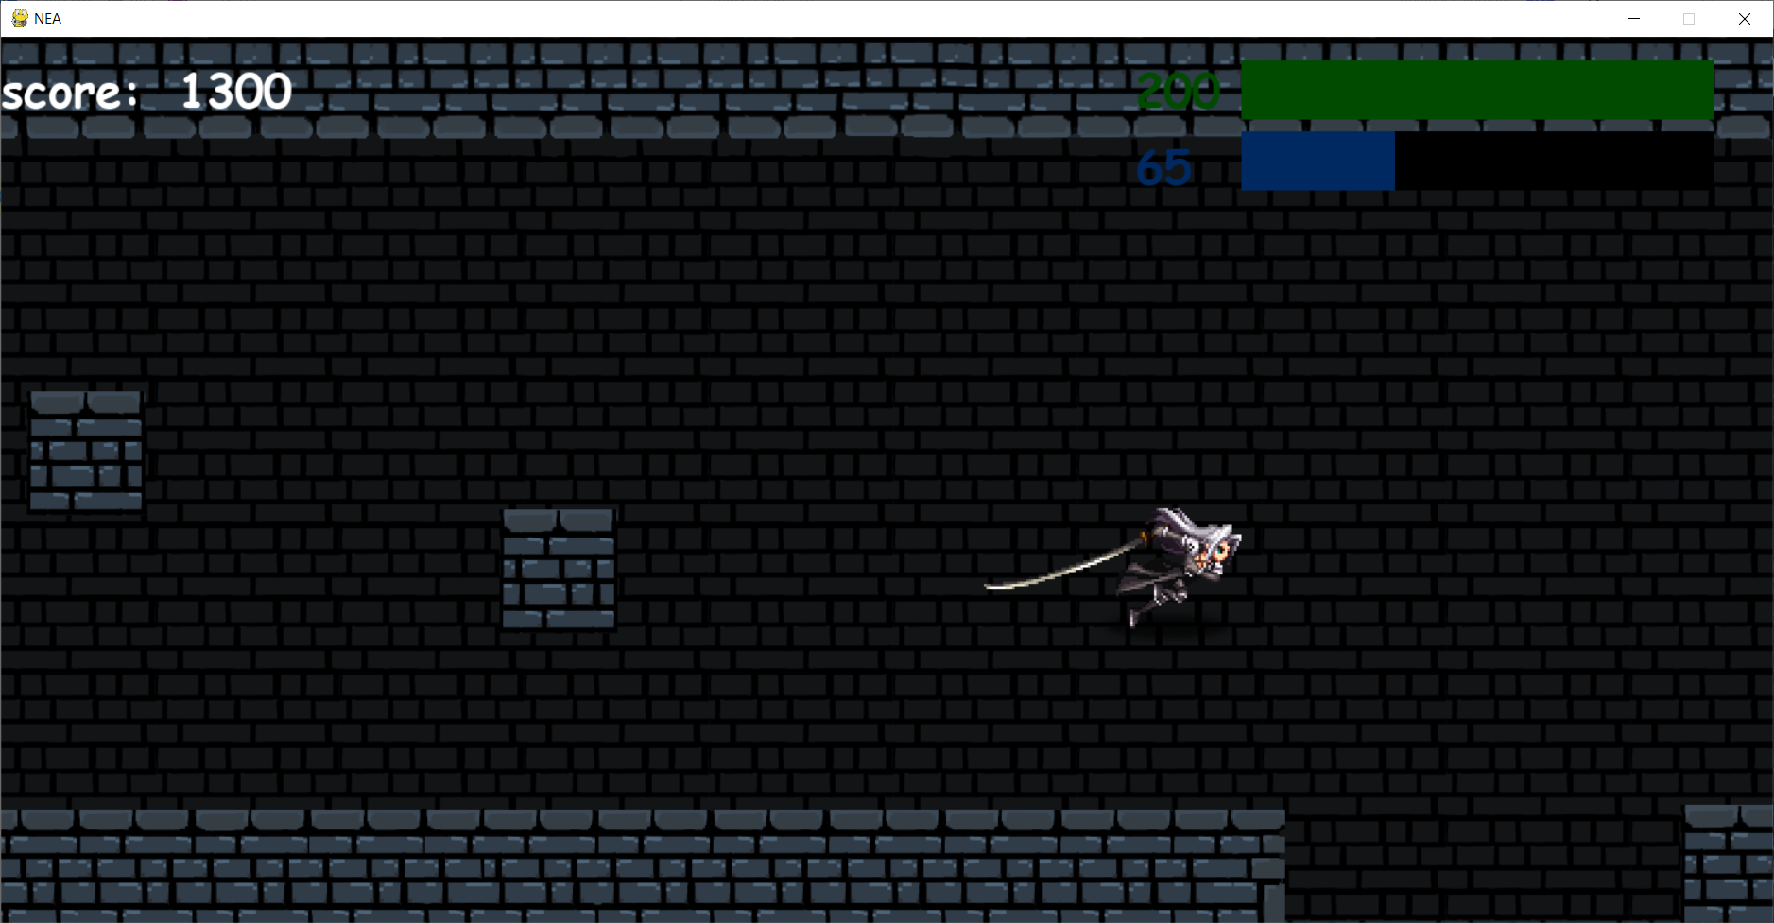

The first screen shot shows how high the player will jump and the second screen shot shows that after the player reaches the max jump height he will fall back down.

Evidence for test 35

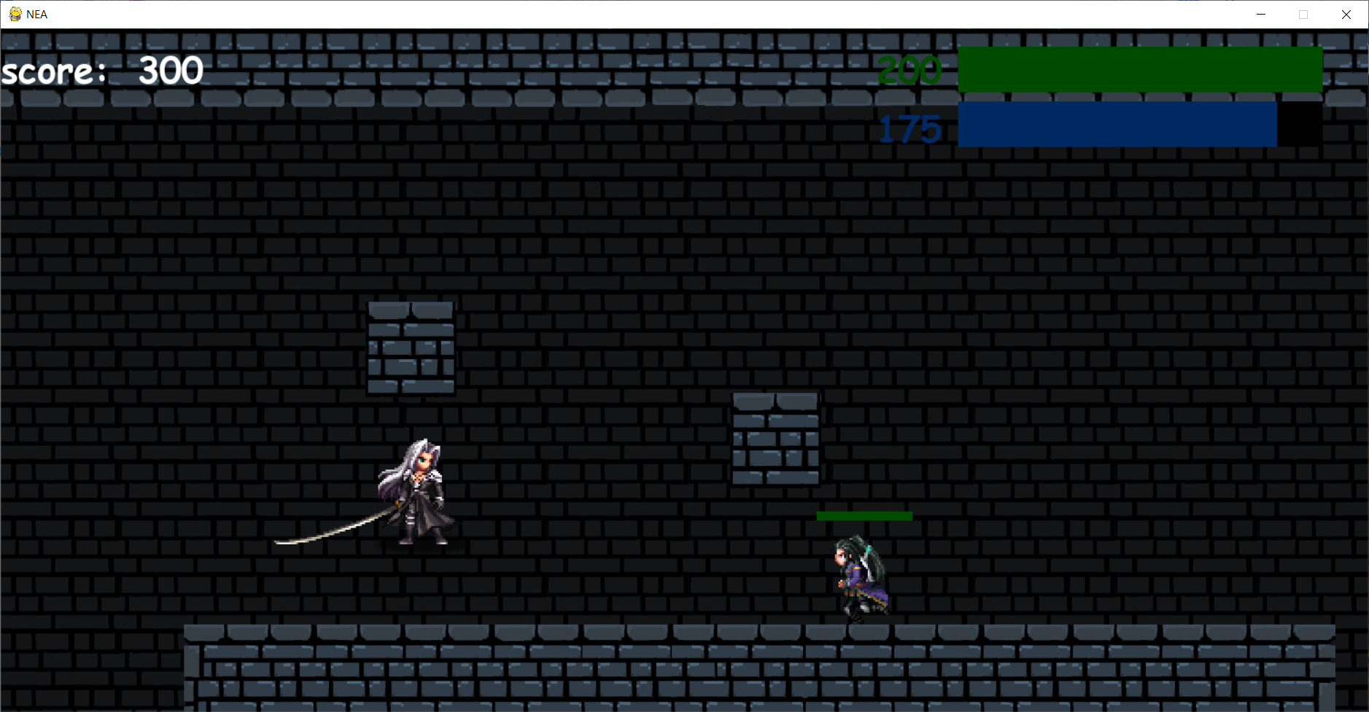

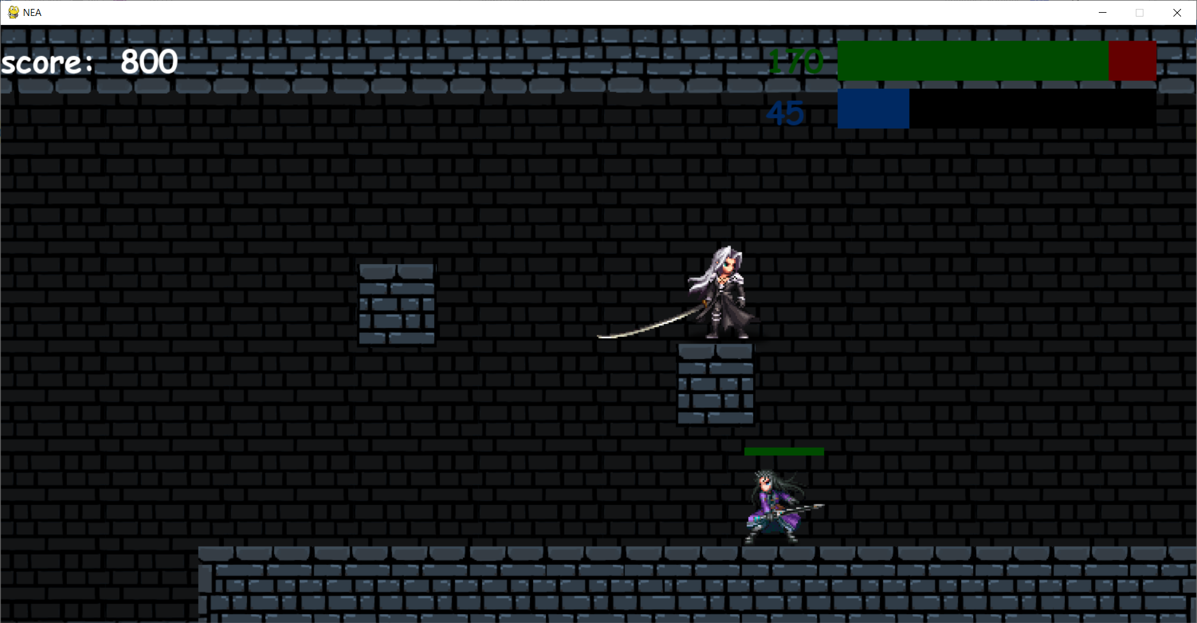

The first screen shot shows that once the players head has hit the platform he will fall back down, and the second screen shot shows that the player is able to stand on the platform.

Evidence for test 36

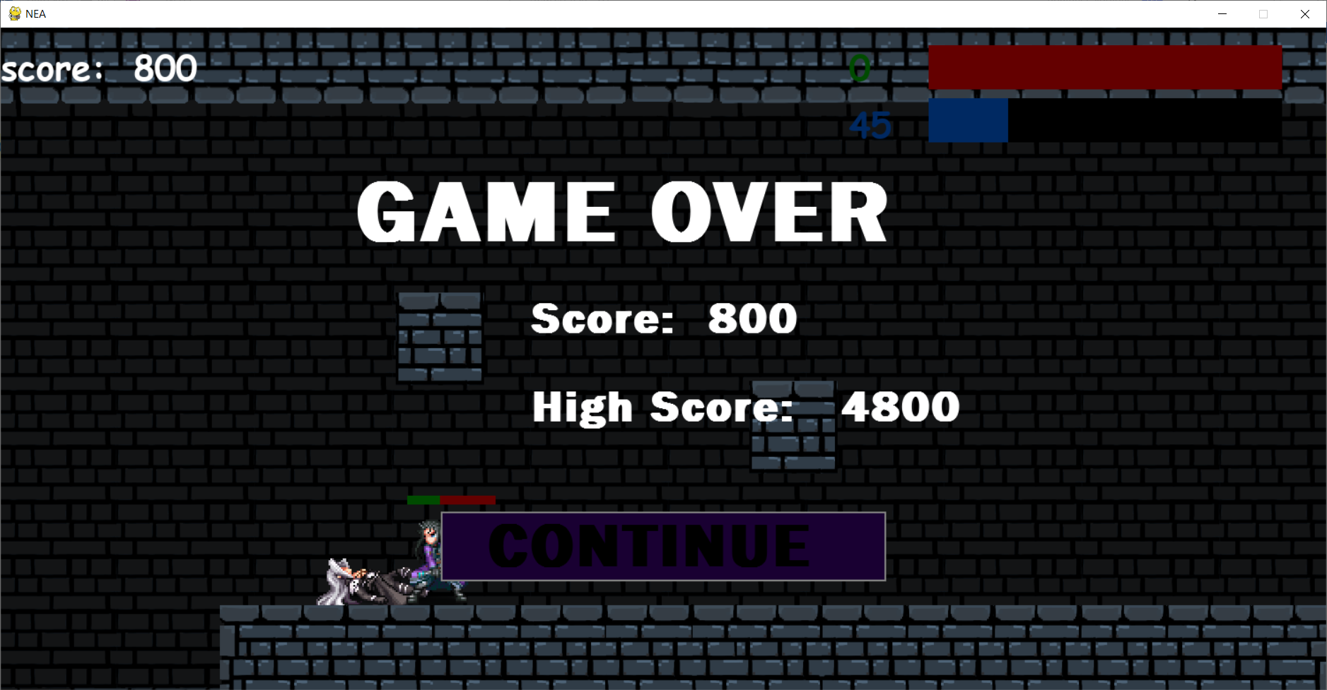

Evidence for test 37

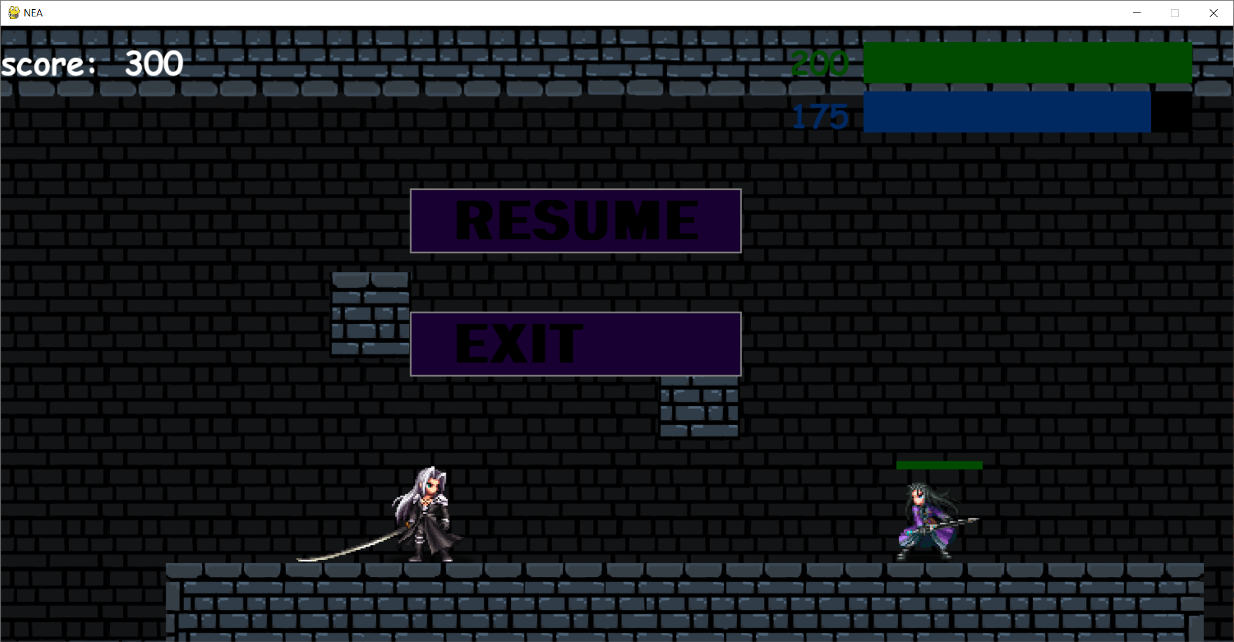

Evidence for test 38

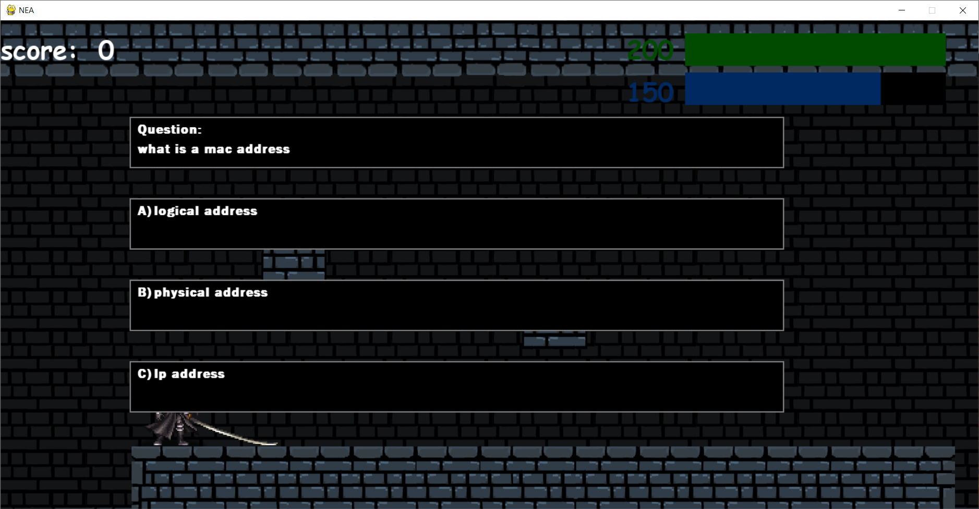

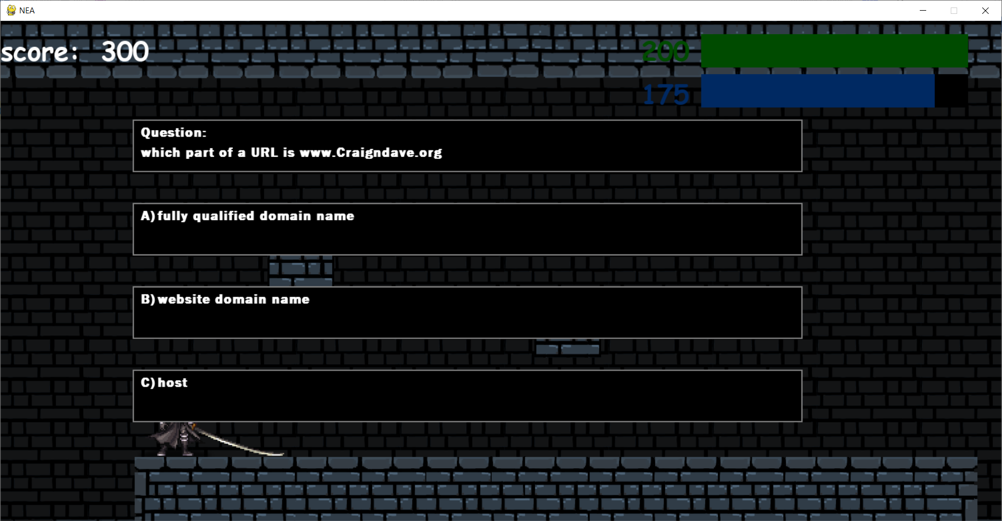

Evidence for test 39

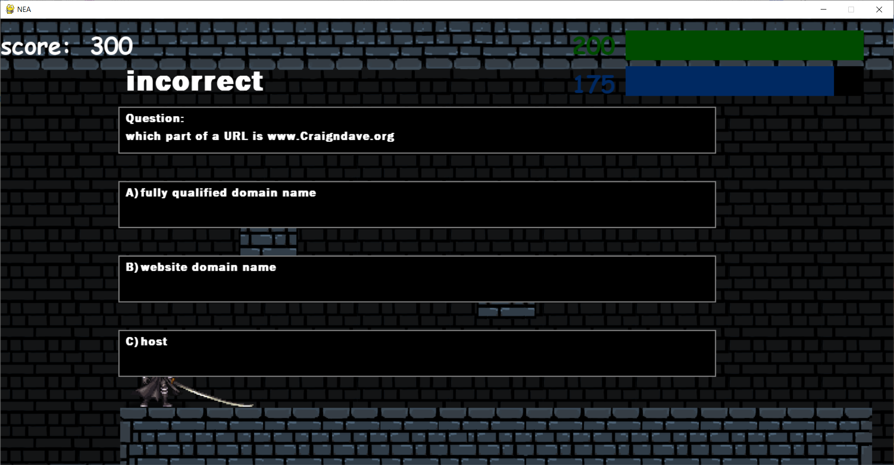

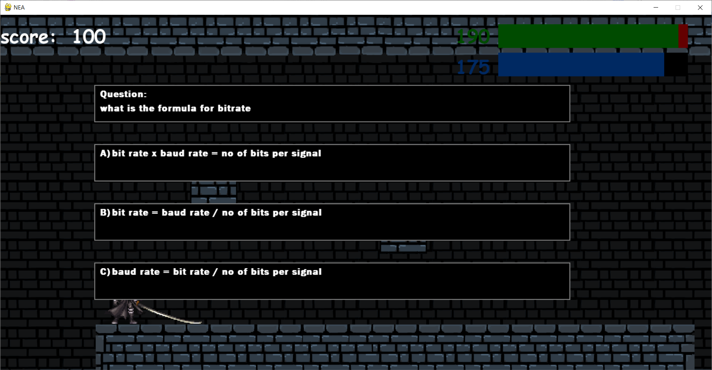

The first screen shot shows that when the wrong answer is chosen a message that tells the user they are incorrect is shown. The second screen shot shows that after the user had gotten the question wrong their score and hp decreased.

Evidence for test 40

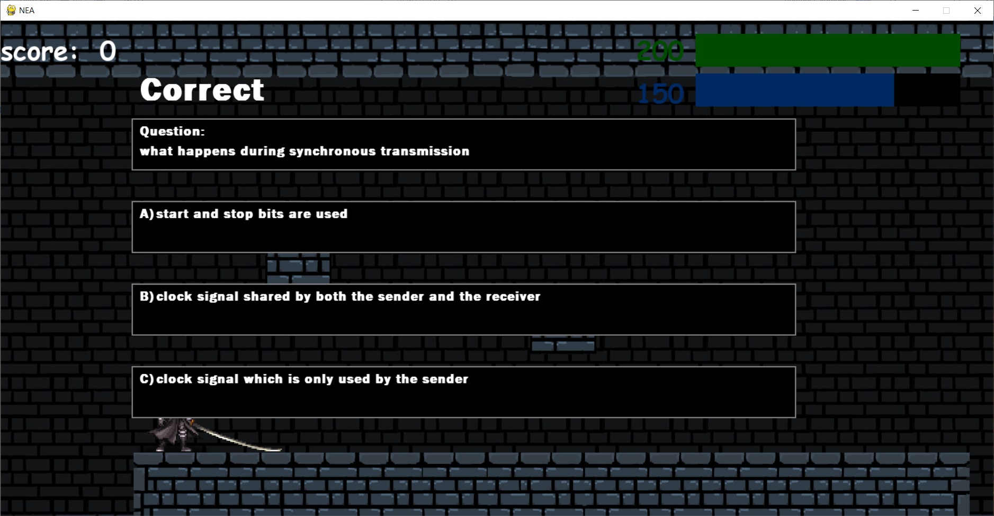

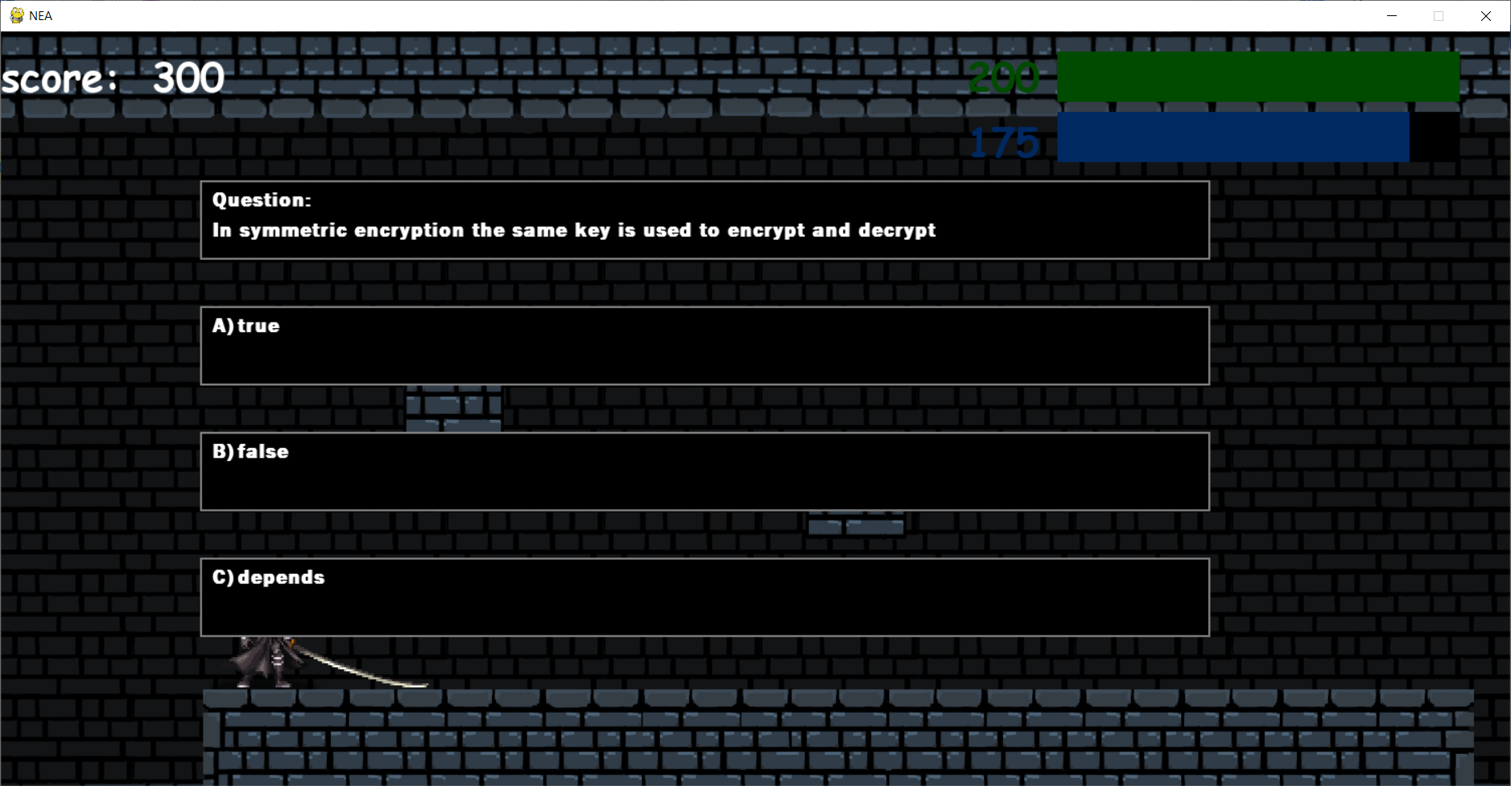

The first screen shot shows that when the correct answer is chosen a message that tells the user they are correct is shown. The second screen shot shows that after the user had gotten the question wrong their score and energy increased.

Evidence for test 41

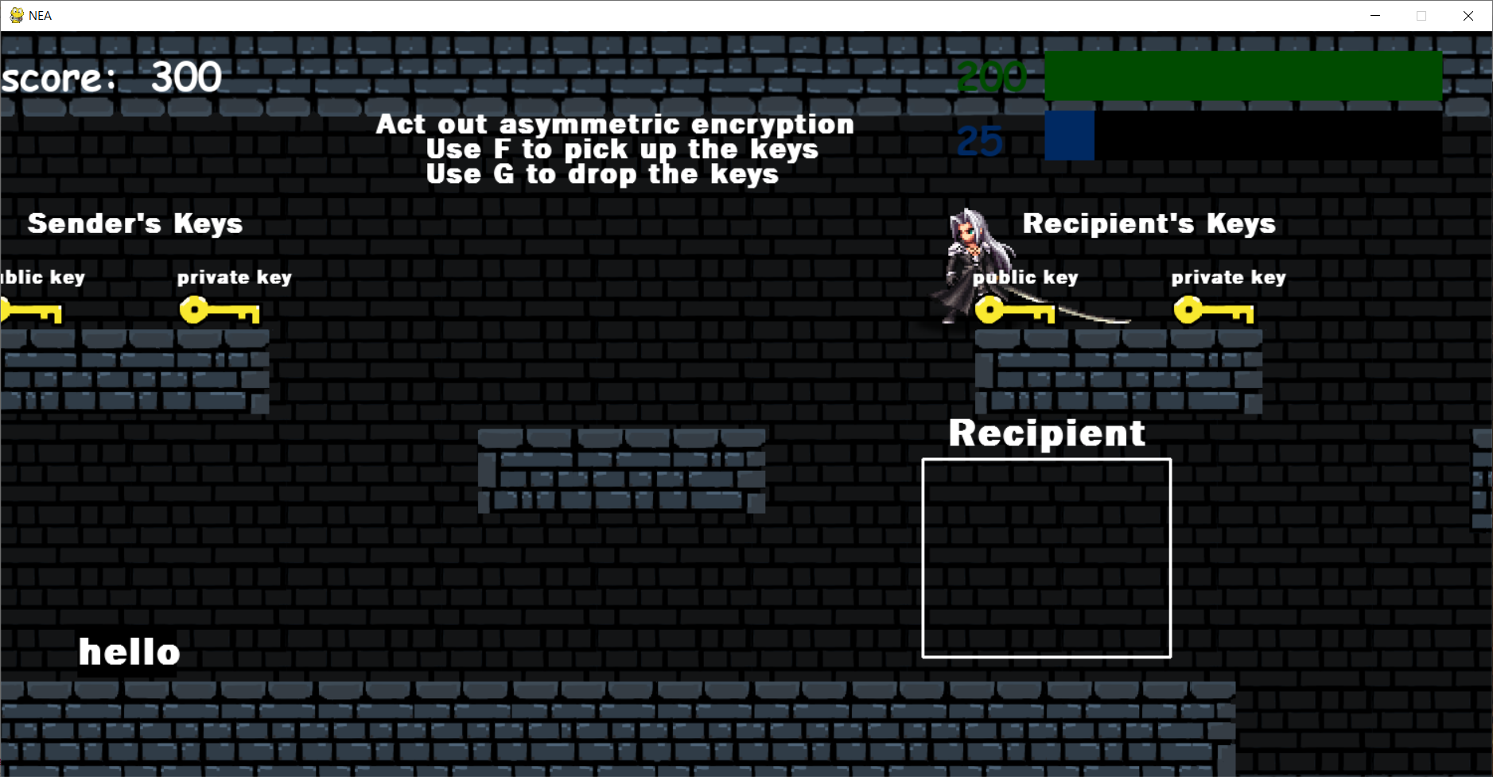

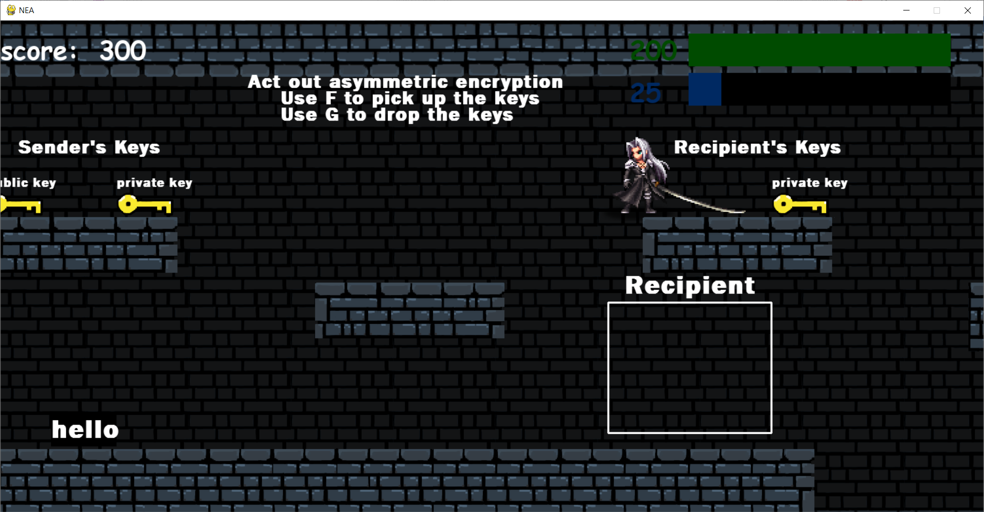

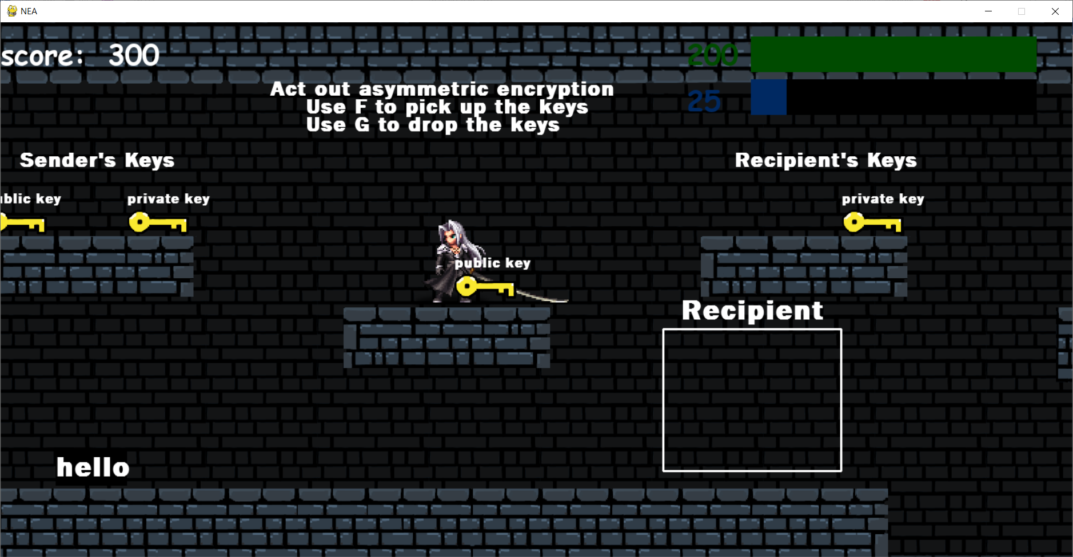

The second screen shot shows that the key has been picked up and the third screen shot shows that the key has now been dropped where the player is

Evidence for test 42

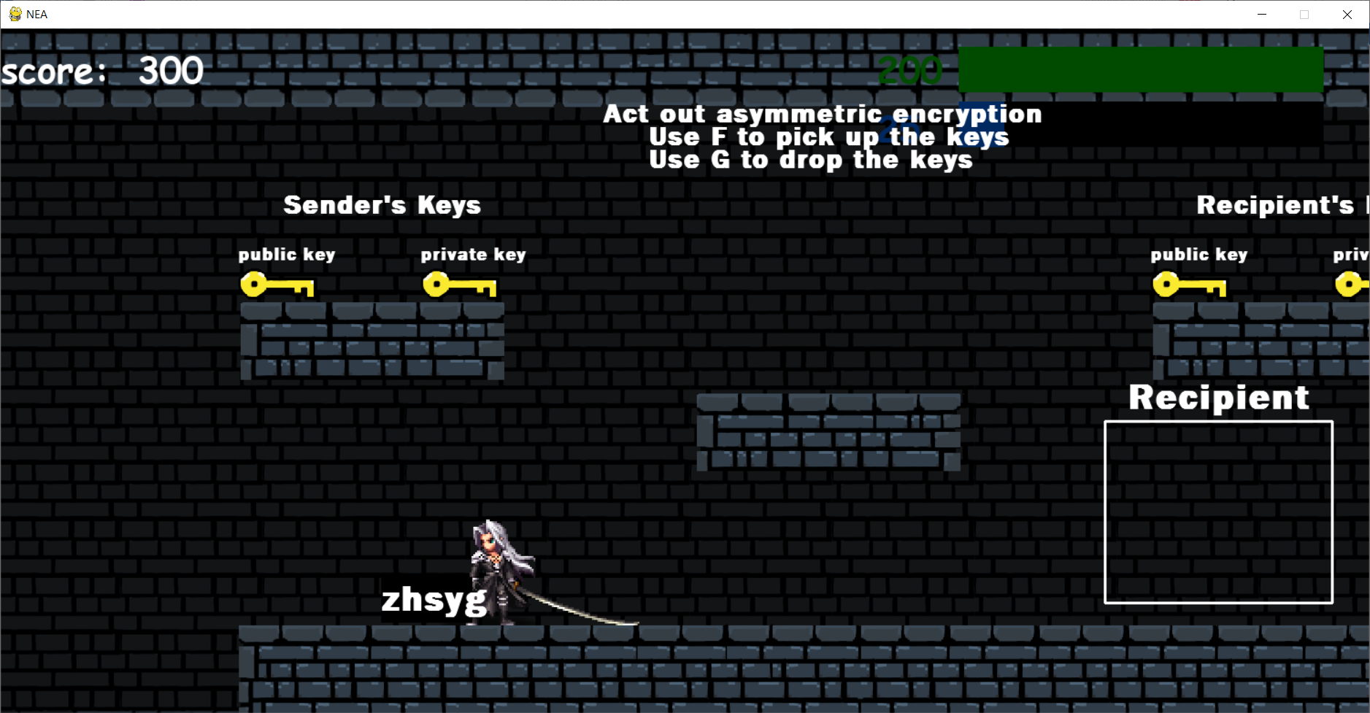

The recipient’s public key was dropped on the message and now the message has become encrypted, and the recipient’s public key is now in its original spot

Evidence for test 43

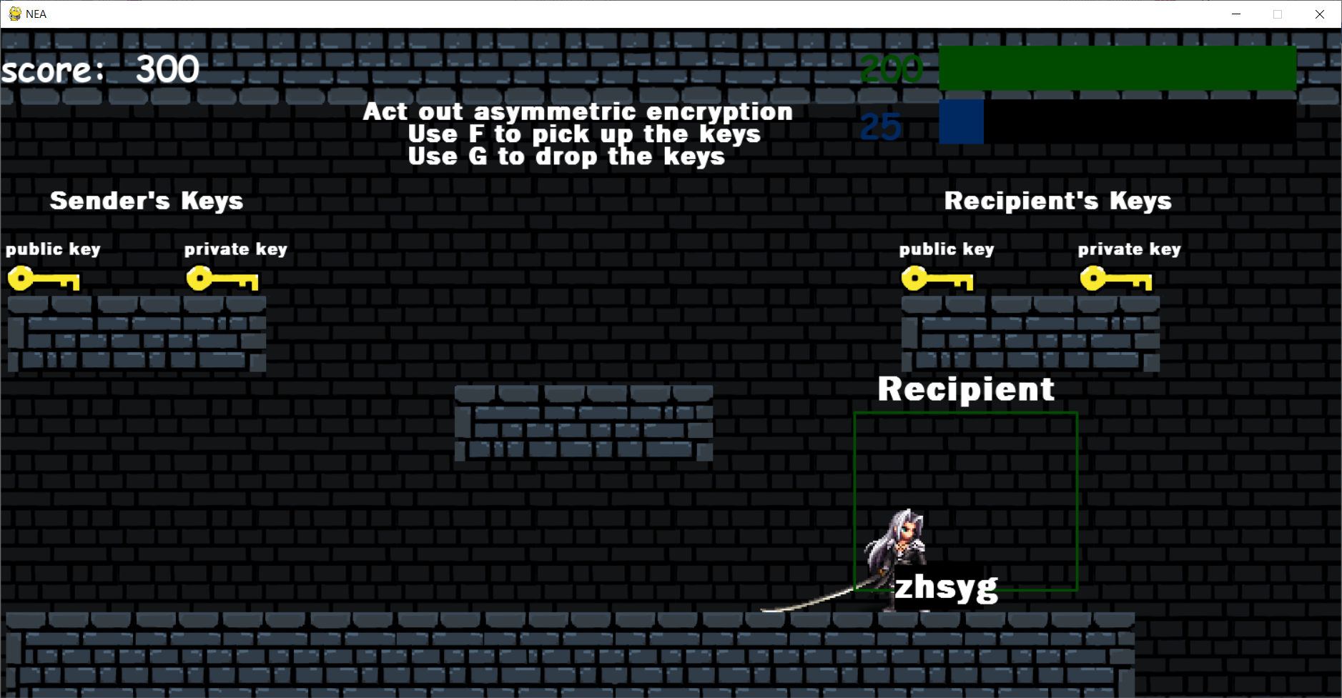

The encrypted message has been delivered to the recipient and the recipient’s rectangle has now turned green indicating the message has been received

Evidence for test 44

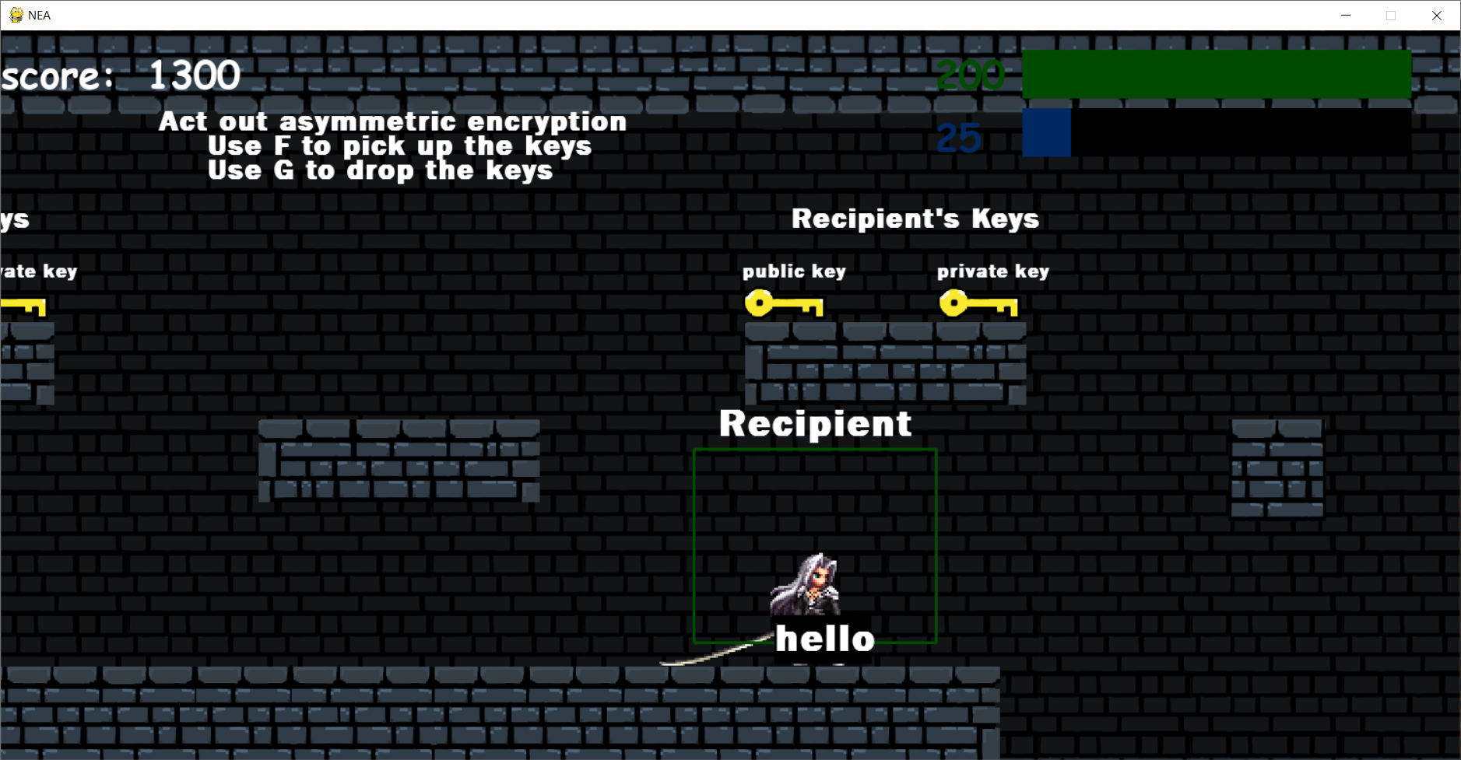

The encrypted message has been decrypted using the private key and now the key has returned to its original spot and the user’s score has increased as they have solved the puzzle

Evidence for test 45

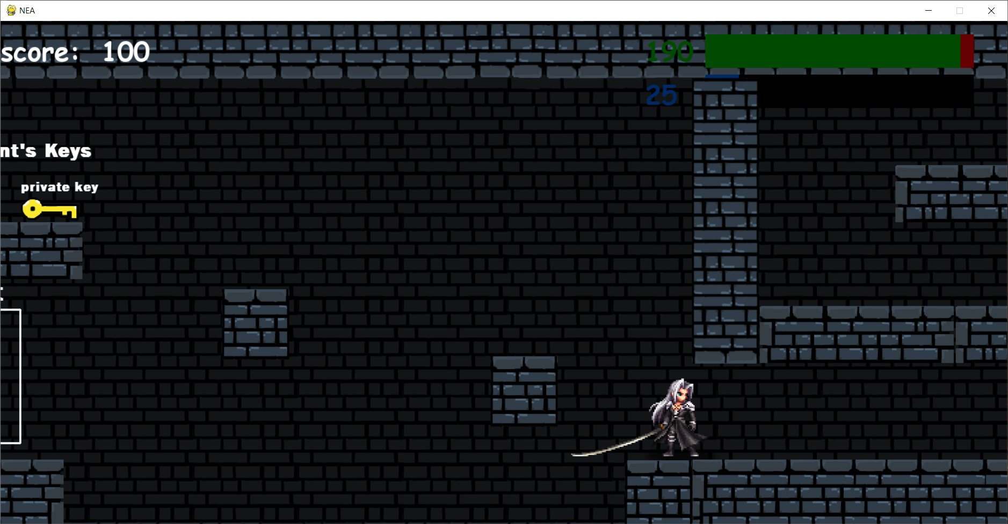

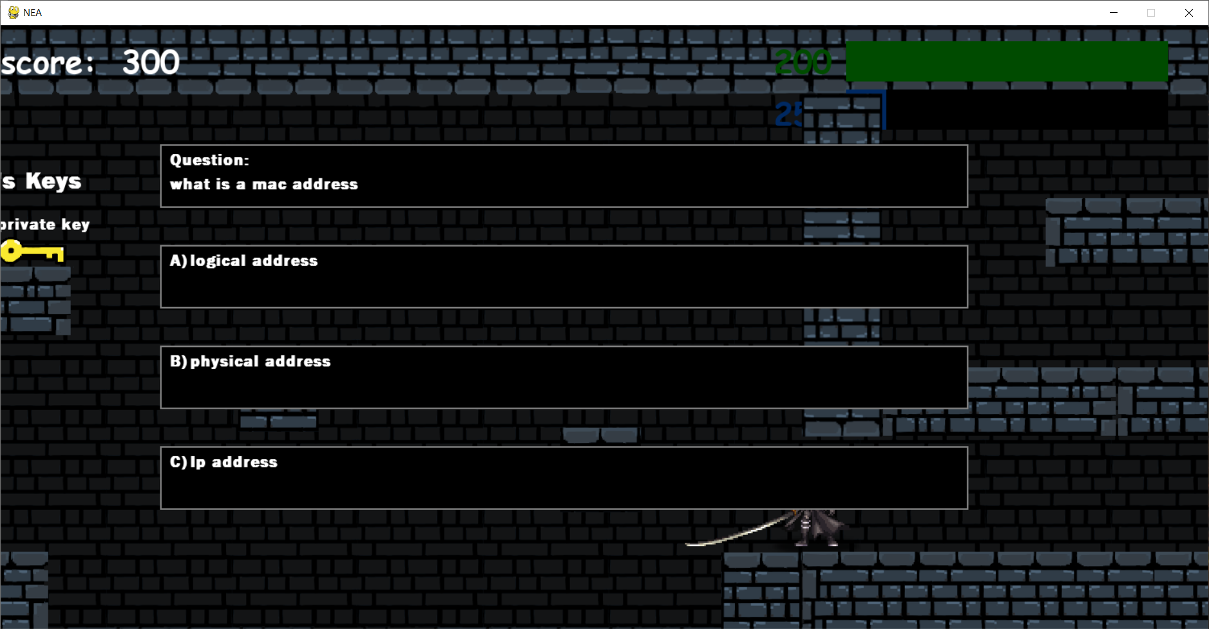

The first screen shot shows the player just before it enters the question section. The second question shows that the player has entered the question section and now a question is being displayed to the user.

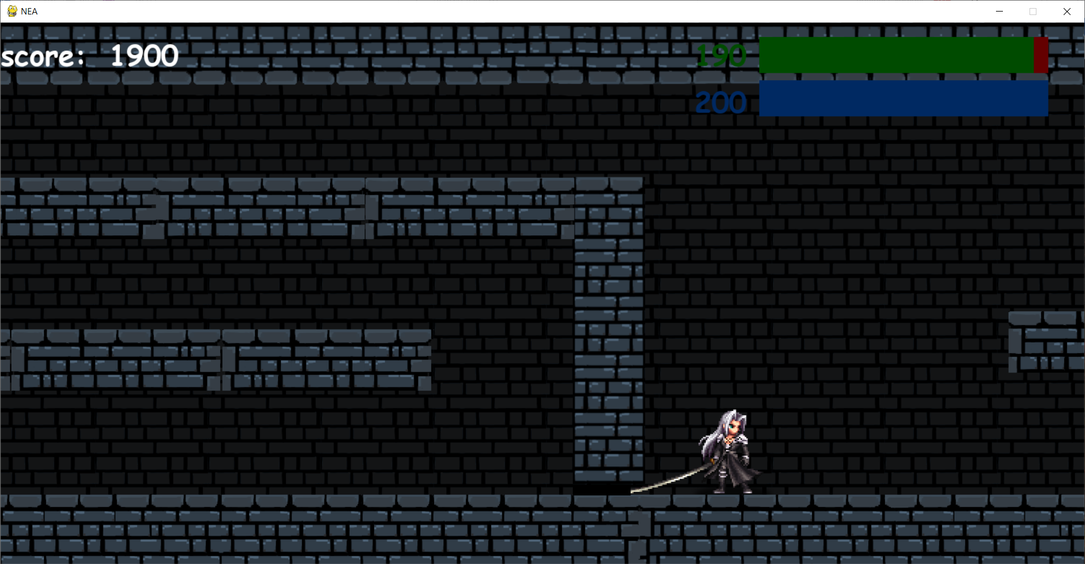

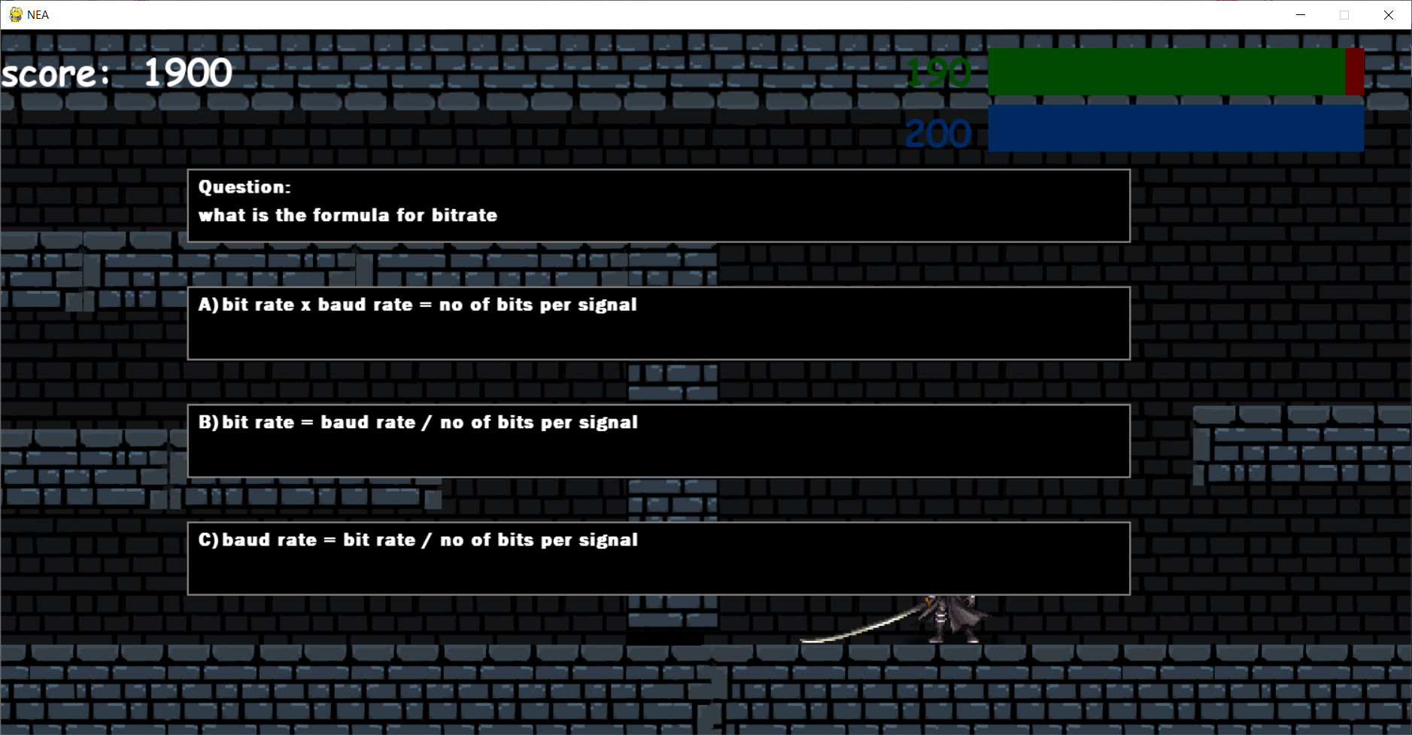

The 3rd screen shot shows the player just before he enters the next question section, and the 4th screen shot shows that the player had entered the next question section and a question is displayed to the user

Evidence for test 46

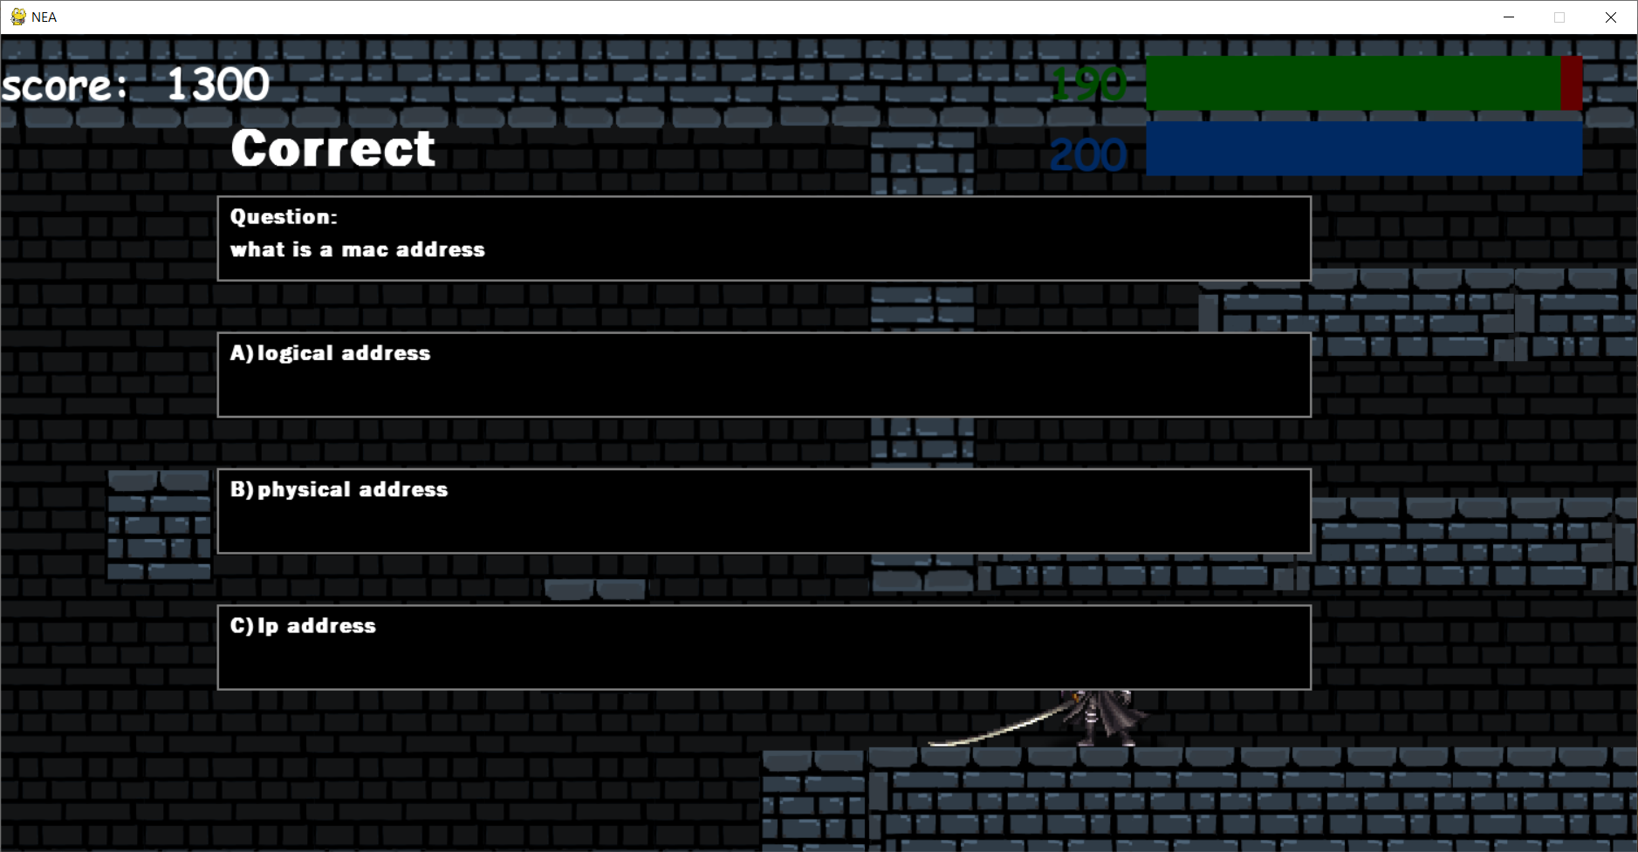

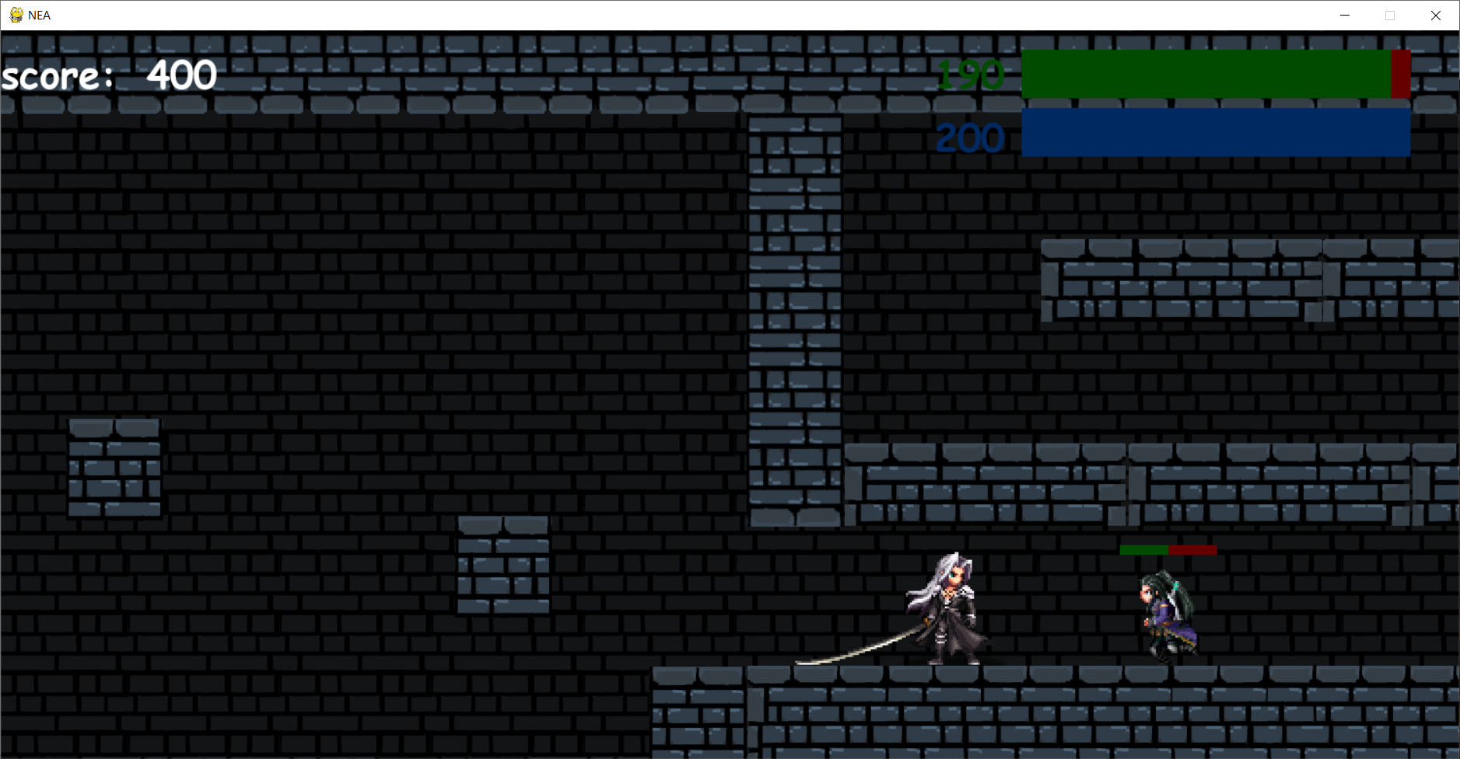

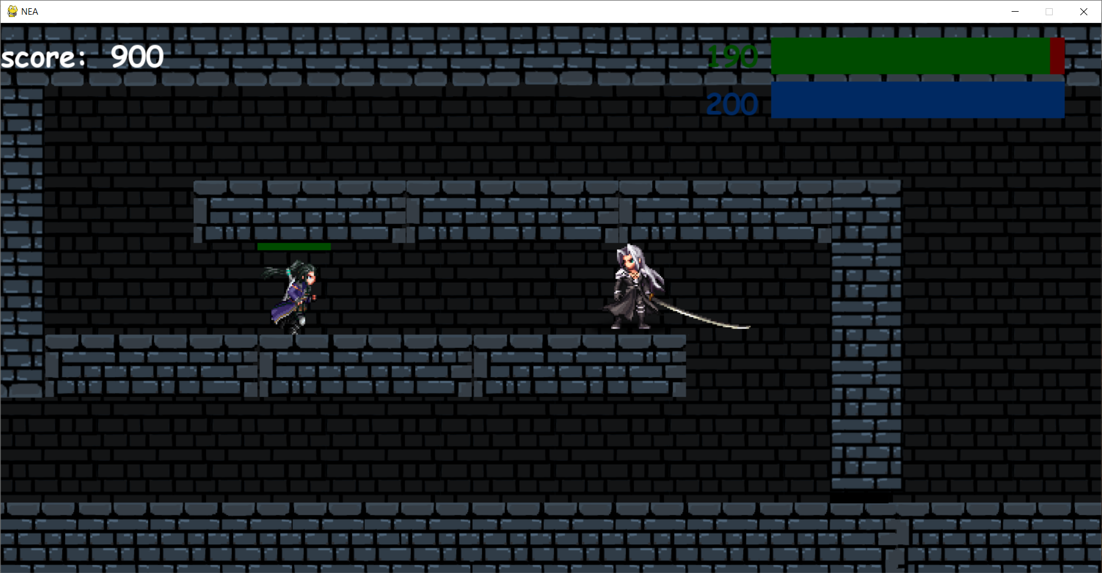

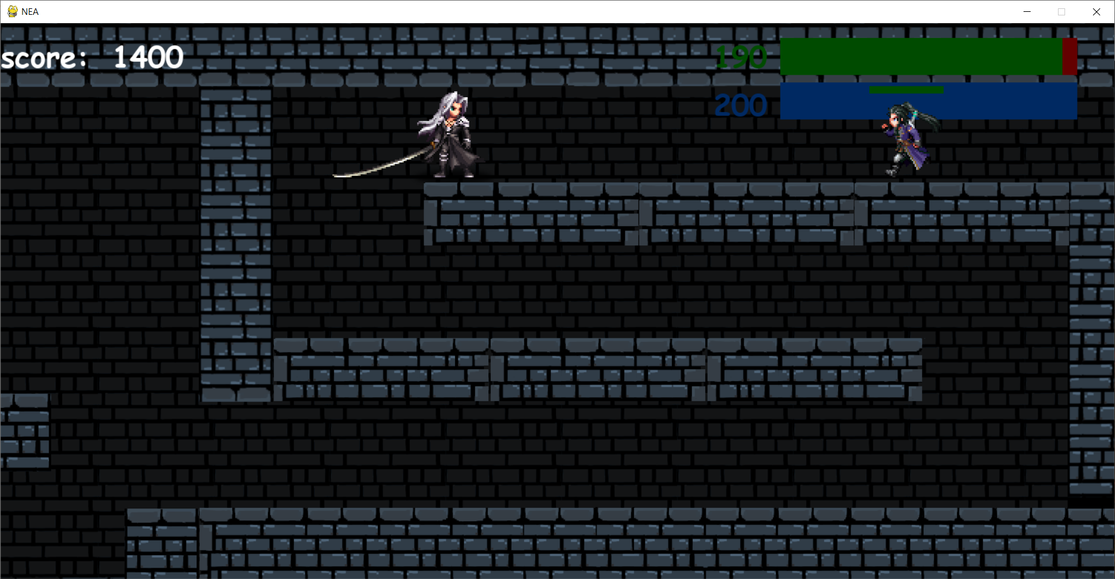

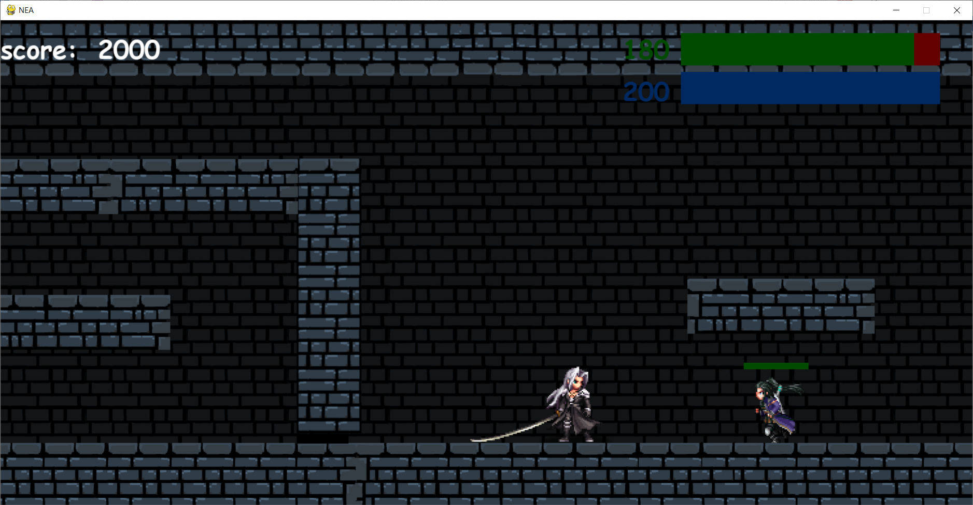

The 1st screen shot shows that the question is being answered correctly and the rest of the screen shots show that after the question has been answered correctly the enemies will spawn

Evidence for test 47

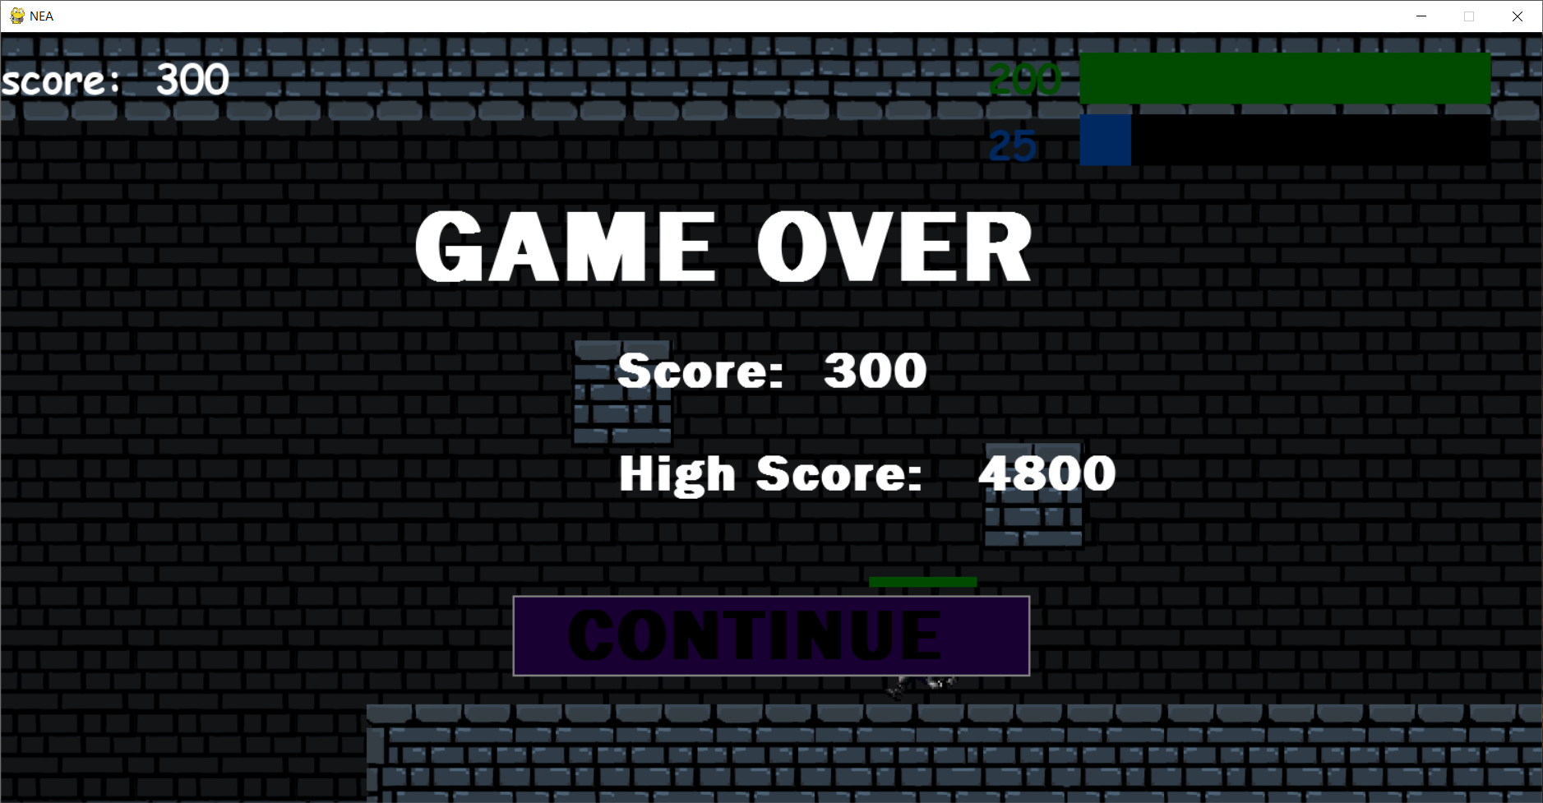

The player has fallen off the map and the game over screen is now shown

# Evaluation

To analyse how successful the project has been I will be assessing each objective and how well each objective has been met . Although I have met almost all my objectives, for certain objectives there is still room for improvement. Certain parts could have been made in a different way and some features could be added to improve the game and help meet some objectives more effectively.

## Objective 1 – Start menu

I was able to achieve this objective by using Tkinter to create a screen that had a resolution of 1500x750. Using Tkinter I was able to add a background picture and add 2 buttons, a start game button, and an exit button. The exit button will close the game and the start button will allow the user to proceed forward to login and play the game. The evidence for this is in test 1

## Objective 2 – Student or Teacher

After clicking the start button, the user is prompted with 2 options, one called teacher and one called student. This choice is important for after the user has logged in. As the student will then be able to view the leader board and play the game. Whilst the teacher will be able to add questions to the game. The evidence for this is test 2

## Objective 3 – Login Page

This objective was successfully achieved using Tkinter and SQL statements. I used the SQL statements to verify the user’s login details and to see if they matched with and account that has been registered and is stored in the database . With Tkinter I was able to create a text box where the student can type in their username and password and if their details are corrected once they click login, they will be taken to another page depending on whether the user has chosen that they are a student or a teacher. Furthermore, if the details entered are incorrect the user will be shown an error depending on what they have entered incorrectly. If they have entered an invalid username, they will be told they have entered a username that does not exist. If they have entered an invalid password, they will be told they have entered an incorrect password. The evidence for testing the login page thoroughly is shown in test 8 – 11.

### Improvement

An improvement that could be made is to the security of the logging in process. When entering your password, the characters are shown which means another person nearby will easily be able to see your password. To prevent this, I can make it so that when entering a character, a * is displayed instead of the character, I can also add a feature that will be able to reveal what the user has wrote so that they can check if the password has been entered correctly.

## Objective 4 – register page

This was objective was fully achieved, when the user clicks register, they are taken to the register page where there are text boxes for the user to enter a username, password and to confirm their password. To check if the details are valid SQL statements are used to check the database to see if the user has entered a unique username that is not stored in the database already. Additionally, when the user is registering what ever is written in the password box must match what is written in the confirm password box. It will also check to see if the password is at least 3 characters long and if it is less than 10 characters. If the details entered are not valid then the user will be prompted with the problem that is causing that error. Once the user clicks register their password and username will then be stored in the database through SQL statements and the user will then be able to login. Also, if the user had chosen student, then when they register, they will have made a student account and the same goes for a teacher.

### Improvements

An improvement that could be made is that the user could enter in their email and once they click register, they will be sent a verification email. Now that account will be associated with an email which will open more features. A new feature could be added so that the user will be able to retrieve their password if they have forgotten it. If they have forgotten it, they can enter their email and an email could be sent telling the user their password

## Objective 5 – student page

This objective was also achieved, if at the beginning the user had chosen student once they login they will be taken to the student page and will be shown 3 different buttons. A play game button that will open the game for the user to play a leader board button that will take the user to the leader board page and an exit to main menu button where the user will be taken back to the start menu.

## Objective 6 – leader board page

To achieve this objective, I made it so that once the user clicks the leader board page the top 10 scoring users is retrieved. This is retrieved using SQL statements and a merge sort. The SQL statements will retrieve all the usernames and the high score associated with that username. The merge sort will then order all the high scores from smallest to largest and then the last 10 scores are retrieved as well as the username for these scores . The username, rank, and high score of the top 10 scoring users will then be displayed on the leader board. There is also a back button where the user can return to the student page

## Objective 7 – teacher page

For this objective if the user had chosen teacher at the beginning when they login they are taken to the teacher page where they are shown 2 buttons, one will be to return to the main menu and the other will be to add a question. They will then be asked to select a level and will be able to add a question for that level . The user will be shown multiple text boxes where they will be able to enter the question text , the 3 options a, b and c for that question and the answer for that question. If the user has not entered an answer or has not entered a or b or c into the answer box, they will be shown an error stating that either a or b or c must be entered into the answer box. If they user leaves the question text or any of the options blank, they are shown an error stating that the question text and option a or b or c cannot be left blank. Once the user clicks add question that question will be added to the database . The level id , question text , answer and the 3 options will all be stored in the database through SQL statements, and they will all be linked to the same question id.

## Objective 8 – display

This objective was achieved successfully, when the user clicks play game, the game will load using pygame and the screen will display a health bar and an energy bar on the top right, the user’s score on the top left, the map will also be displayed, and the user will be able to see the level background and the platforms, and they will be prompted with a question. After answering an enemy will spawn and the enemy’s health bar will be displayed above it. If the enemy is defeated or the user answers a question right the user’s score will update and the score on the top left will increase. I was also able to create the illusion of a camera following the player, once the player reaches a certain side of the screen all the x coordinates of the platforms, player and enemies will increase or decrease depending on which way they player wants to move. Additionally, I created a way to track how much the camera has shifted since its original position, this was very useful as I was able to make it so that only the platforms near the player spawn and the other unnecessary platforms much further away do not. This helped increase the frames per second and helped the game feel much smoother as now the game will not have to be constantly load ever platform and only loading the necessary ones. Also, every action that the player does, or the enemy does an animation is played even if they are idle. To do this I loaded each frame of an animation into a list and created an algorithm that can go through that list and load each frame after a certain period which will create an animation.

## Objective 9 – questions

This objective was fully achieved, if the user had chosen teacher at the beginning, they would have been able to add questions for a certain level. Once the student clicks play game the game will load, and a question is displayed to the user. This question is randomly selected from the questions that the teacher has added using the add question feature. The question is selected by using SQL statements as the question, question options and answer is all stored in the database. First every question is selected then a random question is chosen, and the game will retrieve the question text, option a and b and c and the answer and then display the question to the user. Every time the user answers a question a new question is generated using the same process. If the user answers a question correctly their hp, energy and score will increase. However, if they answer the question incorrectly their score and hp will decrease. The level is divided into 4 sections , 3 sections are for answering questions and fighting the last section contains a puzzle about a computer science concept. Once the user enters a new section that is for questions and fighting the user will be prompted with a question. The user must answer at least 3 questions to proceed to the fighting part of that section.

### Improvement

An improvement that could be made is to the style of questions. Instead of having only multiple-choice questions I could make it so that for some questions instead of choosing an answer they must type the correct answer into a text box . This will help test the user’s knowledge for computer science even further and can help create an exam like scenario as for most questions you will not be given choices and will have to write an answer based on the knowledge that you can recall.

## Objective 10 – pause menu

This objective had been successfully achieved, during the game if the user wants to pause the game, they can press ESC and it will cause everything to stop moving and attacking . Once the user presses ESC the pause menu will appear and the user is presented with 2 buttons, one to resume the game and will allow the player and enemies to start moving and attacking again, the other button is the exit button which will close the game

### Improvement

An improvement that could be added to the pause menu is adding a controls button, so that at any point in the game the user will be able to see the controls if they have forgotten any of them

## Objective 11 – enemy

This objective was also fully achieved once the user answers 3 questions correctly the enemies for that section will spawn. The enemies are designed in a way so that they can move and attack on their own. To make the enemy move on their own I use the player’s x coordinate and the enemy’s x coordinate to see if the player is on the left or right of the enemy, the enemy will then move accordingly towards the player . There is also an invisible rectangle I have created using pygame that acts like an attack range, if the player is within that attack range the enemy will attack them causing the player to lose hp. There is also another invisible rectangle around the enemy that acts as its hitbox and will change according to the action the enemy is performing if it is attacking or running or idle. The enemy has an animation for each action, it has an idle, attack and running animation. If the enemy’s health reaches 0 then the enemy’s death animation is played and after a certain amount of time its body will disappear.

## Objective 12 – player

To achieve this objective, I used pygame to track the keyboard inputs of the user, these inputs would determine what action the player will perform. The player can move left and right using the A and D keys and is able to jump using the spacebar, after a period in the air the player will fall back down. The player also has 3 different attack moves that can be performed by pressing J or K or L. Each action for the player has their own animation and which animation that plays depends on the user’s keyboard input. The J key will perform a normal attack, the K key will perform a special attack that will require the user to have 75 energy to perform and will deal more damage than the J attack and its animation is more detailed, the L key will perform an ultimate attack that will require 150 energy to perform and will deal the most damage out of the 3 attacks and has a very detailed animation. The player also has an invisible rectangle around it that acts as a hitbox for the player. If the player’s hitbox collides with a running enemy or the enemy’s attack hitbox collides with the player’s hitbox then the player will lose hp and will be knocked back. But if the player is attacking and its hitbox collides with the enemy’s the enemy will lose hp and will be knocked back

## Objective 13 – puzzle

To successfully achieve this objective, I had used GIMP to draw my own key which I used to represent the keys used in encryption. For the puzzle I used 4 keys, 2 for the sender and 2 for the recipient, they each had 1 public key and 1 private key. There is also a message and an area called recipient where the recipient can receive the message. I created the puzzle in a way so that it replicates asymmetric encryption. To solve the puzzle, the user must perform asymmetric encryption using the keys. They must encrypt the message using the recipient’s public key. Then give the encrypted message to the recipient. The recipient then must use their own private key to decrypt the message.

## Objective 14 – game over

For this objective I made it so that once the player’s hp reaches 0 or they fall off the map or they complete the level they will be shown a game over screen. The game over screen will display the user’s score and high score . It does this by using SQL statements to retrieve the user’s high score and if the user’s new score is higher than their current high score their high score will be updated. There is also an exit button that will close the game

### Improvement

An improvement that could be added is that after the game has ended the user is taken to a screen so that they can view all the questions they had answered, they can also see which questions they had gotten correct and incorrect as well as the specific topic related to that question. This will make it easier for the student to identify what topics they may be weak on

## User feedback

Once I had finished the project, I asked my client to evaluate the coded solution and my evaluation as well as to test the game to see whether it met the requirements that he had asked for. I then interviewed him and asked him to give me feedback for what has gone well and what may need improving.

### Client response

“ Me and my students would like to thank you for creating this game for them. I have enjoyed thoroughly testing everything about the game and I am very pleased with how it has turned out; you have gone beyond what I imagined the game to be and have exceeded my expectations. I was extremely pleased with how easy it was to navigate through the menus and to create and login to an account, for me as a teacher I was able to easily add questions for topics that I knew my students were struggling on. Once I added questions, I had given the game to them to try and they had a similar response to mine, they were easily able to make an account and login and open the game with no issues . They were also impressed with the GUI and how easy it was to answer questions and at first, they struggled with the combat but after a little while they got the hang of it and were able to progress with ease. They also really enjoyed the fact that there was a leader board, every time they died, they were eager to relaunch the game and play again to get a new high score and have their name on the leader board. I was also delighted to see the puzzle that you had made about asymmetric encryption it helps paint a better picture in the students mind about how it works as some students find it hard to remember it.

I have read through you evaluation and have seen the improvements you want to make, and I agree with every single one of them. There were some improvements I think you could expand on, I like the idea of showing the student all the questions they had answered correctly and incorrectly at the end of the game, to expand on this I think you should add a feature that lets the user see the question scores for the last 10 games for example, this way the student can see if they are improving.

Overall, this game has helped me as well as my students and after playing the game a few times I can already start to see an improvement and I cannot wait to see the different levels you will add and what more you can do with the game."

The feedback I had gotten back from the students and the client was very positive. I am delighted to know that it has already started to help the students learn and that it was a game that they enjoyed and did not think of it as a boring computer science question game. I was also happy to hear them being eager to replay the level and are being competitive with the scoring system. The client also suggested that another feature I could add was to see the user’s previous progress, which I think will be very beneficial for the students learning journey and will be able to see how well they have improved over time.

## Potential improvements

Through analysing my program and the feedback given to me by the client and his students I have come up with some improvements for the game.

**Forgot password or username** – when the user is trying to register an account, they should enter an email that they can access. This way if the user forgets their username or password an email can be sent to their email telling them their username and password

**Writing password for login / registering** – when the user is trying to login or register, they will need to write their password. But when they are typing it, anyone nearby could easily see the password and use their login. To prevent this from happening when the user enters their password it will be hidden, meaning instead of seeing the character you will only see * . There will also be a button that will let you view what you have wrote and the characters will now appear instead of a * to make sure that the user has entered their password correctly

**Different type of questions** – currently the questions are only multiple choice which is good for revision but a way to challenge students even more is by making it so that the student will have to type their answer into a text box instead of choosing from 3 different options. To do this when the teacher is adding a question they can choose if they want the question to be multiple choice or if they want the student to answer it themselves. The teacher will have to write the answer like a mark scheme, there will be one base answer and there will be potential words that can be used to replace what is already in the base answer. This way if the student enters something like the base answer when answering they will still get it correct.

**Instructions in the pause menu** – it is easy for the students to forget the controls of the game so when they press the ESC, I could make it so that a third button will appear called instructions and when they click it the instructions will be shown to the user and the user will be able to return back to the pause menu and resume the game when they have learnt the controls.

**Questions answered menu** – once the player dies, I could add another screen where they will be able to view all the questions they have answered and whether they have gotten it correct. I can do this by making it so that each time they answer a question I keep a record of that question and whether they got it correct, then when the game is over, I could retrieve those questions and display them to the user.

**More levels and enemies -** I could make it so that when the student finishes a level they are taken to the next level and each level will represent a different computer science topic. The questions for that level will be up to the teacher and this will have a different map layout and will have a new puzzle revolve around that computer science topic. I could also make it so that each level will have a new enemy the player will need to defeat. Also, the player’s score, hp and energy will all transfer over from when they finish the previous level to the new level.

## Conclusion

Overall, I feel that my project has met all the demands of the client and I have achieved the objectives that I set out to achieve. I am happy with all the positive feedback I had gotten from the students and the client, and I look forward to improving the game even further and adding new enemies, levels, and puzzles for the students to tackle and learn from.

# Appendix

## sprites

1st sprite - <https://www.spriters-resource.com/mobile/finalfantasybraveexvius/sheet/95474/>

2nd sprite - <https://www.spriters-resource.com/mobile/finalfantasybraveexvius/sheet/87187/>

## Background menu image

<https://pixabay.com/illustrations/solo-leveling-igris-knight-4968012/>

## websites used

<https://www.youtube.com/channel/UCznj32AM2r98hZfTxrRo9bQ>

<https://www.youtube.com/channel/UCPrRY0S-VzekrJK7I7F4-Mg>

<https://www.youtube.com/c/TechWithTim>

<https://www.youtube.com/c/Codemycom>

<https://stackoverflow.com/>